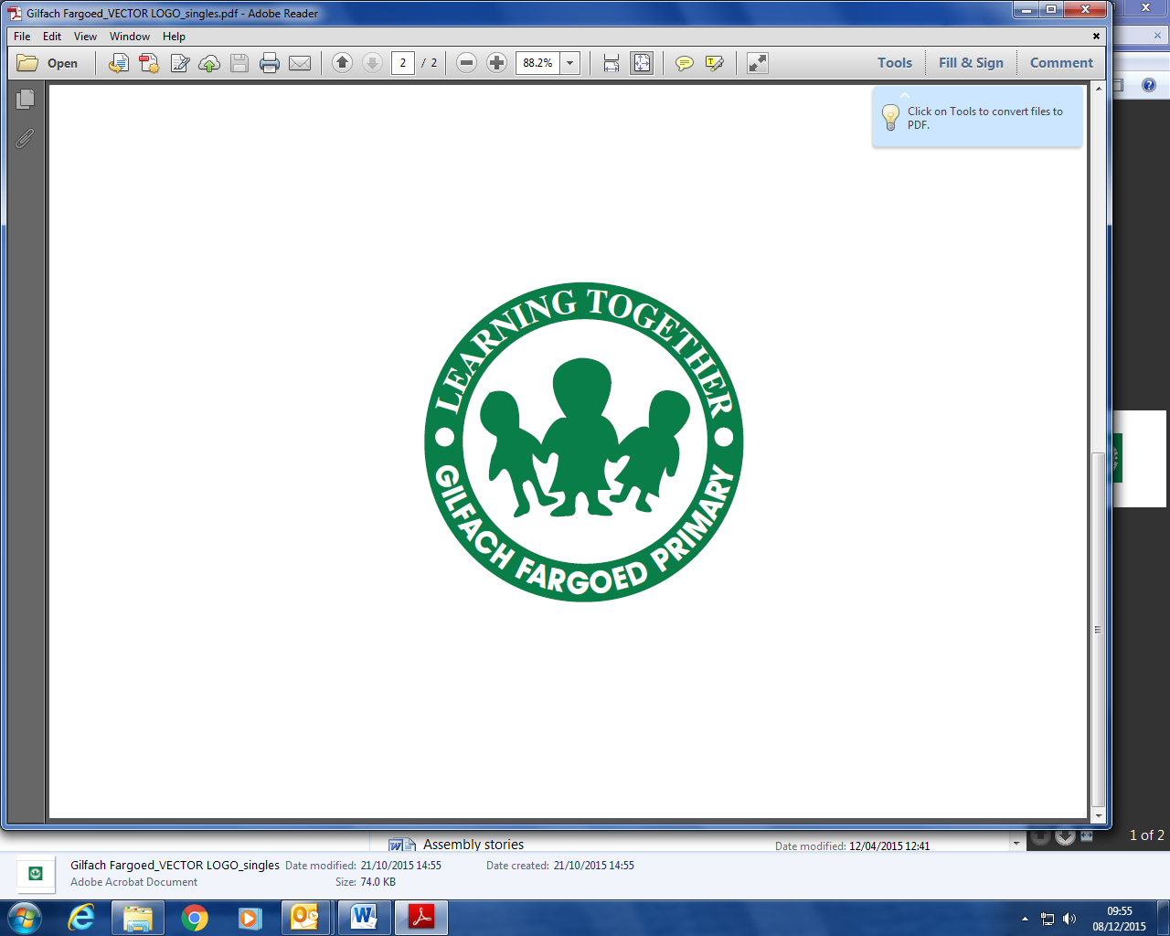

16th July 2025

Dear Parents/ Carers,

As we come to the end of another school year, Gilfach staff and I would like to express our gratitude for your excellent support. We’ve had a very successful year, the children have enjoyed some wonderful experiences to support their learning, and I’m very pleased with the progress they’ve made. On trips and sporting events, our children have behaved impeccably, proving, once again, that they are a credit to their families and their school.

**New Classes**

Every year, when new classes are announced, there is, understandably, a little anxiety for some families. The size of our school dictates that we must always have some or all split classes and every year careful consideration is given to the make up of each class. As I’ve said previously, we use several factors, which include children’s current attainment within the progression steps, as well as their maturity. Our priority is that children are happy and make good progress. I can promise parents that we will continually monitor this to make sure that’s the case for all children. Obviously, if both school and home can encourage children to feel really positively about their new classes, that makes transition even smoother and easier for them. Although classes are set in July, should any parent have concerns once the new term is underway, I will always make myself available to discuss any issues and to solve them in partnership with parents.

**Seesaw**

During Covid, Seesaw became an important tool to assist with home-school communication. However now, in some instances, Seesaw has taken over from the office for some communication and I feel this is no longer appropriate. From September, Seesaw won’t be available for messaging from home. The office is manned from 8.15am until 3.30pm daily, and outside these hours, messages can always be left, which will be dealt with promptly. You will still be able to receive photos of your children in school via Seesaw.

**Staff Changes**

Ms Kostin, who has been with us for many years, and is a much valued and skilful member of staff, is retiring at the end of the year. We will miss her, but she has a new granddaughter who is making demands of her time! Whilst our core staff remains the same, we have appointed some new teaching assistants who I’m sure will bring skills and expertise to the team. I will introduce new staff to parents/ carers in a newsletter prior to the new term. Mrs Usher joins us full-time, while Miss Coles is going to Park for a year. Good news if your child is in the infant department and loves Forest School! Miss Coles, who has recently been fully trained in Forest Schools, will be returning to Gilfach to deliver regular Forest School sessions to Y1/2 and Y2/3 classes next year. More details about Forest School days will be provided before sessions start.

Many thanks for your continued support, and I wish you a wonderful summer.

Mrs C Rees