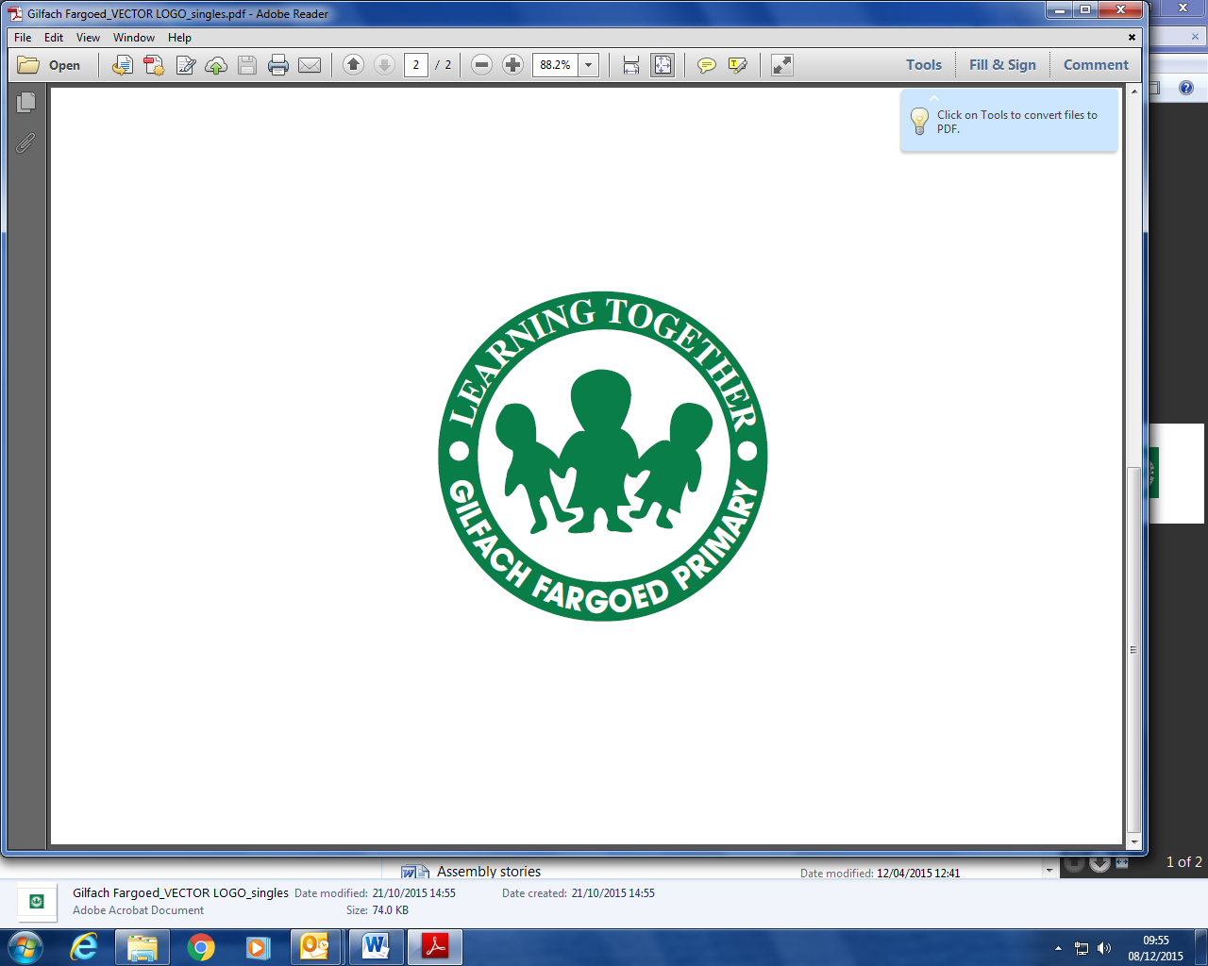
4th September 2024

Dear Parents/ Carers,
I hope you managed to have a lovely break over the summer and were able to make the most of the good weather. It’s been so lovely to have the children back in school. They look very smart in their uniforms and I’m very grateful for your support with this. We already have some confirmed diary dates and I’ll update you further when new dates are made.
Dates for your diary
Thursday 4th September: Caerphilly Employment Support team will be outside school, ready to offer support with employment issues. They’ll be available on the first Thursday of every month.
Tuesday 16th September: Recorder lessons from Caerphilly Music with our Y3/4 class.
Friday 19th September: Individual and sibling photographs with Tempest Photography
Monday 29th September: Chance to Shine Cricket sessions with Cricket Wales for Y2/3; Y3/4; Y5: Y6 (Also 6th, 13th, 20th Oct)
Friday 10th October: Provisional date for Harvest Festival (Reception-Y6)- more details to follow
Friday 10th October: Hello Yellow Day, raising awareness of mental health (a small contribution for Young Minds would be much appreciated)
Friday 18th October: Wear Red for “Show Racism the Red Card”
Monday 27th October- Friday 31st October: Half term holiday
Fruit Tuck
We are going to be resuming our fruit tuck shop next week, starting on Monday 8th September. We will be offering bananas, satsumas or apples, initially. Cost per day is 30p or £1.50 per full week, if you’d prefer. You can send the weekly money in on Mondays, or send in 30p each day if you’d like your child to enjoy our fruit tuck. If you’re sending in the weekly amount, it would be helpful to put it in a marked envelope, if you can.
PE
Our PE sessions will be resuming next week and junior children will be expected to change into their kits before the session. For children in Mrs Williams/Miss Houlihan’s class, Mrs Jones’s class and Mrs Ashford’s class, please ensure your child comes to school bringing their PE kits in a bag on their PE day. Our prospectus states our PE kit as: a white polo shirt and black shorts. White T shirts are also fine. For outdoor games and during colder weather, black joggers or leggings are ideal. Cropped tops aren’t suitable PE kit.
For children in the infant classes, please ensure they come to school wearing joggers or leggings (with their uniform tops) on PE days, also wearing sensible trainers (black if possible, and not brightly coloured ones). Children may wear their forest school clothes to school on those days.

Earrings
A reminder that, for safety reasons, small studs are the only earrings allowable in school. Children are not allowed to wear make-up and long nails are not suitable for primary school at all.
After school clubs
After school clubs will start week beginning 8th September. More information about these will go out to parents/carers separately.
Many thanks,
Mrs C Rees

