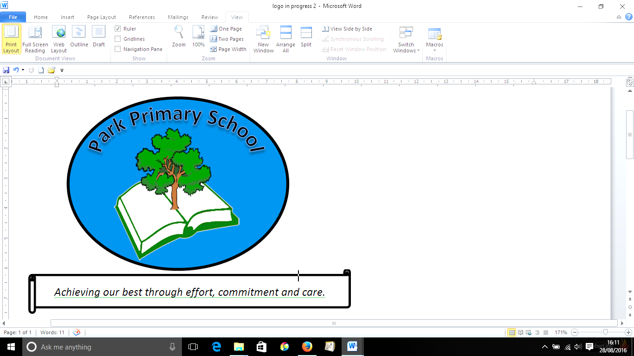

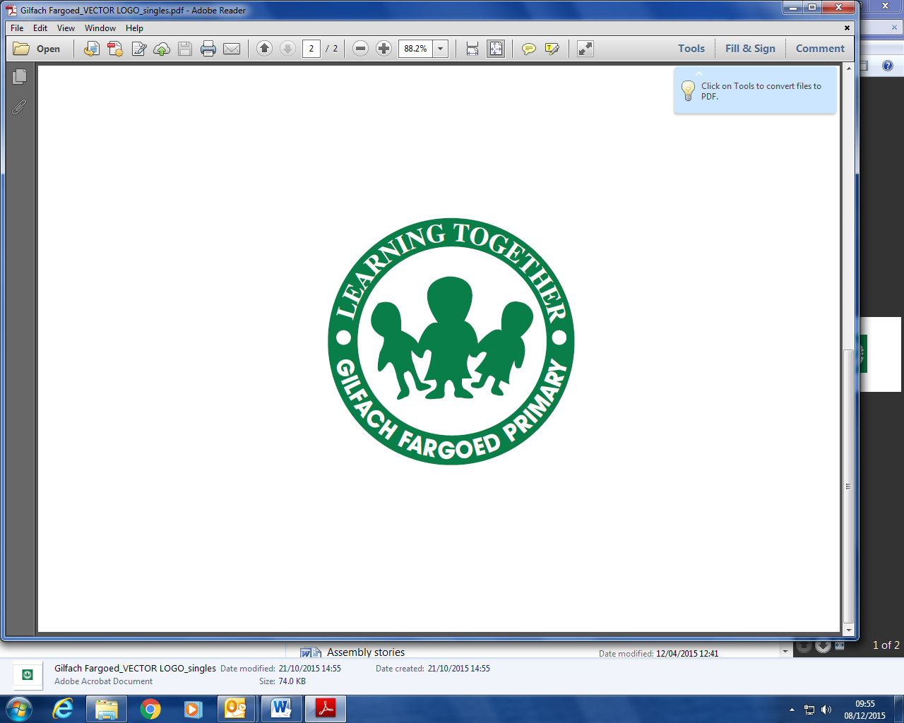

**Gilfach Fargoed and Park Primary Schools Federation**

|  |  |  |  |
| --- | --- | --- | --- |
| Policy Title: | **Admissions Policy (Based on LA document, Admission Arrangements 2025-2026 )** | | |
| Adoption Date: | September 2023 | Review date: | January 2025 |
| Review date | January 2026 |  |  |
| Signed, Chair of Governors: |  | Signed, Headteacher: |  |

**Mission Statement**

In our Federation, we are all learners for life. Our schools prioritise authentic, nurturing relationships through which we provide engaging and inspiring learning experiences. We set high-expectations, achievable through the development of resilient and confident learners who have a curiosity and enthusiasm about their community and the wider world. We take a pride in our learning, we thrive on collaboration and we are ambitious to solve problems and to achieve our best. We respect one another and our wider world while valuing our Welsh heritage. We aim to give our learners the tools to succeed in the 21st Century, with the guidance of a strong moral compass. We develop skills and knowledge, while fostering wellbeing and a growth mindset. Our whole community aims to develop:

* Healthy, confident individuals;
* Ethically informed citizens;
* Creative, confident contributors and
* Ambitious and capable learners.

**Contents**

**Introduction**

* 1. **Choosing a School**
  2. **Admission Limit**
  3. **Oversubscription Criteria**
  4. **Addresses**
  5. **Multiple Birth Children**
  6. **Children of Service Personnel**
  7. **Children with ALN**
  8. **Waiting Lists**
  9. **Primary Education**
  10. **Reduction of Infant Class Sizes**
  11. **Admission to an Early Years Placement**
  12. **Admission to Nursery School**
  13. **Admission to Infant Department**
  14. **Changing Schools: Primary Education**
  15. **Admission to Secondary Schools**
  16. **Applying for a Place**
  17. **Late applications**
  18. **Withdrawal of offer of place**
  19. **Timetable of Admissions**
  20. **What happens if your child is refused a place?**
  21. **Registering your appeal**
  22. **Disability discrimination**
  23. **Usage of accommodation**
  24. **Admission Forum**
  25. **Welsh language policy**
  26. **Teaching of Welsh as a Second Language**
  27. **Capacity Admission Numbers**

**Introduction**

In line with the School Standards and Framework Act 1998, subsequent legislative updates and Welsh Governments (WGs) Schools Admissions Code, these admission arrangements will aim to ensure that:

• Parent’s preference for the schools of their choice is considered in the context of a legislative framework, which has regard to the provision of efficient education and the efficient use of resources.

• Admissions criteria are clear, fair and objective, for the benefit of all children including children with special educational needs or with disabilities.

• Local admission arrangements contribute to improving standards.

• The Local Authority (LA) consults with neighbouring Admission authorities and co-ordinates arrangements, including the rapid reintegration wherever reasonable of children who have been excluded from other schools.

• Parents have easy access to helpful admissions information.

The LA’s admission arrangements seek to achieve full compliance with all relevant legislation and guidance, including legislation on infant class sizes and equal opportunities (Equalities Act 2010, the Human Rights Act 1998 and the Welsh Language Act 1993) and take full account of the guidance in the Code issued by the Welsh Government.

The Equality Act 2010 and Caerphilly County Borough Council’s (CCBC) Strategic Equality Scheme emphasises the legal general duty the Council and its partners have to:-

• Eliminate unlawful discrimination.

• Promote equal opportunities.

• Promote good relations and mutual respect.

This Council will work actively against discrimination and seek to create equal access to its services for all, irrespective of ethnic origin, sex, age, marital status, sexual orientation, disability, gender reassignment, religious beliefs or non-belief, language, nationality, responsibility for any dependents or any other reason which cannot be shown to be justified.

* 1. **Choosing a School**

The entry of children to schools is controlled and administered by an ‘Admissions Authority’. In the case of Community Schools, this is Caerphilly County Borough Council (LA). In the case of the one Voluntary Aided School (St. Helen’s Roman Catholic Primary School) the Admissions Authority is the Governing Body of the school. Within the County Borough, each school has an area that it traditionally serves called the “catchment area”. In line with legislation, LAs must allow all parents the opportunity to express a preference for the school they wish their child to attend.

Parents may exercise their right to express a preference at the following times:

• On admission to an infant school or the infant department of a primary school.

• On transfer from infant to junior school or infant school to junior department of a primary school.

• On transfer from junior or primary to secondary school.

• When parents wish to transfer their child from one school to another.

Parents may also express a preference for their child to attend a Voluntary Aided School.

The LA (in the case of Community Schools) and School Governing Body (in the case of Voluntary Aided) must comply with any preference, which is expressed, provided there is room within the school. However, the decision to admit pupils, must take account of:

• the overall provision of efficient education and efficient use of resources.

• whether it is a co-educational or single sex school.

• Section 87 of the School Standards and Framework Act 1998 (and subsequent legislative updates and WGs Schools Admissions Code), which also allows an admission authority to refuse to comply with parental preference for a period of two years following a second or subsequent exclusion.

• where to admit would be incompatible with the duty to meet Infant class size limit of 30 because the admission would require measures to be taken to comply with those limits which would cause prejudice to efficient education or efficient use of resources.

The local catchment areas for schools providing primary education are normally grouped together (as feeder schools) to form a linked catchment area for each maintained secondary school.

All schools within the LA aim to provide their pupils with an educational opportunity, which is best suited to each individual child. Some pupils will, however, have learning needs requiring special educational provision. In some instances, parents will already be receiving specialist support and guidance regarding the choice of school for their child.

All parents, however, are encouraged to discuss possible areas of concern with their local Headteacher who may then seek specialist advice.

**1.2 Admission Limit**

All maintained schools will admit pupils up to their admissions number. In Gilfach Fargoed Primary, the admission number is 23; in Park Primary, it is 20. A child will normally be offered admission to the school of the parents’ preference unless applications exceed the admission number, when this occurs all applications for that school will be assessed against the oversubscription criteria.

The normal ages for admission to CCBC schools are:

• Age 3/4 in Nursery;

• Age 4/5 in Infant and Primary Schools;

• Age 7/8 in Junior Schools;

• Age 11/12 in Secondary Schools.

Parents will need to submit an online application at each of the above stages.

Where you submit an application for your child to attend Reception at a Primary School, an application will not be required for them to attend the Junior phase. Likewise, if you submit an application for your child to attend Reception at Idris Davies 3 to 18 School, you will not need to submit an application for the Junior or Secondary phase.

The LA’s policy is to provide all 3 to 4 year old children in the Caerphilly County Borough an entitlement to a funded part-time nursery place at their local infant or primary school.

**1.3 Oversubscription Criteria**

1. Looked After Children (children in public care) and those who were previously Looked After Children.

2. Those children who live in the school’s catchment area on or before the published closing date.

Note: Those children who live within the school’s catchment area and have a sibling* already attending the school will be admitted first (the sibling must be of statutory school age), and then those children who live within the school’s catchment without a sibling will be admitted.

3. Children with siblings* living in the same household attending the school in September 2024. The sibling must be of statutory school age.

4. After taking account of the above categories, priority will be based on the closeness to the school measured automatically by the LA’s G.I.S (Geographical Information System).

Distance is measured from the grid reference of the property to the grid reference of the school (as recorded in the GIS system). If the LA has the situation where any home addresses calculate the same distance, then a trundle wheel will be used to establish the nearest address.

*A sibling is a child who is the brother/sister, half-brother/sister (children who share one common parent), step-brother/sister where two children are related by marriage. This definition also includes adopted or fostered children living at the same address.

**1.4 Addresses**

When considering whether a child lives in a school’s catchment area, the address considered is that of the parent or legal guardian, irrespective of a family’s domestic arrangements. i.e. the address of another relative or childminder etc. must not be given. In certain cases, it may be necessary to provide evidence relating to the child(ren) in question, to show the home address of the child(ren).

Where parents have shared responsibility for a child, and the child lives with both parents for part of the week then the home address will be determined as the address where a child lives for the majority of the week (e.g. 3 out of the 5 school days). In such circumstances, the home address to which the Child Benefit is paid will be used. Parents will be required to provide documentary evidence to support the address they wish to be considered for allocation purposes.

**1.5 Multiple Birth Children (e.g. twins or triplets).**

If when applying the oversubscription criteria, the last child to be admitted is one of a multiple birth e.g. twin or triplet then the LA will also admit the other sibling(s).

**1.6 Children of UK Service Personnel**

Children of UK service personnel will be treated as in catchment if their application form is accompanied by an official Ministry of Defence (MOD) letter declaring a definite return date and confirmation of the new address. Pupils from outside the school’s catchment area will be admitted in accordance with parental preference if the Admission Number of the school, class or unit has not been reached and, if selection is necessary, the criteria shown above will be used.

**1.7 Children with a Statement of Special Educational Needs or an Individual Development Plan**

The Local Authority is required by the Education Act 1996 to admit to the school a child with a Statement of Special Educational Needs that names the school and from 1 September 2021, section 48 of the 2018 Additional Learning Needs and Education Tribunal (Wales) Act requires the governing body of a maintained school in Wales to admit a child to the school if the school is named in the child’s individual plan for the purpose of that section, which is to secure the child’s admission to the school. This duty applies despite the limits on infant class sizes and even if admitting the child would result in the school exceeding its admission number. The duty to admit applies at all times, including where a school is named in a plan outside the normal admission round.

**1.8 Waiting Lists**

Following the allocation of places during the normal admission round any pupil that is refused admission to an oversubscribed school will remain on a waiting list for placement until the 30th September of that school year and, should a placement become available, the placement will be allocated in line with the authority’s oversubscription criteria. After the 30th September parents will need to make a new application for admission to their preferred school.

**2.1 Primary Education**

Every child is required by law to receive full time education from the beginning of the school term after his/her fifth birthday. In CCBC, however, all children are able to start school full time at the beginning of the school year (September) in which they become five i.e. between the 1st September and the 31st August.

Parents are able to defer the start of a child until the term following their fifth birthday. All children are able to attend school on a part time basis in the September following their third birthday. Children between the ages of 3/4-11 are recognised as pupils receiving primary education. In Caerphilly County Borough, primary education is provided either in separate infant or junior schools, or in primary schools with one complete 3/4 -11 age range.

**2.2 Reduction of Infant Class Sizes**

In accordance, with Infant Class Size Legislation, infant classes contain no more than 30 pupils where a teaching session is managed by a single qualified teacher (or where the session is managed by more than one qualified teacher, no more than 30 pupils for every teacher).

**2.3 Admission to an Early Years Placement at a Nursery School**

Children born between the 1st September and the 31st March maybe entitled to an Early Years placement (term after their 3rd birthday) at their local Primary/Infant school dependent on availability.

Where a school has reached their Admission Number in their current nursery and where the in-catchment pupils exceed 70%, only pupils who reside within the schools catchment area will be admitted into an Early Years placement.

Admission into an Early Years place in either the Spring or Summer term does not entitle your child to continue education in the nursery year at the school. An application for admission into the nursery year at the school will need to be made at the relevant time.

**2.4 Admission to Nursery School**

The number of places available in a nursery year is set by the LA and the decision whether to admit your child will be taken in accordance with the LA’s guidelines.

Pupils who are admitted to a nursery year, will not have an “automatic” right to continued education within that school. A formal application must be made for entry into the reception year at the appropriate time.

**2.5 Admission to Infant Department within Primary Schools**

Pupils who attain the age of five during the school year may be admitted to an infant school/department, at the commencement of the school year in September. Pupils admitted to a separate infant school will not have an ‘automatic’ right to continued education at the feeder Junior School which serves the same catchment area. Whilst every effort will be made to accommodate such pupils, a formal application must be made for transfer to the Junior school at the appropriate time.

**2.6** **Changing Schools: Primary Education**

Changing schools is a significant step for your child to take. In the case of moving the family home, such a decision may well be a necessity and you will need to contact your local school or the Directorate of Education and Corporate Services for assistance. If, however, you would like your child to transfer from one school to another, please contact the Headteacher of your child’s current school first. Should you still wish to proceed with these transfer arrangements; you can apply at <https://caerphilly.gov.uk/schooladmissions>

If there is a suitable vacancy, your child will be admitted to the school. Parents should note, however, that in Primary Schools, classes may include more than one age group and the Headteacher will have the task of locating your child in the most appropriate class. If the child is in years 10 or 11, the range of subject options chosen may also be a factor. If that particular year has not reached the school’s admissions number, then your child will be admitted to the school. Parents should note, however, that curriculum option choices may vary from school to school.<https://caerphilly.gov.uk/schooladmissions>

**2.7** **Admission to Secondary Schools**

Children normally transfer from primary school to secondary school at the beginning of the school year following their eleventh birthday. If your child was born between 1st September 2011 and 31st August 2012, she/he will transfer to secondary school in September 2023. Headteachers of primary schools will be able to inform parents of the secondary school which their children should normally attend. It should be noted that the home address denotes which school is the ‘catchment’ school and not the primary school attended. Whilst every effort will be made to accommodate pupils, an application must be made for transfer to secondary schools at the appropriate time.

**2.8** **Applying for a Place**

When you apply for a place at a particular school, you must complete the relevant application form online at https://www.caerphilly.gov.uk/schooladmissions

You must apply by the closing dates shown below for Admission in September 2025.

If you require assistance with completing the form, please contact the school admissions team on 01443 864870.

The LA will inform you whether, or not it is possible for your child to attend your preferred school. Each school produces a prospectus, which contains relevant information including school aims and educational beliefs, the organization of the school and curriculum opportunities, including out of school activities. This school prospectus is available from the Headteacher..

**2.9 Late Applications**

Any applications that are received after the closing date for admission will be refused if the school is oversubscribed unless the family has just moved into the catchment area and the application is received before the offer of places are made. If the application is received after the places have been offered and documented evidence is provided to demonstrate that the family have moved into the catchment area of the school the pupil will be given higher priority on the waiting list. Places will then be allocated using the authority’s oversubscription criteria.

**2.10 Withdrawing Offers of Places**

The offer of a school place will be withdrawn on the basis of a fraudulent or intentionally misleading application being received (e.g. falsely claiming to reside within a catchment area of a school).

* 1. **Timetable of Admissions**

Admission to Secondary School

* Admission Forms available online 2nd September 2024
* Forms returned to LA 25th October 2024
* Parents notified of outcome 1st March 2025
* Admission to Primary School
* Admission Forms available online 2nd September 2024
* Forms returned to LA 13th December 2024
* Parents notified of outcome 16th April 2025
* Admission to Nursery
* Admission Forms available online 2nd September 2024
* Forms returned to LA 21st February 2025
* Parents notified of outcome End of May 2025
  1. **What happens if your child is refused a place?**

In the vast majority of cases children are offered places at their parents’ first choice of school. If, however, your child is unable to gain admission, you will need to decide

whether you are willing to accept a place offered at a different school, or whether you

wish to continue with your first application. If you choose the latter course, you may

appeal to an Independent Appeal Panel. This Independent Appeal Panel will judge

whether the school is full and, should that be the case, whether the parent’s application is so strong that the child should still be offered a place.

* 1. **Registering your appeal**

You may make a formal appeal against the LA’s decision, but this must be received within 28 calendar days of you being notified of the decision not to admit your child to your chosen school. You should forward this appeal in writing, to the Directorate of Education and Corporate Services. The LA will refer the appeal to the Council’s Legal Department who will arrange for the appeal to be heard by an Independent Appeal Panel and will set a time and place for the hearing. The Panel will afford parents an opportunity of appearing and making their representations (oral and/or written). Parents are able to seek admission to an alternative school whilst they are pursuing an appeal.

Parents, however, are advised that: -

• They may elect not to attend the appeal meeting and, instead, allow the appeal to be considered on a written statement.

• The outcome of the appeal will be decided on the information available.

• They will be given at least fourteen days (from the date of posting) written notice of

the meeting of the Appeal Hearing.

• They are welcome to be accompanied by a friend, or represented by a solicitor, but

that, in the latter case, the Directorate of Education and Corporate Services should

be informed at least seven days before the hearing.

• A separate Appeal Panel hears appeals against decisions of the Governing Body of

a Voluntary Aided or Foundation School. Guidance on such an appeal should,

therefore, be sought from the school concerned.

• Please note that limitations will be placed on the powers of the appeal panel to

allow appeals against the refusal to admit a child to a school where infant class

size legislation applies.

• The LA will not consider a second appeal application unless there is a significant

change in circumstances (which will need to be evidenced).

**2.14 Disability discrimination**

The Council has in place an Accessibility Strategy, which details how the Council will

meet its duties under the Equality Act 2010 and preceding Disability Discrimination

legislation.

The Strategy covers access to premises for staff, visitors and pupils. The strategy

contains the Council’s plans to improve physical access to school premises across the borough to minimise the barriers to disabled pupils accessing education. In a number of cases, due to the topography of a school site, it may not be deemed accessible for a child with a physical disability. In such cases parents/guardians will be provided with the details of the nearest accessible school which is able to meet the child’s needs.

Admissions forms are screened by Education in order to highlight any children with

medical condition/physical disability. Parents will be contacted at the earliest

opportunity to discuss the child’s needs and a suitable school placement will be

considered. The School and Officers of the Council work closely with parents to ensure that detailed assessments are in place to support the inclusion of pupils, where possible within their chosen school.

**2.15 Usage of Accommodation**

The LA continually reviews the usage of accommodation at all Infant, Junior and Primary schools and subsequently updates the Capacity and Admission Number to reflect this review. Allocation of placement will be carried out using the Authority’s published admission arrangements.

**2.16 Admission Forum**

In line with The Education (Admission Forums) (Wales) Regulations 2003 the Authority has established an Admission Forum which will enable us to bring together admission authorities and others with an involvement in school admissions within the area.

**2.17 Welsh Language Policy**

In accordance with the Welsh Government’s Welsh-medium Education Strategy (April 2010), the LA’s policy is that every child should have the opportunity to learn and use the Welsh language effectively. Currently provision is made for this in the following ways, in line with the LA Welsh in Education Strategic Plan.

**2.18 The teaching of Welsh as a second language**

In the infant department, Welsh is taught to all pupils. The emphasis is on using the language with purpose and in meaningful situations. In addition, the incidental use of the language during the school day is encouraged.

At junior level, language is further developed orally and more attention is given to teaching, reading and writing skills.

**2.19** Capacity Admissions Numbers

Primary Schools

Aberbargoed Primary 210 30

Abercarn Primary 235 33

Bedwas Infants 120 40

Bedwas Junior 173 43

Blackwood Primary 420 60

Bryn Awel Primary 173 24

Bryn Primary 205 29

Cefn Fforest Primary 255 36

Coedybrain Primary - Infants 73 24

Coedybrain Primary - Junior 133 33

Crumlin High Level Primary 131 18

Cwmaber Infants 90 30

Cwmaber Junior 123 30

Cwmcarn Primary 233 33

Cwmfelinfach Primary 203 29

Cwm Glas Infants 55 18

Cwm Ifor Primary 213 30

Cwrt Rawlin Primary 325 46

Deri Primary 80 11

Derwendeg Primary 206 29

Fleur-de-Lys Primary 114 16

Fochriw Primary 120 17

Gilfach Fargoed Primary 161 23

Glyn-Gaer Primary 256 36

Graig-y-Rhacca Primary 210 30

Greenhill Primary 167 24

Hendre Infants 115 38

Hendre Junior 210 52

Hendredenny Park Primary 206 29

Hengoed Primary 177 25

Idris Davies School 3

-18 (Primary) 240 34

Libanus Primary 309 44

Llancaeach Junior 188 46

Llanfabon Infants 120 40

Machen Primary 166 23

Maesycwmmer Primary 158 22

Markham Primary 189 27

Nantyparc Primary 204 29

Pantside Primary 206 29

Park Primary 144 20

Pengam Primary 200 28

Penllwyn Primary 137 19

Pentwynmawr Primary 120 17

Phillipstown Primary 144 20

Plasyfelin Primary 394 56

Pontllanfraith Primary 225 32

Rhiw Syr Dafydd Primary 597 85

Rhydri Primary 91 13

Risca Primary

- Infants 87 29

Risca Primary

- Junior 240 60

St. Gwladys Bargoed School 395 56

St. Helens RC Primary School 210 30

St. James Primary 330 47

The Twyn School 393 56

Tiryberth Primary 134 19

Trinant Primary 190 27

Ty Isaf Infants 120 40

Tynewydd Primary 257 36

Ty Sign Primary 480 68

Tynywern Primary 223 31

Upper Rhymney Primary 155 22

Waunfawr Primary 180 25

White Rose Primary 231 33

Ynysddu Primary 114 16

Ystrad Mynach Primary 378 54

Ysgol Bro Sannan 176 25

Ysgol Gynradd Gymraeg Caerffili 419 59

Ysgol Gymraeg Cwm Gwyddon 251 35

Ysgol Gymraeg Trelyn 195 27

Ysgol Ifor Bach 270 38

Ysgol Gymraeg Gilfach Fargoed 155 22

Ysgol Gynradd Gymraeg Y Castell 486 70

Ysgol Gymraeg Bro Allta 308 44

Ysgol Y Lawnt 206 29

Ysgol Penalltau 240 34

Ysgol Gymraeg Cwm Derwen 210 30

Secondary Schools

Bedwas High 859 146

Blackwood Comprehensive 1062 212

Heolddu Comprehensive 841 145

Idris Davies School 3

-18 (Secondary) 769 144

Islwyn High School 1023 205

Lewis Girls Comprehensive 929 162

Lewis School, Pengam 1070 184

Newbridge School 1067 213

Risca Community Comprehensive 728 146

St. Cenydd School 1089 195

St. Martins Comprehensive 1099 183

Ysgol Gyfun Cwm Rhymni Gellihaf 1219 200

Ysgol Gyfun Cwm Rhymni Y Gwyndy 790 15