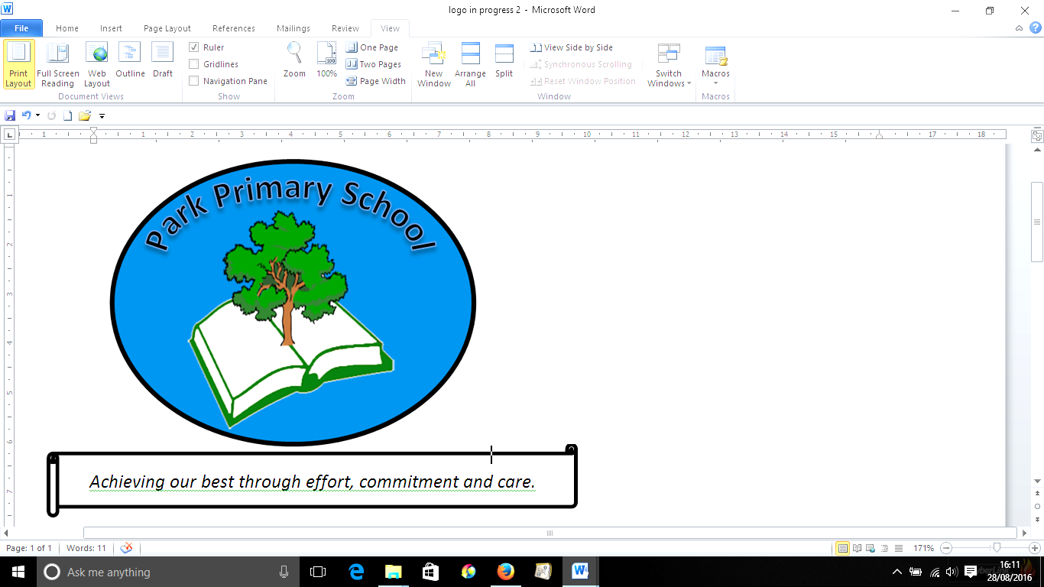

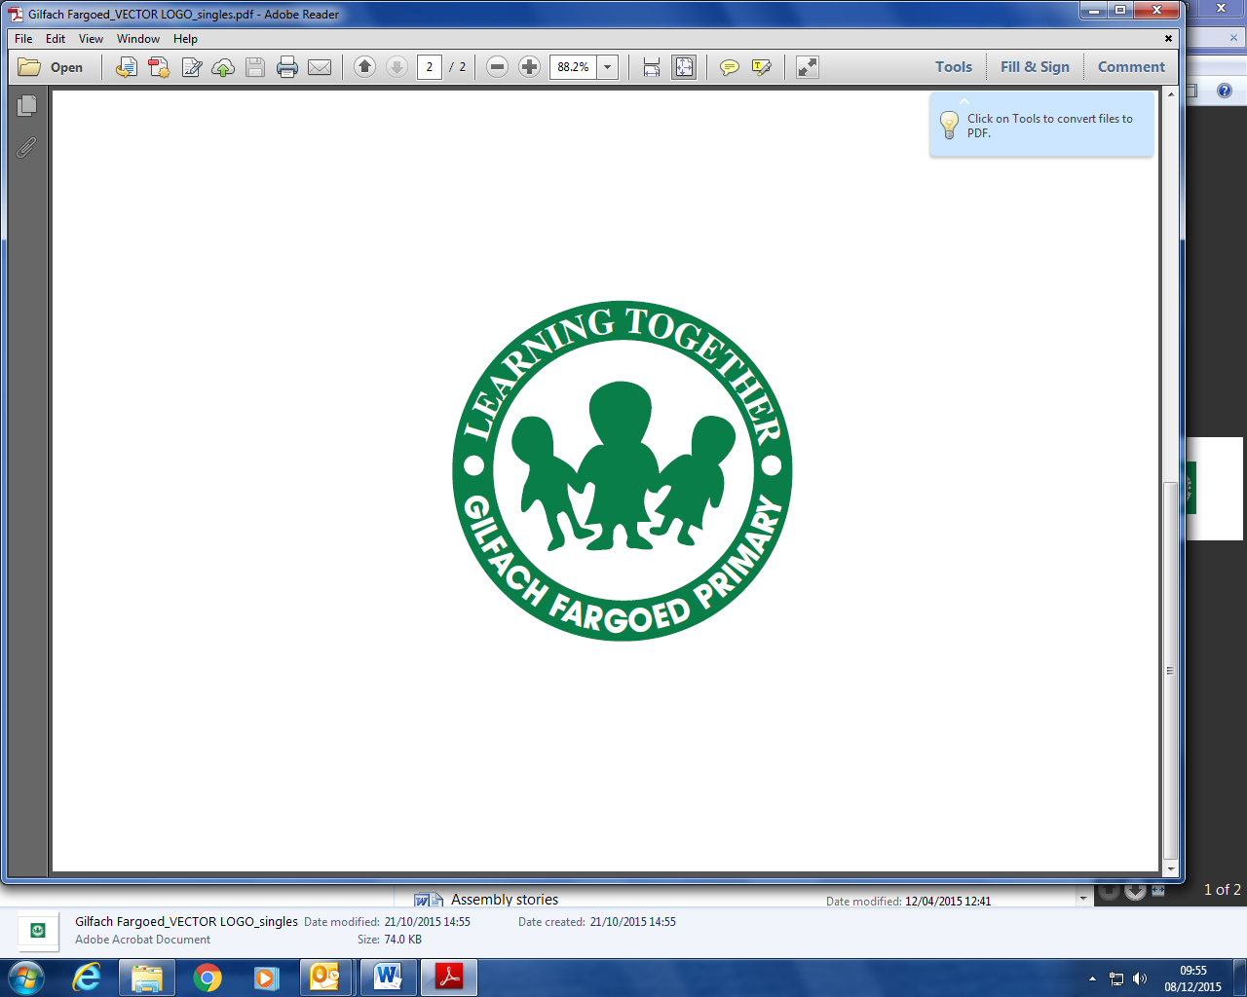

**Gilfach Fargoed and Park Primary Schools Federation**

|  |  |  |  |
| --- | --- | --- | --- |
| Policy Title: | **Anti-Litter Policy** | | |
| Adoption Date: | June 2021 | Review date: | June 2023 |
| Reviewed | May 25 |  |  |
| Signed, Chair of Governors: |  | Signed, Headteacher: |  |

**Mission Statement**

In our Federation, we are all learners for life. Our schools prioritise authentic, nurturing relationships through which we provide engaging and inspiring learning experiences. We set high-expectations, achievable through the development of resilient and confident learners who have a curiosity and enthusiasm about their community and the wider world. We take a pride in our learning, we thrive on collaboration and we are ambitious to solve problems and to achieve our best. We respect one another and our wider world while valuing our Welsh heritage. We aim to give our learners the tools to succeed in the 21st Century, with the guidance of a strong moral compass. We develop skills and knowledge, while fostering wellbeing and a growth mindset. Our whole community aims to develop:

* Healthy, confident individuals;
* Ethically informed citizens;
* Creative, confident contributors and
* Ambitious and capable learners.

**Belief Statement**

Gilfach Fargoed and Park Primary School Federation believes that all members of the school community have the right to learn, work and socialize in a clean, safe and happy environment.

United Nations Convention on the Rights of the Child

Article 24

Every child has the right to the best possible health. Governments must provide good quality health care, clean water, nutritious food, and a clean environment…

Our aims

Our schools strive to be litter free environments.

Pupils will taught to show respect for the environment.

As a school federation we will try to reduce, reuse and recycle when possible as means to reducing litter.

Our schools will try to support these above aims beyond the school gate and into local the community.

Our schools believe all members of the school community have the right to suggest ways to improve the school environment.

**RESPONSIBILITIES OF ALL STAKEHOLDERS:**

All members of the school community have a responsibility to:

* Not create litter.
* To reduce waste and recycle where possible.
* To pick up litter if lying around.

All staff members have the responsibility to:

* Support pupils in their efforts to deal with litter problems.
* Ensure that eliminating litter remains a high-profile agenda item.

The school caretaker has the responsibility to:

* Co-ordinate safe waste disposal from the site.
* To assist in maintaining a clean site.
* Empty waste bins.

The Eco Committee has the responsibility to:

* Monitor and report on the litter situation.
* To listen and respond to suggestions from the school community.
* To promote anti-litter messages across the school.

Curriculum

Our federation provides a broad and balanced curriculum for all pupils. We value the

environment, both natural and manmade. As part of our work to support learners to become ethical and informed, we:

• accept our responsibility to maintain a sustainable environment for future generations

• understand the place of human beings within nature

• understand our responsibilities for other species

• preserve balance and diversity in nature wherever possible

• preserve areas of beauty and interest for future generations

• repair, wherever possible, habitats damaged by human development and other means.

Teaching and learning

Our federation provides teaching and learning opportunities which support pupils so they are able to discuss and understand the anti-social effects of littering and vandalism. Pupils are engaged in practical work to foster their understanding of the impact of this anti social behaviour and the school works to promote litter free communities. The link between caring for and respecting the world we live in is made through all activities.

The school is a registered Eco-School and, and as such litter picks are regularly carried out within the school grounds.

**MONITORING AND REVIEW**

**This policy will be reviewed by May 2028**

**SIGNATURE/DATE**

Head teacher: C Rees ________________________________ May 2025

H Llewellyn______________________________ May 25

