


Gilfach Fargoed and Park Primary Schools Federation

CCTV Policy

Policy Title: | CCTV Policy
Adoption Date: | February 2022 | Review date: | February 2023
Review date | May 2024 | Review date | May 2025
Signed, Chair of Governors: |  | Signed, Headteacher:
Mission Statement

In our Federation, we are all learners for life. Our schools prioritise authentic, nurturing relationships through which we provide engaging and inspiring learning experiences. We set high-expectations, achievable through the development of resilient and confident learners who have a curiosity and enthusiasm about their community and the wider world. We take a pride in our learning, we thrive on collaboration and we are ambitious to solve problems and to achieve our best. We respect one another and our wider world while valuing our Welsh heritage. We aim to give our learners the tools to succeed in the 21st Century, with the guidance of a strong moral compass. We develop skills and knowledge, while fostering wellbeing and a growth mindset. Our whole community aims to develop:
- Healthy, confident individuals;
- Ethically informed citizens;
- Creative, confident contributors and
- Ambitious and capable learners.

Gilfach Fargoed and Park Primary Schools Federation

1.0 Introduction

  - The purpose of this policy is to regulate the management and use of the Closed Circuit Television (CCTV) system at Gilfach Fargoed Primary School and Park Primary School.

  - This policy should be read in conjunction with the Schools’ Data Protection Policies. It will seek to comply with the Information Commissioner’s Office (ICO) Code of Practice 2015 and Data Protection Act legislation:-

2.0 Objectives of the CCTV System

2.1 The CCTV System will be used to
• Help maintain an environment for pupils, staff and others, which supports their personal safety;
• Deter against crime – to persons, school buildings and property
• Assist in the identification and prosecution of persons having committed an offence.

2.2 The CCTV System will not be used for any covert surveillance.

3.0 Administration

3.1 The Headteacher, on behalf of the school as Data Controller, has responsibility for the control of images and deciding how the CCTV system is used.

3.2 The school has notified the Information Commissioner’s Office of both the name of the data controller and the purpose for which the images are used.

3.3 All operators and employees with access to images are aware of the procedures that need to be followed when accessing the recorded images.

3.4 All operators are trained in their responsibilities in line with the Code of Practice 2015 and a training log will be maintained by the Headteacher as Data Controller.

3.5 Access to recorded images is restricted to staff that need to have access in order to achieve the purpose of using the equipment.

3.6 All access to the medium on which the images are recorded is documented (Appendix 1).

3.7 All employees are aware of the restrictions in relation to access to, and disclosure of, recorded images.

4.0 Location of CCTV Equipment

4.1 Several cameras are attached to the school buildings to protect the school buildings and grounds. The exact location of these cameras will be shared with appropriate parties on request but is not published for reasons of security

4.2 Cameras that are adjustable by the operators will not be adjusted or manipulated so as to overlook spaces which are not intended to be covered by the scheme. Filming outside the school boundaries will not occur unless unavoidable due to location of camera.

4.3 In areas where CCTV is used the school will ensure that there are prominent signs placed at both the entrance of the CCTV zone and within the controlled area. The signs will:
• Be clearly visible and readable
•Contain details of the organisation operating the scheme, the purpose for using CCTV and who to contact about the scheme
• Be an appropriate size depending on context

5.0 Maintenance

5.1 The CCTV system is maintained by IDS under an annual maintenance contract. Cameras are owned by The Tiryberth Control room, who can provide further details.

5.2 The headteacher will be the person responsible for
• Weekly operational checks of the system and the keeping of a log book (Appendix 2)
• Ensuring that the date and time reference are accurate
• Ensuring that cameras are protected from vandalism in order to ensure that they remain in working order
• Ensuring that a damaged camera is fixed where appropriate to the objectives of the CCTV system.
• Ensuring that a damaged camera is fixed within a specific time period
• An annual check of the system will be carried out and recorded (Appendix 3) The above actions will be undertaken under the supervision of the Headteacher.

6.0 Storage, Viewing and Retention

6.1 Images will be stored for a period of 30 days unless an incident arises which requires longer retention in line with the specified purposes of the CCTV system.

6.2 Once the retention period has expired, the images will be erased.

6.3 Images that are to be retained for evidential purposes will be retained in a secure place to which access is controlled.

6.4 Access to recorded images will be restricted to the Headteacher on behalf of the school as Data Controller.

6.5 Viewing of the recorded images will take place in a restricted area. Other employees will not have access to this area when a viewing is taking place.

6.6 There will be no disclosure of recorded data to third parties other than to authorised personnel such as the Police and other service providers to the school where these would reasonably require access to the data (e.g. Local Authority Health and Safety personnel) only for the purposes as stated in Section 2 of this policy.

7.0 Complaints
7.1 Any complaints about the school’s CCTV system should be made in line with the school’s complaints policy initially in writing to the Headteacher.

8.0 Subject Access Requests

8.1 The Data Protection Act provides Data Subjects with a right to access data held about them including images obtained by CCTV.

8.2 Requests for images should be made in writing to the Headteacher as a Subject Access Request. Each request will be given individual consideration.

9.0 Public Information Copies of this policy will be available upon request from the school office and on the school website.

February 2022

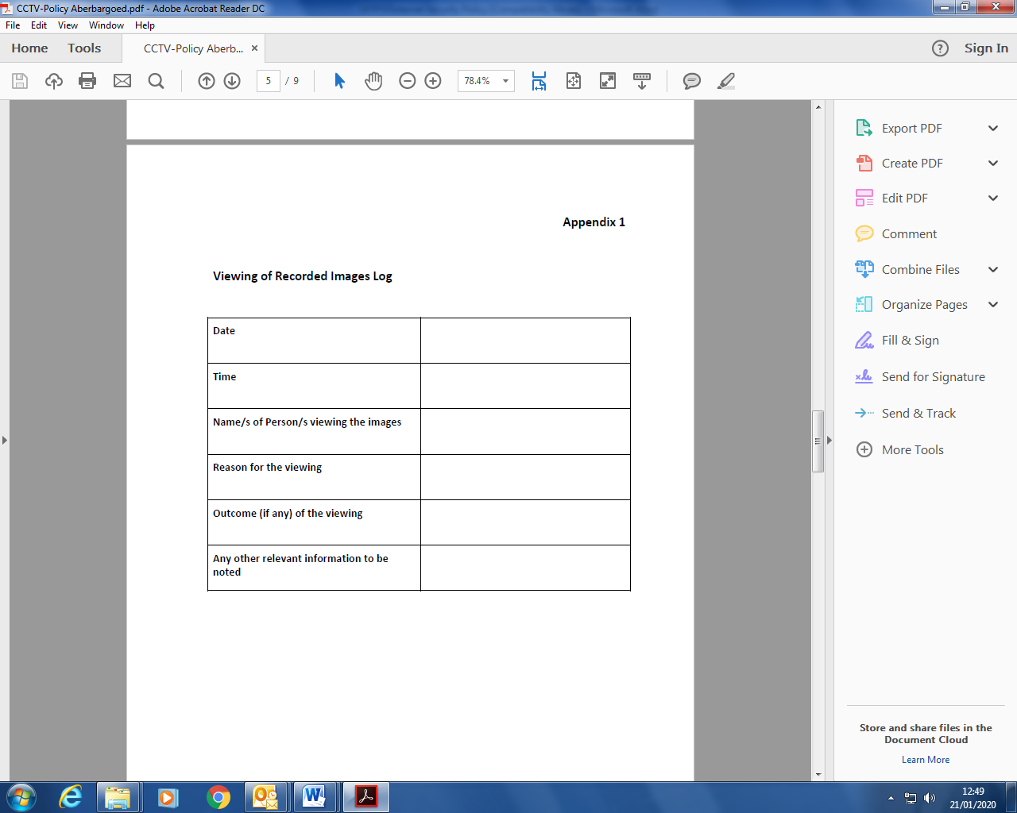

Appendix 2
Weekly Operational Checks Log

Date | Time | Name of person carrying out checks | Correct date and time check | Vandalism Check | Clear image check | Any issues detected | Action to be taken | To be completed by | Completed

Appendix 3
