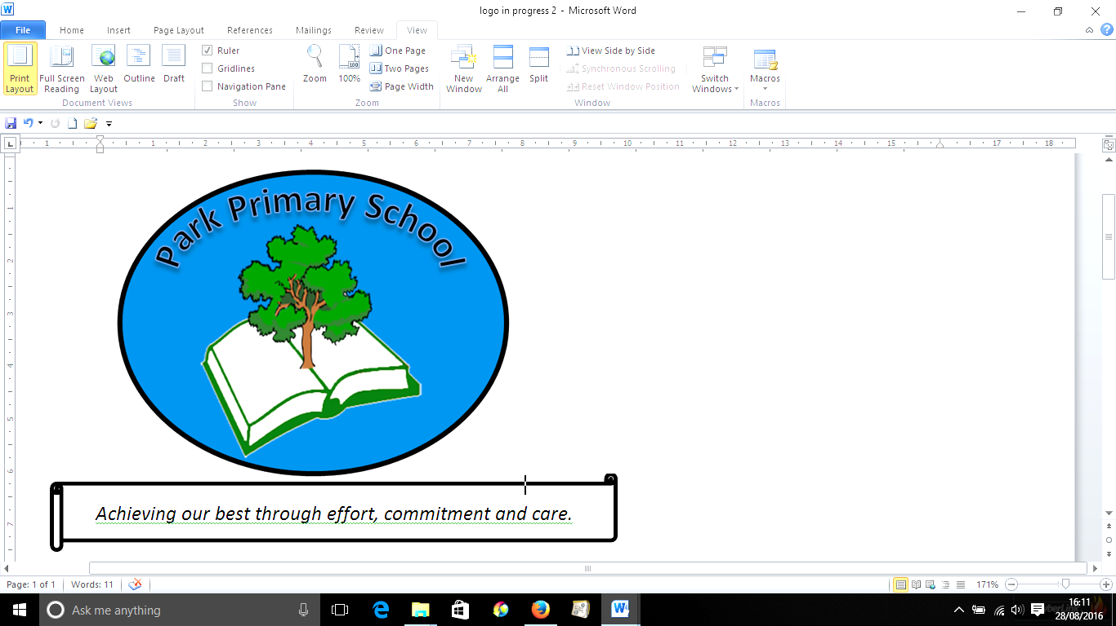



**Gilfach Fargoed and Park Primary Schools Federation**

|  |  |  |  |
| --- | --- | --- | --- |
| Policy Title: | **Children Who Are looked After Policy** | | |
| Adoption Date: | November 2021 | Review date: | November 2022 |
|  | Reviewed: June 2023 |  |  |
| Signed, Chair of Governors: |  | Signed, Headteacher: |  |

**Mission Statement**

In our Federation, we are all learners for life. Our schools prioritise authentic, nurturing relationships through which we provide engaging and inspiring learning experiences. We set high-expectations, achievable through the development of resilient and confident learners who have a curiosity and enthusiasm about their community and the wider world. We take a pride in our learning, we thrive on collaboration and we are ambitious to solve problems and to achieve our best. We respect one another and our wider world while valuing our Welsh heritage. We aim to give our learners the tools to succeed in the 21st Century, with the guidance of a strong moral compass. We develop skills and knowledge, while fostering wellbeing and a growth mindset. Our whole community aims to develop:

* Healthy, confident individuals;
* Ethically informed citizens;
* Creative, confident contributors and
* Ambitious and capable learners.

**SCHOOL POLICY FOR THE EDUCATION OF PUPILS WHO ARE LOOKED AFTER**

Gilfach Fargoed and Park Primary School Federation believes that in partnership with Caerphilly County Borough Council, as Corporate Parents we have a duty to safeguard and promote the education of Children who are Looked After.

This Policy sets out how school will support the education of Children who are Looked After at Gilfach Fargoed and Park Primary Schools.

**AIM:**

* To provide a safe and secure environment, where there is belief in the abilities and potential of all children.
* To support our Children who are Looked After and give them equal access to every opportunity to achieve their potential and to enjoy learning.
* To fulfil our schools’ role as corporate parent, to promote and support the education of Children who are Looked After (pupils looked after by Caerphilly County Borough Council and/or other authorities).
* To ensure that all school policies and procedures are inclusive to and followed for Children who are Looked After

**The Headteacher will:**

* nominate a designated officer for Children who are Looked After who will act as an advocate, co-ordinate support, ensure the PEP is completed and that a relevant plan is in place if the child has ALN in liaison with the LA.
* ensure that a school governor is nominated to oversee that the needs of Children who are Looked After in the school are taken into account at a school management level and to support the designated teacher. This should still be in place even if there are no Children who are Looked After on school role ( Section 20, Children and Young Persons Act 2008)
* arrange time out for the designated teacher to attend where appropriate training and statutory Children who are Looked After review meetings.
* ensure that any new guidance is incorporated into school policy (as this will change regularly)
* adhere to the local authority school admissions policy.

**The Designated Teacher will:**

* ensure that they have up to date knowledge of the care system and the impact being a looked after can have on a pupils educational outcomes
* maintain (with the support of electronic systems) an up to date record of all pupils who are CLA on the school roll
* track and monitor progress of individual pupils who are looked after.
* track and monitor the attendance of pupils who are looked after
* Ensure educational information is transferred speedily between agencies, new schools and individuals
* ensure that there is a high quality Personal Education Plan (PEP) for each pupil who is looked after, to include appropriate targets and provide guidance on the implementation of the plan
* ensure the school shares and supports high expectations for Children who are Looked After
* ensure a culture of positive collaboration is fostered. Where communication difficulties arise with social workers or foster carers, contact is made with the LA
* Encourage a pupil who is looked after to engage after school clubs, the school council or additional revision session where appropriate
* Refer a pupil who looked after for school based counselling if required or provide the pupil with a safe place, if appropriate
* ensure that there are positive links between carer and the school
* ensure that Children who are Looked After, along with all children are listened to and have equal opportunity for pastoral support in school
* ensure the child’s educational needs are identified in consultation with his/her teacher(s) in order to address them by setting realistic challenges and academic targets.
* ensure the school is represented at the Children who are Looked After Reviews and/or the schools consultation document is completed and returned to the Independent Reviewing Officer
* ensure any issues arising that might threaten the school placement are addressed without delay. All steps should be taken to prevent exclusion, including referral to appropriate agencies.

**Governors will:**

* support the Local Authority in its statutory duty to promote the educational achievement of pupils who are looked after
* ensure that the Pupil Deprivation Grant (PDG) is effectively used to overcome additional barriers that prevent learners from disadvantaged backgrounds achieve their full potential
* monitor the impact of the use of the PDG grant as well as other interventions put in place to support Looked After pupils
* support the inclusive ethos within the school as stated in the aims in this policy.

**School staff will:**

* aim to ensure that the planning, delivery and assessment of lessons impacts on the academic attainment and progress of Children who are Looked After.
* develop a classroom curriculum that both engages and motivates pupils to learn.
* support the wellbeing of Children who are Looked After through the PSE/ Health and Wellbeing curriculum and through high quality pastoral support.
* ensure that targets in Personal Education Plans are both aspirational and realistic targets and progress against these targets is tracked appropriately.
* provide appropriate evidence to demonstrate progress against the targets stated in Personal Education Plans.

In respect of admissions for CLA pupils, this is in line with Caerphilly’s Schools Admissions Policy.For further Information access the policy via

<https://www.caerphilly.gov.uk/CaerphillyDocs/Schools/StartingSchoolBooklet.aspx>

**Current Roles and Responsibilities:**

Designated Officer Children who are looked After is Mrs Catherine Rees

Date: November 2021

Reviewed: June 2023

Next review: June 2025