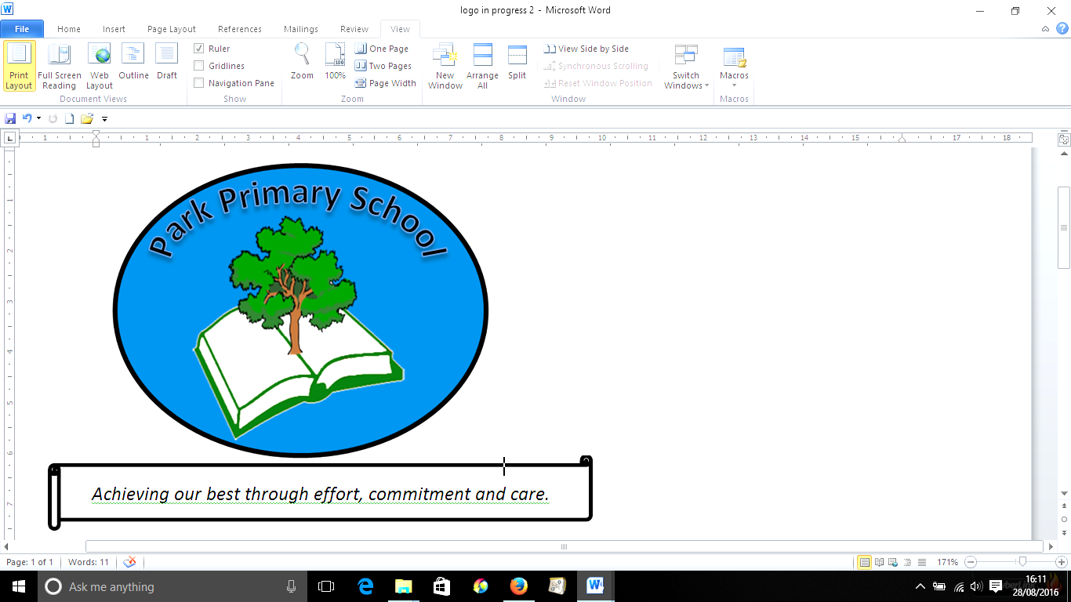



**Gilfach Fargoed and Park Primary Schools Federation**

|  |  |  |  |
| --- | --- | --- | --- |
| Policy Title: | **Charging and Remissions Policy** | | |
| Adoption Date: | February 2023 | Review date: | February 2025 |
| New review date | February 2027 |  |  |
| Signed, Chair of Governors: |  | Signed, Headteacher: |  |

**Mission Statement**

In our Federation, we are all learners for life. Our schools prioritise authentic, nurturing relationships through which we provide engaging and inspiring learning experiences. We set high-expectations, achievable through the development of resilient and confident learners who have a curiosity and enthusiasm about their community and the wider world. We take a pride in our learning, we thrive on collaboration and we are ambitious to solve problems and to achieve our best. We respect one another and our wider world while valuing our Welsh heritage. We aim to give our learners the tools to succeed in the 21st Century, with the guidance of a strong moral compass. We develop skills and knowledge, while fostering wellbeing and a growth mindset. Our whole community aims to develop:

* Healthy, confident individuals;
* Ethically informed citizens;
* Creative, confident contributors and
* Ambitious and capable learners.

1 Introduction

1.1 All education which takes place in school during school hours is free. We do not charge for any activity undertaken as part of Curriculum for Wales.

2 Voluntary contributions

2.1 When organising school trips, visits or visitors which enrich the curriculum and educational experience of the children, the schools may invite parents to contribute to the cost of the trip or visit. All contributions are voluntary. If we do not receive sufficient voluntary contributions, we may have to cancel the event. If the event goes ahead, it may include children whose parents have not paid any contribution. We do not treat these children differently from any others.

2.2 If a parent wishes their child to take part in a school trip or event, but is unwilling or unable to make a voluntary contribution, we always allow the child to participate fully in the trip or activity. Sometimes the schools pay additional costs in order to support the visit. Parents have a right to know how each trip is funded. The schools provide this information on request. We will not identify those who do not make a contribution. We actively encourage every parent/ carer to feel confident about supporting their child to attend trips by sensitive communication regarding any monetary contributions.

2.3 The following is a list of additional activities organised by the schools, which require voluntary contributions from parents. These activities are known as ‘optional extras’. This list is not exhaustive:

* visits to museums and art galleries;
* sporting activities which require transport expenses;
* outdoor adventure activities;
* visits to the theatre;
* school trips abroad;
* school trips which incur entry costs or travel costs;
* musical events
* special workshops and activities within school which involve extraordinary equipment/ resources/ expertise.

**2.4** Any charge made in respect of individual pupils will not exceed the actual cost of providing the optional extra activity, divided equally by the number of pupils participating. In no circumstances will there be an element of subsidy required for any pupils wishing to participate in the activity whose parents are unwilling or unable to pay the full charge.

3 Residential visits

3.1 **Our schools will not charge for:**

## education provided on any visit that takes place during school hours

## education provided on any visit that takes place outside school hours if it is part of Curriculum for Wales, or part of a syllabus for a prescribed public examination that the pupil is being prepared for at the school, or part of religious education

## supply teachers to cover for those teachers who are absent from school accompanying pupils on a residential visit

**3.2 Our school will charge for:**

* **Board and lodging**When any visit has been organised by the school where there may be a cost for board and lodging, parents will be informed of this before the visit takes place. We will charge anything up to the full cost of board and lodging on residential visits, whether it is classified as taking place during school hours or not.The charge will not exceed the actual cost. Parents who can prove they are in receipt of certain benefits may be exempt from paying the full cost. This will be dependent on discussions with the parent and on individual circumstances, with the final decision resting with the headteacher in consultation with the Chair of Governors. We endeavour to support every child who wishes to attend residential trips to be enabled to do so.
* **Travel**Travel charges may apply when the residential activity takes place outside of school hours. The amount charged will be calculated to cover the unit cost per pupil. These charges may not apply to those pupils entitled to remissions, but no other pupils will be charged extra to cover those costs.

**4** Music tuition

4.1 All children study music as part of the normal school curriculum. We do not charge for this.

4.2 There is a charge for individual or group music tuition if this is not part of Curriculum for Wales. The peripatetic music teachers teach individual or small group lessons. We give parents information about additional music tuition at the start of each academic year. The money collected from these contributions does not fully cover the costs, but supports school to be able to provide them on a long term basis.

5 Swimming

5.1 The school organises swimming lessons for children in the junior department. These take place in school time and are part of Curriculum for Wales. We make no charge for this activity. We inform parents/ carers when these lessons are to take place, and we ask parents for their written permission for their child to take part in swimming lessons.

**6. Remissions and concessions**

**6.1** The school will give consideration to the remission of charges to parents or carers who receive the following support payments:

* Income Support
* Income based Job-seekers Allowance
* Child Tax Credit (where the person is not receiving Working Tax Credit as well)
* Support under part VI of the Immigration and Asylum Act 1999
* Guaranteed Element of State Pension Credit
* Income related employment and support allowance
* Universal Credit

**6.2** Children of families who receive these payments are also entitled to free school meals. Although all children in primary school are now entitled to a free school lunch, children who are eligible for free school meals are also entitled to the annual uniform grant. Parents who are eligible for the remission of charges will be dealt with confidentially.

**6.3** The headteacher and chair of governors will authorise the remission of charges.

The school may choose to subsidise part or all of the payment of some charges for certain activities and pupils, and this will be determined by the governing body and headteacher.

**7. Inability or unwillingness to pay**

Gilfach Fargoed and Park Primary Schools Federation is committed to ensuring fair access and treatment of all pupils, and this means ensuring that no child is excluded from an activity because the parents or carers of that child are unwilling or unable to pay. If there is insufficient funding for an activity, then it will be cancelled.

The identity of the child or parents of the child who did not want to make the payment, or could not make the payment, will not be disclosed under any circumstances.

8 Cost of the school day

The federation of Gilfach Fargoed and Park Primaries seeks to remove barriers and poverty related challenges faced by children, parents and carers. We aim to work with a knowledge of the cost of the school day on families in order to:

■ ensure equal access to opportunities at school and remove barriers to participation and learning for children and young people from low income households

■ minimise income stigma and exclusion amongst children and young people

■ reduce the pressures which school costs place on family incomes

■ support families to access financial entitlements

Chair of governors: _____________________________________

Headteacher: _________________________________________

Date: ________________________________________________