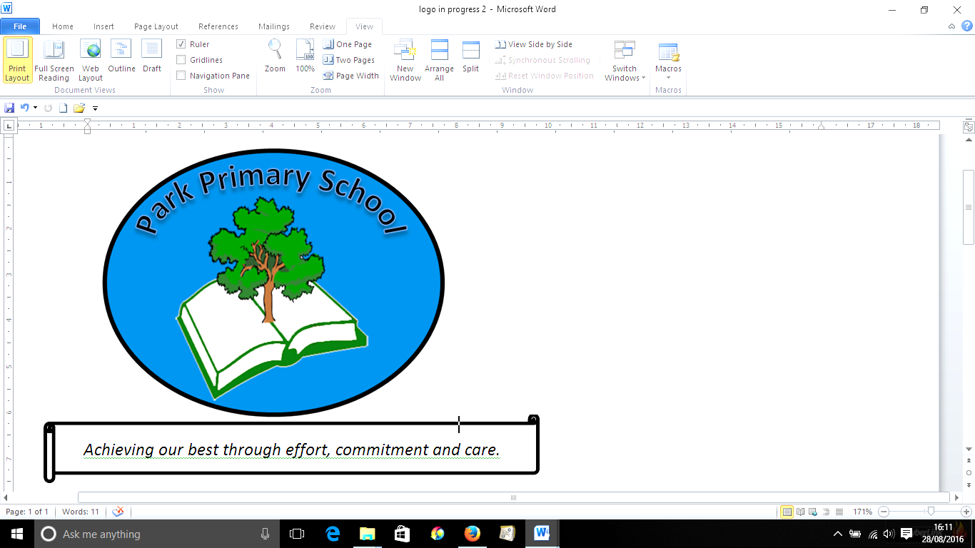



**Gilfach Fargoed and Park Primary Schools Federation**

|  |  |  |  |
| --- | --- | --- | --- |
| Policy Title: | **Flexible Working Policy** | | |
| Adoption Date: | June 2021 | Review date: | June 2023 |
| Reviewed: | July 2023 | Next Review: | June2025 |
| Signed, Chair of Governors: |  | Signed, Headteacher: |  |

**Mission Statement**

In our Federation, we are all learners for life. Our schools prioritise authentic, nurturing relationships through which we provide engaging and inspiring learning experiences. We set high-expectations, achievable through the development of resilient and confident learners who have a curiosity and enthusiasm about their community and the wider world. We take a pride in our learning, we thrive on collaboration and we are ambitious to solve problems and to achieve our best. We respect one another and our wider world while valuing our Welsh heritage. We aim to give our learners the tools to succeed in the 21st Century, with the guidance of a strong moral compass. We develop skills and knowledge, while fostering wellbeing and a growth mindset. Our whole community aims to develop:

* Healthy, confident individuals;
* Ethically informed citizens;
* Creative, confident contributors and
* Ambitious and capable learners.

**INTRODUCTION**

1. The Governing Body and Caerphilly County Borough Council believes that its employees are its most valuable resource and as a result high attendance at work by employees plays a key role in providing efficient and effective services to the residents of the County Borough.

2. The Governing Body and Caerphilly County Borough Council demonstrate a commitment to equal opportunities and the principles of work - life balance working practices. The aim of the policy is to be supportive to employees to allow them to balance work - life issues in the best possible way.

3. The Governing Body and Caerphilly County Borough Council will ensure that flexible working is applied in a fair, equitable and consistent way by adopting a positive, proactive approach. This policy and the accompanying procedure are designed to help Headteachers deal with requests from employees. Applications for flexible working from Headteachers will need to be considered by the Chair of Governors/Relevant Panel of Governing Body.

4. The Governing Body and Caerphilly County Borough Council recognises that there may be times when employees need some time to resolve problems outside of work and need to change their working patterns on either a permanent or temporary basis. Further rights for carers are also detailed in the Council’s Carers Policy.

5. This policy applies to all employees, with 26 weeks continuous service with Caerphilly County Borough Council, as long as they have not made a request under this policy in the previous twelve months. Employees with less than twenty six weeks’ service or agency workers do not have the statutory right to apply to work flexibly.

6. This policy must be cross-referenced with all other relevant Governing Body policies and procedures.

**WHAT THE POLICY COVERS**

7. This policy supersedes all earlier policies and must be used to deal with any requests for flexible working that arise.

**GUIDING PRINCIPLES**

8. The Flexible Working Policy provides guidance for a Governing Body, Headteachers and employees as to the procedure to be followed when an employee wishes to change their current work pattern to a more flexible one. There is a duty to seriously consider any application to work flexibly.

9. A flexible working request under this Policy means a request to do any or all of the following although this is not an exclusive or exhaustive list:-

* To reduce or vary your working hours.
* To reduce or vary the days you work
* To formally job share with a colleague, where both parties agree.

10. All employees with twenty six week’s service have the right to apply to work flexibly, as long as they have not made a request under this policy in the previous twelve months.

11. The right to apply to work flexibly applies equally to all employees. It does not provide an automatic right to work flexibly but Headteachers/relevant panels in the case of a Headteacher must reasonably consider an employee’s request to change their work pattern. There may be occasions where it is not possible, for operational reasons, to agree to the requested work pattern. These occasions should be kept to a minimum and wherever possible a solution that will suit both the School and the employee should be found.

12. All employees who work flexibly will be treated in the same way as full time employees with regard to opportunities for training, promotion, etc. Where a flexible working request results in part time working hours, the employee’s terms and conditions of employment will be accrued on a pro rata basis.

13. Employees who opt to work flexibly will be entitled to remain in the Pension Scheme although they should be aware that reduced hours affects Pension benefits. If a School Support employee requires any further details please contact the Greater Gwent Pensions Section at Torfaen County Borough Council on 01495 766266 or alternatively visit the website http://www.greatergwentpensionsfund.co.uk If a Teacher requires details please contact Teachers Pensions on 0345 6066166 or alternatively visit the website https://www.teacherspensions.co.uk

14. Employees may request to change their work pattern on a temporary or permanent basis. Where the request is of a temporary nature, an end date should be included on the request. A temporary flexible working request will, generally, only be agreed for a maximum period of twelve months, after which the employee will revert back to their original work pattern. However, an employee can then make a request to make a permanent change to their pattern of work. If the working pattern is changed permanently, there is no automatic right to apply to revert to their previous working pattern. The governing body may wish to consider requests to lengthen the period of the temporary flexible working arrangement to more than 12 months or to consider alterations to the flexible working arrangement extending to a period over 12 months in circumstances which are clearly of benefit to the employee, and which can be suitably and effectively managed by school.

15. The employee has a responsibility to think carefully about their desired working pattern when making an application and the Headteacher is required to give each application due consideration.

16. Applications to work flexibly must be submitted to the employee’s Headteacher on the appropriate form. Forms are available from the Headteacher/Nominated Officer and/or HR. Headteachers can attain advice from HR. When approving applications to work flexibly, Headteachers must bear in mind the operational requirements of the School. Once agreed all requests for flexible working must be forwarded to HR for the necessary changes to be made to the employee’s contract. Following which written details of the changes will be sent to the employee.

17. The procedure for dealing with applications to work flexibly is attached to this Policy (Appendix A).

**INTERPRETATION OF THE POLICY**

18. In the event of a dispute relating to the interpretation of this Scheme the Head of Workforce and Organisational Development or the Human Resources Service Manager will make the final decision on interpretation.

**REVIEW OF THE PROCEDURE**

19. A review of this procedure will take place when appropriate. Any amendments will be consulted on with all the relevant parties. However, in the case of amendments relating to legislative requirements, the procedure will be amended and reissued.

**APPENDIX A**

**PROCEDURE FOR DEALING WITH REQUESTS TO WORK FLEXIBLY**

**ENTITLEMENT TO MAKE A REQUEST TO WORK FLEXIBLY**

1. All employees, with twenty six week’s continuous service, are eligible to make a request to work flexibly. Only service with Caerphilly County Borough Council rather than local government service will count as service.

2. If an employee wishes their work pattern to change from a given date, they should ensure that the application is made within the required time scales. Requests to work flexibly can take a lengthy period of time to arrange. This should be borne in mind when the request is being made.

3. Only one permanent application to work flexibly may be made in a 12-month period. The period is counted as the 12 months prior to the date of the current application. However, more than one temporary change may be allowed depending on the circumstances of the case e.g. terminal illness. **T*he governing body may wish to consider requests to lengthen the period of the flexible working arrangement to more than 12 months or to consider alterations to the flexible working arrangement extending to a period over 12 months. .***

4. Before making an application to work flexibly, employees should look at their Governing Body’s Work life Balance Policies and Procedures to identify the most suitable for their circumstances.

**SCOPE OF THE REQUEST**

5. Eligible employees will be able to make a request to work flexibly which may be changes to their working patterns, such as reduced hours or compressed hours (i.e. someone works a 37 hour week over less than 5 days (support staff role)), job sharing, self rostering, shift working, staggered hours and term time working or changes to the times that they are required to work. This list is not exclusive or exhaustive.

6. Changes to work patterns do not always require a significant alteration to the employees’ current working patterns. An example of a change of work pattern could be if a parent starts work an hour later to allow them to take their child/children to school, they make that time up later on in the day.

**MAKING AN APPLICATION TO WORK FLEXIBLY**

7. Before making an application to work flexibly, employees should consider their Governing Body’s other work - life balance policies, especially the Carers Policy.

8. When an application to work flexibly is made, the onus is on the employee to make a full application detailing all the necessary changes that need to be made to the working arrangements in the School, if appropriate.

9. All applications to work flexibly must be in writing on the Flexible Working Application Form, FW1 (a), which is available from HR. The application must state the date of the application, the change to working conditions the employee is seeking and when they would like the change to come into effect, whether there are any relevant equalities implications, the effect, if any, the employee thinks the requested change would have on the School and how, in their opinion, any such effect might be dealt with. If the request is for a temporary change to contract then the end date of the arrangement also needs to be included. The application must also say that this is a statutory request and if and when the employee has made a previous application for flexible working.

10. The form may be used for permanent and temporary changes to working patterns.

11. Applications must be made to the employee’s Headteacher. Forms may be sent through the post (internal or external), faxed or e mailed. The employee should receive a response to their application within 28 days of submission.

12. If the application is handed to the Headteacher, the date that this happens is deemed to be the date that they have received the form. Where applications are received through the post, internal or external, the date that the Headteacher is expected to receive the form will be the date that the application was made. In the case of a non-working day it will be the first working day after the non working day. If the application is faxed to the Headteacher, the date of the application will be deemed to be the day that the fax was transmitted. If the form is sent via e-mail, the date of the application shall be taken to have been the date that the e Mail was transmitted. These principles shall apply to any correspondence given by either the employee or the Headteacher during the process.

13. The onus is on the employee to identify how the change in work pattern will operate and the effects it may have on their work colleagues. On the application, the employee must: -

* Confirm that they are making the request under their right to request to work flexibly.
* Specify the flexible working pattern that they would like to work.
* Specify the date that they would like the flexible working arrangement to commence. This date should allow the Headteacher to consider the request and implement any necessary changes as appropriate.
* Explain what effect the change in work pattern will have on the School and how they think that these effects can be dealt with.
* Confirm whether there are any relevant equalities implications under the Equalities Act 2010.
* Explain the reasons why their preferred working pattern is compatible with the School as far as they can tell.
* Consider how their colleagues will manage if the new working pattern is approved.
* State whether an application to work flexibly has been made in the previous 12 months, and if so give the date.
* Sign and date the application.

14. A meeting to discuss the above points may be held between the employee and their Headteacher prior to the completion of the application form.

15. If the application is for a permanent change to an employee’s working pattern then the accepted application will mean a **permanent** change to the employee’s terms and conditions of employment. Before making any application, the employee must consider: -

* What would be the best for them in terms of how they could arrange their child care.
* The financial implications of any change to hours.
* The effects that the change would have on the School.
* How the changes can be accommodated.

16. Headteachers have a legal duty to reasonably consider all requests to work flexibly and to establish whether the requested working pattern can be accommodated within the operational needs of the School. Once the Headteacher has received the application, they must acknowledge the request either by emailing the employee or where the employee does not have email access using form FW1 (b) which is attached to the application form. If the application is incomplete or fails to provide all the information outlined above, the Headteacher should refer the application back to the employee asking them to complete the form and resubmit the application. In considering the request, the Headteacher must not unlawfully discriminate against the employee in any way. Headteachers should be mindful that agreeing a flexible working request could be seen as a reasonable adjustment for a disabled employee.

17. Once a Headteacher has received the employee’s application for flexible working, they can consult HR for advice on dealing with the application.

18. Upon receipt of the application to work flexibly, the Headteacher, will arrange to meet the employee to explore the desired work pattern and how it may be accommodated. If a Headteacher is unable to accommodate the requested work pattern, at this meeting alternative work patterns may be explored.

19. Employees may be accompanied at the meeting, by a work colleague or a trade union representative (local or full time). If the person who accompanies the employee also works for the Council, they will be granted paid time off to attend the meeting. An employee from HR may also be present to provide advice and guidance on request.

20. If a meeting to discuss the application is arranged, or any appeal, and the employee fails to attend both this and a rearranged meeting without a good reason, the Headteacher can consider the request withdrawn. If this happens, the Headteacher must inform the employee that this has happened.

21. Where the Headteacher agrees to the variation in the working pattern proposed by the employee, then they should notify the employee in writing**,** on form FW2, and there is no need for the meeting to take place. A copy of the FW2 form should be forwarded to HR. HR will confirm any changes to the employee’s terms and conditions in writing.

22. After the meeting to discuss the changes to the work pattern, the Headteacher will write to the employee to either agree or disagree with the change to the work pattern. This should be done using the Flexible Working Response Form, FW2. If the working pattern is to be agreed, Headteachers should use this form to outline the new working pattern and inform the employee of the effective date of the new work pattern. This may be a future date to allow the Headteacher to implement any necessary changes in the workplace. If the change is to be of a temporary nature, the end date of the arrangement should also be included on the FW2 form. Prior to the sending of the FW2 form, Headteachers are encouraged to meet the employee again to inform them of their decision. A copy of the FW2 form should be forwarded to HR. HR will confirm any changes to the employee’s terms and conditions in writing. If a compromise has been agreed then this should be confirmed on the form.

23. If the work pattern is to be refused, it is especially important that a meeting is held with the employee so they understand the reasons why the request to work flexibly has been refused. The reasons for refusal should also be detailed on the form FW2 and given to the employee so they have the reasons in writing. A copy of the form should be forwarded to HR.

24. The employee has a right to appeal within 14 days of being notified of a decision on their application. This should be done in writing and clearly state the grounds on which they are appealing. The appeal will be made to the Headteacher who will arrange the relevant panel of the governing body. The appeal will be heard within 14 days by the panel. The employee must be informed of the decision of the appeal in writing 14 days after the appeal meeting has taken place. If it has been upheld, there is a need to specify the agreed variation and the start date. If the appeal has been dismissed the reasons must be stated.

25. In a minority of cases, some employees will have grounds to pursue their request with third party involvement. This may be by referring their request to ACAS or by using another form of dispute resolution. An employee will only be able to take their claim to an Employment Tribunal in specific circumstances and in such cases Headteachers will have to demonstrate that they have followed the correct procedure. Further information is available from ACAS by way of The Statutory Code of Practice, Handling Requests To Work Flexibly In A Reasonable Manner and Handling Requests To Work Flexibly In A Reasonable Manner: An ACAS Guide.

26. There may be some occasions, when a Headteacher receives more than one request to work flexibly closely together from different employees. Where this happens it may be possible to grant all of the requests received. However, before doing so the employer will need to look closely at the impact this would have on the business before coming to a decision. Requests should be considered in the order they are received. Having considered and approved the first request the Headteacher should remember that the business context has now changed and can be taken into account when considering the second request against the business reasons outlined below.

27. When a Headteacher receives more than one request, they are not required to make value judgements about the most deserving request. The Headteacher should consider each case on its merits looking at the business case and the possible impact of refusing a request. The Headteacher may want to have a discussion with the employees to see if there is any room for adjustment or compromise before coming to a decision.

**REFUSING A REQUEST TO WORK FLEXIBLY**

28. Where as every effort will be made to allow employees to change their work patterns, there may be cases where this is not possible. Before refusing the request to work flexibly, Headteachers should give serious consideration to how the request could be accommodated.

29. There are a limited number of grounds for refusal. These are detailed below.

* The burden of additional costs.
* The detrimental effect on the Council or School’s ability to meet customer demand.
* An inability to reorganise work among existing employees.
* An inability to recruit additional employees.
* A detrimental impact on quality.
* A detrimental impact on performance.
* Insufficiency of work during the periods that the employee proposed to work.
* Planned structural changes.

30. Where the employee’s application is refused other options should be discussed with the employee, for example a change of position within the School to assist with accommodating a request to work flexibly.

31. When refusing a request to work flexibly, the Headteacher must detail the reason for refusal on form FW2, the Flexible Working Response Form. On this form, the Headteacher must provide sufficient explanation as to why one or more of the above reasons apply and how the request cannot be accommodated. It is not acceptable for a Headteacher to repeat one or more of the above e.g. where additional costs are the reason for refusal they should be fully detailed. Employees who are dissatisfied with their Headteacher’s decision should appeal under this procedure. This appeal will be the final decision and there is no recourse under any other Council or School policy or procedure.

32. Under Sections 80F to 80I of the Employment Rights Act 1996, and the Flexible Working Regulations, there are certain circumstances where an employee can make a complaint to an Employment Tribunal after the employee has been informed of the Headteacher’s decision. If an Employment Tribunal finds that a complaint is well founded it has the right to order that the request be reconsidered or to award compensation. The amount of this compensation will be based on an amount not exceeding eight weeks’ pay.

**WITHDRAWING A REQUEST**

33. Employees may withdraw their request to work flexibly. A Headteacher shall treat an application as withdrawn if the employee has: -

* Indicated to the Headteacher, in writing, that they are withdrawing the application.
* Failed to attend more than one meeting to discuss the application.
* Unreasonably refused to provide the Headteacher with information they require in order to assess whether the contract variation should be agreed.

34. Headteachers should confirm in writing the withdrawal of the application to the employee unless they have received written notice of the withdrawal from the employee.