
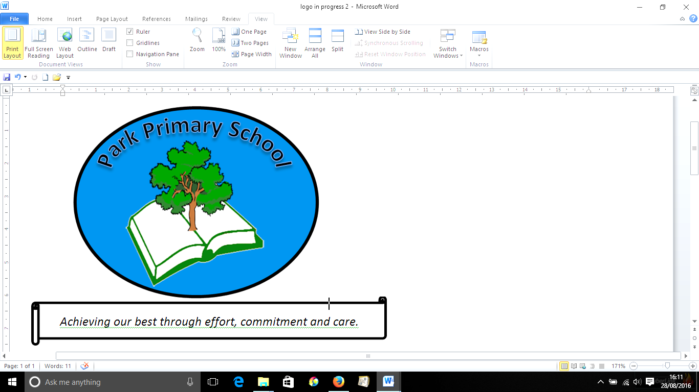
Gilfach Fargoed and Park Primary Schools Federation
Internet Safety Policy
Policy Title: | Internet Safety Policy
Adoption Date: | February 2021 | Review date: | October 2022
Review date: | November 2023 | Review date: | November 2024
Review date: | May 2025
Signed, Chair of Governors: |  | Signed, Headteacher:

Mission Statement

In our Federation, we are all learners for life. Our schools prioritise authentic, nurturing relationships through which we provide engaging and inspiring learning experiences. We set high-expectations, achievable through the development of resilient and confident learners who have a curiosity and enthusiasm about their community and the wider world. We take a pride in our learning, we thrive on collaboration and we are ambitious to solve problems and to achieve our best. We respect one another and our wider world while valuing our Welsh heritage. We aim to give our learners the tools to succeed in the 21st Century, with the guidance of a strong moral compass. We develop skills and knowledge, while fostering wellbeing and a growth mindset. Our whole community aims to develop:
- Healthy, confident individuals;
- Ethically informed citizens;
- Creative, confident contributors and
- Ambitious and capable learners.

Introduction
At Gilfach Fargoed and Park Primary Schools Federation we are committed to ensuring that children learn how to use computers, ICT and modern technologies safely so that they:
- Are able to use ICT safely to support their learning in school
- Know how to use a range of ICT equipment safely
- Are able to use ICT and modern technologies outside school in a safe manner, including using ICT as a tool for communication
- Are prepared for the constant changes in the world of technology and understand how to use new and emerging technologies in a safe manner
- Know what to do if they feel unsafe when it comes to using technology and ICT

Our curriculum, which has Digital Competence as one of its cross curricular responsibilities is designed to ensure children become:
- Healthy, confident individuals;
- Ethical, informed citizens;
- Enterprising, creative contributors;
- Ambitious, capable learners.

Understanding of how to use ICT safely and responsibly is vital in delivering these four core purposes.

This policy outlines the steps the schools take to protect children from harm when using ICT and also how the school proactively encourages children to develop a safe approach to using ICT whether in school or at home. It should be read in conjunction with our Teaching and Learning Policy, the Safeguarding Policy, the Behaviour Policy and the Distance/ Blended Learning Policy, as well as the Acceptable Use Agreement.

The Law
Our E-Safety Policy has been written by the federation, using advice from CCBC and government guidance. The Policy is part of the schools’ Strategic Development Plan and related to other policies including Safeguarding and Data Protection policies.
As legislation is often amended and new regulations introduced the references made in this policy may be superseded. For an up to date list of legislation
applying to schools please refer to the Department for Education website at
www.education.gov.uk/schools.

Roles and Responsibilities
The Headteacher, alongside the E-safety lead (Mrs V Williams) will:
- Ensure the policy is implemented, communicated and compliance with the policy is monitored
- Ensure staff training in e-safety is provided and updated annually as part of safeguarding training
- Ensure immediate action is always taken if any risks or dangers are identified i.e. reporting of inappropriate websites
- Ensure that all reported incidents of cyber bullying are investigated
- Ensure appropriate web filtering software is used to protect users from potentially damaging/offensive material

Governors will:
- Ensure that the federation is implementing this policy effectively
- Adhere to the acceptable use agreement when in school
- Have due regard for the importance of e-safety in school

Teachers and Staff will:
- Keep passwords private and only use their own login details, which are stored securely.
- Monitor and supervise pupils’ internet usage and use of other IT resources
- Adhere to the Acceptable Use Agreement
- Promote e-safety and teach e-safety units as part of computing curriculum
- Engage in e-safety training
- Only download attachments/material onto the school system if they are from a trusted source
- When capturing images, videos or sound clips of children, only use school cameras or recording devices unless they have had the express permission of the headteacher.
- They report any suspected misuse or problem to the Headteacher for investigation.
- All digital communications with pupils, parents and carers should be on a professional level and only carried out using official school systems

It is essential that pupils, parents/carers and the public at large have confidence
in the schools’ decisions and services. The principles set out in this policy are
designed to ensure that staff members use social media responsibly so that
confidentiality of staff members and the reputation of the school and the County
Council are safeguarded. In this context, staff members must always be conscious of the need to keep their personal and professional lives separate.

Teaching and Learning
The education of pupils in online safety / digital literacy is an essential part of the federation’s online safety provision. Children and young people need the help and support of the school to recognise and avoid online safety risks and build their resilience. The federation will actively teach E-safety at an age-appropriate level. The schools follow a scheme of work for each year group covering what should and shouldn’t be shared online, password control and cyber bullying among other topics. E-safety will also be embedded throughout learning whenever children are using ICT in other lessons. Both schools mark Internet Safety Day annually, to further promote its importance. In lessons where internet use is pre-planned students / pupils should be guided to sites checked as suitable for their use and that processes are in place for dealing with any unsuitable material that is found in internet searches. When using digital images, staff should inform and educate students / pupils about the risks associated with the taking, use, sharing, publication and distribution of images. In particular they should recognise the risks attached to publishing their own images on the internet e.g. on social networking sites. Students / pupils should be taught about online safety issues, such as the risks attached to the sharing of personal details. They should also be taught strategies to deal with inappropriate communications and be reminded of the need to communicate appropriately when using digital technologies.

Pupils will:
- Need to understand the importance of reporting abuse, misuse or access to inappropriate materials and know how to do so.
- Should understand the importance of adopting good online safety practice when using digital technologies out of school and realise that their school’s Online Safety Policy covers their actions out of school, if related to their membership of the school

Working in Partnership with Parents/ Carers
Parents / Carers play a crucial role in ensuring that their children understand the need to use the internet / mobile devices in an appropriate way. The school will help parents understand these issues through drawing parent’s attention to the e-safety policy through the school newsletters, information evenings and on the school website. Parents are able to access links to useful websites and information about national / local online safety campaigns, via the school website. Parents and carers will be encouraged to support the schools in promoting good online safety practice and to follow guidelines on the appropriate use of digital and video images taken at school events. Parents will be requested to sign an Acceptable Use Agreement as part of the Home School Agreement on entry to the school.

Monitoring safe and secure systems
Internet access is regulated by CCBC supplied filtered broadband connection which blocks access to unsuitable websites. Antivirus software has been
installed on all computers and is to be maintained and updated regularly. Staff
passwords are changed regularly and must be strong passwords. Staff take
responsibility for safeguarding confidential data saved to laptops, ie use of
strong passwords. If sensitive personal data has to be saved to other media, eg data sticks, it is to be encrypted or strong password protected. Staff with access to the ICT systems containing confidential and personal data are to ensure that
such data is properly protected at all times.

Safe use of the Internet and Web Filtering
- All staff and pupils will have access to the internet through the school’s
network
- All staff and volunteers who have use of the school’s IT equipment, must read and sign the Staff Acceptable Use Agreement.
- All children must read and sign the Pupil Acceptable Use Agreement.
- If a site containing inappropriate material is encountered, children must report it to an adult who will report it to the Headteacher to pass to CCBC.
- If an adult finds a site that they consider unsuitable they should report it to the Headteacher who will report it to CCBC.

The use of Email
All teaching and support staff are provided with a HWB email address. Staff
should use this address when sending work-related emails. All emails should be
professional in nature and staff should be aware that all emails can be retrieved
at a later date should this be necessary. Staff emails should never be used to
forward ‘chain’ or ‘junk’ email.

The school website
The schools’ web sites comply with statutory requirements. Images that include pupils will be selected carefully and only used if parents have given permission for such images to be posted on line.

Social Networking, Social Media and Personal Publishing (blogging)
The federation recognises that it has a duty to help keep children safe when they are accessing such sites at home, and to this end the school will cover such issues within the curriculum. Pupils will be taught about how to stay safe when
using such social media sites, such as Twitter at home.

Staff private use of social media:
- No reference should be made in social media to students / pupils, parents /carers / school staff or issues / situations related to the school
- They do not engage in online discussion on personal matters relating to members of the school community
- Personal opinions should not be attributed to the school
- Security settings on personal social media profiles should be regularly checked to minimise risk of loss of personal information.
- Teachers are instructed not to run social network spaces for student use on a personal basis or to open up their own spaces to their students and their families.

The Use of Cameras, Video and Audio Recording Equipment
Staff may only use the schools’ photographic or video devices to support school
trips and curriculum activities. Personal equipment may only be used following the express permission of the head.

Photos should never be circulated in electronic form outside the school. It is never acceptable to use photographic or video devices in changing rooms or toilets. Written permission from parents or carers will be obtained at the start of the academic year for photographs of students / pupils are published on the schools’ websites / social media / local press. In accordance with guidance from the Information Commissioner’s Office, parents / carers are welcome to take videos and digital images of their children at school / academy events for their own personal use (as such use in not covered by the Data Protection Act). To respect everyone’s privacy and in some cases protection, these images should not be published / made publicly available on social networking sites, nor should parents / carers comment on any activities involving other students / pupils in the digital / video images.

Personal mobile phones and mobile devices
Children are not allowed to bring mobile phones to school. There may be very exceptional circumstances when this is permitted, such as when a child is not going home for the weekend and brings a phone to school on Friday, but, in these circumstances, the mobile phone MUST be given to the school office staff for safekeeping. Any mobile phones belonging to children which are found on site will be confiscated and returned to parents at the end of the school day.
Staff are not permitted to use their own mobile phones or devices for
contacting children, although mobile phones may be used for wellbeing and engagement calls, but only where the caller id of the staff member is blocked. Use of mobiles by staff is, otherwise, discouraged throughout the school sites.

Management of online safety incidents
- There is strict monitoring and application of the e-safety policy and a differentiated and appropriate range of sanctions.
- All members of the school are encouraged to be vigilant in reporting issues, in the confidence that issues will be dealt with quickly and sensitively, through the federation’s escalation processes.
- Support is actively sought from other agencies as needed (i.e. MASH, UK Safer Internet Centre helpline, CEOP, Prevent Officer, Police, IWF) in dealing with online safety issues;
- Monitoring and reporting of online safety incidents takes place and contributes to developments in policy and practice in online safety within the schools.
- Parents/carers are specifically informed of online safety incidents involving children for whom they are responsible;
- The Police will be contacted if one of our staff or pupils receives online communication that we consider is particularly disturbing or breaks the law;
- We will immediately refer any suspected illegal material to the appropriate authorities – CCBC, Police, CEOP

Protecting School Staff
In order to protect school staff we require that parents/ carers do not comment on
school issues or staff using social networking sites. Any concerns or complaints
should be discussed directly with the school. The school will take action if there
is evidence that inappropriate comments about staff have been placed on the
internet in a public arena.

Safeguarding – Scope of this policy
(See also Safeguarding and Behaviour Policies)

The Education and Inspections Act 2006 empowers the Head Teacher to such
extent as is reasonable, to regulate the behaviour of pupils when they are off the school site and empowers members of staff to impose disciplinary penalties for inappropriate behaviour. This is pertinent to incidents of cyber-bullying, or
other e-safety incidents covered by this policy, which may take place outside of
school, but is linked to membership of the schools. The 2011 Education Act
increased these powers with regard to the searching for and of electronic
devices and the deletion of data In the case of both acts, action can only be taken over issues covered by the federation’s Behaviour Management Policy.

The schools will deal with such incidents within this policy and associated behaviour and anti-bullying policies and will, where known, inform parents / carers of incidents of inappropriate e-safety behaviour that take place out of school.

Responding to incidents of misuse
This guidance (see appendix 1) is intended for use when staff need to manage incidents that involve the use of online services. It encourages a safe and secure approach to the management of the incident. Incidents might involve illegal or inappropriate activities. If there is any suspicion that the web site(s) concerned may contain child abuse images, or if there is any other suspected illegal activity, refer to the right hand side of the Flowchart (appendix 1) for responding to online safety incidents and report immediately to the police.

Schedule for Development / Monitoring / Review
5
This Online Safety policy was approved by the Governing Body | February 2021; Reviewed November 23; Reviewed May 25
The implementation of this Online Safety policy will be monitored by the: | Catherine Rees and Victoria Williams
Monitoring will take place at regular intervals: | Annually
The Governing Body will receive a report on the implementation of the Online Safety Policy generated by the monitoring group (which will include anonymous details of online safety incidents) at regular intervals: | Annually
The Online Safety Policy will be reviewed annually, or more regularly in the light of any significant new developments in the use of the technologies, new threats to online safety or incidents that have taken place. The next anticipated review date will be: | May 26
Should serious online safety incidents take place, the following external persons / agencies should be informed: | LA Safeguarding Officer

Other Incidents

Signed: _______________________________ Chair of Governors

Signed: _______________________________ Headteacher

Date: _______________________________

Date of Review: May 2025

