
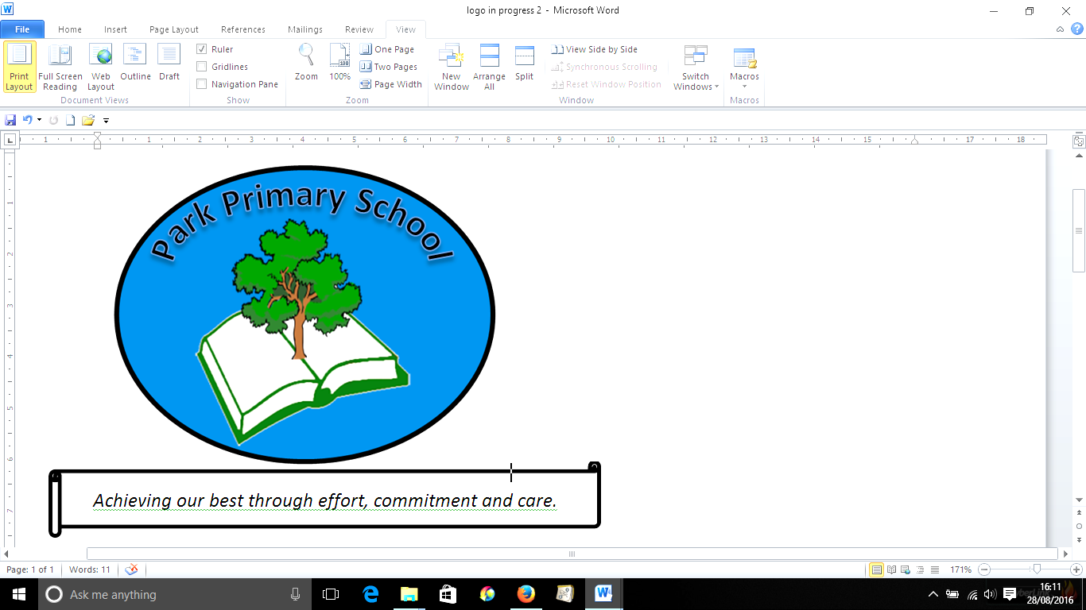

Gilfach Fargoed and Park Primary Schools Federation

Policy Title: | Accessibility Policy- Gilfach Fargoed Primary
Adoption Date: | February 2021 | Review date: | February 2023
Review date: | July 2023 | Next Review: | July 2025
Signed, Chair of Governors: |  | Signed, Headteacher:

Mission Statement

In our Federation, we are all learners for life. Our schools prioritise authentic, nurturing relationships through which we provide engaging and inspiring learning experiences. We set high-expectations, achievable through the development of resilient and confident learners who have a curiosity and enthusiasm about their community and the wider world. We take a pride in our learning, we thrive on collaboration and we are ambitious to solve problems and to achieve our best. We respect one another and our wider world while valuing our Welsh heritage. We aim to give our learners the tools to succeed in the 21st Century, with the guidance of a strong moral compass. We develop skills and knowledge, while fostering wellbeing and a growth mindset. Our whole community aims to develop:
- Healthy, confident individuals;
- Ethically informed citizens;
- Creative, confident contributors and
- Ambitious and capable learners.

1. This Accessibility Plan has been drawn up in consultation with the Local Authority, staff and governors of the school and covers the period from July 2023-July 2025.
2. We are committed to providing a fully accessible environment which values and includes all pupils, staff, parents and visitors regardless of their education, physical, sensory, social, spiritual, emotional and cultural needs. We are committed to challenging negative attitudes about disability and accessibility and to developing a culture of awareness, tolerance and inclusion.
3. Gilfach Fargoed Primary School plans, over time, to increase the accessibility of provision for all pupils, staff and visitors to the school. The Accessibility Plan will contain relevant actions to:
Improve access to the physical environment of the school, adding specialist facilities as necessary. This covers improvements to the physical environment of the school and physical aids to access education.
Increase access to the curriculum for pupils with a disability, expanding the curriculum as necessary to ensure that pupils with a disability are as, equally, prepared for life as are the able-bodied pupils; (If a school fails to do this they are in breach of the DDA). This covers teaching and learning and the wider curriculum of the school such as participation in after-school clubs, leisure and cultural activities or school visits. It also covers the provision of specialist aids and equipment, which may assist these pupils in accessing the curriculum.
Improve the delivery of written information to pupils, staff, parents and visitors with disabilities. Examples might include handouts, timetables, textbooks and information about the school and school events. The information should be made available in various preferred formats within a reasonable time frame.
4. Attached are Action Plans, relating to these key aspects of accessibility. These plans will be reviewed and adjusted on an annual basis. New Plans will be drawn up every three years.
5. We acknowledge that there is a need for ongoing awareness raising and training for staff and governors in the matter of disability discrimination and the need to inform attitudes on this matter.
6. The Accessibility Plan should be read in conjunction with the following policies, strategies and documents:
Curriculum
Equal Opportunities and Diversity
Staff Development
Health & Safety (including off-site safety)
Inclusion
Additional Learning Needs
Behaviour Management
School Improvement Plan
Asset Management Plan
School Prospectus and Mission Statement
Teaching and Learning Policy
7. The Action Plan for physical accessibility relates to the Access Audit of the School, which is undertaken regularly by the Local Authority. It may not be feasible to undertake some of the works during the life of this first Accessibility Plan and therefore some items will roll forward into subsequent plans. The audit will need to be revisited prior to the end of each first three-year plan period in order to inform the development of the new Plan for the following period.
8. As curriculum policies are reviewed, a section relating to access will be added to that on Equality and Diversity. The terms of reference for all governors' committees will contain an item on "having regard to matters relating to Access".
9. The School Prospectus will make reference to this Accessibility Plan.
10. The School's complaints procedure covers the Accessibility Plan.
11. Information about our Accessibility Plan will be published in the Governors' Annual Report to Parents (statutory).
12. The Plan will be monitored through the Curriculum and the Premises Committees of the Governors.
13. The school will work in partnership with the local education authority in developing and implementing this plan.
14. The Plan will be monitored by Estyn as part of their inspection cycle.

Current Provision

Current provision at the school is limited by location and building design.
The fact that the school was built in 1910 makes accessibility and building adaptations to improve accessibility challenging, although both main building are flat and have no internal steps.
We currently have no disabled pupils requiring wheelchair access at the school.

Building Access

• The main front entrance is accessed via two steps.
•There is a slight ramp to access the main building’s rear entrance.
•There is a slight ramp to access the Foundation Phase building’s front entrance, but steps to access the Nursery class two entrances.
• Low level sinks and toilets are available in the Foundation Phase building, with age appropriate toilets in the Nursery classroom.
• Wheelchair access to the playground can be gained via the school yard.
• The demountable classrooms can be accessed via a ramp for the main entrance and a ramp at the fire exit.
• There is a disabled toilet in the main foyer, clearly labelled.

Curricular Provision

• The school endeavours to ensure that all pupils, including those with disabilities, have access to the full range of curricular activities.
• The school employs, when required, additional Teaching Assistants (TAs) for children with disabilities and if necessary in accordance with their statement.
• There are permanently employed Teaching Assistants who provide support for children with a variety of needs.
• If appropriate, risk assessments are carried out for disabled child on their entry to school. These ensure that the child has full access to classroom activities and lessons. These are undertaken with the advice of external agencies such as occupational therapists and the building works department.

General Provision

The school endeavours to ensure that all pupils, including those with disabilities, are able to take part in all school activities. In addition to those described above, children with disabilities are included in all activities e.g school assembly and extra-curricular activities.
Teachers organise their classrooms to ensure that they are accessible to all. In this way pathways around classroom furniture and class and floor areas are large enough for children to work if in plaster casts. Within the school there are a variety of height tables/ chairs that can be used to enable children to work at the required height. The advice of the Occupational Health Service and our Health and Safety officer is sought when considering appropriate classroom furniture.

Staff training/Development
The training/development needs of staff are identified and provided for as part of the school’s on-going staff development. In relation to those staff who work closely with pupils with disabilities, particularly Teaching Assistants, a range of training has been provided over the last few years, including, that in manual handling and First Aid.
In addition we provide training for using epipens, monitoring and administering medication for diabetes and monitoring and providing first aid when necessary for children with epilepsy.

In addition, the school works closely with and utilises the specialist services and expertise of external agencies, to help to ensure that disabled pupils are able to access the curriculum, e.g. Visual/Hearing Impairment, Language/Speech Therapy , Spld service etc.

Barriers to Learning

The school endeavours to reduce all barriers of learning to pupils. This includes any additional learning needs, e.g. SPLD, EAL, etc.
The school seeks support from GEMS, who provide training support and intervention for pupils and their families with English as an Additional Language. This includes translation of documents and letters, translators for parents meetings etc. The school uses the Barriers to Learning Toolkit to assist pupils access learning effectively.

Equalities

We seek to remove barriers to learning and aim to provide equal entitlement of the curriculum for all children who attend Gilfach Fargoed Primary irrespective of ethnicity, faith, gender, age, disability and language. Sensitivity and fairness is emphasised during monitoring and assessment to take into account equality of opportunities. Each child is valued and seen as unique. We endeavour to ensure learning opportunities cater for the learning needs of the individual pupil with the aim of stretching them to the full extent of their capabilities and providing them with the opportunity to demonstrate fully what they know, understand and can do. We are committed to equality of opportunity and access for all our learners and to eliminate unlawful discrimination, harassment and victimisation and other conduct that is prohibited by the Equalities Act 2010. We further recognise the 9 protected characteristics as detailed in the Act. We will advance equality of opportunity between all learners and foster good relationships between all our learners and our stakeholders.

This policy works in conjunction with other policies and plans including our Equalities Plan, Inclusion Policy and ALN Policy.

Signed: C Rees, Headteacher July 2023

__________________________________

Signed: Howard Llewellyn, Chair of Governors July 2023

____________________________________

ACCESSIBILITY ACTION PLAN 2019-20

Target | Timescale | Who | Resources | Coordinator
Update First Aid training to ensure additional TAs trained | By end of Autumn Term 2023 | 2 teaching assistants | First aid training course | CR
To liaise with pre-school providers to  prepare for the new intake of children  into Nursery each year | End of summer term 2023 and summer 24 | Nursery staff, Busy Feet staff, Flying Start staff. | Transition meetings and visits | TC
To establish and maintain close liaison  with parents to. ensure collaboration and information sharing . | On going | SLT and all teaching staff |  | CR
To establish and maintain close liaison  with outside agencies for pupils with  additional needs and to understand the implications of the new ALN code | On going  Teachers and TAs to have accessed basic ALN training but this will be ongoing | SLT and ALNCo |  | LA
To include pupils with a disability,  medical condition or other access  needs as fully as possible in the wider  curriculum including trips and  residential visits as well as extracurricular provision by creation of appropriate risk assessments. | On going | SLT, ALNCo and all  teaching staff, extracurricular service  providers and  educational visits  settings | Risk assessments | CR
Ensure that reasonable adjustments  are made for parents with a  disability, medical condition or other  access needs so as they can fully  support their child’s education | On going | SLT, teaching staff, TAs, clerical staff |  | CR
Improve the provision for outdoor education and every pupil’s right to access this | Additional staff trained in Forest schools by end of 23-24 | Teaching staff, TAs |  | CR

