





Gilfach Fargoed and Park Primary Schools Federation

Policy Title: | Food and Fitness Policy
Adoption Date: | June 2021 | Review date: | June 2023
Reviewed: | July 2023 | Next Review: | June 2025
Signed, Chair of Governors: |  | Signed, Headteacher:

Mission Statement

In our Federation, we are all learners for life. Our schools prioritise authentic, nurturing relationships through which we provide engaging and inspiring learning experiences. We set high-expectations, achievable through the development of resilient and confident learners who have a curiosity and enthusiasm about their community and the wider world. We take a pride in our learning, we thrive on collaboration and we are ambitious to solve problems and to achieve our best. We respect one another and our wider world while valuing our Welsh heritage. We aim to give our learners the tools to succeed in the 21st Century, with the guidance of a strong moral compass. We develop skills and knowledge, while fostering wellbeing and a growth mindset. Our whole community aims to develop:
- Healthy, confident individuals;
- Ethically informed citizens;
- Creative, confident contributors and
- Ambitious and capable learners.

Date: June 2021

Review date: June 2023


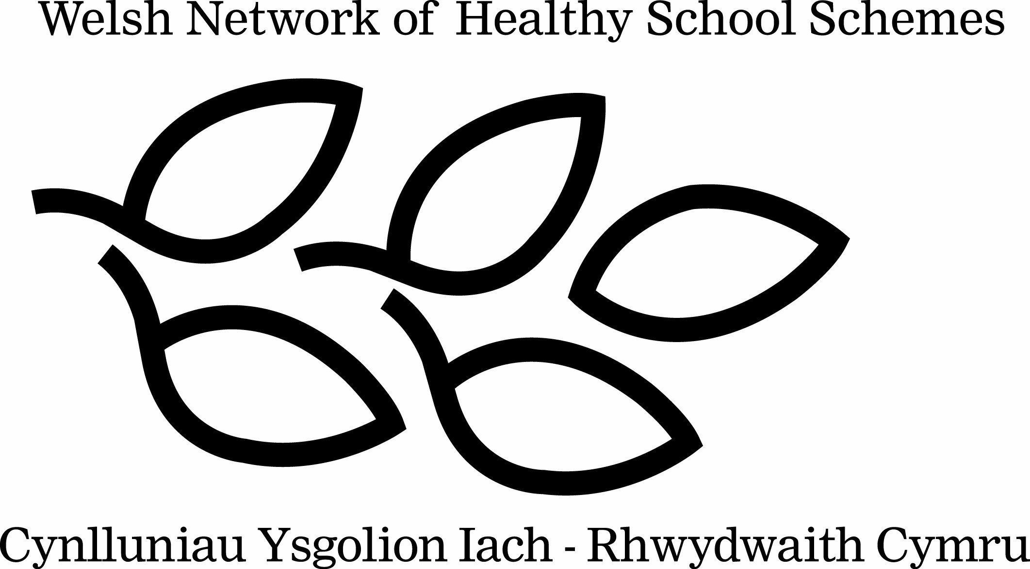
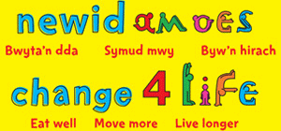
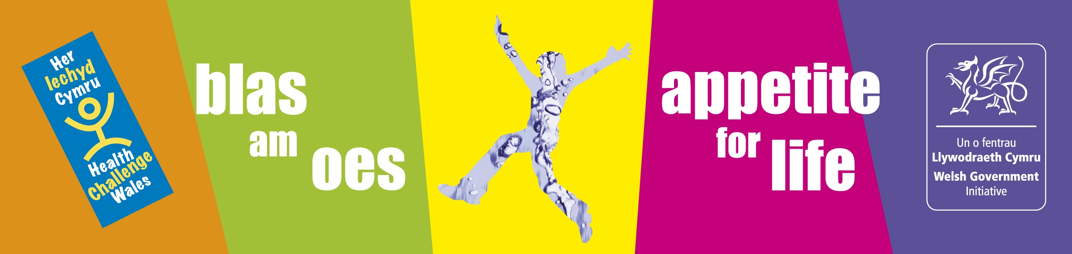

Introduction:

This policy will enable schools to link the positive effects that diet and physical activity can bring to childrens’ physical, mental and emotional well being.

A poor diet and lack of physical activity are major contributing factors to increasing levels of childhood obesity and associated health problems. In response to these concerns, the Welsh Government has produced The Healthy Eating in Schools (Nutritional Standards and Requirements) (Wales) 2013 Regulations (which legislates previous Appetite for Life guidance).This sets out to improve the nutritional standards of food and drink provided in schools in Wales, whilst ‘Creating an active Wales’, the Welsh Government Strategy for Sport and Active Recreation outlines ways to increase physical activity levels.

A recent report from the Chief Medical Officers ‘Start Active, Stay Active’ states that all children and young people should engage in moderate to vigorous intensity physical activity for at least 60 minutes and up to several hours every day.

Important points to remember when introducing a new Food and Fitness policy in your school:

- The whole school community should be consulted about the policy
- The policy must be agreed by The Governing Body
- The policy should be consistent with other school policies
- There is a named person responsible for the policy
- The policy is designed to be inclusive and to offer appropriate opportunities for all children
- The policy is designed to increase the levels of physical literacy and fundamental skill development

Estyn inspectors will look for evidence that schools have an effective approach to the promotion of food and fitness. Inspectors will consider ‘whether the school has appropriate arrangements that encourage and enable learners to be healthy’ and ‘take a broad view of healthy living that encompasses physical activity and fitness as well as eating and drinking’

At Gilfach Fargoed and Park Primary Schools we are committed to encouraging our pupils to lead active and healthy lifestyles. We believe that healthy children will be able to take full advantage of the educational opportunities that the school provides. The partnership of home and school is critical in shaping children and young people, and their future health.
We encourage a whole school community approach to food and fitness. The head teacher, staff and governing body will ensure that food provided in the school and advice given to pupils promotes a healthy and active lifestyle. Additionally, Gilfach Faroged and Park Primary Schools use non-food rewards such as praise, stickers, games and star charts rather than confectionery.
We are committed to providing high quality inclusive PE lessons and health related exercise and work in partnership with Healthy Schools, Dragon Sports and other Community Sports organisations. A combination of all of these different aspects will ensure physical literacy levels of pupils will increase. Physical literacy is the development of fundamental skills such as running, jumping, throwing and catching from an early age so pupils can carry out these actions effectively.
The school will not advertise branded food and drink products on school premises, school equipment or books, and will ensure that any collaboration with business does not require endorsement of brands or specific company products high in fat, sugar or salt.
Aims:

- To improve the health of the whole school community by equipping pupils with the knowledge and skills to establish and maintain life-long active life-styles and healthy eating habits

- To ensure that food and nutrition and physical activity become integral to the overall value system of the school and a common thread of best practice runs through the curriculum, the school environment and links with the wider community

- To develop a whole school food and fitness policy, which reflects a shared vision, coherence in planning, and consistency in the delivery of services, curriculum messages and the supporting environment.

- To ensure that pupils, teachers, parents, governors and all members of the wider school community are stakeholders and contribute to the aims and objectives of this policy.

Objectives:

- To promote pupil participation and decision making in all aspects of food and fitness activities.

- To ensure that activities related to food and fitness provided for pupils throughout the day are inclusive and consistent with curriculum guidance and Welsh Government regulations.

- To work in partnership with School Meal Providers to ensure that consistent messages about nutritional standards and healthy lifestyles are given to our pupils.

- To offer a broad range of inclusive, safe, stimulating indoor and outdoor sports, play and recreational activities to continually develop physical literacy levels.

- To ensure that all physical activity and physical play is inclusive and/or a disability specific alternative is available.

Implementation and Monitoring:

- A named person is responsible for co-ordinating the policy – Miss Aimee Griffiths (Gilfach) ; Mrs Hannah Usher (Park)

- The governing body will take responsibility for the Food and Fitness policy and will nominate a link governor.

- The Healthy School / Eco Committee are actively involved with the implementation of the Food and Fitness policy

- The Senior Management Team will ensure that there is adequate training and resources for staff involved in the delivery of the aims and objectives of the school’s Food and Fitness Policy.

- The Senior Management Team and governors will monitor progress at regular intervals.

- Updates on school food and fitness actions will be included in the Annual Report to Parents.
Physical Activity within the Curriculum

- The school is committed to providing 2 hours of timetabled, quality physical activity per week for every pupil.
- Opportunities for cross curricular links are explored and developed: Science / PSE – Highlighting the health benefits of regular exercise
- Opportunities of developing outdoor and adventurous education with a physical component are actively promoted

Extra Curricular Physical Activity / Active Play

- There is a range of inclusive and/or Disability Specific after school clubs appropriate to pupils across the entire age range
- The school utilises Dragon Sport/ 5x60 initiatives/PESS
- Lunchtime supervisors encourage physical activity during lunch times to reinforce physical literacy skills taught in the programmes above
- Steps are taken to actively encourage physical activity during lunch/break-times. Specific equipment is made available to pupils to stimulate physical activity
- The playground is ‘zoned’ into different activity areas to encourage all pupils to participate in activity during break and lunchtimes that is suitable to their ability
- Children who are above a healthy weight can be referred to MEND (Mind,Exercise,Nutrition,Do it) where families get fit and healthy for free.

Outdoor Education

- As part of the curriculum, pupils are encouraged to actively participate in growing fruit and vegetables in the school grounds/ local allotments.
- Pupils have the opportunity to join the school gardening club/ Forest School Club
- The school aims to promote seasonal food produce
- The school promotes environmental and sustainable initiatives such as Eco Schools and Forest Schools

Tracy

School Travel Plan

- Staff, Pupils and Parents are actively encouraged to walk to school
- Kerb Craft is taught to Year 2 pupils where available.

School Meals

- All school meals comply with The Healthy Eating in Schools (Nutritional Standards and Requirements) (Wales) Regulations 2013
- School Menus are clearly displayed around the school and canteen
- The school has developed welcoming aspects of the dining room environment including displays of food, promoting healthy eating, availability of free water, appropriate queuing arrangements
- Healthy options are promoted which gives pupils the opportunity to try new foods

Free School Meals

- This school considers free school meals as an important part of the social inclusion/child poverty agenda
- Parents are sent regular reminders to ensure that they are made aware of their potential eligibility, and reassured about how the system works at school (pupils who are eligible for free meals are not prevented from sitting with their friends who may bring sandwiches from home.)
- The uptake of free school meals is considered a key indicator for school performance
- Steps are taken to protect the identity of pupils receiving Free School Meals
- FSM Pupils and their families are made aware of opportunities available through MCC Leisure Services PTL Scheme.

Food and Nutrition in the Curriculum

- Pupils are taught to understand the relationship between food, physical activity and short and long term health benefits
- Pupils can acquire the basic skills in preparing and cooking food via the Food Competency Framework
- The Food Competencies include the themes of: Diet and Health, Consumer Awareness, Cooking and Food Safety. They apply to young people aged between 5-16+ years

Healthy Lunchboxes

- WG Information is provided for parents on nutritionally balanced packed lunches at the start of each new pupil intake
- Children are educated on the content of a healthy packed lunch
- A Healthy Packed Lunch policy has been developed and distributed to parents (available from your Healthy school coordinator)

Healthy Breakfast Club

- The school has a Welsh Government Free Breakfast Club (Primary Schools) running in the school providing nutritionally balanced food
- The school supports and takes part in promoting Healthy Breakfasts via newsletters, posters, school web site, displays etc.
- The Breakfast Club provides pupils with the opportunity of participating in active play/ physical activity

Fruit Tuck Shop

- The school has set up a daily Fruit Tuck Shop, which pupils help to run
- Only fresh fruit, vegetables, milk and plain water is sold
- The school regularly holds taster sessions of seasonal/ local/ Fairtrade fruit and vegetables
- The School Council/ Eco-committee are consulted in decisions to support the Fruit Tuck Shop

School Milk

- Free milk is offered to all Foundation Phase pupils each day
- Subsidised milk is made available to all Key Stage 2 pupils
- Refrigerators are cleaned daily and temperatures are recorded for safety

Drinking Water

- Children have access to fresh, clean water at school throughout the school day
- The school provides water free of charge for pupils and staff

Oral Health

- The school actively promotes oral health messages for example, tooth-brushing, limit sugary food, healthy snacks, fruit, milk and water at break times.
- The school actively participates in Designed to Smile programmes and facilitates oral health promotion to children and parents in flying start/communities first areas.
- The school advises its pupils and parents to visit a dentist on a regular basis
- The school encourages the use of mouth guards for contact sports to reduce the risk of oro-facial injuries
- The school will include oral health promotion in any health events in the school and parents meetings.

Appendix 1 Useful Links:

Welsh network of Healthy School Schemes – www.wales.gov.uk/topics/health/improvement/schools/schemes

Physical Activity

30, 40, 50 Club – http://www.welshathletics.org/schools.aspx
Climbing Higher – http://wales.gov.uk/topics/cultureandsport/sportandactiverecreation/climbing
Dragon sport – www.sportwales.org.uk
Eco-schools – www.eco-schools.org
In Perspective Food and Fitness – http://wales.gov.uk/topics/health/improvement/index/perspective/?lang=en
In The Zone – http://www.getinthezone.org.uk/
Physical activity and Nutrition Network for Wales – www.physicalactivityandnutritionwales.org.uk
Safe Routes to School – www.saferoutestoschools.org.uk
The Class Moves! – www.wales.gov.uk/topics/health/improvement/index/class
The Health Promoting Playground – www.wales.gov.uk/topics/health/improvement/index/playground
Sport Wales, What is Physical Literacy - http://www.youtube.com/watch?v=R8PIXqp3JpA

Nutrition:
Food and drink in schools – www.wales.gov.uk/topics/educationandskills/schoolshome/foodanddrink
Healthy Eating in Schools (Wales) Measure 2009
www.legislation.gov.uk/mwa/2009/3/contents
British Nutrition Foundation – www.nutrition.org.uk
Farmhouse Breakfast Week – www.hgca.com/breakfast
Food in the School Curriculum in Wales – http://wales.gov.uk/topics/educationandskills/schoolshome/curriculuminwales/guidanceresources/foodandfitness
Fruity Friday – www.fruityfriday.org
Primary School Free Breakfast Initiative – www.wales.gov.uk/topics/educationandskills/schoolshome/foodanddrink/breakfast
Think Healthy Vending – www.wales.gov.uk/topics/health/improvement/index/vending
Think Water – www.wales.gov.uk/topics/health/improvement/index/water
Food Competencies – www.food.gov.uk/scotland/scotnut/scotteachtools/competencies/
Eatwell Plate –http://www.nhs.uk/Livewell/Goodfood/Pages/the-eatwell-guide.aspx

Food & Fitness:
British Heart Foundation – www.bhf.org.uk
Food and Fitness – promoting healthy eating and physical activity for children and young people in Wales. Five Year Implementation plan – http://wales.gov.uk/topics/health/improvement/index/plan

Health Challenge Wales – http://wales.gov.uk/hcwsubsite/healthchallenge
Mend, a Weight Management programme for children- www.mendprogramme.org
Change For life – www.change4lifewales.org.uk
Rural regeneration Unit – www.ruralregeneration.org.uk

Appendix 2: Covid- Related Amendments

Breakfast Club and Fruit Tuck are replaced by provision of free fruit for the children at breaktimes and first thing in the morning where child would like a piece of fruit

The water dispensers are out of bounds, but children bring in water bottles which are filled regularly by staff

After school clubs are not currently taking place.

Rather than the Deisgned to Smile Programme and class toothbrushing, children in foundation phase have been given toothbrushing packs and have watched toothbrushing instruction videos.

Appendix 3: Staff signatures

I confirm that I have read and understood this policy. I have had an opportunity to ask questions and will ensure that the principles of this policy will be reflected in my practice:

Name of staff member | Job Role | Date | Signature

