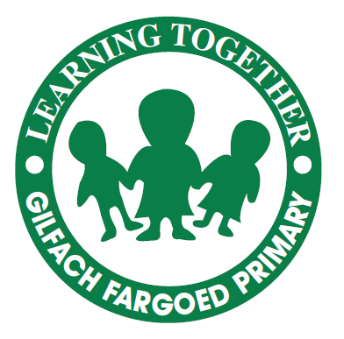
10th June 2026

Dear Parents/ Carers,
I hope you and your families are very well. We are now in the second half of summer term and there’s been lots going on. We’ve had several trips, which have proved very successful, different sporting events and Year 6 are doing extremely well in their intensive swimming sessions. I’m sure you won’t be surprised to know that, when our children are on trips, sporting events or visits, they represent the school in an exemplary manner.
It’s been lovely to see parents in school for our nursery play sessions and for our Maths Come and See visits. We’ve had to postpone the next session planned for 18th June, but I’ll update you when that’s back in the diary. Just a reminder, that literacy, maths and digital skills sessions are available from Caerphilly Adult Community Learning on Thursday afternoons. You’ll need to ring the office if you’d like to join the sessions.
Next week, on 17th and 18th June, our federation has a visit from Estyn who’ll be carrying out an interim inspection. I’m sure we’ll find the process positive and useful, and the children always enjoy visitors!
Dates for your diary
- Monday 22nd June: Y3-Y6 pupils cycle skills. They will need to bring their bike (in good working order) to school with them, along with a helmet.
- Tuesday 23rd June: Summer Fete from 2pm
- Thursday 25th June: Citizens’ Advice sessions at Park Primary. They offer a wide range of advice. If you’d like an appointment, ring Mrs Townsend in Park Primary on 01443 875510.
- Tuesday 30th June: Year 6 Leavers’ Assembly, 2pm (Apologies, we’ve had to move the day for unavoidable reasons linked to Y7 transition.)
- Friday 3rd July: Provisional date for sports day
- Monday 6th July: final parents’ evening of the year if you wish to discuss your child’s report
- Wednesday 8th July: Nursery graduation, 9.30am
- Wednesday 8th July- Friday 10th July: Residential trip for years 5 and 6
- Monday 13th July-Wednesday 15th July: Year 6 children attending Heolddu in September have 3 days of transition visits
- Thursday 16th July: Year 6 visit to Legal and General offices, Cardiff, as part of financial literacy work
- Friday 17th July: End of term for children
Many thanks for your continued support, Mrs C Rees

