Coed Hirwaun Primary School

Prospectus
2026-2027

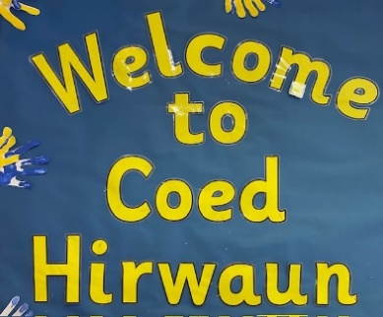

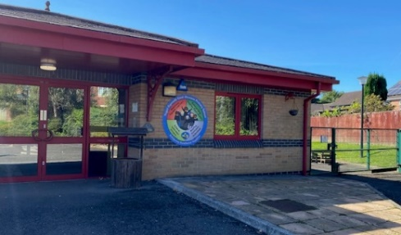

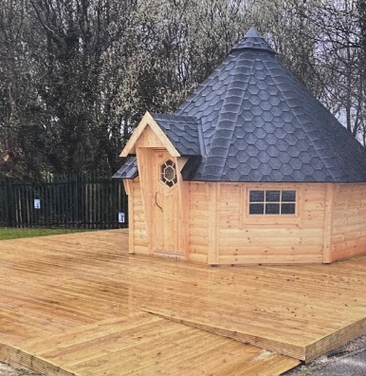

Dear Parents and Carers

On behalf of the Governing Body, Staff and Pupils of Coed Hirwaun Primary School we would like to extend a very warm welcome to you and your child/children and hope that your years spent with us will be both happy, successful and create precious memories to last a lifetime.

The purpose of this prospectus is to help you know more about life and learning at Coed Hirwaun Primary School.

Yours sincerely

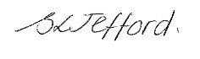

Mrs Sian Jefford
Headteacher

C O N T E N T S

ABOUT OUR SCHOOL………………………….…………………………………………………………………………………………………………….4
SCHOOL INFORMATION……………………………………………………………………………………………………………….…………………..5
STAFF STRUCTURE…………………………………………………………………………………………………………………………………………….6
GOVERNING BODY ……………………………………………………………………………………………………………………………………………7
CLASS STRUCTURE…………………………………………………………………………………………………………………………………………….8
LOCATION / CONTEXT OF OUR SCHOOL…………………………………………………………………………………………………………….9
VISION AND AIMS OF OUR SCHOOL 10
ADMISSIONS 11
SCHOOL SESSION TIMES 12
ATTENDANCE 13
CHILD PROTECTION AND SAFEGUARDING 14
LOOKED AFTER CHILDREN (LAC) 14
PASTORAL CARE AND SECURITY ARRANGEMENTS 14
DBS 15
RULES AND DISCIPLINE 15
THE CURRICULUM 16
SEX EDUCATION 18
RELIGIOUS EDUCATION AND COLLECTIVE WORSHIP 18
PE AND SPORT 19
EXTRA CURRICULAR ACTIVITIES 19
USE OF THE WELSH LANGUAGE 19
REPORTING TO PARENTS/ CARERS 21
ARRANGEMENTS FOR ADDITIONAL LEARNING NEEDS 21
EQUAL OPPORTUNITIES 22
DISABILITY EQUALITY AND ACCESS FOR DISABLED 22
CHARGING AND REMISSIONS POLICY 23
SCHOOL TERMS AND HOLIDAY DATES 24
HOME SCHOOL AGREEMENT 25
UNIFORM 25
DINNER MONEY AND PACKED LUNCH 26
BREAKFAST CLUB 27
CONSENT FORMS 27
COMPLAINTS 27

Coed Hirwaun Primary School opened in January 2002. The school was purpose built for the village of Coed Hirwaun. The school is situated in a semi-rural location, nestled in beautiful woodland very near to Margam Park, which has a wealth of local history.

We have many visitors to the school, and it is noticeable how many pass comment on the high quality of the learning environment and relationships within the school. The school is justifiably proud of its reputation for concern for the individual child, both in terms of well-being and educational provision. We work on the premise that each and every child is entitled to the highest quality educational experience that can be provided.

As a parent there are a number of things you can do to help us:

- Reassure your child about school.
- Work in close partnership with the school.
- Talk to them about their teacher, the activities they are doing and the friends they are making.
- Keep us informed of any significant details relating to your child’s education. Tell us of any allergies, major health problems or personal circumstances that might be significant. This information will be regarded as confidential and will help us care all the more effectively for your child.
- Do not hesitate to come and see us at any time if there is a matter you wish to discuss.

The staff at Coed Hirwaun Primary School are highly skilled at assessing each pupils’ individual level of development, supporting and moving them on at their own pace towards their full potential. We work hard to ensure that well-being is a priority for all our pupils.

Our aim is for every child to achieve their full potential in a happy, caring and stimulating learning environment. The school has been resourced to educate children in the 21st century, with particular emphasis on ICT and Digital Competency.

Parents are encouraged to take an active part in the education of their children. We believe that by working together parents and staff can ensure that each child will make the best of his or her opportunities. In all our activities we will endeavour to work as a family, in which each member will have a sense of value, belonging and a feeling of responsibility for the school and the community.

SCHOOL INFORMATION 2026-2027

SCHOOL ADDRESS: Coed Hirwaun Primary, Cwrt Y Carw, Coed Hirwaun, Port Talbot, SA13 2TS

TELEPHONE: (01656) 747830

E-MAIL: office@coedhirwaunprimary.npt.school

WEBSITE: https://coed-hirwaun-primary-school.j2bloggy.com

TYPE OF SCHOOL: Community co-educational

LANGUAGE: English

AGE RANGE: 3 – 11

NUMBER ON ROLL: 159 (138 full time, 21 part time)

HEADTEACHER: Mrs Sian Jefford

LOCAL AUTHORITY: Neath Port Talbot CBC

CHILD PROTECTION OFFICER: Mrs Sian Jefford

CHILDREN LOOKED AFTER OFFICER: Mrs Sian Jefford

STAFF STRUCTURE

HEADTEACHER: Mrs Sian Jefford

DEPUTY HEADTEACHER: Mrs Lisa Comley

TEACHING STAFF: Mrs Lisa Comley
Mrs Nichola Lewis
Mrs Stephanie James
Mr Richard Shepherd
Mr Jason Rees
Mrs Ffion James
Miss Ffion Davies

NON-TEACHING STAFF: Ms Jordan Hardy, Administration Officer
Mrs Sandra Seldon, Administration Officer

Mrs Tracey McCallion-Davies, Teaching Assistant
Ms Ashley Burnage, Teaching Assistant
Mrs Sam Noon, Teaching Assistant
Miss Kelsey Williams, Teaching Assistant
Mrs Joanne Jones, Teaching Assistant
Ms Alex Lloyd, Teaching Assistant
Mrs Amanda Carter, Teaching Assistant
Mrs Sandra Willis, Teaching Assistant
Mrs Christina Davies, Teaching Assistant

Ms Zara Ace, School Cook
Ms Jayne Dinham, Kitchen Assistant
Mrs Isabella Soares Ferreira Do Carmo, Caretaker

On behalf of the Governing Body, I welcome you to the school. The Governors work closely with the Headteacher and members of staff to create what we consider to be a happy, caring and stimulating environment for pupils to learn and develop in.

In this booklet you will find some items of information which will be of use to you, not only now but also in the future. You will find some details of how the school works and how we can work together for the benefit of your child/children.

Mr Ken Robbins
Chair of Governors

GOVERNING BODY

CHAIRPERSON: Mr Kenneth Robbins LA Governor

VICE CHAIRPERSON: Cllr Robert Jones LA Governor

GOVERNORS:
Mrs Beverly Bolton LA Governor

Mr Edward Ough Community Governor
Mrs Rachael Robins Community Governor
Mrs Helen Griffiths Community Governor

Mr Andrew Meech Parent Governor
Parent Governor
Parent Governor
Parent Governor

Mrs Stephanie James Teacher governor

Mrs Sian Jefford Headteacher
CLERK TO GOVERNORS: Mrs Sandra Seldon

The Governors have a responsibility for the effective management of the school acting within the framework set by Government legislation and the policies of the Local Authority. They determine the aims for the curriculum and have increasing responsibility for the financial management of the school, which is the role of the Head, supported by the teaching staff. Governors regularly visit the school and play an essential role in monitoring and overseeing the running of the school as a whole. Some governors have specific designated areas of responsibility such as safeguarding, health and safety, curriculum and attendance etc.

The Governors produce an annual report to parents. This is uploaded to our school website. Parents may request a meeting with the Head teacher and Governing Body to discuss the content of this report.
Minutes of the Governors’ meetings are available to any parent once they have been signed. The agenda of any meeting is also available. The meetings themselves are confidential.

The school Governors do their work voluntarily and put in a great deal of time to ensure the school is managed efficiently and to the benefit of the children. Each Governor also sits on one or more committees.
The Governing Body serve for a period of four years. Parent Governors bring the views of parents to the Governing Body, however, they are not delegates for parents, as they speak and act as individuals.

CLASS STRUCTURE (2025-2026)

Class Teacher | Class
Mr R Shepherd | Nursery & Reception
Mrs N Lewis | Year 1 & Year 2
Mrs S James | Year 3
Mr J Rees | Year 4
Mrs F James | Year 5
Mrs L Comley | Year 6

ORGANISATION

Pupils are organised into classes according to their age. Sometimes pupils of more than one age group may be placed into the same class due to the number and age balance of children on roll. Within every class a range of teaching methods are used as appropriate. All children are encouraged to achieve their own personal best. We truly believe positive “praise and encouragement” are key aspects if learning is to be enjoyable, meaningful and successful.

LOCATION/CONTEXT OF OUR SCHOOL
Coed Hirwaun Primary is an English medium school, which currently has 159 pupils aged 3-11. The school was purpose built for the residents of a new housing estate, Coed Hirwaun in 2022. It is set in a pleasant residential area on the outskirts of Port Talbot, nestled in beautiful woodland very near to Margam Park.

There is a strong community feel throughout the school and we are proud of the warm, welcoming and caring atmosphere we provide for our pupils and families.

All buildings are single storey and include six classrooms, cloakroom areas and toilets. There is also a demountable classroom which is currently used for playgroup, intervention work and small group work. The Headteacher’s office and main school office are located at the front of the school.

Outside, there is a large tarmac playground and grassed areas. There is a sensory garden and an outdoor classroom. Nursey and Reception have a large, enclosed play area.

We offer a wide range of extra-curricular activities and clubs to our pupils. These change on a regular basis to address the interests of a wider range of pupils. Children achieve well in sport and music both in and outside school and we have close links with our primary cluster schools and Ysgol Cwm Brombil our feeder secondary school.

There is a strong community feel throughout the school, and we are proud of the warm, welcoming and caring atmosphere we provide for our pupils and families.

We have achieved numerous Awards – Healthy Schools Level 4 and Platinum Eco School status. We have achieved the Rights Respecting Schools Level 1 award, the ‘Siater Iaith’ Bronze award.

Strong home/school links are vital, and we work hard to develop good working relationships with parents and carers. Regular opportunities are provided for parents to come into school and keep up with children’s progress. Letters, newsletters, Twitter, school website and Schoop messages ensure up to date information is always available. Our governors, Headteacher and staff are always happy to meet and discuss any queries you may have at a mutually convenient time.

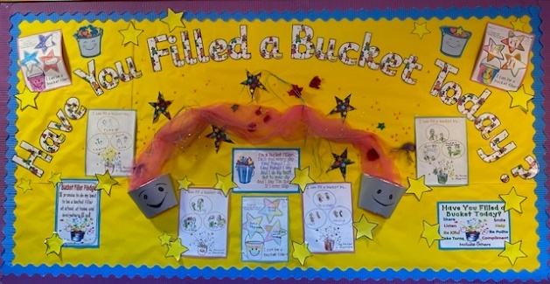

VISION AND AIMS OF OUR SCHOOL
Our school motto is:
‘Achieving Excellence Together’
Vision Statement: We aim to attain our vision by providing inspiring teaching within a supportive learning environment which empowers children to achieve the best they can.
Ethos: We believe our school will nurture all individuals in their journey to achieve their full and individual potential. We are committed to developing a welcoming, safe and stimulating learning environment that will enable our pupils to become resilient, responsible citizens and lifelong learners. We are aware that our pupils bring different experiences, interests and strengths, which will influence the way they learn.
At Coed Hirwaun Primary School we aim to create a warm, friendly and welcoming atmosphere and the relationship between staff, pupils and parents and the wider community is a strength – based on mutual respect, honesty and trust. Pupils are encouraged to show consideration for the needs of others and to play a full and active part of school life. Every child is valued as an individual.

As pupils progress through the school, they are given opportunities and experiences to develop skills for life and a love of learning.

STATEMENT OF SCHOOL AIMS
- To provide a welcoming, safe and stimulating environment where everyone is listened to and respected.
- To provide opportunities within a broad and balanced curriculum so that each child can achieve success and can fulfil his or her potential.
- To develop rounded individuals socially, emotionally, spiritually, physically and creatively.
- To provide our pupils with a curriculum fit for a school in Wales, tailored to reflect the unique nature of the country and its culture.
- To value independence and digital literacy to enable our pupils to become responsible 21st century citizens and lifelong learners.
- To encourage and enable the continuous professional development of staff, ensuring effective communication between all.
- To display a commitment towards making Coed Hirwaun a sustainable school, actively focusing on a wide range of environmental issues.
- To nurture strong partnerships and positive relationships with parents, carers and the wider community.
- To recognise and celebrate success in all aspects of school life.

ADMISSIONS
The school has adopted and follows the Local Authority Admission procedures. All admissions are dealt with by the Local Authority Admissions Officer, Mrs Helen Lewis.

For all children, a placement request must be submitted to the Local Authority. Application packs are available from school. A copy of the Local Authority Admissions policy is also available at school. Prospective parents/carers are welcome to make an appointment to visit the school prior to submitting an application. Any requests for admissions during the school year are also made through the Local Authority.

Children are admitted into the Nursery class in the term following their third birthday. Where possible, visits to the class are arranged for the child and parents/carers beforehand. To build strong relationships school visits are arranged by the class teacher and teaching assistant prior to the child starting Nursery.

Pupils are admitted to full-time education in the September following their fourth birthday and admission requests to school are dealt with by the Local Authority.

School admission team can be contacted on (01639) 763580/ (01639) 763730 or admissions@npt.gov.uk.

SCHOOL SESSION TIMES
 | Rec, Year 1, Year 2 & Year 3 | Year 4, Year 5 & Year 6
Morning session begins | 8.50 am | 8.50am
Registration | 8.55am - 9.00 am | 8.55am - 9.00 am
Session 1 | 9.00am – 10.20 am | 9.00am – 10.40am
Morning Break | 10.20am 10.40 am | 10.40am – 11.00am
Session 2 | 10.40am – 11.45am | 11am – 12.15pm
Lunch | 11.45am – 12.45pm | 12.15pm – 1.15pm
Session 3 | 12.45pm – 3.20pm | 1.15pm – 3.20pm
End of session | 3.20 pm | 3.20pm

NURSERY SESSION TIMES
Morning session 8.50am -11.20am
Lunch 11.45am – 12.45pm
Afternoon session 12.50pm - 3.20pm

At Coed Hirwaun Primary we have the option for a ‘flexible’ nursery, where children can attend up to 2.5 days per week. This must be agreed with the class teacher before starting school.

Please make every effort to ensure your child arrives at school on time and is collected promptly at the end of the day.

Children will be supervised by a member of staff in the main school yard from 8.40am daily. Nursery and Reception children arrive at the class door and will be greeted by a member of staff at 8:50am.

Pupils who arrive late, after the main doors have been locked, must be taken to the main office in the to sign in.

If, for some reason, your child is not being collected by yourself or the usual adult, please inform the school. There are passwords in operation for the safety of our pupils.

PLEASE NOTE, FOR SECURITY REASONS, ALL EXTERIOR DOORS/GATES ARE LOCKED FROM 8.55am UNTIL THE END OF THE SCHOOL DAY. The main pedestrian gate is closed but not locked, to allow access to the office.

ATTENDANCE
Regular attendance and punctuality at school is essential. It is an important factor of your child’s progress in school and helps ensure children’s happiness and academic progress. Every school absence must be accounted for by a satisfactory explanation. This should be done by telephoning/emailing the school by 8.50 am on the first day of absence. Failure to provide a satisfactory explanation for absence can lead to that absence being classed as unauthorised which may lead to enquiries being made by the school, or the Educational Welfare Officer (EWO).

The EWO is also involved with families in a supportive role, such as a management plan for a child’s return after illness.

Any holiday or planned term time absence will be considered on an individual basis. A request for absence form must be completed and these are available in the school office.

Our whole school percentage of attendance of sessions attended by pupils is currently 92.86% for 2024-2025.

The Welsh Assembly Government states that:

Attendance percentage | National Guidelines
95- 100% | Your child is taking full advantage of every learning opportunity and has the optimum chance to succeed.
90 – 95% | Satisfactory attendance. Your child may have to spend  time catching up with work.
85 – 90% | Attendance is a cause for concern. Your child may be at risk of under-achieving. The Education Welfare Officer may call at home.
80 – 85% | Attendance is very much a cause for concern. Your child may need extra support from you to catch up with their work. You will receive a visit from the Educational Welfare Officer.
Below 80% | Unacceptable attendance. Your child is missing out on a broad and balanced education. You will receive a visit from the Education Welfare Officer.

CHILD PROTECTION AND SAFEGUARDING
We strive to provide a safe and welcoming environment where children are respected and valued.

The school’s designated Child Protection Officers are:

Child Protection Officer: Mrs S Jefford (Headteacher)
Deputy Child Protection Officer: Mrs L Comley (Deputy Headteacher Teacher) Mrs Stephanie James (ALNCo)
Child Protection Governor: Mrs B Bolton (Chair of Governors)

Coed Hirwaun Primary School is committed to the protection and safety of its pupils.

The school has a Child Protection and Safeguarding Policy. These are available on request and on our website.

It is the responsibility of the Head Teacher to ensure that all Child Protection procedures are followed correctly and that all staff are trained appropriately to the required standard.

Staff have a duty to report any concerns to Mrs Jefford, Mrs Lisa Comley, Mrs Stephanie James or to Mrs Beverly Bolton, Safeguarding governor.

Should you have any concerns or information you wish to share, please contact a member of staff. All cases will be dealt with professionally, efficiently and discreetly.

CHILDREN LOOKED AFTER (CLA)
Sometimes, children are placed into Local Authority care on a short or longer-term placement. This is usually with foster families. A plan is drawn up for these children called a Personal Education Plan to ensure that they achieve the best they can from their education. Regular meetings are held to ensure they are receiving emotional, social and educational support. Mrs S Jefford is the (CLA) Officer.

PASTORAL CARE AND SECURITY ARRANGEMENTS
The school aims to create a warm, caring and secure atmosphere for your children. Each class teacher is responsible to the Headteacher for the general care of your child at school. Suitable supervisory arrangements are made during break and dinner times.

In the event of a pupil being taken ill, or sustaining a minor accident, the parent or guardian are contacted, and appropriate arrangements made. The emergency services are contacted in the case of major accidents and parents informed accordingly. Medical and dental services attend school on a regular basis.

The Education Welfare Officer makes fortnightly visits.

The school has access to a wide range of outside agencies including Educational Psychology, Speech and Language and the Wellbeing Team. These services support the school to meet the needs of all pupils.

If a child has any allergies, or needs regular prescribed medication, parents are asked to inform the school and complete the relevant form, to ensure the correct procedure is followed if treatment is necessary. No medication will be given without written authorisation from the parent/guardian/carer.

Fire and Lockdown drills are carried out at least on a termly basis as a minimum requirement as included in our Health and Safety policy. All electrical equipment is tested annually.

Health and Safety is everyone’s responsibility. Any hazards are to be reported as soon as possible to a member of staff.

The school has three different pupil toilet facilities, one in each building. Each of these facilities is cleaned at the end of the school day in accordance with the Local Authority’s cleaning service provision.

Parents/carers are not to park on the yellow zig-zag lines outside the school gates for the safety of our pupils. The school has a staff/visitor carpark. You must not drive into the carpark, without prior arrangement. The PCSO monitors the parking in the area with NPT council.

The main school doors are kept locked during the school day and any parent/ carer needing to visit during the day should report to the school office. There are also gate locking arrangements in place for the safety of our pupils.

DBS
All persons that work with the children in our school can only do so with an enhanced criminal records bureau check. The school follows the Local Authority safer recruitment checks when appointing staff.

RULES AND DISCIPLINE
Our school rules are kept to a minimum and are based on consideration and respect for others. Children are encouraged to behave in a responsible way. Reward systems are in place to promote this. Children help set our rules to take ownership and responsibility.

Children at Coed Hirwaun show a caring, responsible attitude in all they do. If a pupil shows unacceptable behaviour, it will be addressed and positive behaviour modelled. In more serious cases the parents of the pupil will be informed to work together to improve/support pupil. If exclusion is necessary, the parents, Governors and LEA will be informed. Bullying is taken seriously. Issues that are brought to our attention are dealt with following school policy. In order to promote good behaviour a celebration assembly takes place every week, where pupil’s achievements are recognised by all staff. The school has a policy on Discipline and Anti-Bullying.

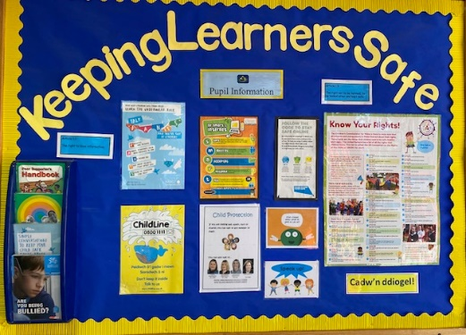

THE CURRICULUM
We present to our pupils a broad, balanced curriculum. As a school we firmly believe that children learn best from meaningful, engaging, practical experiences, accompanied by discussion. A range of teaching/ learning opportunities are used as appropriate, these include whole class, group and individual teaching. We promote independence through all areas of our curriculum.

Pupils in all age groups pursue a wide curriculum covering many areas of development. Each child’s needs and abilities are considered, and care is taken to ensure at all times that the needs of children are met. Pupils are taught in English and Welsh is taught as a second language.

Children’s achievements are celebrated, and everyone enjoys success and praise regularly during their time in school. We encourage our children to be independent and confident.

We aim to create a curriculum with appropriate learning activities that: -
- Focuses on and meets learners needs
- is inclusive and provides an equality of opportunity
- Equips learners with transferable skills
- Is relevant, challenging, interesting and enjoyable for all learners
- Transforms learning to produce resourceful, resilient and reflective learners

A variety of teaching methods and approaches are employed throughout the school and our aim is to affect a balance and flexibility of methods which we find most effective to meet the needs of the individuals.

It is through the Curriculum that the teachers at Coed Hirwaun Primary School attempt to fulfil our aims and the aims of the Curriculum for Wales. The Curriculum encompasses all the teaching and learning which takes place both in and out of the classroom. We acknowledge that not all children develop at the same rate. Therefore, we actively work to match the tasks given to each child with his/her stage of development. We have created and continue to develop a concept-based curriculum which ensures all skills, knowledge and experiences are covered progressively.

Our school plans to meet the objectives from the Four Purposes of the Curriculum for Wales and the statutory framework and mandatory elements within. The four purposes are also underpinned by integral skills which are developed within a wide range of teaching and learning experiences.

At Coed Hirwaun Primary School we will support our pupils to be:
- an ambitious, capable learner, ready to learn throughout their life
- an enterprising, creative contributor, ready to play a full part in life and work
- an ethically, informed citizen, ready to take part in Wales and the world
- a healthy, confident individual, ready to lead a fulfilling life as a valued member of society.

The children are also taught the statutory Literacy, Numeracy and digital skills that can be applied across different subjects.

TEACHING POLICIES AND PLANNING
The school has a detailed Curriculum policy. This document has been agreed by the Governing Body and Staff and relate to how each area of learning will be delivered.

Long, medium and short term plans ensure that all Areas of Learning are adequately represented both in terms of content and time during the course of the school year, across the school and the Literacy and Numeracy Framework. Short term planning shows what is going to be taught in one and two week periods. Within the medium-term plans, certain areas are given much more time than others, this balance is redressed however, in the following half terms. Where it is not possible to integrate a particular subject, then these are taught in discreet lessons. Skills weeks are also in place throughout the year.

Pupils are encouraged to be actively engaged in planning their own learning experiences. There is a strong focus on developing pupils independence and resilience, whilst building on valuable learning skills required for the future.

SCHOOL DEVELOPMENT PLAN - TARGET SETTING
Governors, staff and pupils have worked with the Headteacher to set targets for the forthcoming three years. The process of agreeing targets is based on the following principles:

- Targets should be challenging, realistic and manageable;
- They should be school specific, reflecting an informed evaluation of each year group of children;
- In order to be meaningful, targets should be considered over a time span of more than one year;
- Class teachers have a crucial role to play in the setting of targets and are fully involved in the process.

RELATIONSHIPS AND SEX EDUCATION
Relationships and Sex Education (RSE) is an integral part of the New Curriculum. It is an area that the school is continuing to review and reform in line with the legal requirements of the New Curriculum. The school’s policy is currently based on the Local Authority Policy Statement and approved by the Governing Body.

RELIGION, VALUES AND ETHICS AND COLLECTIVE WORSHIP
Religion, Values and Ethics is provided for all children as part of the curriculum and is in accordance with the Authority’s agreed syllabus.

Religion Values and Ethics is taught in accordance with current guidelines. The content of the RVE curriculum is designed to helps to prepare our learners for life and work in a fast-changing and diverse world, as responsible and informed citizens.

Assembly is an important part of the school day when we meet as a community. It is a time when we place emphasis on the development of values and attitudes towards each other and the world around us. Assemblies follow themes and a variety of religious stories shared. Social and emotional issues are also discussed and reflected upon. Due consideration is given to the multicultural society in which we live. Parents have the right to withdraw their children from collective worship should they so wish. If parents do not wish their child take part in short acts of collective worship, then they should inform us in writing.

PHYSICAL EDUCATION AND SPORT
At Coed Hirwaun Primary, PE and games play an important part in the delivery of the Curriculum. We believe that physical education is about developing children’s enjoyment, confidence and skill in physical activity. Our programme for physical education involves practical activities that give all children, irrespective of age or gender, opportunities for participation, enjoyment, pleasure and success. These activities include games, gymnastics, dance, athletics, outdoor adventure activities and swimming. Other activities arranged include netball, rugby, football, rounders, hockey and athletics.

Children are required to dress in suitable clothing appropriate to the activity undertaken. After school sports is organised throughout the year. We currently have four Sports Ambassadors within our school who organise games and activities at lunch and break times.

EXTRA CURRICULAR ACTIVITIES
Every term class teachers generally arrange an educational visit or visitor to supplement work on their class theme. These visits usually take place during school hours and places visited in recent years include: St Fagan’s, Castell Henllys, Swansea Maritime Museum, Techniquest, theatres and various sports tournaments.

Each year, children from Years 5 and 6 are taken on a residential visit. In recent years, visits have been made to Llangrannog.

Whenever possible some extra-curricular activities may be provided voluntarily by the staff. These may include such things as Games Clubs, craft, singing, wellbeing and Environmental Club. Clubs are advertised through our school newsletter or via the school website. These may take place at lunchtime or after school.

USE OF THE WELSH LANGUAGE
Welsh is introduced as a second language in short, mainly oral lessons from the time the child enters school. Enjoyment in learning the language is incorporated in a variety of situations: incidental, conversational and singing, and is an integral part of classroom life.

As pupils progress they develop reading and writings skills in Welsh.

We have access to support from the Local Authority.

Curriculum Cymreig is also important to our pupils’ development and understanding of their Welsh heritage and is reflected throughout the year in a range of activities. Cynefin is developed through our curriculum for children to understand a sense of belonging.

The school has achieved the Bronze Award and is now working towards the silver award of the Siarter Iaith scheme.

PUPIL VOICE
Children have opportunities to become elected as School Council representatives, Eco Committee, ICT Wizards, Criw Cymraeg and Sports Ambassadors. These pupils meet regularly to discuss school issues and have opportunities to arrange school events. The school has achieved the bronze award of the UNCRC Rights Respecting Scheme. The school will continue to build upon this work.

SUSTAINABLE DEVELOPMENT AND GLOBAL CITIZENSHIP
The school has a clear policy and programme for promoting sustainability and global citizenship and has been awarded with three Healthy School Awards. We have been awarded Platinum Status for Eco Schools. We hold regular Eco activities where the whole school has the opportunity to experience a variety of different activities in the outdoors.

Sustainable development and global citizenship are incorporated into school life through curriculum work, assemblies and organised events.

HOMEWORK
Homework is seen as an opportunity of giving children further practice in skills taught at school. It also gives parents an insight into the type of work being undertaken in school and a structured opportunity to provide help and encouragement. Homework is set by the class teacher.

Reading Children have a home/school reading diary in which you, as well as teachers, have the opportunity to make a comment about your child’s reading. If you want advice about reading please feel free to ask the class teacher.

Spelling and Multiplication are given to pupils when appropriate.

Home School Projects are set occasionally and usually linked to topic work. These projects are completed by pupils and their parents/carers working together.

Your help and encouragement are vital to support your child’s education.

If you have any queries regarding your child’s homework, please do not hesitate to speak to the class teacher.

ASSESSMENT AND REPORTING TO PARENTS/ CARERS
Assessment will be part of your child’s learning every day. They will work with their teachers to understand how well they are doing. This is important to help them:
- see where they are in their learning
- plan their next steps in their learning
- identify any issues or support if needed

Help their teacher:
- find ways to challenge them
- see how well pupils are doing.

Day-to-day formative assessment is the most important type of assessment which is carried out by teachers and teaching assistants in the school to see how well the children do in each lesson to meet the objectives of the session. Feedback is given to the children to help them meet the success criteria or to move learning on.

Pupils from Year 2 – Year 6 will undertake National Tests in Numeracy and Reading each year.

We hold a Back to School evening, parental consultation evenings twice a year, during the Autumn and Spring terms. There is also another opportunity to meet in the Summer term. During these sessions pupil’s progress and their targets are discussed. End of Year Reports are given out at the end of the Summer term and contain comments on your children’s progress.

ARRANGEMENTS FOR CHILDREN WITH ADDITIONAL LEARNING NEEDS
Staff at the school are committed to providing high quality education for all pupils. Every pupil has an entitlement to the full range of curricular opportunities. A whole school approach has been adopted to provide for all children who experience additional learning needs at any time in their primary years. We believe that early intervention is key, and we work closely with outside agencies to ensure that appropriate provision is in place from Nursery onwards.

Parents/Carers will be consulted where there are concerns regarding learning or behavioural difficulties. Children who have been identified as having learning or behavioural difficulties are put on the Additional Learning Needs register in line with ALN Reform. Children who have an Individual Development Plan will receive individual or small group help for part of the school day, within their classroom, or a quieter area within the school building.

The Additional Learning Needs Co-ordinator, Mrs. S. James, will work with class teachers, support staff and families to ensure the pupils are supported to achieve their full potential. All staff meet regularly to update Individual Development Plans and ensure all classes are providing relevant Inclusive Learning Provision to meet the individual needs of the pupils.

Every pupil attending this school should have the opportunity to develop and realise their true potential. In pursuing this aim, we seek to provide an inclusive learning environment in which our more able and talented pupils have an enriched curriculum that offers challenge.

The school’s ALN co-ordinator is Mrs S James and the ALN Governor is Mrs B Bolton.

EQUAL OPPORTUNITIES
We build equality of opportunity into all that we do, with pupils and with staff
- We have developed our school as a place where all are valued and respected
- We provide equality of opportunity in our employment practice
- We provide learning and development opportunities for all our staff to enable us to fulfil our commitment to equality
- We take any complaints about inequality seriously

The Strategic Equality Plan, Accessibility Plan, Race Relations Policy have all been adopted by the Governing Body.

DISABILITY EQUALITY AND ACCESS FOR DISABLED
We ensure that pupils and stakeholders have the same opportunities to benefit from the education our school provides. We will not treat a pupil or stakeholder with a disability less favourably than others because of the nature of his or her disability. All reasonable adjustments will be made to ensure that a pupil or member of staff with disabilities is not placed at a disadvantage.

INSPECTION OF DOCUMENTS/ POLICIES
Documents required to be made available by Regulation may be inspected at the school by prior arrangement.

CHARGING AND REMISSIONS POLICY
The school Charging and Remissions policy is based upon the one provided by the LEA which was accepted by the Governing Body. Please contact the Headteacher if you have any concerns regarding costs. Your concerns will be treated in the strictest confidence. The Governing Body has determined that parents may be invited to make voluntary contributions to support a particular activity e.g. for educational visits a nominal charge to offset transport and where necessary entrance costs. A copy of the school’s Charging and Remissions policy is available at school and on the school website.

SCHOOL TERMS AND HOLIDAY DATES

Academic Year 2026 - 2027

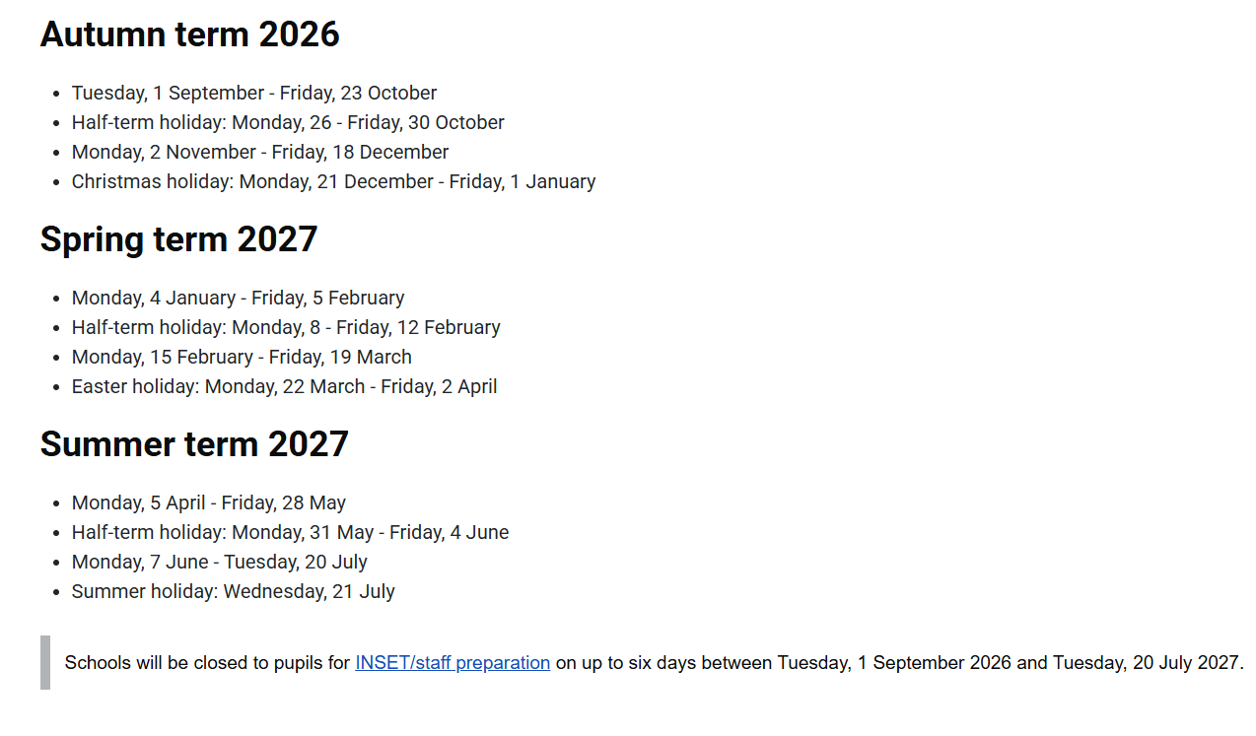Bank Holidays

2026
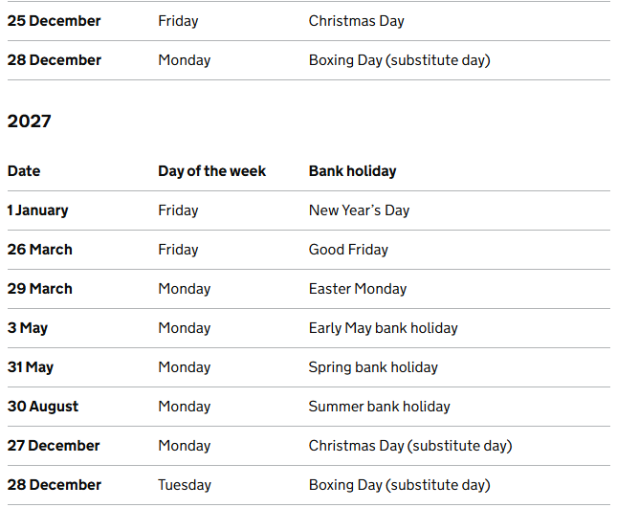

HOME SCHOOL AGREEMENT
The school issues a Home-School Agreement on admission. The agreement outlines the responsibilities of the school; the class teacher; the pupil and the parent/ carer. The agreement is signed by all parties and returned to school and retained. Parents are able to play an extremely important role in the partnership between home and school. This partnership should provide each child with the best possible education in a secure and caring environment.

UNIFORM
We believe that the wearing of school uniform contributes to a sense of belonging to the school community and helps to develop a sense of pride in the school. Our school uniform was agreed through consultation with parents and pupils and is any combination of the following:

Boys
Gold polo shirt (with or without logo)
Navy trousers or joggers
Navy hooded, round or v necked sweatshirt or cardigan
(with or without logo)
Sensible black shoes/plain black trainers

Girls
Gold polo shirt (with or without logo)
Navy skirt, navy pinafore dress, navy trousers or joggers
Yellow and white gingham summer dress with white cardigan
Navy hooded, round or v necked sweatshirt or cardigan
(with or without logo)
A white cardigan can be worn with the summer dress
Sensible black shoes/plain black trainers

In summer pupils can wear smart navy shorts (cycle shorts are not permitted for daily wear). Other items can also be purchased to compliment the school uniform such as P.E. shorts, T-shirts, bags, book bags, backpacks, winter hats and baseball hats.

All the above can be supplied by:

Uniform2go

Telephone Number: 01656 655122
Web Address: www.uniform2go.co.uk

Image Shops

Telephone Number: 01639 888587

However, the plain items without the logo can be obtained at many retail outlets.

We strongly advise that you put your child’s name on every item of clothing. This will help us to resolve any lost property issues!

CLOTHES FOR PHYSICAL EDUCATION
All children are required to bring kit for P.E and Games as they will do this on a regular basis. This will consist of:-

Round neck yellow T-Shirt (with or without logo) and plain navy shorts
for indoor P.E. (no shoes).

For outdoor games, trainers are required, with a tracksuit or sweatshirt and joggers during the winter months.

PE kit can be brought into school in a draw string bag labelled with your child’s name and can be left on their peg between sessions.

All pupils also undertake a weekly outdoor learning session. Suitable clothing can be left in school or brought in weekly.

JEWELLERY/MAKE-UP
Wearing jewellery is not appropriate to the activities which children take part in during the school day. If earrings are to be worn, only the stud types are acceptable. Wristwatches and earrings must be removed before physical activities can take place and these are the sole responsibility of the pupil. The school cannot take responsibility for their safekeeping. The wearing of make-up/acrylic nails by pupils is not permitted.

SCHOOL DINNERS AND PACKED LUNCH
Due to Welsh Government funding, all full-time, primary school pupils in Neath Port Talbot are now entitled to a Free School Meal.

Pupils can bring a healthy packed lunch to school instead of having school lunch. Parents/carers are requested to ensure that all food is wrapped well, and all drinks (no fizzy drinks/no energy drinks) put in secure containers (no glass is allowed). Pupils should not bring sweets as part of the packed lunch.

HELP WITH SCHOOL ESSENTIALS
If you are the parent or guardian of a child in education from Reception to Year 11, you may be eligible for a grant to help to pay for essential school items. You may be eligible if you receive one of these benefits:

Income support
Jobseeker’s Allowance
Employment and Support Allowance
Child Tax Credit - As long as your annual income is £16,190 or less before tax and you don't receive Working Tax Credit
Pension Credit
Universal Credit - Your household earnings must be less than £7,400 a year after tax. This does not include any income from benefits
Help under Immigration and Asylum Seekers Act 1999
You may be eligible if you have no recourse to public funds (NRPF).
Please apply to via Neath Port Talbot Council if you believe you may be eligible.
The official name of this grant is School essentials grant.

BREAKFAST CLUB

Free Breakfast Club, a Welsh Assembly Initiative, is provided on a daily basis for pupils in Reception - Year 6. Breakfast comprises of cereal, toast, fruit, and milk/water.
At our school, Breakfast Club operates from 8.10 am until 8.40 am and no children are allowed into Club after 8.30 am.

CONSENT FORMS
Consent forms are updated every September which cover all general activities and visits in the local area for that academic year. For any visits that take place away from school and the local area, details will be sent home and an additional consent form will need to be completed in each instance. In the case of longer trips (residential to Llangrannog for example) you will be asked for additional information and consent on any medication that may be needed, allergies or any special dietary requirements.

COMPLAINTS
If you have a complaint about any aspect of your child’s schooling, in the first instance, please discuss your concern with the Headteacher and staff. If you are still not satisfied, ask about the complaint procedure, which the Headteacher (or Governing Body representative) will explain to you. The Complaints Procedure is available on the website.

At Coed Hirwaun Primary School we are always willing to discuss any queries/questions you have and welcome open and honest discussions.

FREEDOM OF INFORMATION ACT
The Freedom of Information Act requires publicly funded bodies, including schools, to be clear about the information they publish. We have produced a publication Scheme setting out all the information we publish on a regular basis and where to find it.

We look forward to working with you during your time at Coed Hirwaun Primary School.

