Coronavirus: Army veteran Tom Moore, 99, so far has raised over £18m for NHS
A 99-year-old army veteran who has raised more than £18m to help the NHS in the fight against Covid-19 has vowed to keep going even though he has smashed his original £1,000 target.
Tom Moore aimed to complete 100 laps of his Bedfordshire garden by Thursday, walking with the aid of a frame.
However he has now said he will not stop and hopes to do another 100.
NHS Charities Together, which will benefit from the funds, said it was "truly inspired and humbled".
Nearly 170,000 people from around the world have donated money to his fundraising page since it was set up last week.
Mr Moore began raising funds to thank the "magnificent" NHS staff who helped him with treatment for cancer and a broken hip.
He hoped to walk 100 laps of the 25-metre (82ft) loop in his garden in Marston Moretaine, in 10-lap chunks, before his 100th birthday at the end of the month.
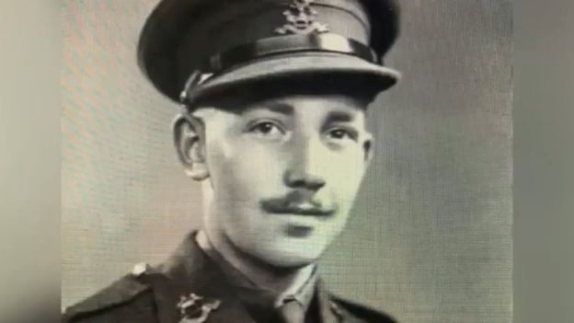
As funds topped the £1m mark earlier, "Captain Tom", as he is known, described it as "almost unbelievable".
"When you think of who it is all for - all those brave and super doctors and nurses we have got - I think they deserve every penny, and I hope we get some more for them too."
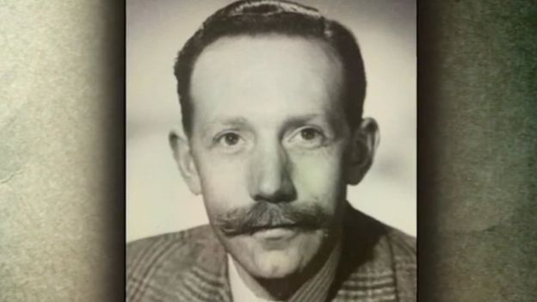
Ellie Orton, chief executive of the charity on the receiving end of Mr Moore's fundraising, said: "I think I absolutely join the rest of the country in being truly inspired and profoundly humbled by Captain Tom and what he has achieved.
"Thank you for being an inspiration and a role model."
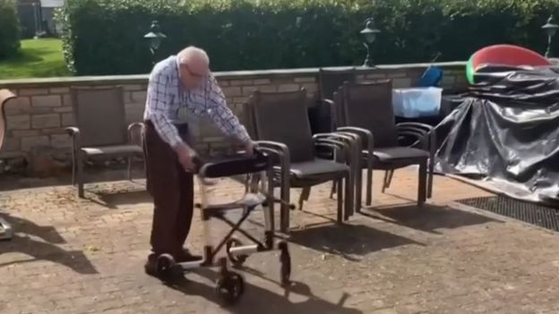
GO GO GO CAPATIN TOM!!!!!!!!
Money raised by him and others for the charity is being spent on well-being packs for NHS staff, rest and recuperation rooms, electronic devices to enable hospital patients to keep in contact with loved ones, and working with community groups to support patients once they have been discharged from hospitals.
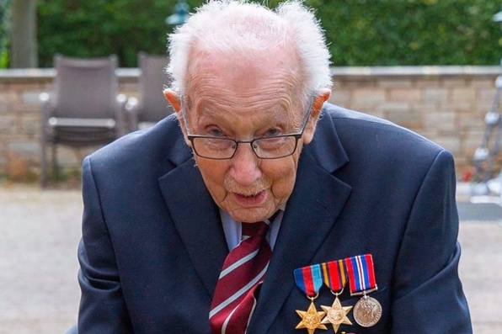
Mr Moore was born in Keighley, West Yorkshire and trained as a civil engineer before enlisting in the army for World War Two. He rose to captain and served in India and Burma.
"I do [laps] each day, so that eventually I'll get to 100, then after that I shall continue and do some more," he said.
The support so far had been "absolutely fabulous", he added.
"Let's all carry on and remember that things will get better," Mr Moore said.
"We have had problems before - we have overcome them - and we shall all overcome the same thing again."
BIG CHEER EVERYONE FOR CAPTAIN TOM MOORE!!!!!!

