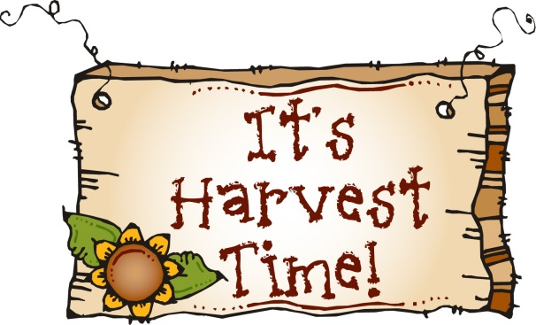

Dear Dear parents/carers,
Harvest is approaching and we are delighted to let you know that we are going to hold our festival in the church and you are all invited! The children will be performing class items and there will be lots of singing! This year we are inviting you to donate food items for the local food bank. These items will be distributed to local families who need support at this difficult time and all donations are gratefully received. Donations can be sent to school at any time or on the day of the festival. The festival will be at 9.30am on October 12th.
The list of items accepted by the foodbank is on the back of this letter. Please could you ensure that all items have a long sell by date, any items out of date cannot be accepted.
Many thanks for your continued support,
Mrs Jones and staff.

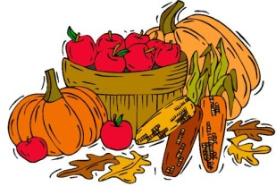
Items Needed:
Food items:
Soup (tins and packets) Tomatoes (tinned)
Potatoes (tinned and dried) Vegetables (tinned)
Meat (tinned) Fish (tinned)
Rice (max 1kg packs) Cooking sauces
Breakfast cereals (size 350g – 500g)
Biscuits Tea
Coffee Fruit (tinned)
Milk (UHT long life 1litre) Fruit juice (long life)
Squash (1 litre) Chocolate/Sweets
Savoury snacks (crisps, crackers etc)
Condiments (ketchup etc)

Toiletries:
Female hygiene products Individual bars of soap
Deodorant Shampoo
Shower gel Shaving gel
Toothpaste/toothbrush (adult and child)
Hairbrush/Comb

Household items:
Washing up liquid Laundry liquid/gel
Toilet roll (small packs or individual rolls)
Cleaning sprays Cleaning cloths & wipe
Hand sanitisers Carrier bags

Cymmer foodbank does not currently need dried pasta or beans.

