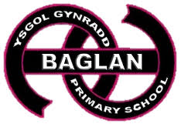
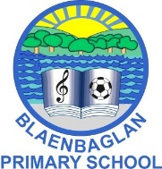
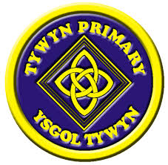

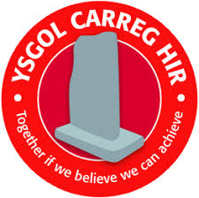
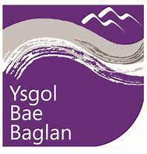
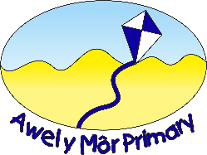

Clwstwr Ysgol Bae Baglan Cluster Transition Plan Year 6-7
2024-2025
Cyflwyniad/Introduction
This policy is a partnership between Ysgol Bae Baglan and the family of schools. Its purpose is to support further improvement in transition practice so that the pupils are better prepared socially and academically for the move to the secondary school. This plan will be renewed annually.
Our agreed aims are:
- To promote the continuity and progression in teaching and learning between the progression steps
- To promote and support cross phase work
- To facilitate greater staff awareness of the other progression step, especially its practice and methodology as well as the pupil experience
- To identify, safeguard and target specific support at those pupils considered to be vulnerable
- To ensure proper availability and use of pupil transfer data
- To provide a smooth, enjoyable transition process for year 6-7
- To ensure parents/carers/families are fully informed of the transfer process
- To develop and promote the wellbeing and safeguarding of all pupils
- To realise the benefits of common inset
- To encourage discussion between progression steps which informs decision making and policy development

ACTION  Objective 1: Managing and Co-ordinating Transition Planning with Cluster Partners. | PERSON RESPONSIBLE | TIMESCALE | RESOURCES | SUCCESS CRITERIA
- The Headteachers’ Cluster Group to meet half-termly  - Views of parents/carers and pupils sought through use of Transition Questionnaire. Results shared with stakeholders  - YBB to provide an annual timetable of events for the year and post it on school website  - YBB team to meet with Cluster Headteachers and parents to outline transition arrangements for YBB | Cluster HT’s  MMO/MMU  MMO/MMU  MMO/MMU  Cluster Headteachers  MMO/MMU | Autumn Term 2024 - Summer Term 2025  December 2024  Autumn Term 2024  Ongoing - 2024/25 | Venue rotated alphabetically  Distribute online questionnaire for Year 7 cohort. Parental questionnaire distributed on parents’ evening Monday 2nd December 2024  No cost  No cost | Progress monitored and evaluated in every meeting – minutes taken and distributed  Content of the plan annually reviewed and amended. The views of parents, pupils and governors taken into consideration.  SDP of each school reflects and supports priorities within plan  All activities co-ordinated and costed across the year  Year 6 parents kept fully informed of transition developments in YBB via X (Twitter) and school website

ACTION  Objective 2: Managing Data, Assessment & Moderation. | PERSON RESPONSIBLE | TIMESCALE | RESOURCES | SUCCESS CRITERIA
- Cluster Schools adopt County Policy and Procedure  - Primary schools to indicate the ability of pupils into 3 bands which are also rank ordered  - Cluster moderation meetings half termly to ensure a common approach and progression of skills in year 7 and 8 | Cluster HT’s  Year 6 teachers  MMU  Headteachers | Ongoing  Summer Term 2025  Summer Term 2024 | Policy docs  None  Need to develop integral plans as a cluster to include high quality training within either ADD’s sessions or  INSET days in the future. | Adopted by each school  Pupils correctly set on entry to YBB. Positive parental comments on setting.  A common approach to the development of the integral skills. This would facilitate progression into years 7 and 8.

ACTION  Objective 3: Teaching and Learning. | PERSON RESPONSIBLE | TIMESCALE | RESOURCES | SUCCESS CRITERIA
1. Cluster Inset November 4th 2024 – Focus on Learning Intentions/Success Criteria  - Sharing good practice with regard to new curriculum  - Joint planning sessions to be implemented if the circumstances allow.  - YBB staff to undertake lessons across primary schools if possible  - Develop common work streams following Cluster INSET | Andrew Herbert  HT ‘s  HT’s  YBB staff  Cluster staff | November – July 2024/25  Autumn Term 2024- Summer 2025  Spring / Summer Term 2025  Summer 2025  Three-year plan | Staff costs  One presentation per cluster meeting  Teachers’ time  reliant upon staff timetables  Time and venue | Consistency in the principles of learning intentions/success criteria across progression steps  Pedagogies shared with school staff and adoption where appropriate  Staff benefit from networking and using common resources  All schools to receive sessions - Cost implication  Year 1  - the use of common progressive vocabulary within the Humanities AOLE  - Common use Critical thinking questions (grid from G Coombes INSET)  Year 2  - the use of common progressive vocabulary within the Science and Tech AOLE  - A common approach to self and peer assessment  Year 3  - the use of common progressive vocabulary within the Health and Wellbeing AOLE  - To be decided

ACTION  Objective 4: Well-being | PERSON RESPONSIBLE | TIMESCALE |  | RESOURCES |  | SUCCESS CRITERIA
1.Sharing good practice to enable a common approach to managing attendance | Headteachers/EWO | 2024/2025 |  |  |  | Improved attendance.  This was achieved with the intervention of ASO’s – ongoing work?
ACTION  Objective 5: Transition Projects | PERSON RESPONSIBLE |  | TIMESCALE |  | RESOURCES | SUCCESS CRITERIA
1. Pupils and parents to be given a tour of YBB as part of Open Evening  2. Cluster Eisteddfod  3. Year 5 transition day  4. Transition Days Year 6  5.Sports Events/Bae Baglan Cup  6. Scholars’ Programme  - One Page profiles | MMO/MMU  MMO/Cluster Welsh leads  MMO/MMU  MMO/ MMU  Yr6 staff  YBB  PE Dept.  MMO/MMU/  Gifted and Talented Co-ordinator (ASU)  MMU |  | Autumn 2025  February 2025  Summer 2025  Summer 2025  Spring 2025  Spring /Summer 2025  Summer 2025 |  | None required  Theatre YBB  School Sports Complex/Science Dept  Transport  No cost?  Minibus shuttle transport from YBB  14 places with the scholars’ programme @£179 =£2506  £2450 (to be funded from the CAL cluster PDG)  MMU/pupil time | Pupils and parents’ attendance on the allocated evening  Hold a meaningful and enjoyable Eisteddfod for pupils year 2-6 across the cluster  Year 5 pupils from across the cluster attend YBB for one day PE/Science theme for 2025  2 day spent by all pupils in YBB undertaking sample lessons and assembly with new WD Year 7 EJ  Various sports events throughout the year on a cluster basis, including 2 days (Autumn Term x 1 and Summer Term x 1) of 2 sports per day – competitive tournaments for the Bae Baglan Cup  Pupils graduate from successful completion of assignments including a graduation in Oxford  One-page profiles shared with YBB staff enabling them to prepare for the new intake of pupils

Evaluating the impact of the policy and improvement initiatives on standards

The partnership of schools is committed to the ongoing and regular development of the plan as set in the areas identified in the plan. The evaluation process will involve making judgements on the success and impact of the actions identified in relation to the overall social and academic progress of pupils.
The transition coordinator and Headteacher of each school will have overall responsibility for evaluating the impact of the plan and this will be communicated via the termly steering group meetings and cluster meetings. Other methods and staff involved in the evaluation process will include:
- The Curriculum Leader of the particular subject, where there has been a subject based development cross phase KS2/3
- The Wellbeing Director, ALN Coordinator and Year 6 teacher will evaluate outcomes where there has been a social/behavioural project
- The Transition Coordinator and core subject Heads of Department will analyse levels of achievement at the beginning and end of KS3 in evaluating the impact of the plan
- Levels of disaffection, absenteeism and exclusions will be considered in the evaluation of the plan
- Pupil and parent views will be taken into full account when evaluating the plan

