Our Ref: SHEP/NW/25

12th May 2025

Dear Parent / Guardian

As part of our continued transition programme, we would like to invite any current Year 6 pupils that will be transferring to us in September to have the opportunity to participate in our School Holiday Enrichment Programme, based around Food and Fun. It will take place at Ysgol Bae Baglan for 12 days during the summer holidays. The programme will take place from Monday 21st July 2025 and finishing on Tuesday 5th August 2025. The programme will start at 8.30am and finish at 12.30pm. There is no cost to the programme.

The aim of the programme is to provide healthy meals, food and nutrition education, physical activity, and enrichment sessions all based around fun activities to children in a school based setting. The programme is delivered over 12 days involving specialist workshops and sporting activities (at least 1 hour per day). Pupils are encouraged to wear appropriate clothing that will enable them to take part in sport and exercise comfortably. Pupils will be provided with a free health breakfast and lunch. Feedback from previous years was excellent and gave pupils the fantastic opportunity to get to know the school, staff and to make new friends prior to starting the new term.

During the programme, there will always be a qualified first aider and safeguarding officer available. The activities have been designed for pupils to integrate with one another and build on their communication and teamwork skills. If you would be interested in a place, please fill in and return the attached slip to your current Headteacher before Friday 20th June 2025. If you require further information please do not hesitate to contact myself. We have 80 places per day available, ideally we would like children to attend the whole 12 day programme. However we do understand that it is the summer holidays and some families may already have plans during this time, so we will endeavour to accommodate as many pupils as we can for their chosen days. We will confirm successful places by the 4th July 2025.

Yours sincerely
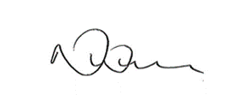

Nicola Williams
School Business Manager

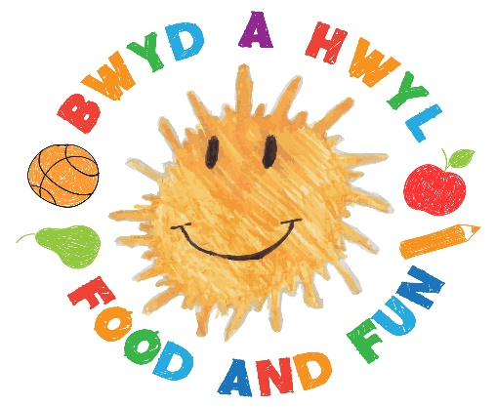
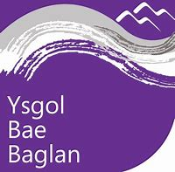

If you are Interested in participating in the Food and Fun Programme, please complete and return this slip to your current Headteacher or at reception in Ysgol Bae Baglan before Friday 21st June.

Pupils Name ______________________________________ Current School _________________________________

Parent/Guardian Name ___________________________________ Contact No. ______________________________

As there are limited places, we will be looking at pupils who can attend the programme everyday first, however we will endeavour to accommodate as many pupils as we can for their chosen days.
Please indicate below which days you would like your child to attend.

Week 1 |  | Week 2 |  | Week 3
Monday 21st July |  | Monday 28th July |  | Monday 4th August
Tuesday 22nd July |  | Tuesday 29th July |  | Tuesday 5th August
Wednesday 23rd July |  | Wednesday 30th July
Thursday 24th July |  | Thursday 31st July
Friday 25th July |  | Friday 1st August

