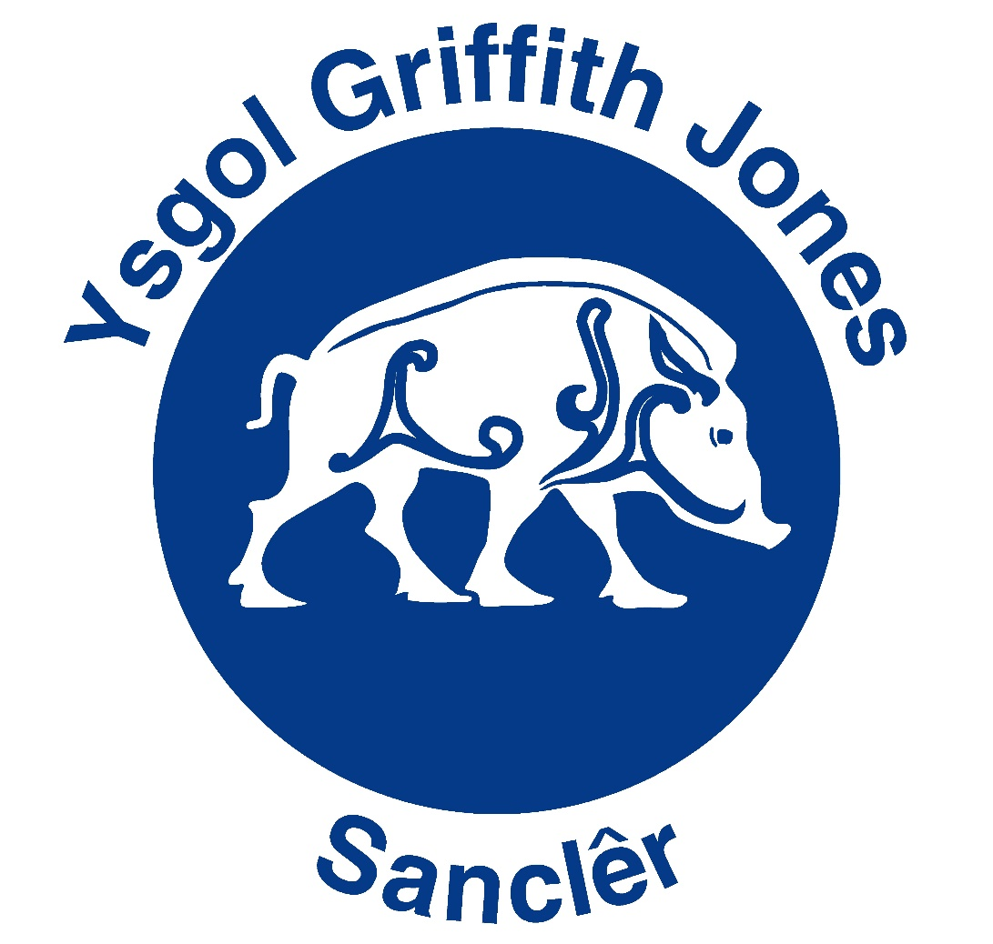

ADRODDIAD BLYNYDDOL

Y LLYWODRAETHWYR I RIENI

2023/24

ANNUAL GOVERNORS REPORT

TO PARENTS

TYMOR YR HYDREF 2024 | AUTUMN TERM 2024
Fel Cadeirydd y Llywodraethwyr, unwaith eto mae’n fraint cael cyflwyno Adroddiad Blynyddol y Llywodraethwyr ar gyfer y flwyddyn academaidd 2023/24.  Mwynhaodd yr ysgol flwyddyn lwyddiannus arall gyda’r Llysgenhadon Iaith yn gweithio’n effeithiol ochr yn ochr â Mrs Giles ac aelodau o’r gymuned i sicrhau bod yr ysgol yn ennill Gwobr Aur y Siarter Iaith a Chymraeg Campus.  Mwynhaodd y disgyblion fod yn rhan o wahanol bwyllgorau i helpu i ddatblygu'r ysgol. Cyflawnodd y Pwyllgor Eco lawer o dasgau a llwyddwyd i gadw ein statws Eco Platinwm am flwyddyn arall. Bu disgyblion eraill Blwyddyn 6 yn helpu gyda chlybiau cyfrifiaduron a chwaraeon i ddarparu cyfleoedd ychwanegol i'r disgyblion iau. Parhaodd y Cyngor Ysgol i gynrychioli’r holl ddisgyblion er mwyn sicrhau bod eu lleisiau’n cael eu clywed. Bu pwyllgorau disgyblion hefyd yn gweithio gyda’r gymuned ac yn cyflwyno gwybodaeth i’r Corff Llywodraethol.  Mae’r Staff Addysgu a Chymorth yn parhau i fynychu cyrsiau hyfforddi i ddatblygu'n broffesiynol ac maent hefyd yn ymdrechu i ddatblygu cwricwlwm yr ysgol i sicrhau bod gwersi amrywiol, heriol, hygyrch a diddorol yn cael eu haddysgu i bob disgybl. Ar ddiwedd Tymor y Gwanwyn, ffarweliwyd â Mr Rhys Thomas, a dderbyniodd swydd Pennaeth parhaol. Ymddeolodd ein Gofalwr ysgol, Mr Henry Owen, yn ystod y flwyddyn - diolch Henry am eich 20 mlynedd o wasanaeth i Ysgol Griffith Jones. Croeso cynnes i'n Gofalwr newydd, Mr Gilroy Thomas. Edrychwn ymlaen at groesawu dwy athrawes newydd i ymuno â’n tîm ym mis Medi, sef Mrs Carys Jones a Miss Ffion Campbell.  Diolch i’r Uwch Dîm Rheoli a’r holl staff sydd, o dan arweiniad y Pennaeth Mr Emyr Davies, yn parhau i weithio’n galed i gynnal y safonau uchel yma yn Ysgol Griffith Jones, gyda llawer o gyflawniadau academaidd, diwylliannol a chwaraeon rhagorol.  Mae Clwb yr Enfys (clwb ar ôl ysgol) yn parhau i ffynnu ac yn darparu darpariaeth ragorol. Diolch o galon i’r holl staff, dan arweiniad Mrs Amanda Jones.  Mae’r CRAFf yn parhau i gefnogi’r ysgol gyda rhaglen wych o ddigwyddiadau sy’n gwneud cyfraniad gwerthfawr i gyllid yr ysgol.  Croesawyd Mr Owain Grant i’r Corff Llywodraethol, a diolchwyd i Mrs Delyth Jenkins sydd wedi ffarwelio â’r Corff ar ôl blynyddoedd o wasanaeth rhagorol.  Rhaid diolch i fy nghydweithwyr ar y Corff Llywodraethol am eu cefnogaeth barhaus. Mae'n cael ei werthfawrogi.  Yn olaf, hoffwn ddiolch i’r holl rieni a ffrindiau am eich cefnogaeth barhaus i Ysgol Griffith Jones. | As Chair of Governors, it is once again a privilege to present the Annual Governor’s Report in respect of the academic year 2023/24.  The school enjoyed another successful year with the Language Ambassadors working effectively alongside Mrs Giles and members of the community to ensure that the school gained the Gold Award for the Language Charter and Cymraeg Campus.  Pupils enjoyed being involved in different  committees to help develop the school. The Eco Committee carried out many tasks and were successful in retaining our Platinum Eco status for another year. Other Year 6 pupils helped with computer and sports clubs to provide extra opportunities for the younger pupils. The School Council continued to represent all pupils to ensure that their voices were heard. Pupil committees also worked with the community and presented information to the Governing Body.  Teaching and Support Staff continue to attend training courses to develop professionally and also strive to develop the school curriculum to ensure varied, challenging, accessible and interesting lessons are taught to all pupils. At the end of the Spring Term, we said farewell to Mr Rhys Thomas, who received a permanent Headteacher role. Our school Caretaker, Mr Henry Owen, retired during the year - thank you Henry for your 20 years of service to Ysgol Griffith Jones. A warm welcome to our new Caretaker, Mr Gilroy Thomas. We look forward to welcoming two new teachers to join our team in September, Mrs Carys Jones and Miss Ffion Campbell.  My thanks to the Senior Management Team and all staff who, under the guidance of Headteacher Mr Emyr Davies, continue to work hard to maintain the high standards here at Ysgol Griffith Jones, with many excellent academic, cultural and sporting achievements.  Clwb Yr Enfys (after school club) continues to thrive and provides excellent provision. A big thank you to all the staff, under the guidance of Mrs Amanda Jones.  The PTFA continue to support the school with a wonderful programme of events from which it makes a valuable contribution to the school’s finances.  We welcomed Mr Owain Grant onto the Governing Body, and said a fond farewell and a big thank you to Mrs Delyth Jenkins after many years of excellent service.  Thanks must go to my colleagues on the Governing Body for their ongoing support. It is appreciated.  Finally, can I thank all parents and friends for your continued support of Ysgol Griffith Jones.
Yn ddiffuant / Yours sincerely
Lynnette Phillips
Cadeirydd y Corff Llywodraethol / Chair of Governing Body

Y CORFF LLYWODRAETHOL / THE GOVERNING BODY

Cadeirydd / Chairperson:
Mrs Lynnette Phillips
Gilfach
Cwmbach
Whitland
Carms
SA34 0DN

Clerc I’r Llywodraethwyr / Clerk To The Governors:
Swyddog Gweinyddol / Administrative Officer
Ysgol Griffith Jones
Heol yr Orsaf / Station Road
Sanclêr / St Clears
SA33 4BT

ENW  NAME | STATWS  STATUS | DYDDIAD TERFYNU  TERM OF OFFICE EXPIRES
Mr Emyr Davies | Pennaeth / Headteacher
Cyng/Cllr Philip M Hughes | Llywodraethwr Awdurdod Addysg Lleol  Local Education Authority Governor | 01.02.28
Mr Kevin Jenkins | “ | 05.02.26
Mr Tim John | “ | 31.03.27
I’w benodi  To be appointed | Llywodraethwr Cymunedol  Community Governor | -
Mrs Lynnette Phillips | “ | 04.05.25
Mrs Carly Jones | “ | 23.03.25
Mr Owain Grant | Llywodraethwr Cymunedol Ychwanegol  Additional Community Representative | 28.03.27
Mrs Helen Thomas | Rhiant Lywodraethwr  Parent Governor | 19.03.25
Mrs Carwen Morgan-Davies | “ | 23.03.25
Mr Richard Davies | “ | 09.10.26
Mrs Lisa Davies | “ | 25.11.26
Mrs Mai Giles | Athro Lywodraethwr / Teacher Governor | 28.11.27
Mrs Amanda Jones | Staff Lywodraethwr / Staff Governor | 26.02.25

Nifer o ddisgyblion – Trefniant Dosbarthiadau (Gorffennaf 2023)
Pupil Numbers – Class Organisation (July 2023)

Categori A / A Category
DOSBARTH  CLASS | ATHRO  TEACHER | Nifer  No of pupils | Blynyddoedd  Years
PWYLL | Mrs Enfys Thomas | 26 | 6
CULHWCH | Mrs Nerys Howells | 27 | 5
BRANWEN | Mrs Mai Giles | 27 | 4
RHIANNON | Mrs Wendy James | 23 | 3
HYWEL | Miss Carys Evans | 27 | 2 & 3
GWENLLIAN | Mrs Eleri Lewis | 27 | 1 & 2
ARTHUR | Mrs Rhian Taylor | 28 | 1
BECA | Miss Jessica Jones | 18 | Derbyn / Reception
DEWI | Mrs Kay Jenkins | 21 | Derbyn / Reception
NON | Mrs Llinos Griffiths | 38 | Meithrin / Nursery

Categori B / B Category
DOSBARTH | ATHRO | Nifer | Blynyddoedd
MYRDDIN | Mr David Toms | 31 | 5 & 6
OLWEN | Mrs Joanna Mason | 16 | 3 & 4

Trosglwyddodd 41 disgybl i ysgolion uwchradd ym mis Gorffennaf: Symudodd ein disgyblion ymlaen i Ysgol Gymraeg Bro Myrddin neu Ysgol Dyffryn Taf.  Mae 16 disgybl meithrin wedi cofrestri i ddechrau yn yr ysgol ym mis Medi 2024. | 41 pupils transferred to secondary schools in July: Pupils moved on to Ysgol Gymraeg Bro Myrddin or Ysgol Dyffryn Taf.  16 new pupils have registered for the nursery class at the school for September 2024.
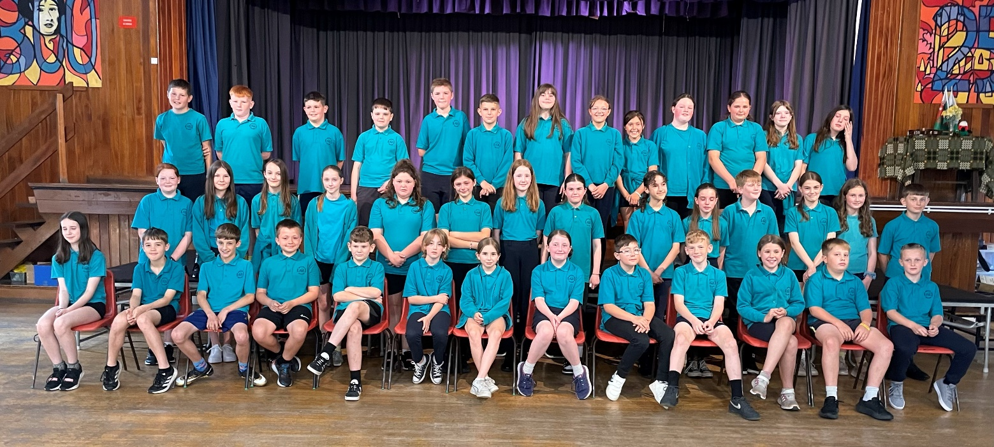
Cynllun Datblygu Ysgol (CDY)  Mae’r CDY yn gosod sail i fentrau’r ysgol ac yn anelu at wella meysydd penodol. Yn ystod y flwyddyn ddiwethaf blaenoriaethwyd yr ardaloedd canlynol:  - Datblygu ein polisi a gweithdrefnau asesu yn unol â gofynion y Pump Egwyddor Cynnydd gan sicrhau eu bod yn gyson effeithiol wrth gyfoethogi cynnydd disgyblion ar draws yr ysgol.  - Mireinio addysgu i alluogi disgyblion i fod yn fwy annibynnol yn yr hyn, a sut, y maent yn ei ddysgu.  - Datblygu sgiliau Rhesymu ein dysgwyr o flynyddoedd 2 i 6 gan sicrhau cynnydd ar draws y Camau Cynnydd.  - Cryfhau ymhellach gapasiti arweinyddiaeth yr ysgol a rôl yr arweinwyr o fewn rhaglen hunan-werthuso gynhwysfawr.  - Codi safonau Llafar Cymraeg ar draws y Camau Cynnydd.  Cefnogwyd Cynllun Datblygu’r Ysgol gan y canlynol:  - Grantiau amrywiol a ddarperir gan Lywodraeth Cymru drwy'r Awdurdod Lleol  - Arian CRAaFf  - Grant Datblygu Disgyblion | School Development Plan (SDP)  The SDP forms the basis of the school’s initiatives and is aimed at improvement in specific areas. During the last year the following areas have been prioritised:  - To develop our assessment policy and procedures in accordance with the requirements of the Five Principles of Progression, ensuring they are consistently effective in enhancing pupil progress across the school.  - Refine teaching to enable pupils to exercise more independence in what, and how, they learn.  - Developing our learners' Reasoning skills from Years 2 to Year 6, ensuring progress across the Progression Steps.  - Further strengthen the school's leadership capacity and the role of the leaders within a comprehensive self-evaluation programme.  - To raise standards in Welsh Oracy across all Progression Steps.  The School Development Plan is supported by:  - Various grants provided by the Welsh Government via the Local Authority  - PTFA Funding  - Pupil Development Grant
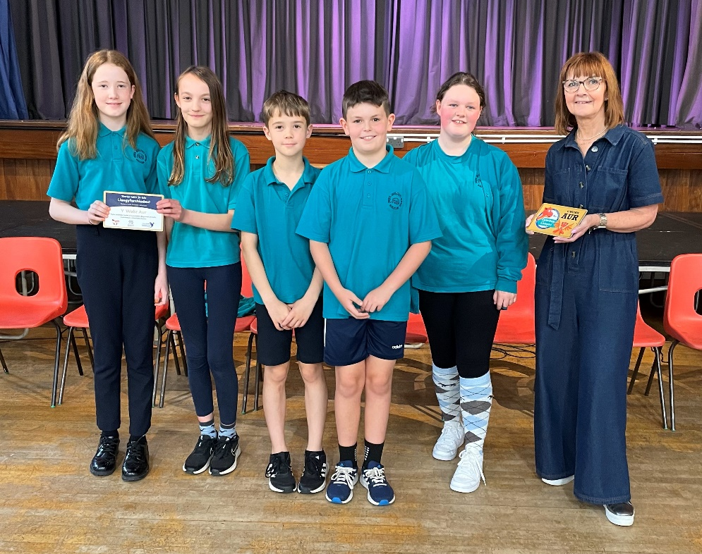
Gosod Targedau  Mae’r ysgol yn parhau i ymgymryd â gofynion gosod targedau. Mae’r disgyblion yn cael eu tracio a gwneir pob ymdrech i gyrraedd targedau unigolion.  Mae’r Adroddiadau Blynyddol i rieni yn nodi’r meysydd lle mae angen gwelliant, yn ogystal â Phroffil Un Tudalen ar gyfer pob dysgwr. | Target Setting  The school continues to meet its target setting requirements. All pupils are tracked to ensure that every effort is made to attain individual objectives.  Annual Reports to parents identify areas of improvement, as well as One Page Profiles for each learner.
Lwfans y Pen  £20 y disgybl oedd lwfans y pen. Mae’r Gymdeithas Rieni unwaith eto wedi cytuno byddant yn cyfrannu i’r gronfa i alluogi adnoddau digonol ym mhob maes o’r cwricwlwm. | Capitation  The capitation allowance was £20 per pupil. The PTFA have agreed that they will supplement this sum to enable all curricular areas to be adequately resourced.
Diogelwch Ysgol  Adolygir systemau diogelwch yr ysgol yn rheolaidd gan Staff yr Uwch Dîm a’r Rheolwr Safle.  Arolygwyd Diogelu o fewn yr ysgol gan yr Awdurdod Lleol ac Estyn yn 2020 a nodwyd bod ein systemau diogelu yn gryf. | School Security  School security is reviewed by the Senior Management Team and Site Manager continuously.  The Local Authority and Estyn have inspected Safeguarding within the school in 2020 and systems were found to be strong.
Iaith  Yn unol â Pholisi Iaith Awdurdod Addysg Sir Gaerfyrddin mae Ysgol Griffith Jones wedi ei chlustnodi yn ysgol ddwy ffrwd yn darparu ar gyfer disgyblion Meithrin, Babanod ac Iau o 3-11 oed.  Ffrwd Gymraeg - Dosbarthiadau yn derbyn eu haddysg drwy gyfrwng y Gymraeg.  Ffrwd Saesneg - Dosbarthiadau yn derbyn eu haddysg yn bennaf trwy gyfrwng Saesneg a Chymraeg yn cael ei ddysgu fel ail iaith.  Cymraeg yw’r prif gyfrwng addysgu yn y Dosbarthiadau Meithrin, Derbyn, Blwyddyn 1 a 2.  O Flwyddyn 3 ymlaen mae rhieni yn dewis naill ai addysg yn y Ffrwd Gymraeg neu’r Ffrwd Saesneg i’w plant.  Mae’r Awdurdod Lleol wedi cynnal ymgynghoriad i Bolisi Iaith yr ysgol. | Language  In accordance with Carmarthenshire Education Authority’s Language Policy, Ysgol Griffith Jones has been designated a dual stream school catering for Nursery, Infants and Junior pupils of the age range 3-11 years old.  Welsh Stream - Classes are taught through the medium of Welsh.  English Stream - Classes are taught mainly through the medium of English with Welsh taught as a second language.  The school Nursery, Reception, Year 1 and Year 2 Classes have Welsh as the main medium of instruction.  From Year 3 onwards parents are given the choice of selecting Welsh Stream or English Stream education for their children. The Local Authority held a consultation of the Language Policy of the school.
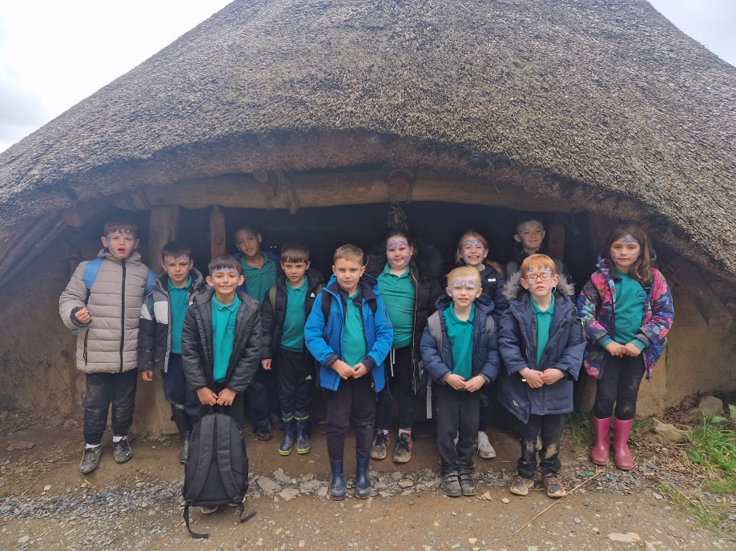

Prosbectws  Adolygwyd y prosbectws. Mae’r ddogfen newydd yn awr ar gael ar ein gwefan. | Prospectus  The Prospectus has been reviewed. The document is now available on our website.
Anghenion Addysgol Ychwanegol (AAY)  Mae'r system ar gyfer cefnogi plant a phobl ifanc ag anghenion addysgol arbennig ac anabledd yng Nghymru yn newid. Mae Llywodraeth Cymru yn cyflwyno system fwy hyblyg ac ymatebol o ddiwallu anghenion plant a phobl ifanc ag anghenion addysgol arbennig neu anableddau ac mae'n ymdrechu i ddarparu system addysg gwbl gynhwysol ar gyfer dysgwyr Cymru. Mae'r ysgol yn gweithredu'r gofynion newydd.  Ar hyn o bryd mae 24% o’n disgyblion yn cael cymorth, naill ai ar ffurf Darpariaeth Dysgu Cyffredinol neu Ddarpariaeth Dysgu Ychwanegol. | Additional Learning Needs (ALN)  The system for supporting children and young people with special educational needs and disability in Wales is changing. The Welsh Government is bringing in a more flexible and responsive system of meeting the needs of children and young people with special educational needs or disabilities and is striving to deliver a fully inclusive education system for learners. The school is implementing the new requirements.  Currently, 24% of pupils receive support, either in the form of Universal Learning Provision or Additional Learning Provision.
Disgyblion ag Anableddau  Mae gan yr ysgol nifer fechan o ddisgyblion ag anabledd amrywiol. Mae’r disgyblion yma wedi eu hintegreiddio’n llwyddiannus i’r brif-ffrwd ac mae’r Awdurdod Lleol yn sicrhau bod adnoddau digonol mewn lle i’w darparu â chyfleoedd cyfartal. Gwnaed archwiliad o ddarpariaeth yr ysgol ar gyfer disgyblion ag anabledd a ffurfiwyd Cynllun Hygyrchedd a’i weithredu. | Pupils with Disabilities  The school has a small number of pupils with different disabilities. The pupils are integrated successfully into mainstream and the Local Education Authority ensures adequate resources are in place to provide them with equal opportunities. An audit of the school’s provision for disabled pupils has been carried out and an Accessibility Plan formulated and implemented.
Cyfleusterau Toiledau  Mae toiledau penodol ar gael i ddisgyblion mewn adrannau gwahanol yr ysgol. Yn yr adran dan 5 mae toiledau cymysg, toiledau i fechgyn a merched i ddosbarthiadau 1 a Derbyn, toiledau ar wahân eto i ddisgyblion Blynyddoedd 3 a 4 a thoiledau ar gyfer bechgyn a merched Blynyddoedd 5 a 6. Mae yna 3 toiled ar gyfer plant ag anabledd. | Toilet Facilities  There are specific toilets for the under 5’s within their classes. Pupils in years 1 and Reception have separate toilets near the main entrance. Pupils in years 3 and 4 have toilets in the main corridor, whilst pupils in years 5 and 6 have their own facilities outside their classes. There are 3 disabled toilets.
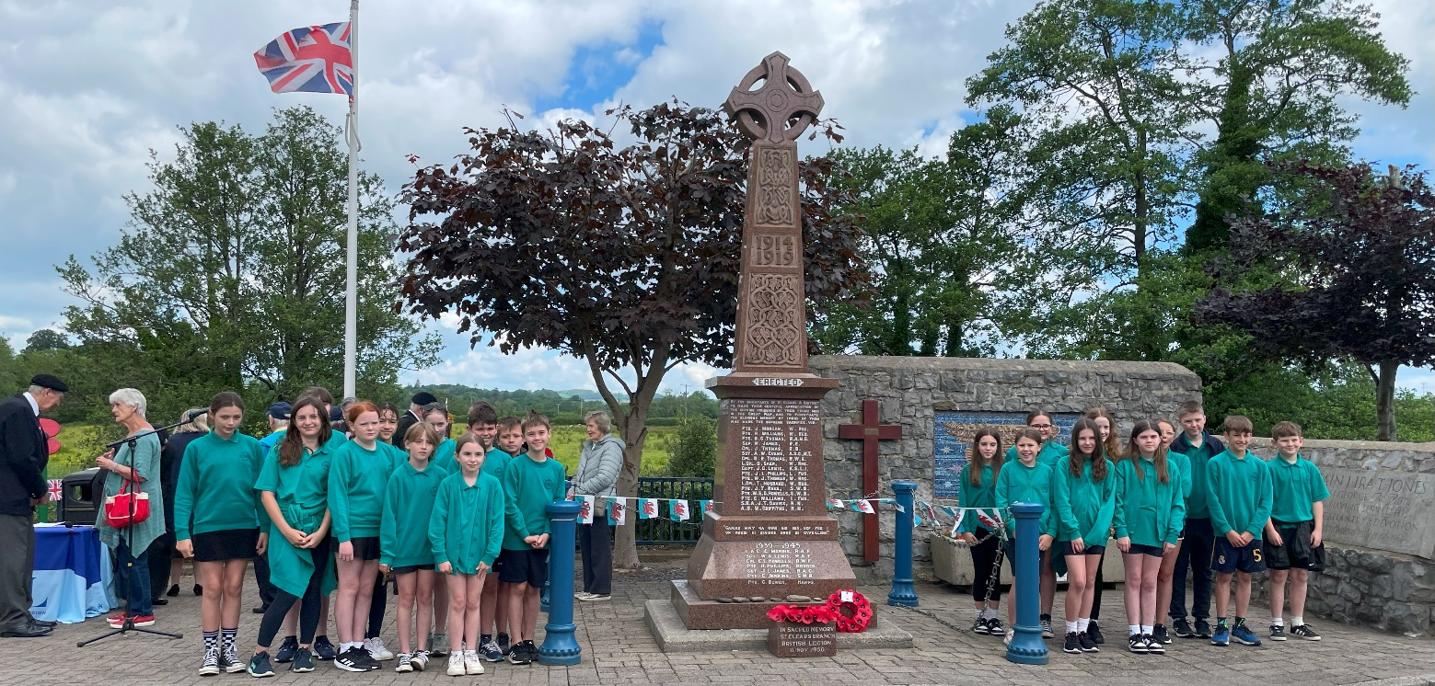

Cwricwlwm ac Asesu  Mae pedwar diben wrth wraidd ein cwricwlwm sy'n rhoi'r cyfle i bob dysgwr ddatblygu i fod:  - yn ddysgwyr uchelgeisiol, galluog, sy’n barod i ddysgu drwy gydol eu hoes;  - yn gyfranwyr mentrus, creadigol, sy’n barod i chwarae eu rhan yn llawn yn eu bywyd a’u gwaith;  - yn ddinasyddion egwyddorol, gwybodus, yng Nghymru a’r byd;  - yn unigolion iach, hyderus, sy’n barod i fyw bywyd gan wireddu eu dyheadau fel aelodau gwerthfawr o gymdeithas.  Gweithia’r holl staff yn gydwybodol er mwyn sicrhau’r gorau ar gyfer yr holl ddisgyblion.  Rydym yn tracio cynnydd disgyblion gan ddefnyddio ystod o strategaethau.  Ein nod yw cynnig addysg a gofal o’r safon uchaf mewn awyrgylch hapus, caredig, gweithgar a diogel fel bod pob plentyn, beth bynnag fo’u gallu, yn cyrraedd ei lawn botensial. Rhoddir pwyslais ar ddysgu medrau sylfaenol llythrennedd, rhifedd a TGCh a phwysleisir pwysigrwydd eu gwneud yn berthnasol ac yn ystyrlon i’r plentyn. Mae’n bwysig gwneud y plant yn ymwybodol o’u hamgylchedd, eu cymuned, eu gwlad a’r byd.  Trwy ddefnyddio dulliau dysgu sydd wedi selio ar themâu, mae strwythur ein cwricwlwm yn cynnwys chwe Maes Dysgu a Phrofiad.  Mae pob un o’r Meysydd Dysgu a Phrofiad yn cyfrannu mewn ffordd bendant a phenodol at ddatblygu pedwar diben y cwricwlwm. Gyda’i gilydd, maent yn diffinio ehangder ein cwricwlwm.  Mae’r profiadau addysgiadol i ni’n cynnig yn rhan annatod o’r cwricwlwm, sy’n ehangu gorwelion ein plant, yn symbylu eu dychymyg ac yn hybu mwynhad wrth ddysgu.  Y chwe maes dysgu a phrofiad yw:  - Iaith, llythrennedd a chyfathrebu;  - Mathemateg a rhifedd;  - Gwyddoniaeth a thechnoleg;  - Celfyddydau mynegiannol;  - Iechyd a lles;  - Dyniaethau (gan gynnwys Addysg Grefyddol).  Darperir cwricwlwm sy’n sicrhau fod pob plentyn yn tyfu i fod yn ymwybodol o’r diwylliant Cymraeg a’r etifeddiaeth sydd ynghlwm â hyn. | Curriculum and Assessment  There are four purposes at the heart of the curriculum, that support the learner to be:  - ambitious, capable learners, ready to learn throughout their lives;  - enterprising, creative contributors, ready to play a full part in life and work;  - ethical, informed citizens, of Wales and the world;  - healthy, confident individuals, ready to lead fulfilling lives as valued members of society.  All staff work conscientiously to ensure the best education for all our pupils. We track pupils’ progress using a range of strategies.  Our aim is to provide the highest quality care and education in a happy, caring, active and safe environment to enable all children, whatever their ability, achieve their potential. Emphasis is placed on learning the basic skills of literacy, numeracy and ICT and the importance of making them relevant and meaningful to the child. It is important to make the children aware of their environment, their community, their country and the world.  By using a teaching and learning method which is based on themes, the structure of our curriculum contains six Areas of Learning and Experience. Each one of these Areas of Learning and Experience make distinct and strong contributions to developing the four purposes of the curriculum. Together, they define the breadth of the curriculum.  The wealth of educational experiences forms an integral part of the curriculum, to broaden the children’s horizons, stimulate their imagination and promote enjoyment in learning.  The six Areas of Learning and Experience are:  - Languages, literacy and communication;  - Mathematics and numeracy;  - Science and technology;  - Expressive arts;  - Health and well-being;  - Humanities (including Religious  Education).  We provide a curriculum that ensures that every child develops an awareness of Welsh culture and its associated heritage.
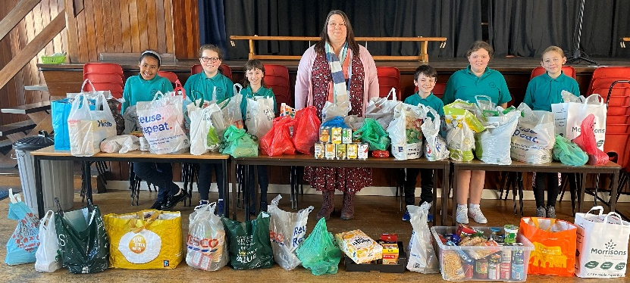
Profion Llythrennedd a Rhifedd  Bu disgyblion o flwyddyn 2 i 6 yn sefyll Profion Safonedig Darllen a Rhifedd (Gweithdrefnol a Rhesymu) Llywodraeth Cymru yn ystod tymor yr haf. | Literacy and Numeracy tests  Pupils from year 2 to year 6 sat Welsh Government National Numeracy (Procedural and Reasoning) and Literacy Tests during the summer term.
Ysgolion Uwchradd  Mae Ysgol Griffith Jones yn aelod o deuluoedd Ysgolion Bro Myrddin, Caerfyrddin, a Dyffryn Taf, Hendy-gwyn. | Secondary Schools  Ysgol Griffith Jones is a member of the Ysgol Bro Myrddin, Carmarthen, and Ysgol Dyffryn Taf, Whitland, family of schools.
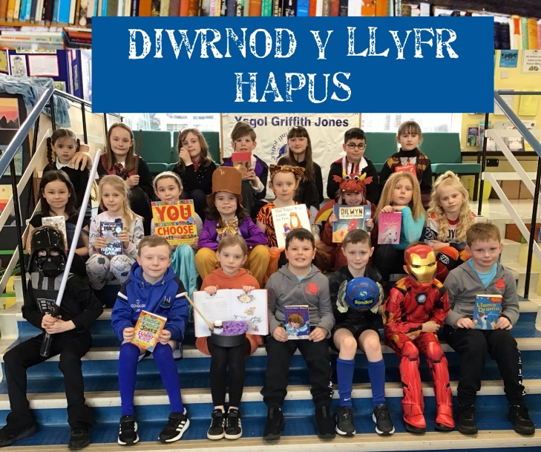
Campau’r Ysgol  - Llongyfarchiadau mawr i’r Llysgenhadon Iaith a gefnogodd yr Ysgol wrth i ni sicrhau’r Wobr Aur ar gyfer y Siarter iaith a Chymraeg Campus  - Diolch i’r Pwyllgor Eco am eu gwaith trwy’r flwyddyn yn sicrhau ein bod yn cadw ein statws Platinwm+.  - Cododd y disgyblion £825.54 i Blant Mewn Angen a daethant i'r ysgol wedi gwisgo yn eu dillad eu hunain.  - Trefnwyd Bingo Ben gan y GRAFf. Codwyd £3,360 gyda'r neuadd yn llawn unwaith eto.  - Mae'r disgyblion wedi mwynhau nifer fawr o gyfleoedd Dysgu yn yr Awyr Agored eleni, diolch i'r cymorth ariannol gan y GRAFf.  - Cyrhaeddodd dwy eitem llwyfan yr Eisteddfod Genedlaethol yr Urdd ym Maldwyn, gyda'r plant yn perfformio'n arbennig.  - Fe wnaeth Sonny Evans ennill y wobr gyntaf am ei byped yn Eisteddfod Genedlaethol yr Urdd.  - Ymwelodd disgyblion Blwyddyn 6 â Chanolfan Addysg Awyr Agored Pentywyn a mwynhau 3 diwrnod llawn hwyl o weithgareddau dringo, abseilio, gwifren wib a môr.  - Mae dosbarthiadau wedi ymweld ag atyniadau lleol i gyfoethogi eu gwaith thema.  - Bu ein côr yn cymryd rhan yn Gŵyl Canol Dre unwaith yn rhagor.  - Bu disgyblion Blwyddyn 6 yn cymryd rhan yn eu Gwasanaeth Gadael. | School Achievements  - A huge congratulations to our Language Ambassadors who helped the school ensure the Gold Award for the Welsh Charter and Cymraeg Campus.  - Thank you to the hard work of the Eco Committee, we have maintained our Platinum+ status for another year.  - Pupils raised £825.54 for Children in Need and came to school dressed in their own clothes.  - Bingo Ben was organised by the PTFA. £3,360 was raised with the hall full once more.  - Pupils have enjoyed a great number of Outdoor Learning opportunities this year, thanks to the extra funding provided by the PTFA.  - Two stage items reached the Urdd National Eisteddfod at Maldwyn, with pupils performing very well.  - Sonny Evans won first prize for his puppet at the Urdd National Eisteddfod.  - Year 6 pupils visited Pendine Outdoor Education Centre and enjoyed a fun filled 3 days of climbing, abseiling, zip-wire and sea activities.  - Classes have visited local attractions to enhance their theme work.  - Our choir took part in Gŵyl Canol Dre once more.  - Year 6 pupils took part in their Leavers’ Service.
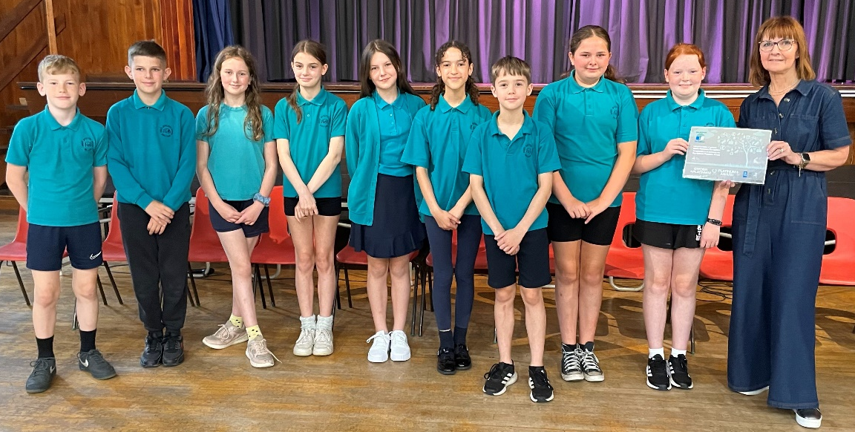

Campau Chwaraeon  - Bu ein Llysgenhadon Efydd Ifanc yn arwain clybiau chwaraeon i’w cyd-ddisgyblion.  - Mae'r disgyblion wedi cystadlu yng nghystadlaethau pêl-droed, pêl-rwyd a rygbi'r Urdd.  - Llongyfarchiadau i’r bechgyn canlynol am gael eu dewis ar gyfer Rygbi Rhanbarth Sir Gaerfyrddin: Hunter Phillips, Iwan Morris, Jac Bowen a Luke Williams.  - Llongyfarchiadau i’r disgyblion canlynol am gael eu dewis i dimau Pêl-droed Ysgolion Sir Gâr: Lottie John, Elis Williams, Alfie Thomas Jones a Noah Morris-Brown.  - Llongyfarchiadau i Corey Rees a ddaeth yn gyntaf yng nghystadleuaeth Gymnasteg i blant o dros Gymru gyfan.  - Mwynhaodd y disgyblion gymryd rhan yn ein diwrnod mabolgampau ysgol flynyddol.  - Mwynhaodd llawer o ddisgyblion o Flynyddoedd 4 i 6 gystadlu mewn twrnameintiau criced. | Sporting Achievements  - Our Bronze Young Ambassadors led sports clubs for fellow pupils.  - Pupils have competed in Urdd football, netball and rugby competitions.  - Congratulations to the following for being chosen to play for Carmarthenshire District Rugby: Hunter Phillips, Iwan Morris, Jac Bowen and Luke Williams.  - Congratulations to the following pupils who were selected to play for Carmarthenshire Schools’ Football teams: Lottie John, Elis Williams, Alfie Thomas Jones and Noah Morris-Brown.  - Congratulations to Corey Rees for coming first in the Welsh gymnastics tumbling competition.  - Pupils enjoyed participating in the annual school sports day.  - Many pupils from Years 4 to 6 enjoyed competing in cricket tournaments
Cysylltiadau â’r Gymuned  - Partneriaeth â: Prifysgol Cymru y Drindod Dewi Sant Caerfyrddin ac Abertawe; Colegau Sir Gâr a Sir Benfro.  - Gweithgareddau cyswllt ag Ysgol Bro Myrddin ac Ysgol Dyffryn Taf.  - Gweithwyr Iechyd Proffesiynol yn ymweld â’r ysgol.  - Swyddog yr Heddlu PC Cath Williams yn gweithio’n agos â’r ysgol.  - Lleng Brydeinig Frenhinol.  - Nyrs yr ysgol.  - Cyngor Tref Sanclêr | Community Links  - Partnerships with University of Wales Trinity Saint David Carmarthen and Swansea, Carmarthenshire and Pembrokeshire Colleges.  - School liaison activities with Ysgol Bro Myrddin and Ysgol Dyffryn Taf.  - Health Professionals visit school.  - Police Officer PC Cath Williams works closely with school.  - Royal British Legion.  - The School Nurse.  - St Clears town Council.
Presenoldeb  2023/24 – 93.24%  Targed yr ysgol yw 96% - Ni allwn gyrraedd y targed yma heb help ein rhieni. Gofynnwn yn garedig i chi osgoi trefnu gwyliau yn ystod amser ysgol. | Attendance  2023/24 – 93.24%  The school’s target is 96%. We can only reach this target with the support of parents. We kindly ask that you avoid booking holidays during term time.
Hybu bwyta ac yfed yn iach  Gweithia’r ysgol yn galed i hyrwyddo bwyta ac yfed yn iach.  Mae yna ddŵr yfed i’w gael ym mhob dosbarth.  Byddwn yn parhau i godi ymwybyddiaeth trwy negeseuon, gwasanaethau, gwersi, gweithgareddau tu allan i’r dosbarth, siaradwyr gwadd a gwefan yr ysgol.  Yr ydym wedi ennill 5 gwobr Ysgolion Iach. | Promoting healthy eating and drinking  The school works hard to promote healthy eating and drinking.  There is clean drinking water available in each class.  We will continue to raise awareness through messages, whole school assemblies, lessons, outdoor activities, guest speakers and the school website.  We have won all 5 Healthy Schools’ awards.
Cyfarfod Blynyddol Llywodraethwyr a Rhieni  Ni chafwyd cyfarfod blynyddol eleni. | Annual General Meeting – Parents/Governors  No meeting was held this year.
Dymuna’r Llywodraethwyr a’r Pennaeth ddiolch i holl staff yr ysgol am eu gwaith cydwybodol yn ystod y flwyddyn a diolch hefyd i’r rhieni am eu cefnogaeth cyson. | The Governors and the Headteacher wish to thank all members of staff for their conscientious work throughout the year and also to the parents for their continued support.
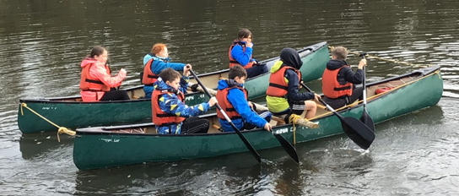

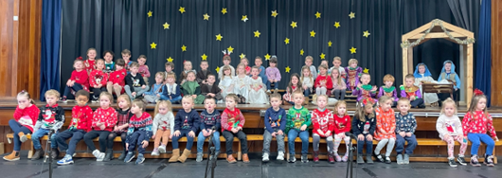

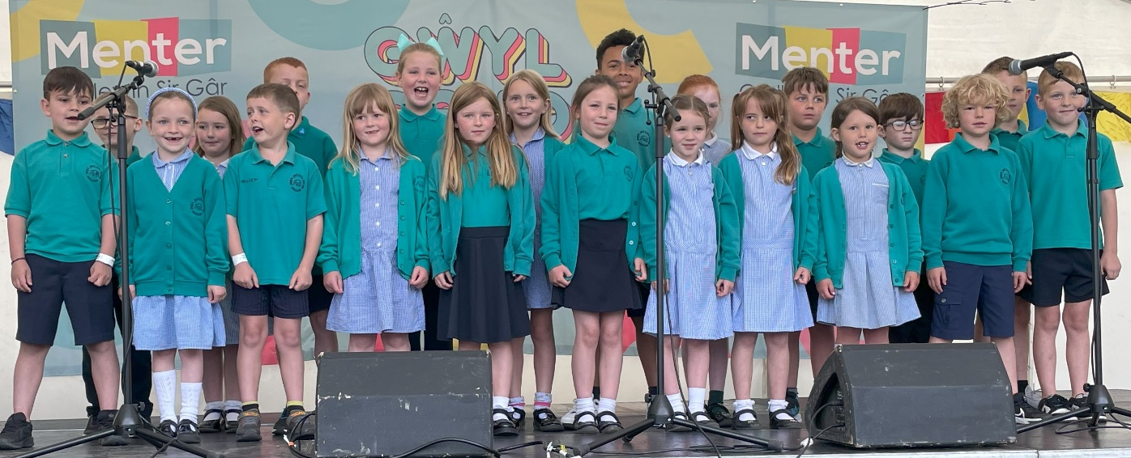

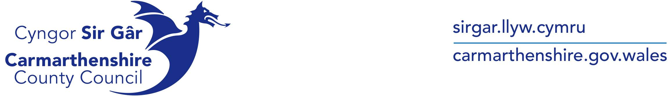

Eich cyf / Your ref: Gofynner am / Please ask for:

Fy nghyf / My ref: E-bost / E-mail:

2384 |  | Ysgol Griffith Jones
Gwelir isod crynodeb sefyllfa ariannol terfynol eich ysgol ar gyfer 2023/24. |  | Please see below a summary of your school's final outturn position for 2023/24.
 | £
Gwariant Net 2023/24 | 1,427,702 | Net Expenditure 2023/24
Dyraniad Ariannu yn ôl Fformwla 2023/24 | -1,349,255 | Formula Funding Allocation 2023/24
Arian Wrth Gefn a Ddysgwyd Ymlaen o 2022/23 | -248,288 | Surplus Brought Forward from 2022/23
Arian Wrth Gefn yn Cario Drosodd i 2024/25 | -169,841 | Surplus Carried Forward to 2024/25

CYNGOR SIR CAERFYRDDIN
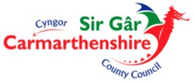
CARMARTHENSHIRE COUNTY COUNCIL

TYMHORAU A GWYLIAU YSGOL - BLWYDDYN ACADEMAIDD 2023/2024

 |  | Gwyliau Hanner Tymor
Tymor | Dechrau’r Tymor | Dechrau | Diwedd | Diwedd Tymor | Dyddiau
Hydref  2023 | Dydd Gwener  1^{af} Medi | Dydd Llun  30^{ain} Hydref | Dydd Gwener  3^{ydd} Tachwedd | Dydd Gwener  22^{ain} Rhagfyr | 75
Gwanwyn  2024 | Dydd Llun  8^{fed} Ionawr | Dydd Llun  12^{fed} Chwefror | Dydd Gwener  16^{eg} Chwefror | Dydd Gwener  22^{ain} Mawrth | 50
Haf  2024 | Dydd Llun  8^{fed} Ebrill | Dydd Llun  27^{ain} Mai | Dydd Gwener  31^{ain} Mai | Dydd Gwener  19^{eg} Gorffennaf | 69
Dyddiau HMS Penodol: Dydd Gwener, 1^{af} Medi 2023 |  |  |  |  | 1
Cyfanswm |  |  |  |  | 195

O.N. Gwener y Groglith: 29^{ain} Mawrth 2024 Gŵyl Fai: 6^{ed} Mai 2024

SCHOOL TERMS AND HOLIDAYS - ACADEMIC YEAR 2023/2024
 |  | Half Term Holiday
Term | Term Begins | Begins | Ends | Term Ends | Days
Autumn  2023 | Friday  1st September | Monday  30th October | Friday  3rd November | Friday  22nd December | 75
Spring  2024 | Monday  8th January | Monday  12th February | Friday  16th February | Friday  22nd March | 50
Summer  2024 | Monday  8th April | Monday  27th May | Friday  31st May | Friday  19th July | 69
Designated INSET Days: Friday, 1st September 2023 |  |  |  |  | 1
Total |  |  |  |  | 195

N.B. Good Friday: 29th March 2024 May Day: 6th May 2024

