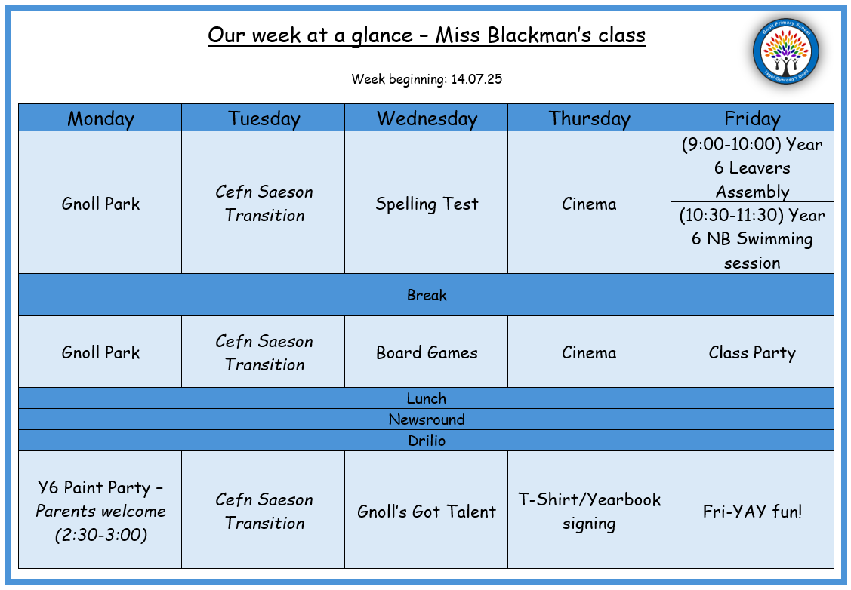
Monday 14th – You can bring balls etc, that you want to play with at the park. Please bring a spare white t-shirt that you don’t mind getting paint on for the afternoon.
Tuesday 15th – Cefn Saeson pupils to attend Cefn Saeson all day – all other pupils to attend Gnoll.
Wednesday 16th – Bring your board games, trading cards etc to enjoy with friends. If you are in the talent show, bring what you need for your act.
Thursday 17th – Bring a snack and drink for the cinema in the morning. Bring a spare school polo shirt or plain white t-shirt for signing and some pens.
Friday 18th – Leavers assembly for the whole school – wear your school uniform. Bring your swimming kits. Bring in party food.

