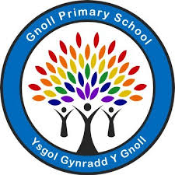**Parent and Toddler Group at**

**Gnoll Primary School**

***Grŵp Rhiant a Phlentyn Bach yn Ysgol Gynradd y Gnoll.***

Every Tuesday starting 16th of September 9.15am-1045am

bob dydd Mawrth yn dechrau ar y 16eg o Fedi

Grown ups and children aged 0-3

*Oedolion a plant 0-3 oed*

Lots of fun activities including sensory and messy play.

*Gwaethgareddau hwyl, synhwyddiarau a chwarae bler.*

£1.50 per session – Tea/Coffee and snack included

*£1.50 y dro – Te/coffi a snac.*

**Come along and have fun with your little ones!**

***Dewch ymlaen i gael hwyl a sbri gyda dy phlant!***

