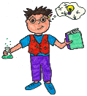  Ambitious, Capable  Learners | 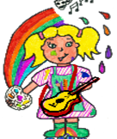  Enterprising, creative Contributors | 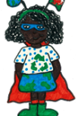  Ethically Informed Citizens | Healthy Confident  Individuals  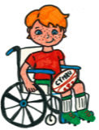
CHANGES
Within this theme, learners will develop an appreciation of identity, heritage and cynefin, including the story of their locality and Wales. Learners will explore how the concepts of change, diversity and continuity can be seen through a variety of local, national and international contexts.
Through learning about the past, learners will consider how it has impacted on life today.
TOPIC Through my window  Concepts: Change, Diversity  - WOW Start: Virtual Window- Show the children a screen to show a live webcam from an interesting location (e.g., a city street, a beach, a forest).  - Discuss what life might be like beyond that window and how it differs from their own.  Contributor Task:  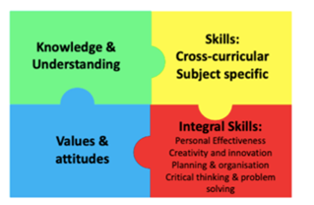  Trips/ Visitors: Harriet Eaton/virtual Visit from St Fagans/Walks to the library/park and beach park. | Knowledge and Understanding:  Understand feel valued as a member of the setting community  Make connections with people, places and things | Cross- Curricular Skills:  Numeracy-  I am progressing to use estimates by using counting or measuring.  I can explore movement and directions.  Literacy  Ask and answer questions to clarify my understanding  Science and Technology  Take care of things in my environment, living and non-living • recognise that I belong to a wider community
Big Question: How can we change and grow?  Rights of the Child:  13- Sharing thoughts freely  28- Access to Education | Values and Attitudes:  Participation- Taking Part  Subsidiarity-Everyone should have a say.  Learning to say please and thank you. | Integral Skills:  Critical Thinking and Problem-Solving. Ask meaningful questions.  Personal Effectiveness- Independence.  Planning and Organising- managing time.

Pupil Voice

Knowledge | Comprehension | Application |  | Analysis |  | Synthesis | Evaluation
EXPRESSIVE ARTS  (e.g., Music, Art, Drama, Dance, Film and Digital Media)  Studying work by Shani Rhys Jones: a local artist who was inspired by painting flowers. We will explore colour, shape, techniques and different mediums to create our own work based on the artist.  Explore traditional Welsh folk dancing and the music used for this type of dance. Learning and performing a Welsh dance.  Children to draw/paint/explore their own window into their family. |  |  | LANGUAGE, LITERACY AND COMMUNICATION  (English, Welsh and International Languages)  (Applied Cross- Curricular, Real-Life LLC)  RWI phonics.  Tric a Chlic sessions.  Instructional writing- How to grow a daffodil.  Looking in depth at ‘The Growing Story’ by Ruth Krauss. |  | SCIENCE and TECHNOLOGY  We will be growing a daffodil and looking at the lifecycle of a seed.  Pets and what living things need to survive.
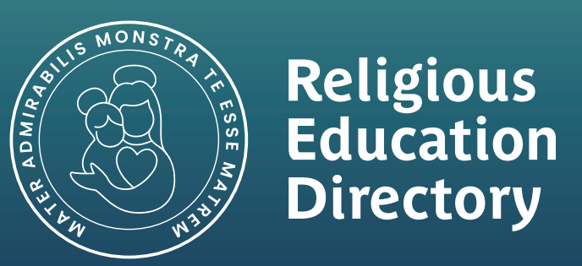  HUMANITIES  (History, Geography, RE)  Mapping- What is a map? What is it used for? We will be planning a route from one part of the school to another.  Learning that we live in Port Talbot which is in Wales.  Going on a local area walk.  Walk to the library/park/beach park.  Branch 3- Galilee to Jerusalem  Who does Jesus show love to? |  |  |   MATHS AND NUMERACY (Applied Cross- Curricular, Real-Life Maths)  Alive in 5  Mass and capacity  Growing 5, 6, 7, 8  Length, height and time  Building 9 and 10  Explore 3-D shapes.  Measuring flowers that we have grown.  Exploration of Orienteering around the school. |  | HEALTH AND WELL-BEING  (e.g., PSE, Learning to Learn, Relationships and Emotions, Healthy Choices, Physical Activity, Keeping Safe)  How do we grow and change over time?  A map of my heart- what is special to me?  Responsibilities- Responsibilities of people in power. What is my responsibility? My roles and responsibilities in class.

