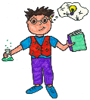  `  Ambitious, Capable  Learners | 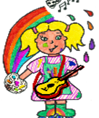 | 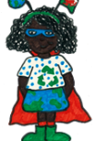  Ethically Informed Citizens | Enterprising, creative Contributors  Healthy Confident  Individuals  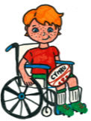
CHANGES
Within this theme, learners will develop an appreciation of identity, heritage and cynefin, including the story of their locality and Wales. Learners will explore how the concepts of change, diversity and continuity can be seen through a variety of local, national and international contexts.
Through learning about the past, learners will consider how it has impacted on life today.
TOPIC TITLE – Why is Wales Unique?  Concepts: Change, Diversity  WOW Start:  Contributor Task: Picture sort, Source square, Big question  Trips/ Visitors: Harriet Eaton – NPT Museum services - Cynefin: History on Our Doorstep  End Product – Produce a leaflet or presentation about why people should visit Wales | Knowledge and Understanding:  • Learners will develop knowledge of Wales’ culture, language, geography, history, and identity, including:  - The concept of cynefin and what makes Wales unique.  - Historical milestones such as coal mining, the Chartist movement, and devolution.  - Wales’ role in a global context and its balance between tradition and modernity.  - Environmental responsibility and sustainability in Welsh landscapes.  • Understanding how these cultural, historical, and geographical factors shape identity and influence Wales’ place in the modern world. | Cross- Curricular Skills:  • literacy: Writing biographies, poetry, bilingual poems, and creating captions for digital projects.  • Numeracy: Measuring and comparing shapes in nature, linking geometry to Welsh art and industrial design.  • Digital competence: Using Hwb tools for video recording, creating infographics, and designing collaborative multimedia projects.
Big Question:  Why is Wales Unique?  Rights of the Child:  Article 29 – Education should develop every child’s personality, talents and abilities to the full  Article 30 – Children have the right to learn and use their own language and culture  Article 12 – Children have the right to express their views and be listened to  Article 31 – Children have the right to participate in cultural and artistic activities  Article 24 – Children have the right to a clean and sustainable environment | 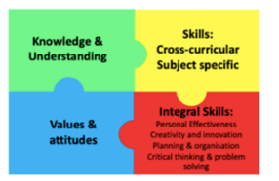  Values and Attitudes:  • Respect and empathy for cultural heritage and diversity.  • Responsibility for sustainability and environmental stewardship.  • Curiosity and pride in Welsh identity and language.  • Ethical informed citizenship through authentic experiences (e.g., reflecting on Wales’ past struggles and modern challenges). | Integral Skills:  • Critical thinking and problem solving: Evaluating questions like Should we always protect our cultural traditions? and Should identity be shaped by where we live?  • Creativity and innovation: Writing bilingual poems, creating geometric patterns inspired by Welsh art, and designing a “Future Wales” poster.  • Planning and organisation: Managing collaborative projects such as multimedia presentations and digital biographies.  • Personal effectiveness: Working in teams during outdoor learning, paired activities, and digital projects.

Pupil Voice

Knowledge | Comprehension | Application |  | Analysis |  | Synthesis | Evaluation
EXPRESSIVE ARTS  (e.g., Music, Art, Drama, Dance, Film and Digital Media)  - Create a personal identity map using collage and drawings to represent “What makes me belong?”  - Create visual prompts for poetry using patterns and symmetry  - Sketch landscapes inspired by Welsh scenery  - Draw or model industrial buildings  - Eisteddfod preparation—music, poetry, and art.  - create infographics on sustainability |  |  | LANGUAGE, LITERACY AND COMMUNICATION  (English, Welsh and International Languages)  (Applied Cross- Curricular, Real-Life LLC)  Talk 4 Writing (T4W)  - Biographies  - Poetry  - Fables & Myths  - Write a short reflection: “What does belonging mean to me?”  - Write language poems  - Create structured biographies |  | SCIENCE and TECHNOLOGY
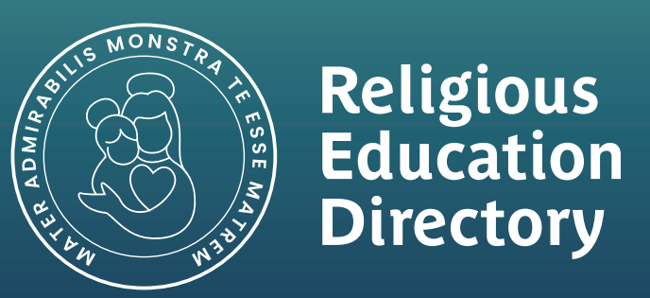  HUMANITIES  (History, Geography, RE)  - Outdoor walk to observe Welsh signs and landmarks; record findings in a group map.  - Discuss why language is important for identity.  - Research Welsh industrial past  - Investigate renewable energy projects in Wales.  - Reflect on essential questions: “Should we always protect our cultural traditions?” |  |  | 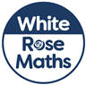  MATHS AND NUMERACY (Applied Cross- Curricular, Real-Life Maths)  White Rose Maths – Addition & Subtraction  - Multiplication & Division  - Space, Shape & Measure  - Symmetry in Welsh art and design.  • Renewable energy geometry.  - Investigate shapes in wind turbines and solar panels.  - Pupils calculate angles in turbine blades or surface area of panels |  | HEALTH AND WELL-BEING  (e.g., PSE, Learning to Learn, Relationships and Emotions, Healthy Choices, Physical Activity, Keeping Safe)

