Franksbridge County Primary School

Ysgol Pontffranc

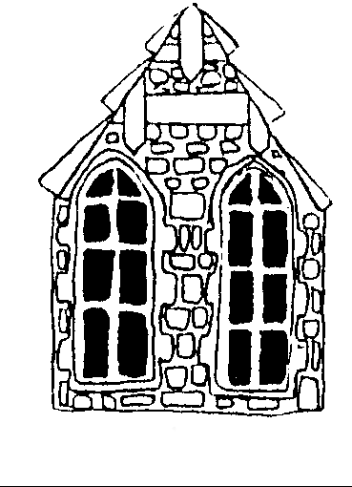

Information for Parents
2025-26
Gwybodaeth i Rieni

YSGOL PONTFFRANC  Pontffranc  Llandrindod  Powys  LD1 5SA | Pennaeth/Headteacher  Mrs. Rhian Wilkie | FRANKSBRIDGE SCHOOL  Franksbridge  Llandrindod Wells  Powys  LD1 5SA

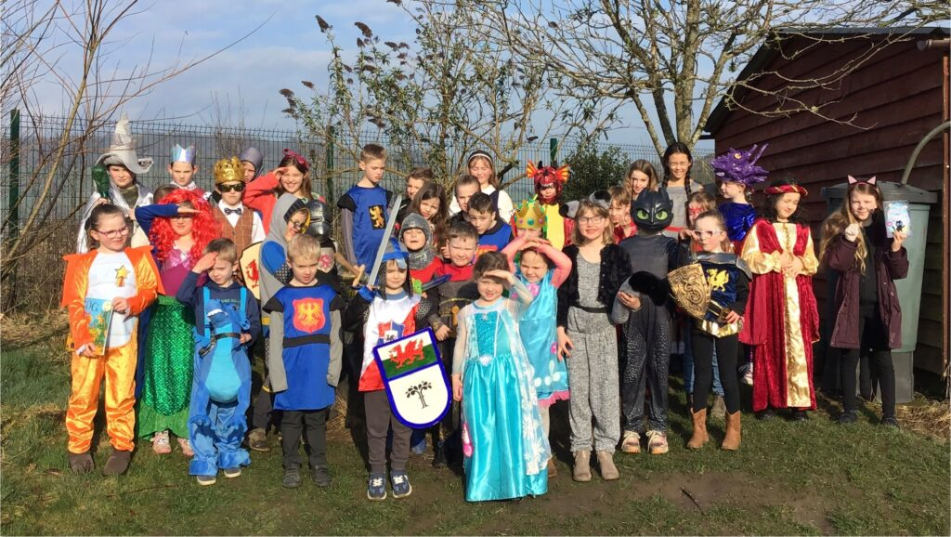
Croeso i Ysgol Pontffranc
Welcome to Franksbridge School
A Small School with a Huge Heart
Ysgol Bach Gyda Calon Enfawr

Franksbridge C.P. is a lively, happy, rural school which enjoys strong support from parents and the local community. Small class sizes mean that each child receives plenty of time and attention from our experienced teachers and support staff. Learning is tailored to the needs of individuals, ensuring that every child is supported and challenged to fulfil their potential.
Our children spend a great deal of time learning and playing outdoors. The children of Franksbridge School enjoy having the freedom and resources to climb trees, practise gymnastics, dress up, role play and make dens at play times, as well as taking part in a wide range of sports and games. We are committed to bringing excitement, fun and creativity into learning and teaching. Our termly Launch Days, Exploration Days and our summer Den Day are among the highlights of our school year. A wide range of visits and visitors also enrich our pupils’ learning experiences.
All learners at Franksbridge School (children and adults) are committed to developing ‘Growth Mindset’: we take opportunities to explore ideas, methods and possibilities in an open, creative way. We expect to make mistakes along our learning journeys but rather than fearing mistakes, we embrace them as important parts of our learning experiences.
Personal, social and emotional development is of paramount importance to us at Franksbridge School. We learn how to care for ourselves and each other and we are aware of our responsibilities within our school, our community and the wider world.

OUR SCHOOL MISSION STATEMENT
At Franksbridge School we seek to kindle children’s love of learning
whilst nurturing them as individuals and helping them to understand and care for
themselves, each other, and the world in which they live.

OUR SCHOOL VISION: ROOTS AND FRUITS OF LEARNING
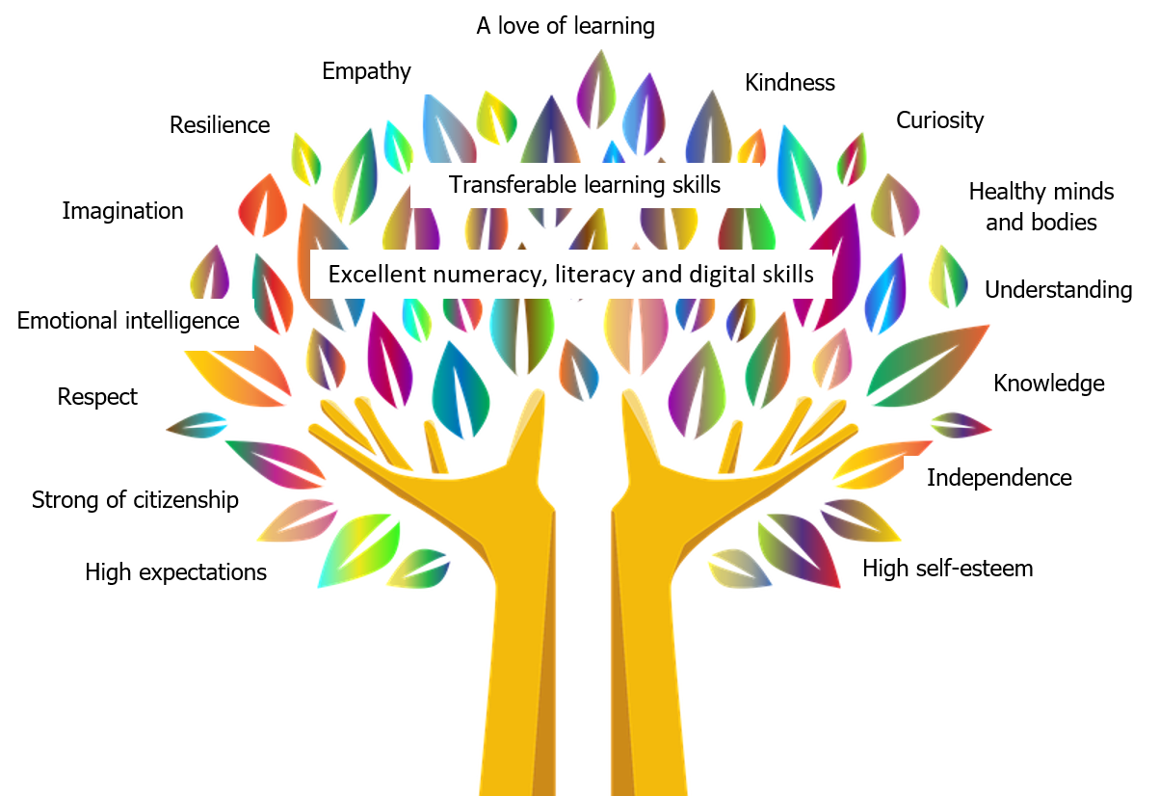
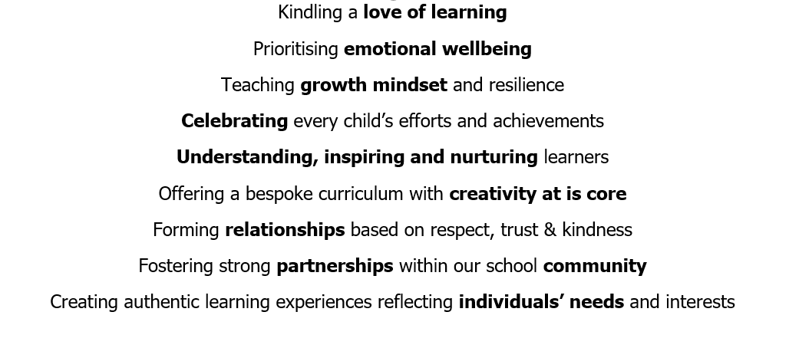

OUR LAST INSPECTION REPORT
Our school was inspected by Estyn in November 2025. The report states that:

The report highlights Franksbridge Community Primary School as a welcoming, caring and inclusive learning environment that plays a central role in its rural community. Estyn inspectors recognised the school’s success in nurturing considerate, confident learners and fostering a positive atmosphere where pupils feel well-prepared for the next stages of their education.
The inspectorate highlighted as ‘Spotlights’ two areas of excellent practice.
Spotlight One: A creative and ambitious curriculum that provides hands-on, meaningful learning experiences rooted in both local context and wider global understanding.
The school provides extensive local and wider learning opportunities that inspire pupils and support their aspirations. Staff value and utilise pupils’ own backgrounds, such as strong links to the farming community, to enrich their learning. Through purposefully planned visits and use of resources, pupils develop a strong understanding of their local area, Welsh identity, and the wider world, embedding cultural and historical awareness across the curriculum. Firsthand interactions with people from a range of communities, faiths and cultures help pupils to develop positive and respectful attitudes towards diversity. The school also carefully provides an interesting range of creative and artistic experiences, often involving the local community, to further enhance and enrich pupils’ learning. The school provides extensive local and wider learning opportunities that inspire pupils and support their aspirations.
Spotlight Two: A successful approach to developing strong teaching and learning of Welsh.
A strong focus on strengthening the teaching and learning of Welsh has been effective. Staff model the language with confidence, having enhanced their own skills through purposeful professional learning. They promote Welsh consistently across school life, encouraging pupils to use it naturally and with pride. As a result, pupils of all ages demonstrate positive attitudes towards the language and make strong progress in developing their Welsh communication skills
Other key strengths identified include:
- A warm and inclusive culture where pupils enjoy school and demonstrate respectful behaviour towards staff and peers.
- Strong emphasis on pupils’ well-being, healthy lifestyles, and meaningful contributions to school life.
- Positive progress in literacy, digital skills, and a growing enthusiasm and proficiency in Welsh language usage.
- Effective early identification and support for pupils’ additional learning needs, supported through close partnership with parents and external agencies.

The full report can be found by clicking on the following link:
www.estyn.gov.wales/provider/6662066

As you will see from the following information, the children take part in a wide range of activities. It is unlikely that this booklet will answer all your queries so please do not hesitate to contact me if you wish to visit the school or would like any further information. Additional information is available on our school website: www.franksbridge.powys.sch.uk

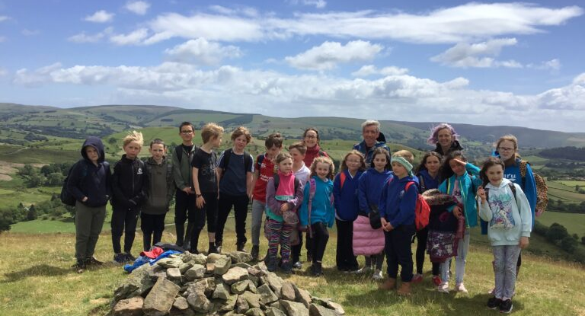
VISITING FRANKSBRIDGE SCHOOL

Parents and carers are welcome to visit the school at any time but it would be appreciated if visits could be kept to a minimum while the children are being taught. If a longer visit is required parents and carers are requested to make an appointment in person or by telephone.

In addition to the above, parents’ evenings are held each year in October and February and a further meeting is offered in July following the distribution of annual reports. Parents are invited to attend talks on educational matters and various social functions and meetings of the Friends of Franksbridge School are held throughout the year.
SCHOOL FACILITIES

Franksbridge School was first opened on 29th July 1878 and was redesigned in 1965.
We have two classes. The younger children (4 to 7 years) are taught by Mrs. Jones with the support of Mrs. Dunne. The older children (7 to 11 years) are taught by Mrs. Wilkie, with support from Mrs Griffiths. The main school building consists of three classrooms and two smaller learning areas (KIVAs). We also have well-stocked fiction and non-fiction libraries, and a small computer suite. In addition, we have a portacabin containing an additional classroom and a meeting room. Delicious dinners are cooked on site by Mrs. Groves.
Our extensive outside space is used for learning and play. Franksbridge Community School stands in exceptional grounds, comprising a large playground, outdoor classroom, games field, community play area, school vegetable garden, nature reserve, pond, quiet garden, wild flower meadow, wooded areas and muddy kitchen.

THE SCHOOL DAY

8.50 am Children arrive at school
9.00 a.m. School begins
12.30 p.m. Morning session ends
1.30 p.m. Afternoon session begins
3.30 p.m. End of school day
(There is no afternoon break)
Parents are requested not to send their children to school before 8.50 a.m.

TEACHING AND SUPPORT STAFF

Mrs. Rhian Wilkie Headteacher and KS2 teacher
Mrs. Philippa Jones Foundation Phase, Years 1 and 2
Mrs. Liz Hulin-Taylor Headteacher’s Management Time/PPA Cover
Mrs. Nicola Dunne Foundation Phase Learning Support Assistant
Mrs. Charlotte Griffiths KS2 Learning Support Assistant

OTHER STAFF

Mrs. Lyn Brown Admin. Assistant
Mrs. Nicola Dunne Mid-day Supervisor
Mrs. Charlotte Griffiths Mid-day Supervisor
Mrs. Amanda Groves Cook-in-Charge
Miss Denise Smith School cleaner

SCHOOL GOVERNORS

Co-opted Members
Mrs. A. Long (Chair) Reverend Andrew Perrin

L.E.A. Representatives
County Councillor Mr. G. Jones (Vice-Chair)
Mrs. E. Price

Parent Representatives
Mrs. E. Turner Miss D. Morris Mrs. A. Wozencraft
Community Representative Teacher Representative Headteacher
Mr. Kevin Jakeway Mrs. P. Jones Mrs. R. Wilkie
Non Teaching Staff Representative Clerk to the Governors
Vacancy Mrs. L. Brown
Franksbridge School

GENERAL INFORMATION

SCHOOL UNIFORM

Children are encouraged to wear school uniform: school sweatshirts, hoodies, polo shirts, fleece and reversible fleece/waterproof with our logo and in the school colours of royal blue/white, are available to order from Constructiv Clothing on the following link: https://www.constructiv.co.uk/shop/products.asp?cat=180
The clothes are good quality, comfortable to wear, and suitable for school activities.

The children should wear comfortable, safe, protective footwear – black leather shoes are ideal. No high heels, trainers, crocs or flip-flops please.

SCHOOL VISITS

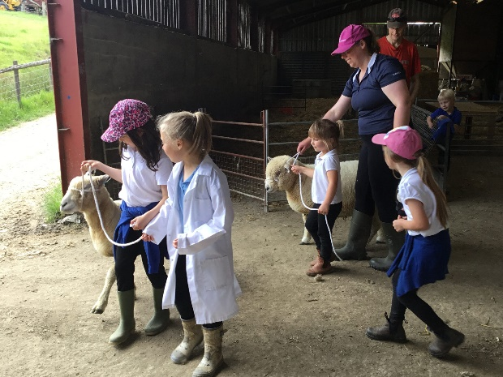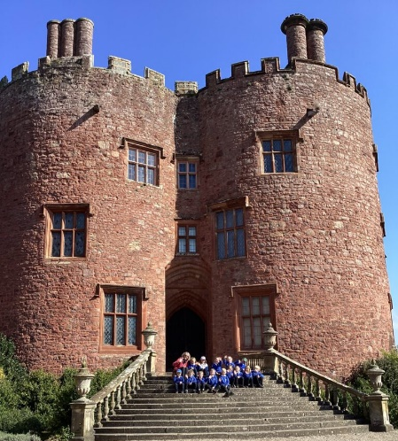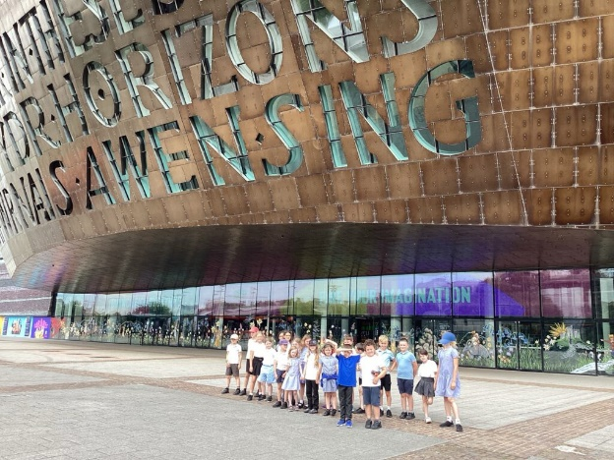

Regular educational visits to such places as museums, theatres and other places of interest enrich the school curriculum. Older children have opportunities to take part in residential visits to an outdoor pursuit centre and The Urdd Centre in Llangrannog.

CHARGING FOR SCHOOL ACTIVITIES

In order to provide certain activities we request a voluntary financial contribution. (For example, trips to museums, places of interest, theatres, etc., and residential visits.) We do try to keep costs to a minimum and usually use school funds to subsidise trip costs. The Friends of Franksbridge School have also made generous donations towards the cost of transport on many occasions. Sensitive enquiries are made to ensure that no child is excluded because of financial difficulties.

ADMISSION PROCEDURES

If you would like your child to come to Franksbridge School then please contact the head teacher for further information. Children are admitted in the September following their fourth birthday. There is an admission form to be completed by parents or carers, which can be obtained from the Admissions Department at Powys County Hall.

INCLUSION
We are an inclusive school and we strive to fully meet the needs of all our pupils. We recognise that not all pupils are neurotypical: we learn about and value neurodiversity. It is recognised that some children may have particular physical disabilities, which would require alterations to the building in order for them to gain adequate access. In these circumstances we would consult with the parents and LEA in order to reach a satisfactory outcome.

Activities are differentiated and planned to match the needs and abilities of each child. The identification and assessment of these needs is carried out in accordance with the Additional Learning Needs Act (ALNet Act). Children in receipt of Additional Learning Provision (ALP) have Individual Development Plans (IDPs) prepared by the school. These are shared with pupils and their families.

AIMS OF THE SCHOOL

In line with Curriculum for Wales, Four Purposes form the basis of everything that we do in school. We seek to nurture:

- Ambitious capable learners, ready to learn throughout their lives
- Enterprising creative contributors, ready to play a full part in life and work
- Ethical, informed citizens of Wales and the world; and
- Healthy, confident individuals, ready to lead fulfilling lives as valued members of society

We aim to promote each child’s education by providing a stimulating happy and caring environment. We strive to create the ideal learning atmosphere, one where each child will feel encouraged and not inhibited; where each child will feel confident enough to explore new ideas; one where differing views are valued and where good behaviour is achieved in a spirit of co-operation, friendship and appreciation of others. We offer a broad and balanced curriculum where the subject matter is relevant to the children and differentiated to enable each child to thrive at their level of ability.

EFFECTIVE LEARNING:
Metacognition, Growth Mindset, Positive Habits of Mind, and Assessment for Learning

At Franksbridge School we ‘learn how to learn well’.
Metacognition
We are all encouraged to reflect on our learning and develop an understanding of the strategies and approaches that are effective for each of us as individual learners. Our children are actively involved in evaluating and improving their own learning skills through self-assessment. They also provide feedback to each other (peer assessment).

Growth Mindset
All learners at Franksbridge School (children and adults) are committed to developing ‘Growth Mindset’: we take opportunities to explore ideas, methods and possibilities in an open, creative way. We expect to make mistakes along our learning journeys, but rather than fearing mistakes, we embrace them as important parts of our learning experiences. We know that we all have the ability to make progress and fulfil our potential.

5 Positive Habits of Mind are taught throughout the school:

- Persistence
- Collaboration
- Self-discipline
- Imagination
- Inquisitiveness

Through the development of positive ‘Habits of Mind’, children reach their full potential to develop resilient, lively and enquiring minds, capable of independent endeavour and effective collaboration.

CURRICULUM for WALES

The primary curriculum is divided into 6 Areas of Learning and Experience:
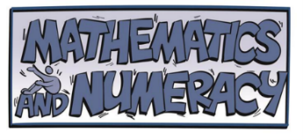
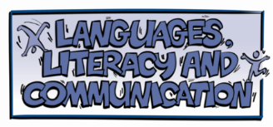




In addition, there are 3 Cross-curriculum responsibilities:



The basic knowledge, skills and understanding in the core subjects of English and Maths are largely taught as separate subjects. The remainder of the curriculum, including reinforcement of English and Maths (Literacy and Numeracy Framework), is taught through a mixture of topic work and separate (discrete) subjects, as appropriate. We use a mixture of teaching methods including whole class, ability group, mixed ability group and individual tuition.

AREAS OF LEARNING AND EXPERIENCE


Children are helped through a wide range of tasks to appreciate literature in its various forms, and to develop their powers of communication by reading, writing, speaking and listening.

We strive to ensure that our learners will:
- develop the ability to listen attentively, follow instructions and communicate through the spoken work in a variety of situations;
- read a wide range of literature fluently, for pleasure and interest, and develop research skills using non-fictional materials;
- develop legible, stylish handwriting and the ability to communicate in writing to a variety of audiences;
- develop appreciation and skills in the use of Welsh as a language of communication;

We recognise that parents have an important part to play in the development of language and each child will regularly bring books home to enjoy with his/her parents. Some of these activities will involve the study of the Welsh language. Welsh is taught daily as a second language throughout the school and the Welsh language is used incidentally throughout the day for simple instructions, greetings, etc.
Children in Class 2 are also introduced to the French language through French songs, games and basic phrases.
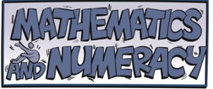
Children are helped to acquire the basic skills and much more through a wide range of activities. Whilst we realise the importance of learning the four rules (+, -, x and -) we are also aware of the importance of using these skills in a variety of investigations and problem solving activities. The children also develop skills for analysing and communicating information and ideas. Children will be learning to think logically and to enjoy mathematics. We strive to ensure that our learners will enjoy mathematics and apply mathematical skills and knowledge across a range of subjects and experiences.

Through a range of situations and subjects including PSE, PE and Science, children develop an understanding of how to live a healthy life. They learn how to recognise and manage their emotions, and care (physically and emotionally) for themselves and those around them.

RELATIONSHIPS AND SEXUALITY EDUCATION (RSE)

RSE became a mandatory part of the curriculum in 2022. At Franksbridge School, RSE takes place in the context of Science, P.S.E. (Personal and Social Education) and other related topics as appropriate to the children’s age. Teachers use their professional judgement when dealing with sensitive issues. By the time pupils leave Franksbridge School, they will have learnt about puberty and sexual reproduction, through a holistic approach that encompasses learning about emotions and relationships.
The 3 strands of the RSE framework are:
- Relationships and identity
- Sexual health and wellbeing
- Empowerment, safety and respect
SPORTS PROVISION

Our main aim is to provide as many sporting opportunities as possible so that all the children are actively involved in sport and develop interest and enthusiasm. We facilitate the development of good physical co-ordination and provide opportunities for collaboration as part of a team. Children are involved in many physical activities, that enable all of them to derive pleasure from taking part. Children in Years 1 to 6 learn to swim during our visits to Builth Wells pool.
By Y3, within the school curriculum, all children are learning basic skills for football, hockey, rugby, netball, cricket, rounders, tennis, running, jumping, gymnastics and swimming. We also take part in friendly tournaments of football, netball and hockey against other schools. Some of the tournaments have fixed rules and may necessitate some selection, depending on our numbers. We also encourage the children to take part in local sport development sessions and to join local junior teams. Year 5 and 6 have the opportunity to take part in an outdoor pursuits residential course.

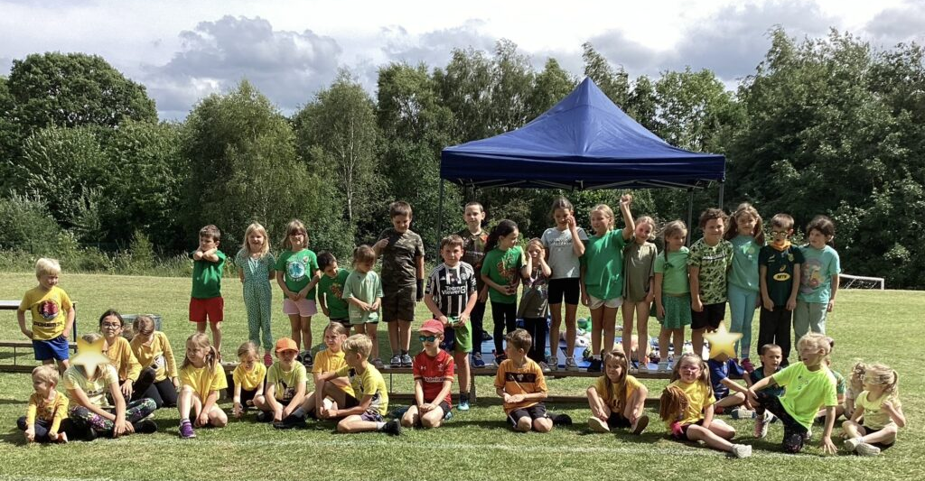
PE KITS
GAMES (KS2 only): Shorts, T-shirt and football boots or strong trainers.
During cold weather children will require a sweatshirt or jumper and leggings of some sort.
For health and safety reasons we wish to stress the importance of the need for children of all ages to change into appropriate clothes for PE and Games. This must include a change of footwear.

PE: Girls and boys will need gym shoes (daps) shorts and a T-shirt. In winter months, children also need warmer layers such as tracksuit bottoms and fleeces or jumpers.

Our after-school sports club is held once a week and gives the Key Stage 2 children a chance to enjoy playing the following sports:
Hockey Football Netball Rugby Rounders
In the spring term, there is also a computer club run by our ‘Digital Wizards’.

Children are encouraged to express their ideas, moods and emotions through a variety of media e.g. poetry, story, dance, drama, painting and music. Children have the opportunity to observe, appraise, compose, create, design and perform. All children in Key Stage 2 have the opportunity to play tuned musical instruments. Each year we join the musicians of Sinfonia Cymru in a creative project that culminates in a public performance.


Children are encouraged to develop lively, enquiring minds and to develop their powers of observation and investigative skills, building their knowledge of science on first hand observation and questioning the world around them. We strive to ensure that our learners will develop scientific ideas, language and skills through practical investigations and research. The children develop the notion of a fair test and using their language and maths skills communicate their findings with others in gradually increasing accuracy and detail.

Children are encouraged to design and build/make/sew/cook with various materials. They evaluate, refine and adapt their products and creations. Through Information Technology and the use of computers across the curriculum they communicate their ideas and develop an increasing understanding of the systems available. Whilst developing their skills, children learn to develop respect for and safe use of tools, equipment and instruments, including new technologies. Online safety is learnt regularly.


Children study the local community, society and the environment both in the past and in the present. As the children develop, the work will involve national and international topics. Children are given opportunities to develop a sense of time and place a global awareness and an appreciation of the importance of living sustainably.
Religious Education takes place in each class: children are encouraged to understand and appreciate religious ideas and cultures, celebrating diversity and developing knowledge and understanding of World religions. Parents have the right to remove their children from Collective Worship and RE lessons.

For more information about the curriculum in Wales, please go to htpps://hwb.gov.wales and click on

COLLECTIVE WORSHIP There is a daily act of collective worship and whole school assemblies take place on four days of the week. A set of (Christian) moral values structure the year’s programme of collective worship. Parents have the right to withdraw their children from these activities on religious grounds. Alternative provision will then be made for these children within the resource limitations of the school.

Throughout the above areas of learning the children will focus on aspects which are particular to Wales i.e. those aspects that give an identity to Wales such as the language, music, art, geography, history and modern culture. A sense of ‘cynefin’ (belonging) is encouraged and much of the curriculum relates specifically to the local area.
ASSESSMENT

Most of our assessment is formative in purpose: the results of informal teacher assessments (from marking books and discussing learning with pupils) are used to move each child’s learning forward. Standardised assessments are also used twice yearly by children in Years 2 to 6 to monitor standards in spelling, reading comprehension, procedural maths and maths reasoning.
REPORTING PROGRESS
Each child receives a written report at the end of each school year with room for any comments that parents may wish to add. Copies of the reports are filed with the children’s records. The parents or carers are then sent a copy, which they may keep.

There are parental consultations held in the autumn and spring terms. A third is offered towards the end of the summer term. During the rest of the year parents are welcome to come to school to see their children’s work and to discuss their progress and/or any difficulties they may have. These visits can be at any time during the school year although it might be necessary to make an appointment. Please contact us.
HOMEWORK

We regard this family engagement in learning as a very important contribution to the progress of each and every child in school. We very much hope that parents and carers will take an active interest in their children’s schoolwork. The children are expected to take a reading book home every day. It is hoped that parents/carers will hear their children read, discuss the book and sign the reading record, adding comments for the teacher’s attention at times.
In addition, children have a piece of homework each week. This might include learning spelling lists, practising maths (including tables and number bonds), learning words for songs, carrying out research or completing activities. Homework is often added to J2E (Class One) or Teams (Class Two) so that pupils and their families can access resources.

ARRANGEMENTS FOR MAKING COMPLAINTS ABOUT THE CURRICULUM
If parents wish to make a formal complaint about the curriculum or related matters then copies of the leaflet entitled “Complaints, Concerns and Requests” are available from the school or the Local Authority.

TRANSFER PROCEDURES

Most children completing Year Six transfer to Ysgol Calon Cymru. This secondary school has two campuses: one in Builth Wells and the other in Llandrindod Wells. Parents are required to complete an online form entitled ‘Parental Preference for Secondary School Admission’ during the autumn term of the year in which their child is in Year Six. Children and parents have the opportunity to visit the high schools prior to applying. Information regarding transport arrangements may be obtained from the Admissions and Transport team at Powys County Hall.

During the spring and summer terms local secondary schools offer transition programmes for the Year Six children, to facilitate smooth, happy transition from primary school to secondary school. We liaise closely with secondary school staff and ensure that the appropriate records are forwarded to the relevant secondary school.

Further information can be obtained from us, the high schools concerned, or via the County Council document “Primary and Secondary Schools Information and Admission Arrangements – Information for Parents”.

Parents moving away from the area and out of Powys LEA should let the headteacher know the name of the school to which their child is to transfer, so that records may be sent as soon as possible.

CHILDREN’S WELLBEING
EQUAL OPPORTUNITIES
At Franksbridge C.P. School, we are committed to ensuring equality of education and opportunity for all pupils, staff, parents and carers receiving services from the school, irrespective of disability, race, gender, age, sexual orientation, religion or belief, gender reassignment, pregnancy & maternity, marriage and civil partnership.

(A copy of the full Equal Opportunities policy and Strategic Equality Plan can be seen in school)
HEALTH AND SAFETY
Health and Safety is a high priority for all children and staff. The children are well supervised, taught to act in a safe manner at all times and know basic safety procedures (e.g. fire drill and reverse evacuation procedures). The building and grounds are kept secure: all external doors are self-locking and visitors to school are admitted by responsible adults only. Online safety is very important to us: our children are taught how to be se safe, responsible digital citizens.
ILLNESS IN SCHOOL
Unfortunately, we have no sick room, or school nurse, and so we endeavour to contact the parents/carers of any child who is ill in school. As such, it is important that we have a home or work telephone number, which should be entered on the Admissions Form and regularly updated. Children must be kept away from school for a period of 48 hours following vomiting or diarrhoea to minimise the risk of infection.
ACCIDENTS
The school staff deal with small cuts and grazes which occur in the playground. If serious injury is suspected the child may be taken to hospital or an ambulance called. In all such cases the parents will be contacted once the child’s welfare has been safeguarded.
MEDICAL INFORMATION
Medicines should only be brought to school where it is absolutely essential e.g. for those who suffer from a condition such as asthma or when it is necessary to take other medication during the day.

If medicines must be brought to school they should ideally be the smallest possible amount, clearly labelled with the child’s name, contents and dosage. The parent should hand them to a member of teaching staff, and an indemnity form should be signed. For known asthma sufferers, children requiring an epipen, or others who take regular medication over a longer term, an initial letter would be sufficient, and agreed alternative arrangements could be made.

All medicines (except epipens, antihistamine and asthma pumps) will be locked in a cupboard or kept in the fridge as appropriate, and returned directly to the parent concerned at the end of the day. We are, of course, concerned for the health and welfare of all the children in school. The above arrangements have been implemented to minimise dangers to children. If these arrangements cause any difficulties please do not hesitate to contact the school.

CHILD PROTECTION

In order to protect the children, we follow the Wales Safeguarding Procedures (2019). This places certain obligations on us including the need to share information with other agencies where necessary. Further details can be found in our Child Protection Policy. This document and the is available for parents and carers to read in school and on our website. The Wales Safeguarding Procedures (2019) can be downloaded as an app.

All staff and governors receive regular training on Child Protection procedures. Volunteers also receive Level One Child Protection training. Strict DBS (Disclosure and Barring Service) procedures are adhered to when appointing staff and volunteers. Regular volunteers in school require enhanced DBS checks. Occasional volunteers are not required to undertake a DBS check but they are always accompanied by a member of staff when in the presence of pupils.

Mrs. Rhian Wilkie is the Designated Senior Person for Child Protection and Mrs. Pippa Jones is the Designated Deputy for Child Protection. Our Designated Governor for Child Protection is Mrs Alison Long.

PHOTOGRAPHING AND VIDEOING

Photographs and videos are regularly taken in school and on visits as records of activities and events. Photographs are saved electronically and some are placed on the school website. Individual children are never identified by name. We ask that parents complete a form to indicate that they are happy with this arrangement. If parents do not wish for their child to be photographed then this can be indicated on the form and that decision will be respected.

Sometimes the children are involved with teachers, organisations and experts from outside school, for example when taking part in sporting events and creative arts projects. Parents/carers are therefore also asked to indicate whether or not their children’s images may be shared on other (named) websites. We do not allow other organisations to post images of our school pupils in a school context on social media.

At school events such as the Christmas Show, families are permitted to take photographs and videos but are not allowed to share the images or recordings on social media.

ATTENDANCE
2024-25 Attendance figures: 95.71% attendance, 4.05% authorised absence, 0.38% unauthorised absence. Our school attendance target is 95% Absences are expressed as a percentage of the total possible attendances in the school year.

ABSENCE FROM SCHOOL
Children are deemed to be officially absent if they are suffering from an illness or injury, or for religious observance. These absences can be authorised once reported to school. It would be greatly appreciated if parents would let the school know the cause of absence as soon as possible. A telephone call, e-mail or note would be ideal. If teachers have not been made aware of the reason for absence, a phone call home will be made in order to establish the reason.

In special cases, and at the head teacher’s discretion, children may be absent from school for up to 10 authorised sessions. If parents do wish to take their children out of school during term time, they are asked to request a holiday form from the school office, at least 28 days before the period of planned absence.

All other absences are deemed as unofficial and have to be recorded on the register as unauthorised. Attendance figures are submitted electronically to the Local Authority and Welsh Government as a matter of routine.

OTHER USEFUL INFORMATION
MONEY AND VALUABLES
Children sometimes like to bring items from home to school to show friends and teachers. We take interest in children’s possessions, but we cannot be held responsible if any item is damaged or lost. We would discourage children from bringing items to school if they are delicate or valuable (in terms of financial or sentimental value).
SCHOOL MEALS
Our cook, Mrs. Groves, provides delicious warm dinners that are cooked on site. All children in primary school are entitled to a free meal each day under the Welsh Government’s Universal Free School Meals scheme. Almost all children take school dinners but children may also bring their own packed lunches to school. Healthy eating is actively encouraged.

Children are encouraged to bring a healthy snack to school each day. Fresh fruit and vegetables are the only snacks allowed, in the interests of healthy teeth and bodies. Children also need to bring a bottle of water to school every day, labelled with their name.
SCHOOL TRANSPORT
Currently, free transport is available for all primary children who live a distance of two miles, or more, from their nearest school. Further information can be obtained from the Transport Co-ordination Unit, Powys County Hall.
NEWSLETTERS
These are e-mailed weekly to parents, governors, staff and Friends of Franksbridge School. They inform the parents of any relevant news and events. The newsletters are seen as an important link between home and school. If you do not have access to a computer, please let us know so that a paper copy of the newsletter may sent home weekly with your child.

THE FRIENDS OF FRANKSBRIDGE SCHOOL
The Friends of Franksbridge School is an invaluable organisation in the life of our school. The Friends contribute much by promoting friendship and co-operation between children, staff, parents and others in the community. As a result of fund-raising activities, the Friends have been able to purchase valuable resources for the school. The AGM is usually held in October each year, when the chairperson, secretary and treasurer are elected. The Friends hold meetings each term in order to plan events and organise their affairs. Anyone with an interest in the school is welcome to attend.

APPENDICES
Appendix 1
Fair Processing Policy – gives information on what the School, Powys County Council and the Welsh Assembly Government do with personal and performance information that is collected on your child.

Appendix 2
Home/School Agreement – all schools are now required to provide parents/guardians with the opportunity to sign a Home/School Agreement. There is no legal obligation for you to sign the agreement and if you do sign you are not bound legally to any of the commitments. However, the agreement does set out the basis on which we all can work together for the benefit of the children at Franksbridge School.

Appendix 3
Use of Internet – the school is connected to the internet and, in order for the children to access this, parents/carers are required to read and sign the consent form.

Appendix 4
Admission Information Form – this provides the personal information required by the school to enable staff to add your child to the school’s data base.

Appendix 5
School Calendar

Appendix 6
Blanket Consent letter – permission to take pupils out of school on visits.

Appendix 7
Photographing and Videoing Letter – permission for photographs to be taken.

Appendix 8
Hwb Platform – Access approval.

APPENDIX 1
FRANKSBRIDGE C.P.SCHOOL
Fair Processing Notice: What the School, Local Education Authority and Government does with information it holds on Pupils
Subject
This leaflet tells you about what the National Assembly for Wales, Powys Local Education
Authority (LEA) and Franksbridge C.P. School does with your, or your child’s, personal and
performance information (data).

The collection of personal information

The school collects information about pupils and their parents or legal guardians when they go to a new school, they also collect information at other times during the school year. Information is also received from other schools when pupils transfer.

The LEA and National Assembly for Wales will receive information on pupils from the school, normally as part of what is called the Pupil Level Annual Schools Census which takes place in January each year. The school, LEA and National Assembly for Wales receive information about exam and national curriculum assessment and test results.

The use made of this personal information

The National Assembly for Wales uses the information collected to do research, primarily to inform educational policy changes and funding. The research is done in a way that ensures individual pupils cannot be identified. Examples of the sort of statistics produced can be viewed at www.learning.wales.gov.uk or www.wales.gov.uk/statistics

The LEA also uses the personal information collected to do research. It uses the results of the research to make decisions on policy and the funding of schools, to calculate the performance of schools and help them to set targets. The research is done in a way that ensures individual pupils cannot be identified.

The School uses the information it collects to administer the education it provides to pupils. For example;

• the provision of educational services to individuals;
• monitoring and reporting on pupils’ educational progress;
• the provision of welfare, pastoral care and health services;
• the giving of support and guidance to pupils, their parents and legal guardians;
• the organisation of educational events and trips;
• planning and management of the school.

Organisations who may share personal information

Information held by the School, LEA and the National Assembly for Wales on pupils, their parents or legal guardians may be shared with other organisations when the law allows, for example with;

• other education and training bodies, including schools, when pupils are applying for courses, training,school transfer or seeking guidance on opportunities;
• bodies doing research for the National Assembly for Wales, LEA and schools, so long as steps aretaken to keep the information secure;
• central and local government for the planning and provision of educational services;
• social services and other health and welfare organisations where there is a need to share information to protect and support individual pupils;
• various regulatory bodies, such as ombudsmen and inspection authorities, where the law requires that information be passed on so that they can do their work.

Personal information held

The sort of personal information that will be held includes;

- Personal details such as name, address, date of birth and contact details for parents and guardians;
- Information on performance in internal and national assessments and examinations;
- Information on the ethnic origin and national identity of pupils (this is used only to prepare summary statistical analyses);
- Details about pupils’ immigration status (this is used only to prepare summary statistical analyses);
- medical information needed to keep pupils safe while in the car of the school;
- information on attendance and any disciplinary action taken;
- information about the involvement of social services with individual pupils where this is needed for the care of the pupil.

Other information

The National Assembly for Wales, LEA and school will try to ensure that information is accurate and secure. Personal information will not be sent outside the United Kingdom.

Your rights under the Data Protection Act 1998

The Data Protection Act 1998 gives individuals certain rights in respect of personal information held on them by any organisation. These rights include;

• the right to ask for and receive copies of the personal information held on you, although some information can sometimes be legitimately withheld;
• the right, in some circumstances, to prevent the processing of personal information if doing so will cause damage or distress;
• the right to ask for wrong information to be put right;
• the right to seek compensation if an organisation does not comply with the Data Protection Act 1998 and you personally suffer damage;
• in some circumstances a pupil’s parent or legal guardian may have a right to receive a copy of personal data held about a pupil in their legal care. Such cases will be considered on an individual basis where the individual is deemed to have insufficient understanding of their rights under the Act. You also have the right to ask the Information Commissioner, who enforces and oversees the Data Protection Act 1998, to assess whether or not the processing of personal information is likely to comply with the provisions of the Act.

Seeking further information

For further information about the personal information collected and its’ use, if you have concerns about the accuracy of personal information, or wish to exercise your rights under the Data Protection Act 1998, you should contact;
• your child’s school on 01982 570275;
• your LEA on 01597 826455;
• the National Assembly’s data protection officer at, The National Assembly for Wales, Cathays Park,Cardiff, CF10 3NQ;
• the Information Commissioner’s office help line can be contacted on 01625 545 745;
• information is also available from www.informationcommissioner.gov.uk

APPENDIX 2
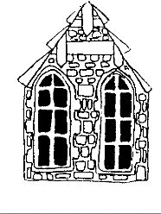 | FRANKSBRIDGE C.P. SCHOOL  Home/School Agreement

The Parents’ commitment

To:

- Ensure that my child/children goes/go to school regularly, on time and properly equipped;
- Inform the school promptly about any reason for absence;
- Make the school aware of any concerns or problems that might affect my child’s/children’s work or behaviour;
- Support the school’s policies and guidelines for behaviour;
- Support my child/children in homework and other opportunities for home-learning;
- Attend parents’ evenings and discussions about my child’s/children’s progress;
- Encourage my child/children to do their best at all times.

Signed: __________________________________

The School’s commitment

To:

- Encourage children to do their best at all times;
- Provide work, including homework, which is appropriate to the age and ability of the pupil with regard to the needs of the most gifted and those with learning difficulty;
- Inform parents of their children’s progress at parents’ evenings and through annual written reports, or by appointment;
- Provide a caring, well-disciplined working environment;
- Keep parents informed about general school matters.

Signed: ___________________________________

The Pupil’s commitment

To:

- Work to the best of my ability at all times;
- Attend school regularly and on time;
- Take good care of the school environment and equipment;
- Treat all children and adult involved in the school with respect and to be polite and helpful to others at all times.

Signed: ____________________________________

APPENDIX 3
FRANKSBRIDGE C.P. SCHOOL

Internet Authority

Parent Consent Form

Please complete and return this form to the Head Teacher of Franksbridge C.P. School.

- I am the parent or carer of __________________________________

- I understand that the school will take all reasonable steps to ensure that my child uses the school’s internet and electronic mail services for appropriate purposes;

- I understand that no filtering system can guarantee to be 100% effective all the time;

- I understand that my child will be held accountable for his/her use of the internet and electronic mail services and that deliberate misuse will be treated as a serious breach of school rules and reported to me;

- I give permission for my child to use the internet and electronic mail services in the school.

Signed: __________________________________ Date: ____________________________

Pupil consent form

As a school user of the internet, I agree to comply with the school rules on its use. I will use the internet in a responsible way and observe all the restrictions explained to me by the school.

Signed: __________________________________ Date: _____________________________

APPENDIX 4
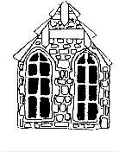 | YSGOL PONTFFRANC FRANKSBRIDGE SCHOOL  ADMISSION INFORMATION FORM
Full Name |  |  | Date of Birth |  |  | Date to Start School
Address/Post Code |  |  |  | Home Tel. No. |  |  |  | Tel. No. (School Hours)
 |  |  |  | Mother Tongue
 |  |  |  | Name of Parents/Carers  1.  2. |  |  |  | Parental Responsibility  (Please tick)
e-mail address:
I agree/do not agree to my contact details being shared on the School Telephone Tree/Newsletters/emails, etc.
Emergency Contact (if different from above) including name, address, telephone number and relationship to pupil
1. |  |  |  |  | 2.
Name/Telephone Number of Previous School  (If appropriate) |  |  |  |  | Name, address and telephone number of GP
Any medical conditions or dietary requirements of which we should be aware

SCHOOL USE
Admission Number |  | Details entered on Teacher Centre |  |  |  |  | Date
PTO

Section A: National Identity
Please tick ONE box only and indicate who provided the information below (pupil or parent)
Welsh
English
Scottish
Irish
British
Other (please specify):
I do not wish a national identity to be recorded

This information was provided by:
Parent |  | Pupil

Section B: Ethnic Background (extended categories)
Please tick ONE box only and indicate who provided the information below (pupil or parent)

- White
White – British |  | Kosovan
Traveller of Irish Heritage |  | Latvian
‘New’ Traveller |  | Lithuanian
Occupational Traveller |  | Maltese
Other Traveller |  | Montenegran
British Gypsy/ Gypsy Roma |  | Polish
Gypsy/Gypsy Roma from Other Countries |  | Portuguese
Other Gypsy/Gypsy Roma |  | Romanian
Albanian |  | Russian
Bosnian-Herzegovinian |  | Scandinavian
Bulgarian |  | Serbian
Croatian |  | Slovakian
Czech |  | Slovenian
French |  | Spanish
German |  | Turkish/Turkish Cypriot
Greek/Greek Cypriot |  | Ukranian
Hungarian |  | White European Other
Italian |  | Other White

- Mixed |  |  | - Asian or Asian British
White and Black Caribbean |  |  | Indian
White and Black African |  |  | Mirpuri Pakistani
White and Asian |  |  | Other Pakistani
White and Chinese |  |  | Bangladeshi
White and Any Other Ethnic Group |  |  | African Asian
Asian and Black |  |  | Kashmiri
Asian and Chinese |  |  | Nepali
Asian and Any Other Ethnic Group |  |  | Sinhalese
Black and Chinese |  |  | Sri Lankan Tamil
Black and Any Other Ethnic Group |  |  | Other Asian
Chinese and Any Other Ethnic Group
Other Mixed Background

- Black or Black British |  |  | - Chinese or Chinese British
Caribbean |  |  | Hong Kong Chinese
Ghanaian |  |  | Malaysian Chinese
Nigerian |  |  | Singaporean Chinese
Sierra Leonian |  |  | Taiwanese
Somali |  |  | Other Chinese
Sudanese
Other Black African
Black European
Black North American
Other Black

- Any other ethnic background
Afganistani |  | Libyan
Arab |  | Lebanese
Egyptian |  | Malay
Filipino |  | Moroccan
Irani |  | Polynesian
Iraqi |  | Thai
Japanese |  | Vietnamese
Korean |  | Yemeni
Kurdish |  | Other Ethnic Group
Latin/South/Central American

I do not wish an ethnic background to be recorded

This information was provided by:
Parent |  | Pupil

Explanatory note

National identity and ethnic background

Our national identity relates to which of the national identity groups above we most identify with. Our ethnic background describes how we think of our own ethnicity which may differ from our national identity and may be based on many things, including, for example, our skin colour, language, culture, ancestry or family history. Neither national identity nor ethnic background are necessarily equivalent to nationality or country of birth.

The Information Commissioner has advised that pupils aged 12 to 15 are generally considered capable of deciding their own national identity and ethnic background. It is recommended that decisions regarding a pupil’s own ethnic and national identity, if they are aged between 12-15 years old, are best made with the support and knowledge of those with parental responsibility in a family context. The Information Commissioner advises that pupils aged 16 and over should make their own decisions.

Please study the two sections, A and B, of the form above and tick one box only in each section, to indicate the national identity and ethnic background of the pupil named above. Please also tick whether the form was filled in by a parent or by the pupil.

The data requested will be stored on the school management information system and used for the purposes outlined in our Privacy Notice. Every effort is made to ensure the accuracy and security of personal data held by the school. Individuals have certain rights of access to personal information held on them; these are outlined in our leaflet “What the School, Local Education Authority and Welsh Assembly Government does with Information it holds on Pupils” copies of which are available on request from the school or on our web site at www.franksbridge.powys.sch.uk

APPENDIX 5

2025 - 2026
SCHOOL CALENDAR

Autumn Term 2025 | Non-Pupil Days | No of School Days
Monday 1 September 2025 to Friday 24 October 2025 | Monday 1 September 2025  Tuesday 2nd September 2025 | 37
Half Term – Monday 27 October 2025 to Friday 31 October 2025
Monday 3 November 2025  to  Friday 19 December 2025 |  | 35

Spring Term 2026 | Non-Pupil Days | No of School Days
Monday 5 January 2026 to  Friday 13 February 2026 | 5th and 6th January 2026 | 34
Half Term – Monday 16 February 2026 to Friday 20 February 2026
Monday 23 February 2026  to  Friday 27 March 2026 | 6th March 2026 | 29

Summer Term 2026 | Non-Pupil Days | No of School Days
Monday 13 April 2026  to  Friday 22 May 2026 |  | `  19
Half Term – Monday 25 May 2026 to Friday 29 May 2026
Monday 1 June 2026  to  Friday 17 July 2026 | Monday 1st June | 33

Useful dates:

*Good Friday: Friday 3 April 2026
*Easter Monday: Monday 6 April 2026
*May Day Bank Holiday: Monday 4 May 2026
*Spring Bank Holiday: Monday 25 May 2026
*Royal Welsh Show: Monday 20 July - Thursday 23 July 2026

APPENDIX 6
YSGOL PONTFFRANC  Pontffranc  Llandrindod  Powys  LD1 5SA | 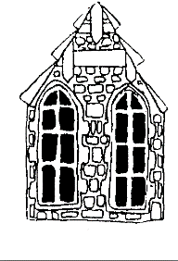  Pennaeth/Headteacher  Mrs. Rhian Wilkie | FRANKSBRIDGE SCHOOL  Franksbridge  Llandrindod Wells  Powys  LD1 5SA

Child’s Name: ___________________________________

I hereby agree to my child:
- Taking part in school visits and other activities that take place off school premises; and
- To be given first aid or urgent medical treatment during any school visit or activity.

Please note the following important information before signing this form:

- The visits and activities covered by this consent include:
- All visits (including residential visits) which take place during the holidays or a weekend
- Adventurous activities at any time
- Off-site sporting fixtures outside the school day
- All off-site activities for nursery schools
- The school will send you information about each trip or activity before it takes place
- You can, if you wish, tell the school that you do not want your child to take part in any particular school visit or activity.

Written parental consent will not be requested from you for the majority of off-site activities offered by the school, for example, year group visits to local amenities, as such activities are part of the school’s curriculum and usually take place during the normal school day. Where visits fall outside the scope of the consent, visit specific consent will be requested.

Please complete the medical information section below (if applicable) and sign and date this form if you agree to the above.

Medical Information

Details of any medical condition that my child suffers from and any medication my child should take during off-site visits.

_______________________________________________________________________________________

_______________________________________________________________________________________

Full name and signature of Parent/Carer: _____________________________________________________

Address: ______________________________________________________________________________

__________________________________________ Date: _______________________________________

APPENDIX 7

YSGOL PONTFFRANC  Pontffranc  Llandrindod  Powys  LD1 5SA | Pennaeth/Headteacher  Mrs. Rhian Wilkie | FRANKSBRIDGE SCHOOL  Franksbridge  Llandrindod Wells  Powys  LD1 5SA

Annwyl Rhieni a Gofalwyr,
Dear Parents and Carers,

Consent Form for Photography and Videos of Children

As you will be aware, photographs and videos of your child/ren are regularly taken in school and on trips. These photographs and videos are used as records of activities and events and some are uploaded to the school website. However, individual children are never identified by name. Before taking any photographs of your child, we need your permission. You may withdraw your consent at any time.

Over the last few years, we have had an increasing number of requests from groups associated with our school such as Oakerwood (residential centre), Sports Wales and Mid Wales Music Trust, asking for permission to use photos for their websites and social media sites. I have, therefore, renewed the permission form to take these situations into account.

Please answer the questions, sign and date the form and return it to the school as soon as you are able. Should you have any queries, please do not hesitate to contact me.

Yn gywir/Yours sincerely,

Mrs. Wilkie

Pennaeth/Headteacher

Name of child (Block Capitals) :
Name of person responsible for the child:
I give permission for:
 |  | Yes | Never | At times – please ask specifically at the time
Photographers acting on behalf of the school or Powys County Council may take images for use in books, displays and publications
The school or Powys County Council may take images for use on a website
The local media may take and publish in newspapers images of activities that show the school and children in a positive light
Mid Wales Music Trust may take images for use in displays or in publications
Mid Wales Music Trust may take images for use on their website
Mid Wales Music Trust may take images for use on social media
Sports Wales may take images for use in displays or in publications
Sports Wales may take images for use on their website
Sports Wales may take images for use on social media
Other groups associated with school may take images for use in displays or in publications
Other groups associated with school may take images for use on their websites
Other groups associated with school may take images for use on social media
If you have any comments or stipulations relating to this issue, please include them in the box below for our attention.
Comments:

Signature
Relationship to the child:
Date (date/month/year):

APPENDIX 8

YSGOL PONTFFRANC  Pontffranc  Llandrindod  Powys  LD1 5SA | Pennaeth/Headteacher  Mrs. Rhian Wilkie | FRANKSBRIDGE SCHOOL  Franksbridge  Llandrindod Wells  Powys  LD1 5SA

Annwyl Rhieni a Gofalwyr,
Dear Parents and Carers,

Hwb Platform: Changes to Access Arrangements

From September 2018, it is compulsory for all pupils in maintained schools in Wales to be provided with a secure log-in to the Hwb Platform.

Please find enclosed the following documents:-

Schedule 1 – outlining details of the data that will be shared with the Welsh Government;
Schedule 2 – consent form for completion and return to school;
Schedule 3 – Security

Although not compulsory, I would recommend that you agree and sign up to the Additional Services as this will allow access to useful learning resources.

Should you have any queries, please do not hesitate to contact me.

Yn gywir/Yours sincerely,

Mrs. Wilkie

Pennaeth/Headteacher

YSGOL PONTFFRANC  Pontffranc  Llandrindod  Powys  LD1 5SA | Pennaeth/Headteacher  Mrs. Rhian Wilkie | FRANKSBRIDGE SCHOOL  Franksbridge  Llandrindod Wells  Powys  LD1 5SA

Schedule 1 – Data

Pupil Data:

- Surname
- Forename
- Date of birth (only for the purpose of Online Personalised Assessments)
- Gender
- Class/registration group – name and ID
- Subject/class (allow for multiple entries) – name and ID
- National curriculum year
- School – name and ID
- Hwb hashed UPN

Staff data:

- Surname
- Forename
- Subject/class/registration group (allow for multiple entries) with which member of staff is associated (if available) – name and ID
- National curriculum year with which member of staff is associated (if available, e.g. for heads of year)
- School – name and ID
- Staff identifier – letters/number (though Hwb log-in may be used as staff ID)
- Teacher Category

Headteacher:

- Surname
- Forename
- School – name and ID
- Staff identifier – letters/number (though Hwb log-in may be used as staff ID)
- Teacher Category

YSGOL PONTFFRANC  Pontffranc  Llandrindod  Powys  LD1 5SA | 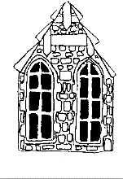  Pennaeth/Headteacher  Mrs. Rhian Wilkie | FRANKSBRIDGE SCHOOL  Franksbridge  Llandrindod Wells  Powys  LD1 5SA

Schedule 2 – Consent Form

The Hwb Platform

The Hwb platform provides all maintained schools in Wales with access to a wide range of centrally-funded bilingual digital tools and resources to support the digital transformation of classroom practices. The Hwb platform is managed and operated by the Welsh Government.

All pupils in maintained schools in Wales must be provided with a secure log-in to the Hwb platform. This is because mandatory reading and numeracy tests, currently on paper, have moved or will be moving in the near future online and must be completed by each pupil via the platform. In order to provide your child with a secure log-in, the school will be sending basic information to the Welsh Government. The log-in will allow your child to take the mandatory online assessments, known as “personalised assessments”.

For more information about the Hwb platform and how information about your child is used, please see
https://hwb.gov.wales/privacy
For more information about the online personalised assessments please see
https://learning.gov.wales/resources/collections/national-reading-and-numeracy-tests?lang=en#collection-2

Additional Services

If you agree, Welsh Government can also provide your child with access, via the Hwb platform, to a variety of additional services which are provided by other organisations. These include online learning environments such as Hwb Classes, Microsoft Office 365, Google for Education, and other relvant educational tools and resources. Welsh Government is making these additional services available to help your child access educational resources. These additional services are centrally funded and there is no cost for you or for your school to access and use them.

Welsh Government will only provide access to these additional services if you sign the form below to indicate your agreement.

Your Agreement

If you agree:
- We will tell Welsh Government to provide access to the additional services
- Welsh Government will share information about your child with its service providers, including Microsoft and Google Education, in order to enable access to the additional services

If you do no agree, we will still share information about your child with Welsh Government to set up a secure log-in for the Hwb platform but your child will not be able to access the additional services.

If you wish to withdraw your consent, please contact the Headteacher.

Signature

Please sign and date this form if you agree to the above

Name: __________________________________ Signed: _________________________________

Date: _________________________________
YSGOL PONTFFRANC  Pontffranc  Llandrindod  Powys  LD1 5SA | Pennaeth/Headteacher  Mrs. Rhian Wilkie | FRANKSBRIDGE SCHOOL  Franksbridge  Llandrindod Wells  Powys  LD1 5SA

Schedule 3 – Security
The Hwb Platform

The Platform has data protection requirements included as part of the design process, the main intention being to prevent:

- Unauthorised people seeing personal data
- Unauthorised changes to personal data

The Platform is assessed at least once a year to make sure the security measures remain appropriate, this includes risk reviews and ethical hacking tests.

The Platform is cloud-based and only cloud service providers that meet the following are used:

- Data centre locations:
- Either, in the UK, Euripe or other countries that have been independently assessed as implementing suitable data protection arrangements
- And/or, a contractual commitment to enforce data protection principles, using wording that has been independently approved as being suitable
- Physical security at their data centres to prevent intruders
- Technical security measures as part of the cloud service to make sure personal data is safe.

For the Plantform functionality controlled by Welsh government the following technical security measures are implemented:

- Additional authentication for access to administrative functions
- Use of encryption when sending or receiving personal data
- Controls to prevent web-based attacks, such as:
- Cross-site scripting
- SQL injection
- Clickjacking
- Cross-site request forgery

Additional Services

Only services that can demonstrate compliance with Data Protection Legislation will be accessible via the Platform.

Where feasible access to Additional Services will use pseudonymised data, this means using a temporary unique but non-identifying value instead of your name, so that the service being accessed knows you are an authorised Hwb user, but not who you are.

For some Additional Services, identification is a fundamental requirement of the service being offered, for example e-mail. For these services, the personal data shared will be restricted to what is necessary to make the service available, this will minimise what the services knows about you.

