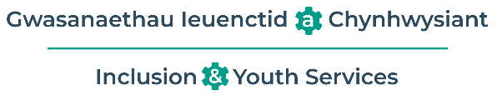


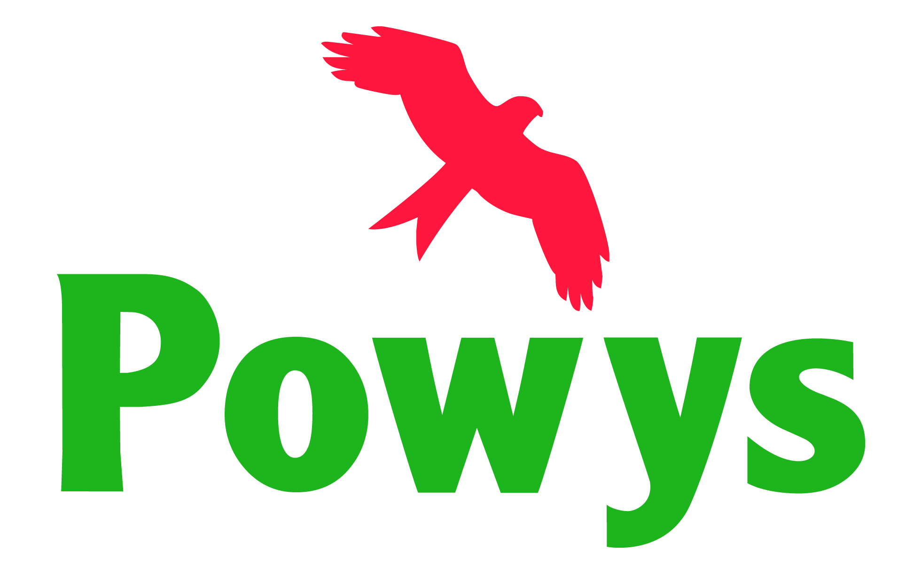

Powys County Council
Education Services

Policy for

Children Looked After (CLA)
Children Previously Looked After (CPLA) including adopted children and/or children under special guardianship order (SGO)
Children on edge of care

Date reviewed: | 01/07/2024
Next review date: | 01/07/2026

Mae’r ddogfen hon hefyd ar gael yn Gymraeg
Contents Page

- Introduction and Legal Framework 3
- Definitions 4
- Powys Virtual School 5
- Supporting Powys schools 5
- Corporate parenting 6
- Personal Education Plans 7
- Funding 8
- Responsibility of Powys Schools 8

Introduction and legal framework
‘Children looked after’(CLA refers to children who are looked after by local authorities in Wales. A child is a person who is aged under 18. Section 74 of the Social Services and Well-being (Wales) Act states that a child who is looked after by a local authority is a child who is in its care; or provided with accommodation, for a continuous period of more than 24 hours, by the authority in the exercise of any functions which are social services functions.
Adoption is the legal process by which a child or siblings who cannot be brought up within their birth family become full, permanent and legal members of their new family. Adopters become the child's legal parents with the same rights and responsibilities as if the child was born to them. Most adopted children have lived in foster care for part of their childhood. Time spent in foster care can range from days to several years, and many children have more than one foster placement before being placed for adoption.
Special guardianship is a family court order that places a child or young person in long-term care with someone other than their parent(s). The person(s) with whom the child lives with will become the child’s special guardian.
Children are classed as on the edge of care when there are serious child protection concerns and Children’s services are working with the family and other agencies to avoid a care order.
The Virtual School sits with the Local Authority for the purpose of discharging the local authority's duty under Social Services and Well-being (Wales) Act 2014 – Part 6 Code of Practice (Looked after and Accommodated Children) to promote the educational achievement of its Children Looked After.
The Virtual School will wherever possible, provide advice to support children who are adopted, those under special guardianship and those classed as on edge of care.

Children Looked After (CLA) and Children Previously Looked After (CPLA) are, statistically, more at risk of academic underachievement and are at greater risk of exclusion. Many CLA will have experienced disruption to their educational experience, either through periods of being out of education or because of the wider disruption in their life, including the significant emotional impact caused by both the life experiences that led to them becoming a Child Looked After, and the emotional impact of being a CLA and being separated from their family. In addition, many CLA also have Additional Learning Needs (ALN).
Supporting CLA and CPLA to succeed and improve their prospects is a key priority for the Schools Service and Powys County Council.
Powys County Council recognises, however, that all learners are individuals: despite the vulnerabilities listed above, it is not appropriate to assume that all CLA will be negatively affected or will require additional support to succeed in education. Therefore, we will ensure that all CLA or CPLA are assessed according to their individual needs and supported appropriately thereafter.
This policy takes account of the following:
- Section 52 of the Children Act 2004.
- Section 20 of the Child and Young Persons Act 2008.
- Part 6 of the Social Services and Well-Being (Wales) Act 2014.
- Making a difference: A guide for the designated person for looked after children in schools (Document nº: 255/2017, November 2017).
- The Additional Learning Needs Code for Wales (2021)

Definitions
For the purposes of this policy, a Child Looked After is a child who is looked after by a local authority within the meaning of section 76 of the Social Service and Well-Being (Wales) Act or section 22 of the Children Act 1989. For the purposes of this policy, Children Looked After encompasses both CLA by Powys and Children of Other Local Authorities (COLA) who may or may not attend schools maintained by Powys but who reside in Powys.
The term Child Previously Looked After refers to a child who is no longer looked after in England and Wales because s/he is the subject of an adoption, Special Guardianship Order (SGO), or child arrangements relating to with whom the child is to live or has been adopted from “state care” outside England and Wales.
The approach of the Schools Service to supporting the educational achievement of CLA and CPLA is based on the following principles:
- Prioritising education
- Promoting attendance
- Supporting transitions
- Targeting support
- Having high expectations
- Promoting inclusion by challenging individuals’ attitudes and changing those attitudes
- Achieving stability and continuity
- Early intervention and priority action
- Student voice
- Promoting health and well-being
- Avoiding exclusions
- Working in partnership with carers, social workers, school staff and other professional

Virtual School
Powys Schools Service has a Virtual School team who can be contacted as follows:
Postal: Virtual School
Schools Service
County Hall
Llandrindod
LD1 5LG
Email: virtual.school@powys.gov.uk
Telephone: 01597 826000
The Virtual School consists of a team of specialist teachers and a caseworker and family liaison officer.
The function of the Virtual School is to
- Source education following a placement move
- Work closely with social workers and Independent Reviewing Officers (IROs) to ensure education within a child’s care plan is met
- Ensure all Personal Education Plans (PEPs) are completed termly
- Attend CLA reviews for the more complex cases
- Attend Team around the Cluster meetings to answer any queries from schools
- Attend statutory ALN panels
- Work with social care on engagement and participation events
- Maintain data on all Powys CLA
- Support and challenge schools in and out of county where Powys CLA attend
- Write and review all Local Authority Individual Development Plans (LAIDPs) for CLA with identified ALN
- Attend ALN meetings
- Consult with school UK wide when required
- Carry out school and placement visits
- Track the progress and outcomes of CLA learners
- Attend National Delivery Group meetings with Welsh Government
- Participate in Wels Government research
- Liaise with other Local Authorities with regards to Powys CLA
- Provide support and guidance to other Local Authorities for COLA
- Support unaccompanied asylum seeking children (UASC) with all aspects of education
- Arrange and monitor emergency tuition
- Arrange meetings to address concerns of attainment, attendance and behaviour
- Work directly with schools to avoid exclusions
- Work directly with multi agencies e.g. CAMHS etc
- Carry out direct intervention with a CLA or school
- Provide a model policy for schools
- Provide training for designated persons and staff in schools

Supporting Powys Schools
Schools that are maintained by Powys County Council may have on roll CLA by Powys as well as learners who are COLA. The Schools Service will ensure that these learners are known to be CLA by the school, and that their CLA status is accurately reflected on education information management systems, including accurately recording which local authority looks after them.
In addition, there will be learners on roll at Powys schools who are CPLA, either adopted or subject to an SGO. There is no mechanism by which these learners can be readily identified through information management systems: where learners are known to be CPLA, the Virtual School will maintain a list of these learners and provide support where appropriate.
The Virtual School will also maintain a list of Designated Persons for CLA in each school, and those Persons’ contact details. This will facilitate communication between the Schools Service and the Designated Person.
The Virtual School will provide information, advice and guidance to Designated Persons and their schools in respect of either CLA and CPLA as a group, or individual CLA or CPLA. This will include the provision of or signposting to training opportunities, and advice and signposting to relevant and appropriate routes for additional support for CLA and CPLA (for example, referrals to TYFU Powys ALN system). There are established principles for the provision of additional support for learners (i.e. a graduated response) which must be followed for all learners: having Looked After status does not circumvent these processes.
Whilst it is the responsibility of the school to liaise with any named social worker and the carers of CLA, the Virtual School can take a role in regard to fostering and supporting effective multi-agency working.
The Virtual School will monitor the academic outcomes of CLA who are educated in Powys Schools, through attendance at Personal Education Plan (PEP) meetings. Due to the low numbers of learners in any year group, year-on-year trends for CLA as a group are statistically unreliable: measures will instead take account of individual progress.

Corporate Parenting
In addition to having a direct role with Powys maintained schools in respect of CLA and CPLA, the Virtual School also has a role in supporting the education of all CLA by Powys.
The Virtual School will liaise with and support all partners (Children’s Services, carers, non-Powys schools, host local authority) in respect of educational provision, including, but not limited to:

- Admissions.
- Additional support.
- Funding.
- School consultations and placement
The Virtual School will also obtain and collate information and data on Powys CLA to monitor progress and outcomes, and to ensure the Corporate Parenting Group is able to fulfil its role. This data will include:
- Current academic levels.
- Attendance data.
- Exclusions data.
- Destinations data (where known).
Academic data cannot be combined into cohort measures, due to the differences in education systems in England and Wales.

Personal Education Plans (PEPs)
Each CLA must have a PEP as part of their overall care and support plan. It is the responsibility of the child’s named social worker to ensure that the PEP is completed, maintained and reviewed. Schools have a duty to contribute to the PEP. Part 6 of the Social Services and Well-Being (Wales) Act 2014 is clear that the PEP must be reviewed in line with the care and support plan as a whole, i.e at least every six months. However, Part 6 also states that the PEP should be treated as a living document. Best practice is that PEPs should be updated on a termly basis. Powys has an electronic PEP system as part of TYFU.
The Virtual School will support and facilitate the completion of PEPs by working with social care to book PEP meetings, providing log ins to Social Workers, Schools, Foster Carers for the ePEP Quality Assuring the completed school forms, and ensuring that Targets are SMART. This will allow the Virtual School to quality assure the data being provided, and allow the Schools Service to support the education of all Powys CLA regardless of where they are educated.
Where COLA attend Powys schools, the home authority for that child retains responsibility for the PEP and will liaise directly with the Powys school.
Where a CLA also has ALN/SEND, they will have an Individual Development Plan (IDP) as per 2021 ALN Code of Practice. As a CLA pupil they can only have a Local Authority held IDP.
CLA in England may have an EHCP or be on SEND Suppprt. CLA might also have another plan, such as an Individual Behaviour Plan (IBP) or a Pastoral Support Plan (PSP). Where a learner has any other educational plan, the Schools Service advocates that their PEP should align with that plan and they should be uploaded to the ePEP system, TYFU.
PEPs are not required for CPLA.

Funding
CLA in Wales are eligible to receive support via the Pupil Development Grant – Looked After Children (PDG LAC). The Schools Service will administer the PDG LAC as per the terms and conditions set by Welsh Government. The grant is available to any CLA looked after by any Welsh local authority and the Virtual School is funded for Powys CLA in Powys schools.
Where a CLA by an English authority attends a Powys maintained school, they are eligible for Pupil Premium (English funding model). Powys schools should liaise with the Virtual School for that child’s home authority: the Schools Service can advise on this.
CLA educated in special schools are not eligible for the PDG LAC.

Responsibility of Powys Schools
There is a model school policy for CLA, which all Powys schools are advised to adopt. This clearly sets out the responsibilities of the school, in both a statutory and advisory capacity.
For schools, this policy can be found at
https://hwb.gov.wales/networks/f8a73fdf-3918-46a5-8fa2-b8e8da9876d8/files/1bfdced9-238b-4aa5-8abf-8697d138bfc1
For those outside of Powys County Council a copy of the school’s model policy can be found on the school’s website or by emailing tyfu@powys.gov.uk

