About Me….. Victoria Esaias
Children & Families Team Worker, EIP
Supporting families in Sandfields, Aberavon, Baglan, and Briton Ferry areas of Neath Port Talbot
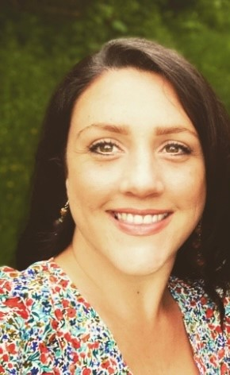
Tel/ Ffôn: 07815705847
Email: v.esaias@npt.gov.uk

What Can Our Team Offer?
Support for Families Across Neath Port Talbot
The Children & Families Team provides support to families with children aged 0–18 living throughout Neath Port Talbot.
We offer tailored one-to-one support through referrals made to the Early Intervention and Prevention Panel via SPOC. In addition, we deliver group sessions, play activities, and themed activity days to help families connect, learn, and grow together.
Attached is a list of the groups we currently offer and can support you with.
If you’d like more information or would like to arrange a visit from our team, please don’t hesitate to get in touch — we’re here to help.


