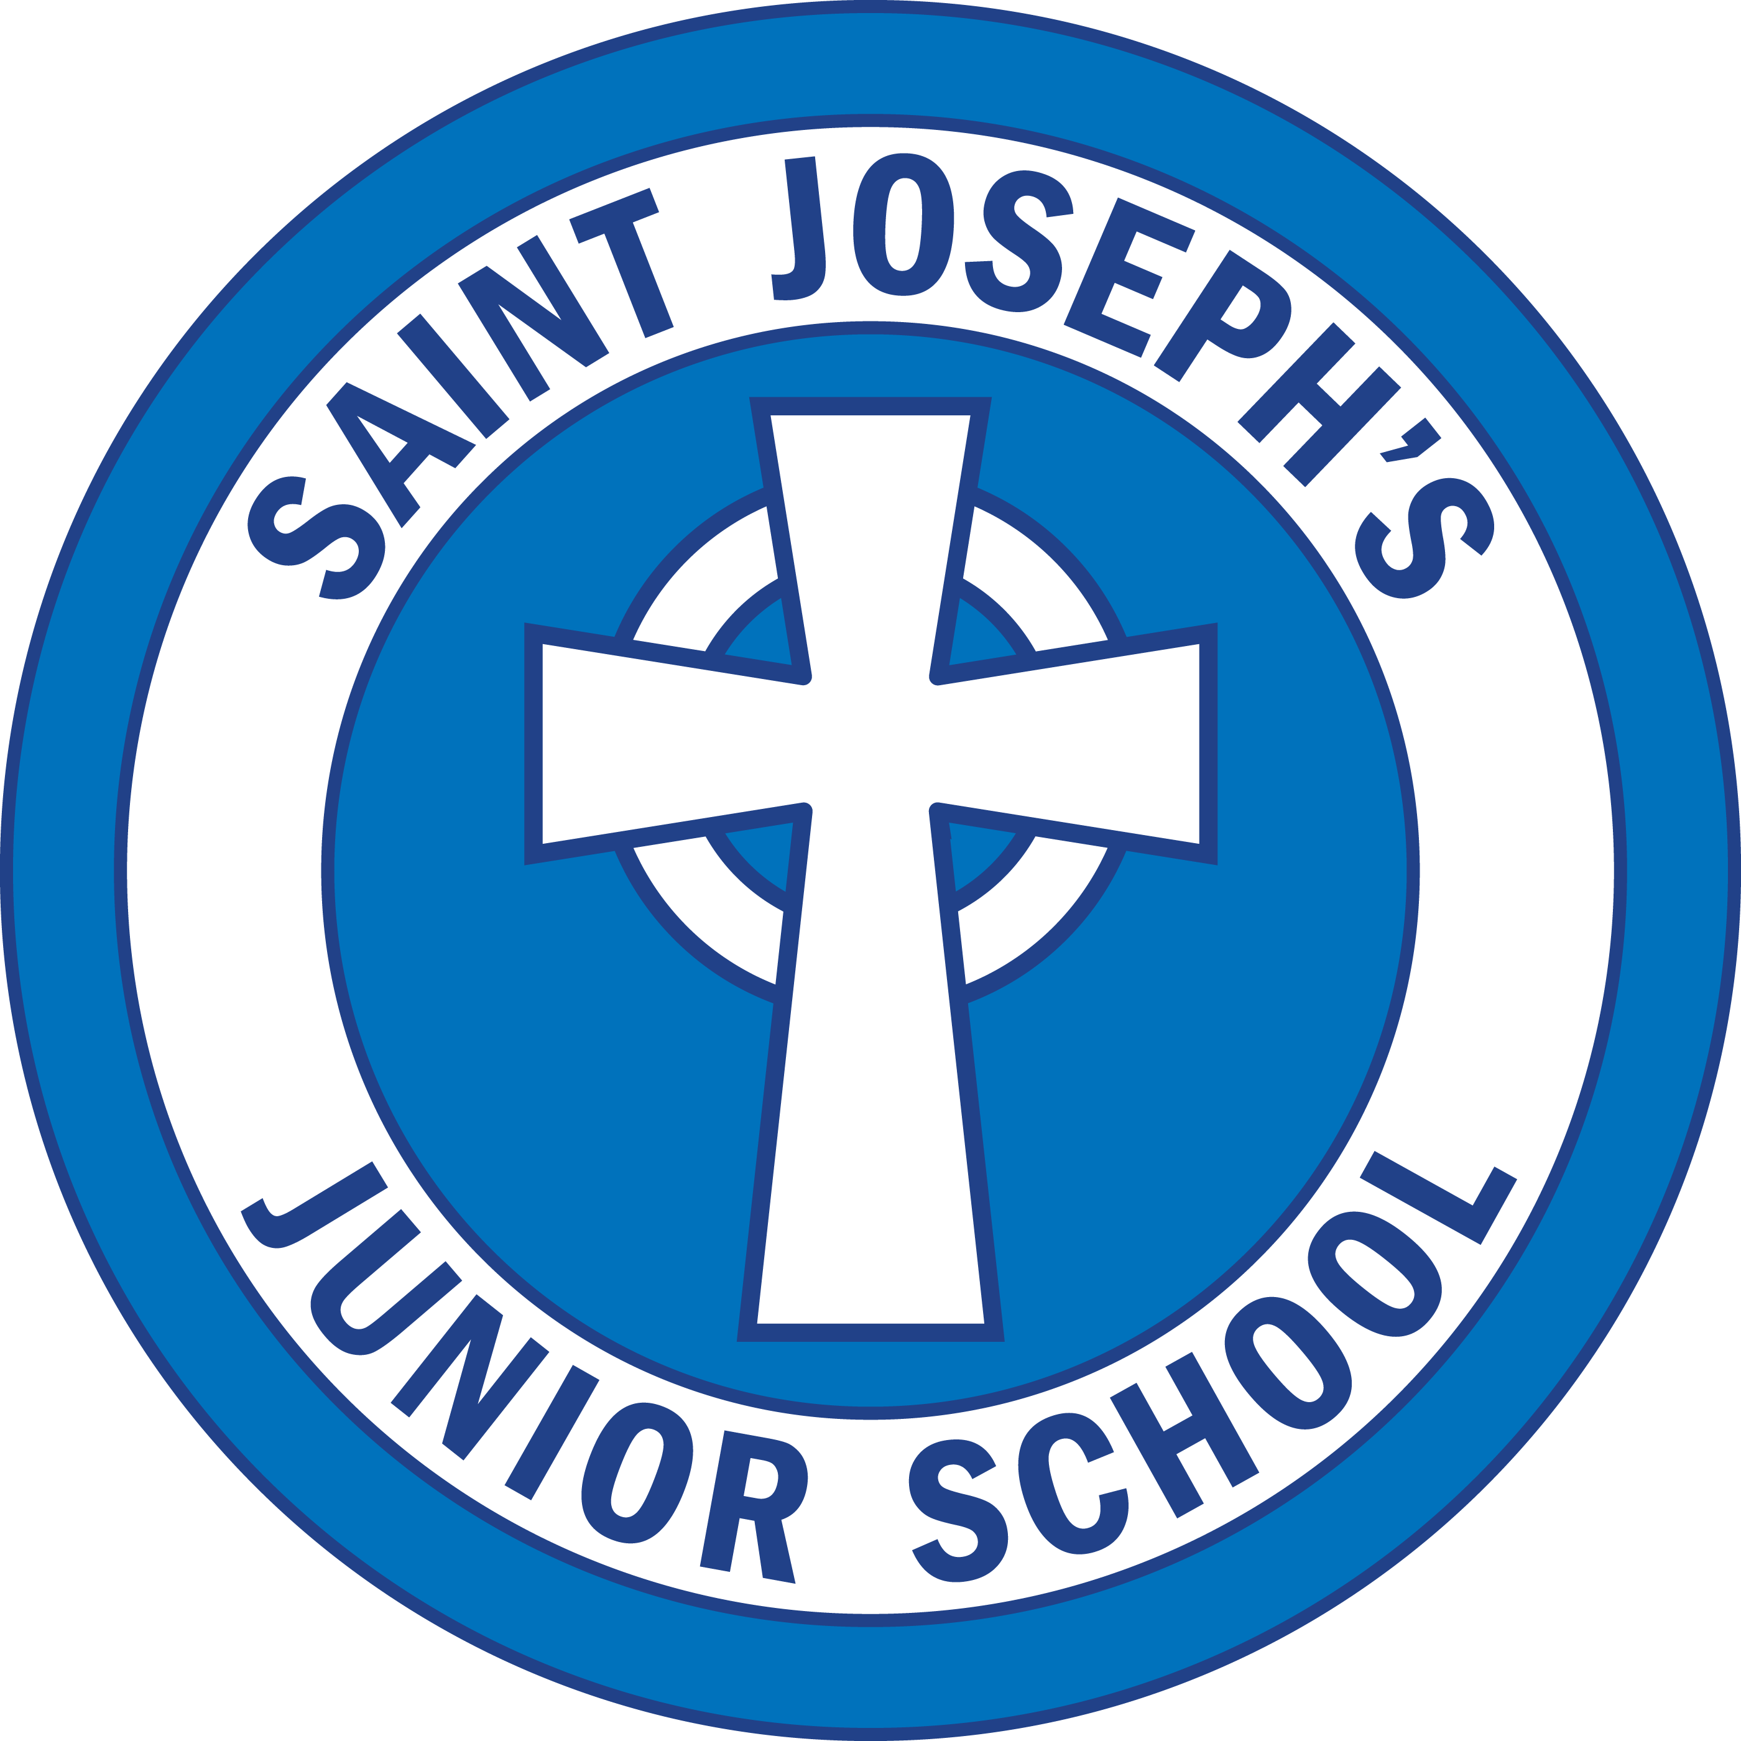

Additional Learning Needs Policy

Date: November 2025
Review Date: November 2026

1. Vision and Ethos
At St Joseph’s Catholic Junior School, we pride ourselves on our inclusive practice. The child is at the heart of every decision we make. We believe in maintaining a balance between what is important to the child (their interests, views, and wellbeing) and what is important for the child (their progress, development, and future aspirations).
Our commitment is to foster independence, confidence, autonomy, and resilience, enabling all learners to thrive. We aim to create a happy, secure, and stimulating environment where children are inspired to reach their full potential, collaborate respectfully, and celebrate both their own heritage and the diverse cultures of others.
We believe that every child has unique gifts, and all learners are valued regardless of attainment, gender, race, faith, or background. Every child is given access to a broad, balanced curriculum that is differentiated to meet individual needs—whether physical, sensory, emotional, behavioural, specific, or general. Children with Additional Learning Needs (ALN) are the responsibility of the whole school community.

2. Legislative Context
This policy is informed by:
- The Additional Learning Needs and Education Tribunal (Wales) Act 2018
- The Additional Learning Needs Code for Wales (2021)
- The Equality Act (2010)
- Welsh Government ALN Statutory Guidance (2023)
- Neath Port Talbot Local Authority Principles and Expectations Document
These frameworks replace the former Special Educational Needs (SEN) system with a unified approach to supporting learners with ALN through Individual Development Plans (IDPs).

The Key Principles:
- Early identification and assessment of need
- A continuum of support, proportionate to need
- Co-production with children, parents, and professionals
- Access to a broad and balanced curriculum
- Person-Centred Practice at the heart of decision making

3. Principles of Inclusion
- Early Identification: Timely recognition of ALN ensures prompt support and intervention.
- Child-Centred Approach: Children’s views, preferences, and strengths are central to all planning and review.
- Collaboration: All stakeholders—governors, leadership, teachers, support staff, and parents—work together to ensure inclusive provision.
- Cluster Collaboration: We work closely with our local cluster of schools to share best practice and maintain consistency.
- Balanced Provision: We recognise the equal importance of what is important to the child and for the child.

4. Aims
We aim to:
- Enable all children to access learning and achieve personal success.
- Create a stimulating and nurturing environment that motivates all learners.
- Deliver a differentiated, inclusive curriculum matched to each child’s abilities and interests.
- Work in partnership with parents, carers, and external agencies.
- Build self-esteem, confidence, and resilience.
- Ensure all staff are trained and equipped to meet diverse learning needs.

5. Roles and Responsibilities

ALNCo – Claire Thomas
The ALNCo is responsible for:
- Day-to-day operation of the ALN policy
- Maintaining the ALN register and records
- Coordinating ALN provision and interventions
- Liaising with staff, parents, and external agencies
- Overseeing assessment, IDP creation, and review
- Providing training and attending LA cluster meetings

ALN Governor – Katrina Heery
The ALN Governor ensures:
- Provision for ALN learners is monitored and evaluated
- Statutory duties under the ALN Code are met
- The school collaborates effectively with the Local Authority and partner schools

Class Teachers
Class teachers are responsible for:
- Early identification of ALN and sharing concerns with the ALNCo
- Differentiating the curriculum to meet individual needs
- Creating, monitoring, and reviewing IDPs
- Liaising with parents and support staff
- Implementing in-class support and interventions

Everyone – A Unified Approach
All staff, governors, and parents share responsibility for supporting children with ALN. Collaboration and communication are key to ensuring every child can succeed.

6. Identification and Assessment of ALN
Children may be identified as having ALN at any stage of their education.

Definition of ALN (Two-Step Test – ALN Code, 2021)
Test 1 – Learning Difficulty or Disability:
A child has a learning difficulty or disability if they:
(a) Have a significantly greater difficulty in learning than most of their peers, or
(b) Have a disability which prevents or hinders them from accessing education on an equal basis.
Test 2 – Need for Additional Learning Provision (ALP):
If the learning difficulty or disability calls for support additional to or different from that which is provided generally for others of the same age, the child is identified as having ALN.

Assessment Methods Include:
- Teacher observation and feedback
- Standardised and diagnostic assessments
- Pupil progress data
- Parental concerns and discussions
- Input from external professionals

7. Individual Development Plans (IDPs)
An IDP is a statutory plan outlining a child’s ALN, the Additional Learning Provision (ALP) required, and who is responsible for delivering it.
- IDPs replace previous IEPs or Statements of SEN.
- They are developed collaboratively with parents, pupils, and relevant professionals.
- IDPs are reviewed termly and updated annually (minimum).
- The plan includes measurable outcomes and next steps.

The Person-Centred Review Process:
A review meeting involves all relevant stakeholders (parents, child, teachers, ALNCo, and professionals). Discussions will include:
- What people appreciate about the child
- The child’s aspirations and what matters to them
- What works well and what doesn’t
- Agreed outcomes and an action plan
At the end of the review, all actions and responsibilities are clearly documented within the updated IDP.

8. Areas of Additional Learning Need
The four main ALN categories (ALN Code for Wales, 2021):
- Communication and Interaction – e.g. speech and language difficulties, ASD.
- Cognition and Learning – e.g. dyslexia, global learning delay, moderate learning difficulties.
- Social, Emotional and Mental Health – e.g. anxiety, attachment needs, emotional regulation.
- Sensory and/or Physical Needs – e.g. visual or hearing impairment, motor coordination difficulties.

9. Interventions and Support
St Joseph’s provides a wide range of interventions tailored to meet pupil needs, including:
- ELSA (Emotional Literacy Support Assistant sessions)
- Talkabout social communication groups
- Precision Monitoring for literacy and numeracy
- POPAT for handwriting and fine motor development
- Phonics multisensory programme for reading and spelling
- Dyslexia awareness and resource
- Tailored reading interventions for reluctant or low-attaining readers
- Sensory circuits and corridor activities
- Calm/cool down zones for emotional regulation
- Access to school-based counselling
- Collaboration with external professionals (Educational Psychology, SALT, OT, ASD team)
Provision is reviewed regularly to ensure impact and progress.

10. Curriculum Access and Inclusive Learning
All pupils have access to the full curriculum through high-quality teaching and effective differentiation. Strategies include:
- Adjusted questioning and scaffolded tasks
- Simplified language and instructions
- Use of visual aids, ICT, and multi-sensory materials
- Flexible grouping and targeted TA support

Inclusive Learning Provision (ILP):
Available to all pupils:
- Quality First Teaching
- Differentiated learning tasks
- Targeted small-group support
- Visual timetables and routines

Additional Learning Provision (ALP):
Targeted interventions for those identified with ALN:
- Structured programmes (literacy, numeracy, emotional wellbeing)
- Specialist input (SALT, EP, OT)
- 1:1 or small-group sessions
- Personalised learning resources

11. Parent and Pupil Involvement
Parents are valued as partners in their child’s learning.
- They are fully involved in the creation and review of IDPs.
- Ongoing communication is encouraged through meetings, emails, and parents’ evenings.
Pupils are encouraged to:
- Share their views and aspirations
- Contribute to target setting and review
- Develop independence and self-advocacy skills

12. Monitoring and Review
- The ALNCo monitors the progress of all learners with ALN.
- IDPs and interventions are reviewed termly for effectiveness.
- The ALN Governor and Headteacher evaluate policy implementation annually.
- Cluster collaboration supports consistency and best practice across schools.

13. Site Access and Inclusion
- Ramps and wide doors for wheelchair access
- Disabled toilets and parking facilities
- Easy access from car park to school
- Equal access to all learning, play, and extracurricular opportunities

14. Staff Training and Development
Staff receive regular training in:
- Dyslexia awareness and multi-sensory teaching
- Autism Spectrum Disorder support
- Emotional and social development (ELSA, Lego Therapy)
- Speech and Language strategies
- Sensory regulation and circuits
- POPAT handwriting programme
Training needs are identified annually and linked to both school and cluster priorities.

15. Useful Links
- Additional Learning Needs Code for Wales (2021)
- NPT Local Authority – ALN Principles and Expectations
- Welsh Government ALN Guidance

16. Policy Review
This policy will be reviewed annually or sooner if statutory guidance changes. Updates will reflect new interventions, local collaborations, and current best practice in inclusive education.
Headteacher: Caroline May
ALNCo: Claire Thomas
ALN Governor: Katrina Heery 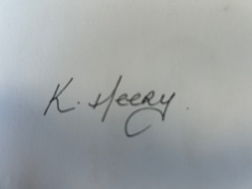
Date: November 2025

