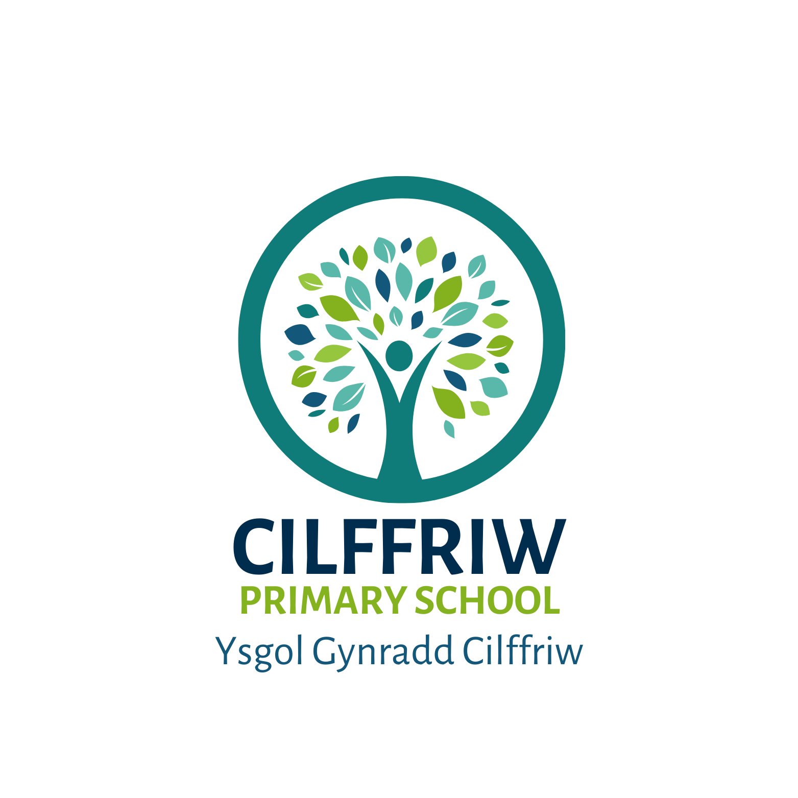

PUPIL DEVELOPMENT GRANT (PDG) STRATEGY STATEMENT
2024-25

Cilffriw Primary School
Pupil Development Grant (PDG) Strategy Statement

This statement details our school’s use of the PDG for the 2024 to 2025 academic year.

It outlines our strategy, how we intend to spend the funding in this academic year and the effect that last year’s spending had within our school.
.

School Overview
Number of pupils in school | 144 (13 part time pupils)
Proportion (%) of PDG eligible pupils | 38.6%
Date this statement was published | October 2024
Date on which it will be reviewed | July 2025
Statement authorised by | Craig Storey
PDG Lead | Kate Key
Governor Lead | Simon Thomas

Funding Overview
Detail | Amount
PDG funding allocation this academic year | PDG - £37,950  EYPDG- £16,100
 | Total PDG- £54, 050
Total budget for this academic year | £970, 898

Part A: Strategy Plan

Statement of Intent
We believe that it is necessary for all learners to be socially and emotionally thriving demonstrating readiness to learn in an environment that is safe and secure. Leaders effectively plan, monitor and review strategically so that high quality teaching & learning meets the individual needs of all learners, accessing high expectations and support to achieve individual success. All learners receive effective support and interventions closely matched to individual need. Barriers are removed and success in learning will be achieved for learners make rapid progress and attainment, where progress is measured carefully and adjusted.
This is in line with our school vision and values:
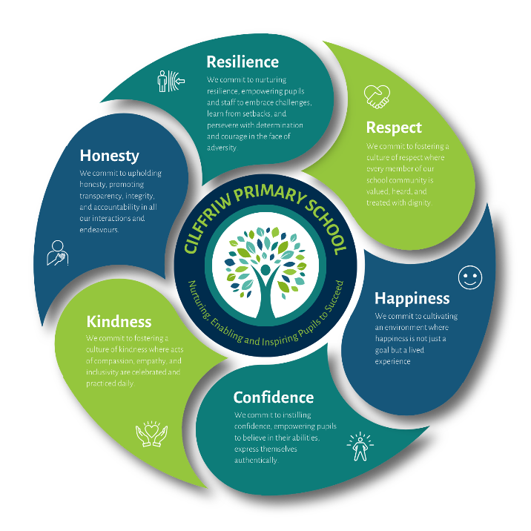
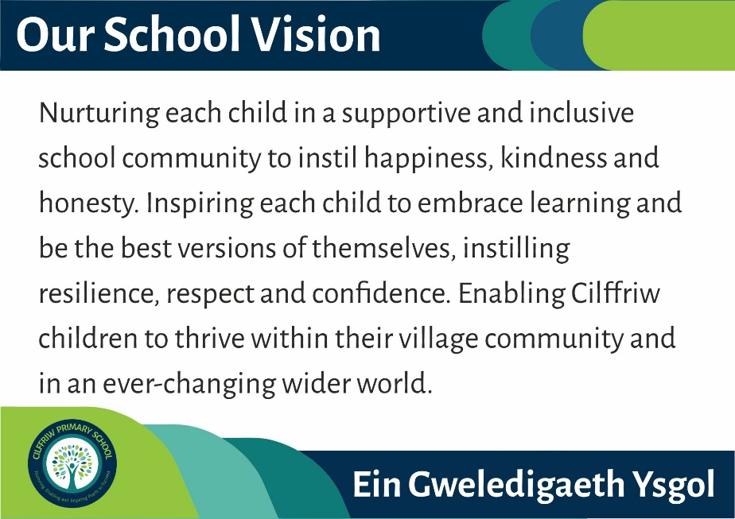

We will support out learners to become:

- Ambitious, capable learners, ready to learn throughout their lives
- Enterprising, creative contributors, ready to play a full part in life and work
- Ethical, informed citizens of Wales and the world
- Healthy, confident individuals, ready to lead fulfilling lives as valued members of society

Intended Outcomes

This explains the outcomes we are aiming for by the end of our current strategy plan, and how we will measure whether they have been achieved.

Intended outcome | Success criteria
- To improve teachers’ use of on-going assessment to inform appropriate next steps in pupils’ learning and to challenge pupils to achieve to the best of their ability. | • Teachers and teaching assistants have high expectations of what pupils can achieve.  • Teachers tailor their teaching approaches to meet pupils’ needs successfully.  • Teachers provide pupils with learning activities with suitable challenge and that build systematically on pupils’ existing knowledge, understanding and skills.  • Teachers take the opportunity to address misconceptions that arise when pupils are completing tasks independently.  • Teachers ensure independent learning activities enable pupils to consolidate previous learning, deepen their knowledge or extend pupils’ skills suitably.  • Many pupils achieve effective progress over time.  • Many pupils produce work across the curriculum that is of a good quality.  • Teachers do not over-direct tasks in small group teaching.  • Teachers use formative assessment effectively to evaluate pupils’ progress in learning and to plan for pupils’ next steps.  • Teachers provide pupils with success criteria with a suitable level of challenge.  • Teachers’ written feedback informs pupils of what they need to do to improve and supports pupils to progress with their learning.  • Teachers deploy teaching assistants effectively to support and enhance pupils’ progress with their learning.
- To improve provision for the teaching of and the progressive development of pupils’ skills. | • Many pupils develop their letter formation well and present their work neatly.  • Many pupils develop their technical writing ability well including the use of accurate punctuation and spelling.  • Many pupils add interest to their writing by varying their sentence structures successfully and through using a range of vocabulary.  • Many pupils edit and redraft their work to improve its quality.  • Teachers will promote the Welsh language successfully and ensure progressive development in pupils’ Welsh language skills.  • Many pupils will develop a strong grasp of Welsh vocabulary and sentence patterns, in line with the expectations for their stage of learning. Many pupils will use the language with increasing confidence both within and outside of Welsh lessons.  • Pupils will develop the full range of mathematical skills and knowledge.  • Many pupils apply their numeracy skills to real-life contexts and across the curriculum well.  • Many pupils will develop a wide range of digital skills successfully and apply these skills at an appropriate level, across the curriculum.  • Teachers provide pupils with learning activities with suitable challenge and that build systematically on pupils’ existing knowledge, understanding and skills.  • Many pupils achieve strong progress and produce work across the curriculum to a good standard.  • Teachers provide opportunities for pupils to apply their crosscurricular skills in meaningful contexts across the curriculum.  • Teachers ensure independent learning activities enable pupils to consolidate previous learning, deepen their knowledge or extend pupils’ skills suitably

Activity in this academic year

This details how we intend to spend our PDG this academic year to address the challenges listed above.
Professional Learning to continue to evolve practice:

- Ongoing use of on-going assessment (high quality teaching and learning):
- When planning, teachers will take account of the principles of progression and the Progression Code document.

- LA to support teachers to continually evolve the curriculum they provide to pupils, ensuring their planning supports pupils to progress in line with the principles of progression and the progression code.
- Two teachers to attend NPT teaching and learning programme (6 days training with follow-up sessions with the Education Support Officer back in school between each training day) which will model excellent teaching and learning while informing, upskilling and motivating the teachers in line with the core values of the Curriculum for Wales and a shared understanding of progression.
- LA to provide two workshops for teachers focused on: • What is formative assessment? Developing clarity with what you want pupils to learn and why? Understanding the link between learning intentions, success criteria and effective feedback.
- Following the series of workshops, Acting Headteacher to arrange termly ADDs sessions where teachers will share examples of pupils’ work in triads. Teachers to discuss the following aspects about the pupils’ work: • What was the learning intention and why? • How did this work enable pupils to either consolidate prior learning; build on pupils’ prior knowledge or skills; or transfer their learning to new contexts? • What are the pupils next steps?
- LA to provide training for teachers on developing effective success criteria and improving the quality of feedback to pupils. The session will include training on ‘live’ marking, the effective use of success criteria, pit-stops, mini-plenaries.
- SLT and teachers to develop their own bespoke tracking system for assessing and recording pupil progress with their literacy and numeracy skills. Teachers to use this system to plan for pupils’ next steps in their learning.

- Progressive development of pupils’ skills (high quality teaching and learning):
- LA to support the literacy coordinator to strengthen the curriculum for literacy and in particular, the progressive development of pupils’ writing skills, in line with the areas for development identified in the review and ensuring there are effective opportunities within the school’s curriculum for pupils to: • Develop their letter formation and present their work neatly. • Develop their technical writing ability well including the use of accurate punctuation and spelling. • Add interest to their writing by varying their sentence structures successfully and through using a range of vocabulary. • Edit and redraft their work to improve its quality.
- LA to provide professional learning in line with areas identified for development within the review. Professional learning to also focus on developing an effective approach to developing pupils’ writing skills, strengthening pupils’ technical writing ability, spelling, punctuation, sentence construction, use of vocabulary and their ability to redraft their writing to improve its quality. LA to provide training in effective opportunities for pupils to develop their literacy skills across the curriculum.
- Literacy coordinator to develop exemplars of what the writing process looks like when it is good, at Cilffriw Primary School and share with all teachers. Literacy coordinator to develop nonnegotiables criteria so that all teachers are clear on the expectations of the approach to teaching writing and the transference of literacy skills across the curriculum at Cilffriw Primary School.
- Teacher Development Officer (TDO) for Mathematics to work alongside the school’s numeracy coordinator to provide in class coaching to teachers focused on the effective delivery of the CPA approach and in line with the areas identified for development for teaching in Rec. 3. For example: • Teachers provide pupils with learning activities with suitable challenge and that build systematically on pupils’ existing knowledge, understanding and skills. • Teachers take the opportunity to address misconceptions that arise when pupils are completing tasks independently. • Teachers ensure independent learning activities enable pupils to consolidate previous learning, deepen their knowledge or extend pupils’ skills suitably.
- TDO for Mathematics to provide training in effective opportunities for pupils to develop their numeracy skills in real life contexts and across the curriculum.
- TDO to support the Welsh coordinator and teachers to strengthen the curriculum for Welsh and particularly the progressive development of pupils’ skills. (R4.19) LA to provide professional learning in line with areas identified for development within the review of Welsh and areas identified for development by Estyn.
- Curriculum Development Officer (CDO) to provide whole school professional learning focused on the effective delivery of Drilio.
- TDO for Digital Learning to work alongside Digital Learning coordinator to review the school’s current provision for digital learning, with a particular focus on communication, coding, modelling, data and computational thinking. How effective is the school’s current curriculum for developing digital competency? How well do teachers currently plan for the progressive development of pupils’ digital skills across the curriculum? What professional learning is required to strengthen provision for digital skills? How well resourced is the school?
- TDO to support the digital learning coordinator and teachers to strengthen the curriculum for digital competency, and particularly the progressive development of pupils’ communication, coding, modelling, data and computational thinking.
- TDO to provide professional learning for teachers in line with areas identified for development within the review of pupils’ communication, coding, modelling, data and computational thinking.

Targeted Interventions
- Continue to fund Teaching Assistants to provide targeted intervention to targeted pupils to support their progress with basic skills and their wellbeing, increasing capacity for ELSA support.

Family Engagement Officer- Pilot
- To continue to support pilot funded by WG to improve community involvement within the school.

Activity in this academic year These details how we intend to spend our PDG this academic year to address the challenges listed above.

- Ongoing use of on-going assessment (high quality teaching and learning):
Budget Cost: £20,000

Activity: | Evidence that supports this approach:
- Two teachers to attend NPT teaching and learning programme (6 days training with follow-up sessions with the Education Support Officer back in school between each training day) which will model excellent teaching and learning while informing, upskilling and motivating the teachers in line with the core values of the Curriculum for Wales and a shared understanding of progression.  - Creating enabling environments across the school to enable effective learning.  - Resourcing and enabling freely chosen, self-directed play through rich play opportunities including provision for outdoors (forest schools).  - Tracking progress and attainment of identified learners/groups.  - Identifying ELSA support and training an additional member of staff using SDQ and other evidence.  - Staff members developing their understanding of the pedagogical principles through collaboration activities (visits to other schools across Wales, triad working, cluster professional inquiries, research, training, coaching with TDOs).  - Staff members to be trained and supported to effectively understand that integral skills are integral to the 4 purposes (critical thinking and problem solving, personal effectiveness, planning and organising, creativity and innovation).  - Staff members to develop their understanding of how an effective curriculum supports effective pedagogy through training (Learning Partnership, Kath Murdoch) school visits, research tasks.  - Staff to understand that ongoing assessment through observing, analysing and responding can lead to accelerated progress for pupils. They will receive training (LA, Internal, Gareth Coombes) carry out research (including school to school collaboration), collaborate internally and externally to trial initiatives (in the moment marking, success criteria, pupil progress meetings). | Evidence from the Education Endowment Foundation highlights that the development of pupils’ higher order thinking skills has ‘very high impact for very low cost based on extensive evidence’ (an additional 7 months progress over the academic year).  The Sutton Trust reports that: Outdoor Adventure Learning might provide opportunities for disadvantaged pupils to participate in activities that they otherwise might not be able to access. Through participation in these challenging physical and emotional activities, outdoor adventure learning interventions can support pupils to develop non-cognitive skills such as resilience, self-confidence and motivation. The application of these non-cognitive skills in the classroom may in turn have a positive effect on academic outcomes.  Chartered College of Teaching (CCT) and the Helen Hamlyn Centre for Pedagogy (0-11 Years) at IOE, UCL’s Faculty of Education and Society REA findings: This rapid evidence assessment addressed the effects of experiential learning approaches on children’s motivation, engagement, agency, wellbeing, and academic achievement, as well as children’s own experiences and views of experiential learning. The evidence points to experiential learning having a strong positive effect on all these outcomes, as well as on other outcomes not initially identified for analysis, including children’s connections with nature, environmental and ecological awareness, and the development of practical skills. Dewey in his book Experience and Education (1938).  Introducing teaching of metacognitive habits and dispositions. EEF Metacognition and Self-regulation- Very High Impact

2.Progressive development of pupils’ skills (high quality teaching and learning):
Budget Cost: £20,000

Activity: | Evidence that supports this approach:
- All staff to continue to receive professional learning on the effective delivery of synthetic phonics programme (Monster phonics).  - All staff to receive training and support (LA and Helen Bowen) to develop their understanding of the process for teaching writing (driven by high quality literacy texts and by developing oracy, reading and writing skills simultaneously).  - All teachers to receive professional learning focused on how to develop pupils’ conceptual understanding through verbal, concrete, visual, and abstract approaches in Mathematics. | Evidence from the Education Endowment Foundation highlights that the development of pupils’ phonics has ‘very high impact for very low cost based on extensive evidence’ (an additional 5 months progress over the academic year). Significant evidence exists which highlights that the embedding of a systematic approach to the teaching of synthetic phonics has a considerable impact on pupils’ progress with reading and ability to access the wider curriculum.  EEF Communication and Language Approaches- Very High Impact

Targeted Interventions
Budget Cost: £10,000

Activity: | Evidence that supports this approach:
- Continue to fund Teaching Assistants to provide targeted intervention to targeted pupils to support their progress with basic skills and their wellbeing, increasing capacity for ELSA support. | Evidence from the Education Endowment Foundation highlights that the use of Teaching Assistants to provide targeted intervention skills has ‘moderate impact for moderate cost based on moderate evidence’ (an additional 4 months progress over the academic year).  Evidence from the Education Endowment Foundation highlights that the development of pupils’ social and emotional learning has ‘moderate impact for very low cost based on very limited evidence’ (an additional 4 months progress over the academic year). Evidence from school monitoring highlights progress many pupils make with their overall wellbeing and self-esteem through participating in nurture provision, Elsa etc.  Corridor circuits to aid Gross Motor Skills (Sensory Processing).

Community Schools
Budget Cost: £4,000

Activity: | Evidence that supports this approach:
Family Engagement Officer- Pilot  - To continue to support pilot funded by WG to improve community involvement within the school.  - Activities include parental engagement, community engagement, working with vulnerable families, attendance.  - Workshops will be run for parents to help them support their children at school (Maths, cooking on a budget, Science, budgeting).  - Flying Start will use a room within our school to support new families. | Evidence from the Education Endowment Foundation highlights that parental engagement has ‘moderate impact for very low cost based on extensive evidence’ (an additional 4 months progress over the academic year).  Evidence from Janet Goodhall’s ‘parental engagement’ shows significant impact with children’s learning particularly in areas of high deprivation. In addition, evidence from local schools that have already developed the role and highlights positive impact regarding attendance, wellbeing and learning outcomes.  Evidence from Education Endowment Foundation shows significant impact when parents engage at home with their children. EEF Parental Engagement- Moderate Impact  The 4 Pillars of Parental Engagement-Robbins & Dempster, 2021. Engage Every Family-Constantino, 2021

PDG outcomes
For evidence of the impact of the PDG for the last academic year please ask school for information.

Further information (optional)
At Cilffriw Primary our FSM, ACEs and additional varying vulnerabilities in our community mean that we aim for all our strategies to impact holistically on all our children. We know our families well and recognise that the range of different challenges facing our community may not be highlighted by PDG identification. As a result, our primary aim is to prioritise the wellbeing of our community and to introduce ways of working that will positively impact our learners both in school and in the wider social context of the community. Our approach to teaching & learning is continuing to evolve so that our children build the skills, habits and dispositions of good learners in line with our school vision and values.
Review of PDG Plan 2024-25
Intended outcome: | Review of PDG:
To improve teachers’ use of on-going assessment to inform appropriate next steps in pupils’ learning and to challenge pupils to achieve to the best of their ability. | Leaders demonstrate a clear understanding of the school’s strengths and areas for improvement in teaching and learning. The headteacher monitors the quality of teaching and has a detailed understanding of individual staff members’ professional strengths and development needs. Where areas for improvement are identified, appropriate support is put in place promptly. The deputy headteacher and literacy leader have participated in the Neath Port Talbot teaching and learning programme, which promotes high-quality teaching aligned with the Curriculum for Wales and deepens understanding of pupil progression. In addition, two members of staff benefit from working with a teaching and learning coach. These professional learning experiences are beginning to have a positive impact on the consistency and quality of teaching across the school, which impact on pupils eligible for FSM. The Deputy Headteacher and Literacy Lead have supported staff in developing more consistent teaching and assessment practices. This has led to increased collaboration and a growing focus on using a range of evidence to judge progress. These approaches are developing well and show potential to improve consistency and outcomes further across the school.  The headteacher works closely with teachers to develop and refine the school’s curriculum, ensuring that planning aligns well with the principles of progression and the progression code. This collaborative approach has led to a curriculum that increasingly supports all pupils to make meaningful progress over time. In the Nursery and Reception, staff have successfully strengthened the enabling learning environment, experiences and skills as enabling adults. These improvements have led to noticeable gains in pupils’ ability to think critically, solve problems, and take increasing ownership of their learning. As a result, pupils are becoming more independent, creative, and confident in organising their own learning experiences. Practice in Nursery and Reception has been recognised as good practice within the local authority. The effective approaches used in these classes are being shared across the early years phase and have attracted visits from a number of teachers and school leaders from across the local authority, who are keen to learn from the school’s strong provision in this area.  The Deputy Headteacher has introduced teaching triads across the school to support professional learning and collaboration. As part of this process, staff have observed one another’s practice and produced brief impact reports outlining key reflections. This has helped to establish a more open and supportive culture, encouraging staff to engage with teaching across different classes. Although in its early stages, this work has already begun to strengthen professional dialogue. Following initial implementation, the Deputy Headteacher evaluated the approach and introduced a clearer focus to enhance its effectiveness. This now includes targeted staff training on specific areas of pedagogy, such as the use of worked models, followed by classroom trials and structured discussion. Collaborative sessions involving all staff are supporting the sharing of strategies and are beginning to build greater consistency in teaching and learning across the school.  Staff have developed a clearer understanding of what they want pupils to learn and why. They are beginning to use observations more effectively to inform the planning of meaningful and purposeful learning experiences. This practice is particularly strong in the Nursery and Reception classes, where observation is used skilfully to shape learning. As a result, provision in these classes is effective and is being shared as good practice across the school. Many teachers now have high expectations for pupils’ learning and progress. They have improved their ability to evaluate pupils’ learning and plan for their next steps. As a result, planned learning experiences increasingly allow pupils to consolidate prior learning, build on existing knowledge and skills, and apply their learning in new and unfamiliar contexts. Teachers are developing a secure understanding of the importance of planning for progression based on pupils’ developmental stages rather than their chronological age. This is beginning to support more personalised and responsive approaches to learning across the school.  The teacher with responsibility for this area of improvement has developed a progressive continuum for all aspects of formative assessment across the school. This supports staff in understanding and applying a consistent approach to assessment for learning. There is a growing understanding among teachers of the importance of purposeful learning intentions. Many staff are now using ‘steps to success’ with pupils to clarify expectations and support feedback. In a strong example observed in Year 3, ‘steps to success’ were clearly displayed in language that was accessible to the pupils. Ground rules for group work were well established, enabling effective collaboration and purposeful learning.  Teachers regularly provide verbal feedback and have adopted ‘live marking’ approaches during lessons. A colour-coded system using blue to highlight strengths and green to indicate areas for improvement has been introduced. This strategy is beginning to foster a positive culture where pupils are increasingly able to reflect on their work, self-assess, and make meaningful improvements. Pupil involvement in self-reflection and peer assessment is developing well. Teachers now use success criteria at the end of a unit of work, and the school has established a consistent and progressive approach to this. As a result, pupils are beginning to take greater ownership of their learning and understand what they need to do to improve.  The school analyses pupil performance data alongside teacher assessments to identify support needs and implement appropriate interventions. These are regularly reviewed, with adjustments made to ensure effectiveness. Following a recent evaluation, the ALN leader identified the need to refine some entry and exit measures used to track intervention impact. This reflects the school's ongoing commitment to improving provision. Pupils’ phonic knowledge is assessed rigorously, and interventions are in place where progress is limited. Where teaching support needs are identified, staff receive targeted coaching and enhanced training, including for teaching assistants. This is helping to build staff expertise and improve outcomes for learners.  The school, alongside the leader for this area, has undertaken a thorough evaluation of effective teaching and learning approaches. As a result, leaders recognise the importance of using a broad range of evidence to inform pedagogy and support accurate assessments of pupil progress. To strengthen this approach, the school has introduced an electronic evidence-gathering system (Seesaw), which is currently being trialled across all classes. This initiative aims to enhance the way evidence of learning is captured, shared and used to inform teaching, ensuring a more comprehensive understanding of each pupil’s progress.  The school has introduced a new narrative baseline assessment aligned with developmental pathways to support more accurate identification of pupils’ starting points. This is enabling staff to target learning more effectively to meet individual needs. The approach has been shared with staff in the speech and language unit and older early years classes, where it is planned for implementation from September to support greater consistency in assessment and progression. The Headteacher has undertaken focused visits to classrooms to evaluate the effectiveness of teaching and learning in measuring pupil progress over time. This approach will be implemented more formally from the beginning of the next academic year. Their evaluations have specifically considered how well pupils demonstrate increasing depth and complexity in their understanding, the extent to which they transfer knowledge and skills to unfamiliar contexts, and how they develop increasing independence in their learning. As a result of these evaluations, leaders have established a structured approach where clusters of teachers meet prior to each parent progress evening to collaboratively produce a narrative summary of each pupil’s progress. This encompasses key areas of Language, Literacy and Communication (in both English and Welsh), Mathematical Development and Numeracy, and Digital Skills. Senior leaders then meet with teachers to discuss and scrutinise progress, with a particular focus on different groups of learners, including those who are vulnerable. This enables leaders to identify emerging patterns, provide appropriate support, and where necessary, challenge underperformance to ensure all learners make strong progress.  In order to effectively share and evaluate pupil progress over time during the current academic year, the school has introduced ‘transfer of progress’ meetings. During these meetings, teachers will discuss each pupil in detail, using their books and a range of evidence to support judgements. All relevant data and information are shared and recorded systematically. This process ensures a clear, consistent understanding of individual learner progress across the staff team. An increased focus on collaborative working, including the regular review of pupils’ work during teacher training and support sessions, has already enhanced staff understanding of pupils’ progress over time. This shared approach is helping to build greater consistency in assessment practices and to inform planning that meets the needs of all learners more effectively.  The school’s next steps will focus on continuing to strengthen teaching pedagogy through the ongoing sharing of effective practice and increased collaboration, both within the school and with cluster partners and beyond. There will be a greater emphasis on empowering pupils to take more ownership of their learning, with opportunities to engage more actively in monitoring their own progress and that of their peers. Leaders will further promote a more fluid and integrated approach to learning across Areas of Learning and Experience, ensuring that pupils make meaningful connections between disciplines. The school also plans to evaluate the effectiveness of using a range of methods to judge progress, beyond written outcomes, to ensure that all aspects of learning, including the development of integral skills, are captured and valued. A key focus will be the implementation and monitoring of robust systems for measuring progress over time. Once embedded, these approaches will be shared with cluster schools to support moderation and ensure a consistent understanding of progression across the partnership.
To improve provision for the teaching of and the progressive development of pupils’ skills. | Leaders have developed a strong understanding of how effectively the school’s current curriculum supports pupils to make progress in Language, Literacy and Communication, including in Welsh. They have a clear grasp of the curriculum’s strengths and areas for development and are taking purposeful steps to refine and strengthen provision. For example, leaders have focused on improving the curriculum to better support pupils’ phonological awareness, reading and writing skills, and to ensure clear progression in Welsh language patterns. Staff have engaged in a range of high-quality professional learning, which they are beginning to implement in their classroom practice. As a result, teachers’ confidence, subject knowledge and pedagogical skills have improved, leading to more consistent and effective delivery of Language, Literacy and Communication across both English and Welsh. This is beginning to have a positive impact on the quality of pupils’ learning experiences and outcomes.  The school identified the need to strengthen pupils’ oracy and reading skills as a priority before developing their writing. In response, leaders implemented a strategic and consistent whole-school approach to ensure pupils could make effective progress. The literacy leader played a key role in developing clearly defined non-negotiables, underpinned by research-informed decisions aligned with Cilffriw’s vision for a rich Language, Literacy and Communication curriculum. Recognising the importance of understanding pupils’ starting points, she led a comprehensive baseline assessment across the school to inform planning and provision. High-quality professional learning and well-selected resources enabled all staff, including support staff, to deliver the programme with consistency and confidence. The literacy leader has regularly monitored its implementation, providing targeted support where needed. As a result, recent monitoring indicates that all pupils assessed have made progress, with many achieving accelerated gains in key early reading skills, including grapheme-phoneme correspondence, blending, and segmenting. The school’s recognition of the low baseline in phonological awareness and reading led to timely and focused intervention. By increasing the frequency of sessions and allocating additional learning support time, leaders have significantly enhanced the school’s capacity to accelerate progress in this key area.  Monitoring of Language, Literacy and Communication indicates that pupils are highly engaged during guided reading sessions, with many stating it is their favourite part of the week. Pupils demonstrated particular enthusiasm when using online research tools such as Britannica to explore topics like Africa, making clear links between their research and the shared text Little Red and the Very Hungry Lion. Professional learning, including support from the local authority and external consultant Helen Bowen, has focused on developing a consistent and effective approach to improving pupils’ writing skills. Recent monitoring shows that in Years 1 and 2 there has been significant progress in the quality of provision, with learning activities enabling pupils to build securely on prior knowledge and skills. In Year 3, pupils are beginning to edit at word level and improve their writing through redrafting, with a focus on enriching their work using adjectives and adverbs. By Year 5, pupils demonstrate increasingly sophisticated vocabulary, such as ‘petrified’, and use expressive phrases like ‘fear slowly overcame him’. In Years 5 and 6, pupils are making good progress in vocabulary development and sentence construction. However, in Year 5, progress in punctuation is less evident, as it is not consistently addressed during feedback. The Headteacher has ensured that staff have dedicated time to work with Helen Bowen on refining medium-term planning, to better embed opportunities for pupils to progress in their literacy skills across the curriculum. This collaborative approach is supporting improved consistency and quality in the teaching of writing throughout the school.  The Welsh Teaching and Development Officer (TDO) has provided effective support to staff in delivering regular 'drillio' sessions, which are having a positive impact on pupils’ Welsh oracy skills. In May 2025, the school’s Education Support Officer, Welsh Teacher Development Officer, headteacher and Welsh leader undertook a listening to learners activity to evaluate pupils’ Welsh oracy skills across Years 2 to 6. The findings highlighted the strong impact of recent professional learning on pupils’ progress in developing their Welsh language skills.  Nearly all pupils demonstrate positive attitudes towards learning Welsh and use accurate pronunciation and intonation. Many younger pupils display a secure grasp of core vocabulary, and nearly all pupils in Years 3 and 4 confidently use the first person, with a majority also applying third person and past tense forms appropriately. Older pupils respond to questions fluently using full sentences and a range of connectives, with Year 6 pupils demonstrating clear progression by confidently forming and answering questions in different tenses. Nearly all pupils understand the relevance of Welsh beyond the classroom and describe regular opportunities to use the language across the school, supported by the active role of the Criw Cymraeg. Pupils participate regularly in Welsh assemblies and songs, and many speak enthusiastically about learning about Welsh culture and heritage through the curriculum. The local authority has recognised the school’s strong Welsh ethos and the positive impact on pupils’ Welsh language skills, using it as a case study of effective practice during their recent local authority inspection.  In a recent evaluation exercise (February) conducted in collaboration with the local authority and cluster school, mathematics was identified as a key area of focus in line with PIAP recommendation, with particular strengths noted in pupils’ number skills and areas for development relating to breadth of coverage and consistency in teaching approaches. In summary findings included that many teachers plan learning activities that build well on pupils’ prior knowledge, particularly in number, leading to strong progress by Year 6. Learning intentions are mostly clear, though in a few classes they lack precision, which can hinder pupils’ understanding of the lesson purpose. Differentiation is generally effective, but the breadth of mathematical coverage, especially in shape and measure, is inconsistent. The school should ensure all pupils access a broad curriculum. Where practice is strongest, pupils apply their skills through regular problem-solving, though this is not yet embedded across all classes. Concrete and pictorial approaches are being used, but further development is needed to deepen pupils’ conceptual understanding. Teachers support the development of mathematical language well, but more structured talk and use of sentence stems would strengthen this further. While feedback and questioning support progress effectively in some classes, greater consistency is needed across the school.  Following a thorough evaluation of mathematics provision, the school has revised its curriculum for mathematics to better meet the needs of all learners. In collaboration with the local authority’s Teaching and Development Officer, the leader for Numeracy and Mathematical Development has designed a bespoke, unit-based curriculum. This approach includes pre- and post-assessments to ensure teaching is developmentally appropriate and responsive to pupils’ individual progress. Each unit incorporates visual, pictorial and abstract representations, alongside regular opportunities for problem-solving and real-life application of mathematical skills. Staff have received focused professional learning to support implementation and are beginning to embed this new approach across the school. A full audit of mathematics resources has been completed, with materials redistributed to ensure effective use and a planned investment in additional resources identified. Staff have also engaged with the recently published Estyn research on mathematics and have reflected on the key messages to inform ongoing practice. Moving forward, the school has identified the need to strengthen the application of numeracy skills across all areas of learning to ensure pupils have regular and meaningful opportunities to apply their mathematical understanding in a wider range of contexts.  As part of its self-evaluation processes, the school undertook a thorough review of pupils’ digital skills (May 2025). Findings indicate that across the school, nearly all pupils demonstrate increasing confidence in using digital tools to support their learning. Younger pupils use digital devices effectively for tasks such as taking photographs and creating pictograms, and talk appropriately about key online safety messages. By Year 4, nearly all pupils confidently use a range of apps and digital tools, applying creative features and contributing to shared digital tasks such as branching databases and charts. Among older pupils, nearly all can research, save and present their work online and understand how to stay safe in a digital environment. However, across the school, pupils’ skills in using spreadsheets, searching databases, and developing coding beyond basic loops remain underdeveloped. Moving forward, the school will strengthen pupils’ digital skills by increasing opportunities for coding, data handling and spreadsheet use, while also embedding digital learning purposefully across the curriculum. Staff training will be prioritised to support this development.  As a result of a recent digital evaluation activity, the school has appointed a new digital learning lead who is working effectively with the local authority’s Teacher Development Officer (TDO) to strengthen the school’s digital provision. Together, they have reviewed the current digital curriculum and mapped out teaching and learning expectations, beginning with key areas for improvement identified through the evaluation. In response, the school has planned a programme of professional learning and coaching to support staff in delivering specific elements of the Digital Competence Framework. This includes targeted support for staff to develop their confidence and expertise in areas such as coding, data handling and digital creativity, ensuring greater consistency and progression across the school.  Following ongoing self-evaluation and monitoring activities, leaders have identified a series of strategic next steps to continue strengthening provision across key areas of learning.  In literacy, the school will focus on improving the accuracy of pupils’ written work by addressing common spelling, punctuation and grammar errors (SPAG). The school will continue to monitor progress in phonics through regular assessment by teachers and quality assurance by the LLC leader. The development of the Language, Literacy and Communication curriculum will remain a key focus, ensuring the inclusion of Cilffriw’s progressive literacy skills framework across all elements of reading, writing and oracy. In addition, the school will continue to refine the use of short burst writing to provide clearer structure and progression in pupils’ literacy journeys.  In Welsh, the school will prioritise improving the use of incidental Welsh throughout the school day, including in less formal settings such as the playground, through the use of visual prompts and encouragement from staff and the Criw Cymraeg. The school will also work towards achieving the Cymraeg Campus Bronze Award.  In mathematics and numeracy, the school will provide professional learning and coaching for staff to further develop their expertise in the teaching of mathematical concepts. There will be an increased focus on problem-solving and on embedding numeracy across the curriculum. Leaders will also ensure that pupils are given more opportunities to apply mathematical skills in real-life and meaningful contexts.  In digital learning, coding and databases will be used as a key starting point for improving pupils’ digital competence. The school will continue to upskill teachers through targeted professional learning. Moving forward, leaders will seek to identify and implement further opportunities for digital tools to be used meaningfully and purposefully across the curriculum, embedding digital competence more intrinsically into everyday learning.
To continue to support pilot funded by WG to improve community involvement within the school. | Since April, the school has implemented a revised model for family support, with a daily afternoon Family Engagement Officer (FEO) in place, replacing the previous 1–2 days per week provision from an external FEO unfamiliar with family contexts. This change has had a significant impact on both FSM performance and family engagement.  The internally appointed FEO, through consistent daily presence, has developed a detailed understanding of families’ backgrounds, enabling targeted support for harder-to-reach families. Engagement has increased markedly, from just 4 families prior to her appointment to over 20 families since May. She also specifically targets families where attendance is below school expectations and children who are persistently absent from sessions, ensuring that support is prioritised where it is most needed. The improvement in attendance over the last two academic years has had a positive impact on pupils’ engagement and progress. As attendance rose from 90.3% in 2023/24 to 93.1% in 2024/25, more pupils have benefited from consistent access to learning. This has supported better continuity in teaching and learning, enhanced pupil wellbeing, and contributed to improved outcomes across the curriculum.  Provision has been carefully designed to support both learning and parenting. The FEO has run sessions focused on literacy and numeracy, alongside interactive, hands-on activities such as craft and forest school sessions. Forest School sessions, in particular, have high attendance levels, providing regular opportunities for the FEO to model high-quality interactions between parent and child, supporting parents to actively engage in their children’s learning and development.  The creation of a dedicated community area within the school, with separate adult and child spaces, provides an inviting environment that mirrors a high-quality home setting, further encouraging parental involvement. Weekly stay-and-play sessions for under-3s reinforce this approach, offering consistent opportunities for early engagement.  Through a combination of well-planned provision, targeted support, skilled modelling of positive parent–child interaction, and consistent engagement, the FEO has significantly strengthened parental involvement, enabling more targeted support for FSM pupils and contributing to improved educational outcomes.

