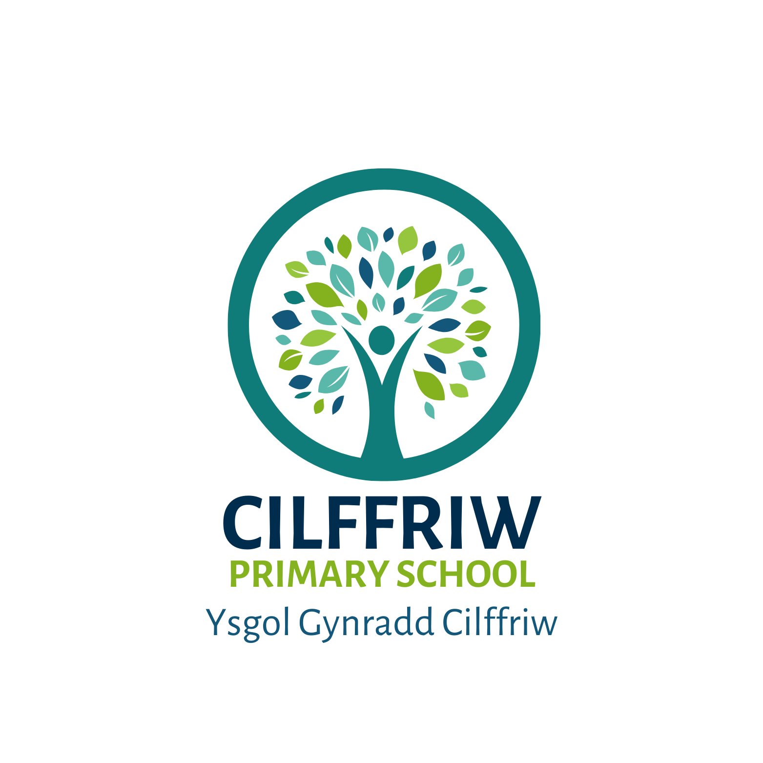

PUPIL DEVELOPMENT GRANT (PDG) STRATEGY STATEMENT
2025-26

Cilffriw Primary School
Pupil Development Grant (PDG) Strategy Statement

This statement details our school’s use of the PDG for the 2024 to 2025 academic year.

It outlines our strategy, how we intend to spend the funding in this academic year and the effect that last year’s spending had within our school.
.

School Overview
Number of pupils in school | 135 (12 part time pupils)
Proportion (%) of PDG eligible pupils | 37%
Date this statement was published | October 2025
Date on which it will be reviewed | September 2026
Statement authorised by | Samantha Sharp
PDG Lead | Kate Key
Governor Lead | Simon Thomas

Funding Overview
Detail | Amount
PDG funding allocation this academic year | PDG - £40,250  EYPDG- £18,400
Total budget for this academic year | £58,650

Part A: Strategy Plan

Statement of Intent
We believe that it is necessary for all learners to be socially and emotionally thriving demonstrating readiness to learn in an environment that is safe and secure. Leaders effectively plan, monitor and review strategically so that high quality teaching & learning meets the individual needs of all learners, accessing high expectations and support to achieve individual success. All learners receive effective support and interventions closely matched to individual need. Barriers are removed and success in learning will be achieved for learners make rapid progress and attainment, where progress is measured carefully and adjusted.
This is in line with our school vision and values:
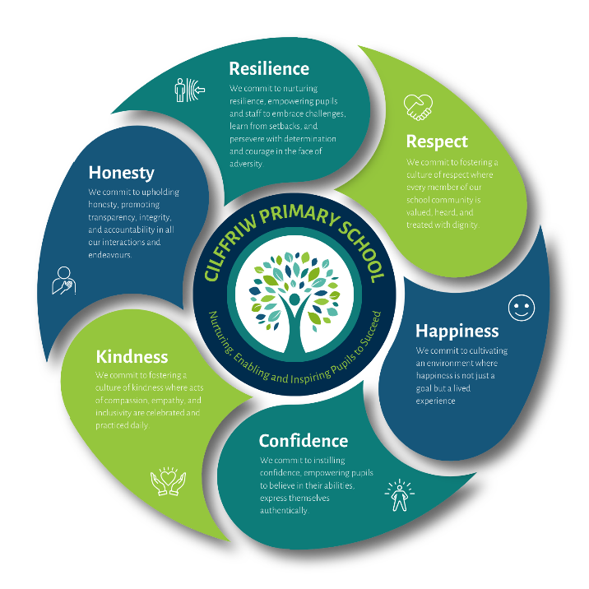
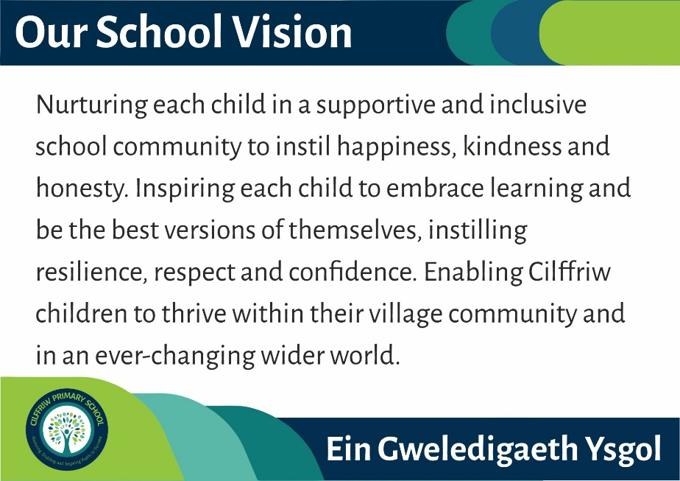

We will support out learners to become:

- Ambitious, capable learners, ready to learn throughout their lives
- Enterprising, creative contributors, ready to play a full part in life and work
- Ethical, informed citizens of Wales and the world
- Healthy, confident individuals, ready to lead fulfilling lives as valued members of society

Intended Outcomes

This explains the outcomes we are aiming for by the end of our current strategy plan, and how we will measure whether they have been achieved.

Intended outcome | Success criteria
- To improve teachers’ use of on-going assessment to inform appropriate next steps in pupils’ learning and to challenge pupils to achieve to the best of their ability. | -Teachers and teaching assistants have high expectations of what pupils can achieve.  - Teachers tailor their teaching approaches to meet pupils’ needs successfully.  - Teachers provide pupils with learning activities with suitable challenge and that build systematically on pupils’ existing knowledge, understanding and skills.  - Teachers take the opportunity to address misconceptions that arise when pupils are completing tasks independently.  - Teachers ensure independent learning activities enable pupils to consolidate previous learning, deepen their knowledge or extend pupils’ skills suitably.  - Many pupils achieve effective progress over time.  - Many pupils produce work across the curriculum that is of a good quality.  - Teachers do not over-direct tasks in small group teaching.  - Teachers use formative assessment effectively to evaluate pupils’ progress in learning and to plan for pupils’ next steps.  - Teachers provide pupils with success criteria with a suitable level of challenge.  - Teachers’ written feedback informs pupils of what they need to do to improve and supports pupils to progress with their learning.  - Teachers deploy teaching assistants effectively to support and enhance pupils’ progress with their learning.
- To improve provision for the teaching of and the progressive development of pupils’ skills. | • Many pupils develop their letter formation well and present their work neatly.  • Many pupils develop their technical writing ability well including the use of accurate punctuation and spelling.  • Many pupils add interest to their writing by varying their sentence structures successfully and through using a range of vocabulary.  • Many pupils edit and redraft their work to improve its quality.  • Teachers will promote the Welsh language successfully and ensure progressive development in pupils’ Welsh language skills.  • Many pupils will develop a strong grasp of Welsh vocabulary and sentence patterns, in line with the expectations for their stage of learning. Many pupils will use the language with increasing confidence both within and outside of Welsh lessons.  • Pupils will develop the full range of mathematical skills and knowledge.  • Many pupils apply their numeracy skills to real-life contexts and across the curriculum well.  • Many pupils will develop a wide range of digital skills successfully and apply these skills at an appropriate level, across the curriculum.  • Teachers provide pupils with learning activities with suitable challenge and that build systematically on pupils’ existing knowledge, understanding and skills.  • Many pupils achieve strong progress and produce work across the curriculum to a good standard.  • Teachers provide opportunities for pupils to apply their cross curricular skills in meaningful contexts across the curriculum.  • Teachers ensure independent learning activities enable pupils to consolidate previous learning, deepen their knowledge or extend pupils’ skills suitably

Activity in this academic year

This details how we intend to spend our PDG this academic year to address the challenges listed above.
Professional Learning to continue to evolve practice:

- Ongoing use of on-going assessment (high quality teaching and learning):
- Enable one teacher to participate in the second year of the NPT Teaching and Learning Programme (6-day training), including follow-up support sessions with the Education Support Officer. This will ensure engagement with effective, research-informed practice through collaboration with a triad of teachers across the local authority. Learning gained will be used to inform, upskill, and motivate staff within the school, strengthening alignment with the Curriculum for Wales’s core values and promoting a shared understanding of progression.
- Embed a structured triad professional learning model to promote consistent, high-quality practice across the school. Implement a pilot programme in collaboration with cluster partners, including practitioners from neighbouring primary schools and the secondary feeder school, to facilitate cross-school learning, shared expertise, and aligned pedagogical approaches.
- Provide one teacher with bespoke coaching through collaboration with a Teacher Development Officer. This tailored support will focus on individual professional growth, refining teaching strategies, and enhancing classroom practice to improve learner outcomes.
- Provide staff in Nursery, Reception, Year 1 and 2, and unit classes with Froebel training to develop a thorough understanding of enabling adults, learning environments, and experiences. This training will enhance their skills in observation, analysis, and responsive teaching, supporting more effective pedagogy and improved outcomes for all learners.
- Implement a termly staff moderation cycle to analyse learner progress across all year groups. Following each moderation session, staff will populate a shared progress overview to ensure visibility of attainment and identify learners requiring targeted intervention. This information will be integrated into the whole-school tracking system, enabling ongoing analysis of progress for FSM pupils and supporting leaders in evaluating the impact of strategies and provision on individual FSM learners over time.
- Facilitate opportunities for staff to collaborate with other professionals within the local authority and across Wales on teaching, learning, and formative assessment. This collaboration will enable staff to share expertise, reflect on practice, and implement improvements, thereby strengthening their pedagogical understanding and enhancing outcomes for learners.

- Progressive development of pupils’ skills (high quality teaching and learning):
- Strengthen the literacy curriculum by developing pupils’ letter formation and neat presentation, enhancing technical writing skills, and promoting accurate use of punctuation. Pupils will also be supported to evaluate, edit, and redraft their work, fostering greater independence, accuracy, and clarity in their writing.
- Further develop the curriculum by ensuring all teachers provide pupils with purposeful, cross-curricular opportunities to progress their literacy skills. This approach will embed literacy across all areas, reinforcing reading, writing, and communication skills in meaningful contexts.
- Provide training for teachers in assessing pupils’ progress in Monster Phonics. The Literacy Leader will oversee and quality assure the assessment process to ensure accuracy, consistency, and effective use of data to inform teaching and targeted interventions.
- The Literacy Leader will continue to monitor and evaluate literacy provision across the school, maintaining an overview of pupil progress. By analysing trends and patterns, the leader will identify areas for targeted staff support and design bespoke interventions to address gaps and enhance outcomes for all learners.
- Finalise a bespoke Mathematics and Numeracy curriculum that provides all pupils with a Curriculum for Wales (CfW) approach, progressing from core skills to problem-solving and investigation through authentic, real-life contexts after each learning period. The Numeracy and Mathematics Lead will provide ongoing support to staff to ensure effective implementation and consistency of practice across the school.
- Further develop the curriculum by ensuring all teachers provide pupils with purposeful, cross-curricular opportunities to progress their mathematics and numeracy skills. This approach will embed numeracy across all subject areas, reinforcing calculation, problem-solving, and reasoning in meaningful, real-life contexts.
- The LA, in collaboration with the Headteacher or SLT link, will work alongside the Numeracy Coordinator to conduct learning walks, work scrutiny, and pupil feedback activities with members of the Governing Body. This will evaluate the quality of mathematics and numeracy provision and its impact on pupil progress. An action plan will be revised to address identified areas for improvement.
- The Maths Leader will continue to monitor and evaluate mathematics and numeracy provision across the school, maintaining an overview of pupil progress. By analysing trends and patterns, the leader will identify areas for targeted staff support and design bespoke interventions to address gaps, improve teaching, and enhance outcomes for all learners.
- Embed the Welsh curriculum into the Language, Literacy, and Communication curriculum to ensure a bilingual approach. Finalise a bespoke Welsh curriculum that allows all pupils to progress from foundational language skills to more complex communication and application in meaningful, real-life contexts. The Welsh Leader will provide ongoing support to staff to ensure effective implementation and consistency of practice across the school.
- The Welsh Leader will continue to monitor and evaluate Welsh language provision across the school, maintaining an overview of pupil progress. By analysing trends and patterns, the leader will identify areas for targeted staff support and design bespoke interventions to address gaps, strengthen teaching, and enhance outcomes for all learners.
- The Digital Teacher Development Officer (TDO) will support the Digital Learning Coordinator and teachers to strengthen the digital competency curriculum. This will focus on the progressive development of pupils’ skills in communication, coding, modelling, data handling, and computational thinking, ensuring a coherent and consistent approach across the school.
- The Digital Teacher Development Officer (TDO) will provide targeted professional learning for teachers, focusing on areas identified for development through the review of pupils’ skills in communication, coding, modelling, data handling, and computational thinking. This will support teachers in improving practice and enhancing pupils’ digital competency across the curriculum.
- The Digital Leader will continue to monitor and evaluate digital learning provision across the school, maintaining an overview of pupils’ progress in digital skills. By analysing trends and patterns, the leader will identify areas for targeted staff support and design bespoke interventions to address gaps, improve digital pedagogy, and enhance outcomes for all learners.

Targeted Interventions
- Continue to fund Teaching Assistants to provide targeted intervention to targeted pupils to support their progress with basic skills and their wellbeing, increasing capacity for ELSA support.

Family Engagement Officer- Pilot
- To continue to support pilot funded by WG to improve community involvement within the school. Further resources are required to engage a wider number of families.

Activity in this academic year These details how we intend to spend our PDG this academic year to address the challenges listed above.

- Ongoing use of on-going assessment (high quality teaching and learning):
Budget Cost: £20,000

Activity: | Evidence that supports this approach:
- Enable one teacher to participate in the second year of the NPT Teaching and Learning Programme (6-day training), including follow-up support sessions with the Education Support Officer. This will ensure engagement with effective, research-informed practice through collaboration with a triad of teachers across the local authority. Learning gained will be used to inform, upskill, and motivate staff within the school, strengthening alignment with the Curriculum for Wales’s core values and promoting a shared understanding of progression.  - Embed a structured triad professional learning model to promote consistent, high-quality practice across the school. Implement a pilot programme in collaboration with cluster partners, including practitioners from neighbouring primary schools and the secondary feeder school, to facilitate cross-school learning, shared expertise, and aligned pedagogical approaches.  - Provide one teacher with bespoke coaching through collaboration with a Teacher Development Officer. This tailored support will focus on individual professional growth, refining teaching strategies, and enhancing classroom practice to improve learner outcomes.  - Provide staff in Nursery, Reception, Year 1 and 2, and unit classes with Froebel training to develop a thorough understanding of enabling adults, learning environments, and experiences. This training will enhance their skills in observation, analysis, and responsive teaching, supporting more effective pedagogy and improved outcomes for all learners.  - Implement a termly staff moderation cycle to analyse learner progress across all year groups. Following each moderation session, staff will populate a shared progress overview to ensure visibility of attainment and identify learners requiring targeted intervention. This information will be integrated into the whole-school tracking system, enabling ongoing analysis of progress for FSM pupils and supporting leaders in evaluating the impact of strategies and provision on individual FSM learners over time.  - Facilitate opportunities for staff to collaborate with other professionals within the local authority and across Wales on teaching, learning, and formative assessment. This collaboration will enable staff to share expertise, reflect on practice, and implement improvements, thereby strengthening their pedagogical understanding and enhancing outcomes for learners | The EEF Implementation Guidance Report emphasises the importance of using highly skilled coaches to provide ongoing instructional support: “If coaching is used to provide follow-on support … ensure the coaches are highly skilled … More effective coaches … offer support in a constructive, collaborative manner …” EEF  Research shows that sustained, structured professional development has a strong impact. According to EPI’s review:  “High-quality CPD for teachers has a significant effect on pupils’ learning outcomes … CPD programmes have the potential to close the gap … the impact of CPD on pupil outcomes … compares to the impact of having a teacher with ten years’ experience rather than a new graduate.”  Education Policy Institute state that a scalable, research-engaged model of professional learning emphasises mechanisms such as goal setting, feedback, and practice (which align with your bespoke coaching). As noted in relation to EEF’s approach:  “Insight … revisit prior learning, ‘goals’ … credible goals … ‘techniques’ … modelling, feedback and strategy rehearsal, and ‘practice’ … ingraining habitual practice.”  Also, regarding remote professional development (e.g. coaching), the EEF’s rapid evidence assessment found that:  “Remote coaching, mentoring and expert support can be effective … Making remote content interactive maximises its benefit … spaced approaches enable ongoing interaction … the use of video … enables … review … and reflection.”  Why this research matters to our plan:  - Using coaching is supported by strong evidence: well-trained coaches and ongoing support are critical to effectively translating training into classroom practice.  - Ongoing professional development (especially when structured around evidence-based mechanisms like feedback, goal setting, and rehearsal) is more likely to produce sustained improvements in teacher practice — and therefore in pupil outcomes.

2.Progressive development of pupils’ skills (high quality teaching and learning):
Budget Cost: £20,000

Activity: | Evidence that supports this approach:
- Strengthen the literacy curriculum by developing pupils’ letter formation and neat presentation, enhancing technical writing skills, and promoting accurate use of punctuation. Pupils will also be supported to evaluate, edit, and redraft their work, fostering greater independence, accuracy, and clarity in their writing.  - Further develop the curriculum by ensuring all teachers provide pupils with purposeful, cross-curricular opportunities to progress their literacy skills. This approach will embed literacy across all areas, reinforcing reading, writing, and communication skills in meaningful contexts.  - Provide training for teachers in assessing pupils’ progress in Monster Phonics. The Literacy Leader will oversee and quality assure the assessment process to ensure accuracy, consistency, and effective use of data to inform teaching and targeted interventions.  - The Literacy Leader will continue to monitor and evaluate literacy provision across the school, maintaining an overview of pupil progress. By analysing trends and patterns, the leader will identify areas for targeted staff support and design bespoke interventions to address gaps and enhance outcomes for all learners.  - Finalise a bespoke Mathematics and Numeracy curriculum that provides all pupils with a Curriculum for Wales (CfW) approach, progressing from core skills to problem-solving and investigation through authentic, real-life contexts after each learning period. The Numeracy and Mathematics Lead will provide ongoing support to staff to ensure effective implementation and consistency of practice across the school.  - Further develop the curriculum by ensuring all teachers provide pupils with purposeful, cross-curricular opportunities to progress their mathematics and numeracy skills. This approach will embed numeracy across all subject areas, reinforcing calculation, problem-solving, and reasoning in meaningful, real-life contexts.  - The LA, in collaboration with the Headteacher or SLT link, will work alongside the Numeracy Coordinator to conduct learning walks, work scrutiny, and pupil feedback activities with members of the Governing Body. This will evaluate the quality of mathematics and numeracy provision and its impact on pupil progress. An action plan will be revised to address identified areas for improvement.  - The Maths Leader will continue to monitor and evaluate mathematics and numeracy provision across the school, maintaining an overview of pupil progress. By analysing trends and patterns, the leader will identify areas for targeted staff support and design bespoke interventions to address gaps, improve teaching, and enhance outcomes for all learners.  - Embed the Welsh curriculum into the Language, Literacy, and Communication curriculum to ensure a bilingual approach. Finalise a bespoke Welsh curriculum that allows all pupils to progress from foundational language skills to more complex communication and application in meaningful, real-life contexts. The Welsh Leader will provide ongoing support to staff to ensure effective implementation and consistency of practice across the school.  - The Welsh Leader will continue to monitor and evaluate Welsh language provision across the school, maintaining an overview of pupil progress. By analysing trends and patterns, the leader will identify areas for targeted staff support and design bespoke interventions to address gaps, strengthen teaching, and enhance outcomes for all learners.  - The Digital Teacher Development Officer (TDO) will support the Digital Learning Coordinator and teachers to strengthen the digital competency curriculum. This will focus on the progressive development of pupils’ skills in communication, coding, modelling, data handling, and computational thinking, ensuring a coherent and consistent approach across the school.  - The Digital Teacher Development Officer (TDO) will provide targeted professional learning for teachers, focusing on areas identified for development through the review of pupils’ skills in communication, coding, modelling, data handling, and computational thinking. This will support teachers in improving practice and enhancing pupils’ digital competency across the curriculum.  - The Digital Leader will continue to monitor and evaluate digital learning provision across the school, maintaining an overview of pupils’ progress in digital skills. By analysing trends and patterns, the leader will identify areas for targeted staff support and design bespoke interventions to address gaps, improve digital pedagogy, and enhance outcomes for all learners. | Evidence from the Education Endowment Foundation highlights that the development of pupils’ phonics has ‘very high impact for very low cost based on extensive evidence’ (an additional 5 months progress over the academic year). Significant evidence exists which highlights that the embedding of a systematic approach to the teaching of synthetic phonics has a considerable impact on pupils’ progress with reading and ability to access the wider curriculum.  The Literacy Development evidence review (commissioned by EEF) highlights that affective factors (like motivation and engagement) are just as important as cognitive skills (like phonics or comprehension). Although the review discusses many facets, it supports using rich texts (stories, narrative) because they help develop both comprehension and writing. High-quality literature can help meet these affective and cognitive needs simultaneously, motivating pupils while building their language/comprehension skills.  Concrete experiences help pupils understand what numbers and operations represent rather than just memorising rules.  According to the EEF guidance Improving Mathematics in the Early Years and KS1/2:  “Pupils need to develop a deep conceptual understanding of mathematical ideas before moving on to abstract calculations. The CPA approach supports this development by enabling pupils to see and explore relationships.” (EEF, 2020). Using manipulatives and visual representations helps learners process complex ideas step by step, scaffolding understanding.  The EEF research states:  “Teachers should select genuine problem-solving tasks that pupils do not have well-rehearsed, ready-made methods to solve.”, “Pupils should be taught to use and compare different approaches.”, “Pupils should be encouraged to use visual representations.”  “Teachers should use worked examples to enable pupils to analyse the use of different strategies.”, “Pupils should be required to monitor, reflect on, and communicate their reasoning and choice of strategy.” From the EEF maths-teaching guidance: “Use manipulatives and representations.” On the importance of metacognition in problem solving: “pupils need to think flexibly and apply prior learning to the context to select suitable strategies for themselves.”  According to the EEF’s Using Digital Technology to Improve Learning guidance report: “An overarching recommendation … is that technology itself is unlikely to improve young people’s learning … if … used purposefully … they stand a much better chance of doing so.” In other words: simply having devices isn’t enough. What matters is how technology is integrated — for example, to support practice, feedback, or modelling.  Why this research matters to our plan:  - Systematic phonics instruction ensures pupils develop strong decoding skills, which are essential for reading fluency and comprehension.  - Pupils who master phonics early are better able to access the wider curriculum, because reading is a fundamental skill across subjects.  - Investing in phonics training and resources represents a high-impact, cost-effective intervention, directly addressing literacy gaps for disadvantaged pupils.  - Embedding high-quality literature into the curriculum can increase pupil engagement and enjoyment, which research shows correlates with improved reading and writing outcomes.  - Literature-rich teaching meets pupils’ cognitive needs (vocabulary, comprehension, narrative structure) and affective needs (motivation, interest), ensuring interventions support sustained literacy development.  - Disadvantaged pupils often benefit most from this dual approach, reducing gaps in reading confidence and achievement.  - Concrete experiences (manipulatives) and visual representations scaffold pupils’ understanding of maths concepts, reducing cognitive overload and ensuring they grasp why procedures work.  - Disadvantaged pupils often lack exposure to hands-on maths experiences at home; CPA ensures equitable access to deep conceptual understanding.  - This approach builds a strong foundation, which is critical for tackling more complex problem-solving and real-life maths later in the curriculum.  - Encouraging pupils to reason, reflect, and choose strategies develops metacognitive skills and deeper mathematical understanding.  - Teaching multiple strategies and using visual supports helps disadvantaged learners access problem-solving in ways that promote confidence and independence.  - Applying maths to authentic, contextualised problems prepares pupils to transfer skills to real-life situations, improving both attainment and resilience.  - Embedding digital competency across the curriculum is not just about providing devices, but about how technology is used to support deeper learning, feedback, and reasoning.

Targeted Interventions
Budget Cost: £10,000

Activity: | Evidence that supports this approach:
- Continue to fund Teaching Assistants to provide targeted intervention to targeted pupils to support their progress with basic skills and their wellbeing, increasing capacity for ELSA support. | Evidence from the Education Endowment Foundation highlights that the use of Teaching Assistants to provide targeted intervention skills has ‘moderate impact for moderate cost based on moderate evidence’ (an additional 4 months progress over the academic year).  Evidence from the Education Endowment Foundation highlights that the development of pupils’ social and emotional learning has ‘moderate impact for very low cost based on very limited evidence’ (an additional 4 months progress over the academic year). Evidence from school monitoring highlights progress many pupils make with their overall wellbeing and self-esteem through participating in nurture provision, Elsa etc.  Corridor circuits to aid Gross Motor Skills (Sensory Processing).

Community Schools
Budget Cost: £4,000

Activity: | Evidence that supports this approach:
Family Engagement Officer- Pilot  - To continue to support pilot funded by WG to improve community involvement within the school.  - Activities include parental engagement, community engagement, working with vulnerable families, parenting support, supporting attendance.  - Workshops will be run for parents to help them support their children at school (maths, literacy, digital, Welsh, cooking on a budget).  - Workshops will help adults with everyday life skills and increase their learning skills (courses for parents, budgeting, financial management, application forms and CVs, parenting skills).  - Establish and refine a community room for families.  - Flying Start will use a room within our school to support families. | Evidence from the Education Endowment Foundation highlights that parental engagement has ‘moderate impact for very low cost based on extensive evidence’ (an additional 4 months progress over the academic year).  Evidence from Janet Goodhall’s ‘parental engagement’ shows significant impact with children’s learning particularly in areas of high deprivation. In addition, evidence from local schools that have already developed the role and highlights positive impact regarding attendance, wellbeing and learning outcomes.  Evidence from Education Endowment Foundation shows significant impact when parents engage at home with their children. EEF Parental Engagement- Moderate Impact  The 4 Pillars of Parental Engagement-Robbins & Dempster, 2021. Engage Every Family-Constantino, 2021

PDG outcomes
For evidence of the impact of the PDG for the last academic year please see the plan and review on the school website.

Further information (optional)
At Cilffriw Primary our FSM, ACEs and additional varying vulnerabilities in our community mean that we aim for all our strategies to impact holistically on all our children. We know our families well and recognise that the range of different challenges facing our community may not be highlighted by PDG identification. As a result, our primary aim is to prioritise the wellbeing of our community and to introduce ways of working that will positively impact our learners both in school and in the wider social context of the community. Our approach to teaching & learning is continuing to evolve so that our children build the skills, habits and dispositions of good learners in line with our school vision and values.

