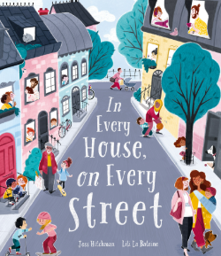
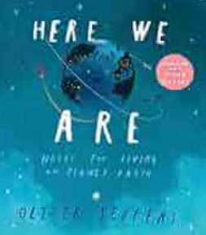
Autumn Term 2025
Nursery Topic Activities

Marvellous Me!
Our Theme | This half term, our theme is “Marvellous Me”, designed to support children in their personal, social, and emotional development as they begin their school journey.  In this first term, we will focus on helping children to settle confidently into school life, exploring both indoor and outdoor environments; build positive relationships with peers and adults; develop independence in everyday routines such as eating, using tools and equipment, and managing personal hygiene, including toilet use. Through engaging activities and discussions, children will begin to understand that everyone is special and unique. We will celebrate our differences and help each child feel proud of who they are!
Languages, Literacy  and  Communication | As children become more familiar with the school day and routines, they will begin to follow directions and instructions independently, such as helping with tidying up time when asked. Children will be encouraged to talk about what they are doing with an adult and with support will begin to respond to ‘how’ and ‘why’ questions. They will talk about and answer questions about the stories and begin to join in small group and class discussions.
Mathematics and Numeracy | This term the children will:-  - Make comparisons between objects.  - Make collections that are the same/ different and of small and large amounts.  - Explore shapes in their play.  - Listen to repeats in songs and stories.  - Join in with repeats in songs.  - Clap along to familiar songs.  - Make line patterns and choose blocks to build roads and towers.  - Hear some number names.  - Practise saying number names in order.
Science and Technology | Throughout this topic, pupils will be encouraged to question the world around them using their senses – what do they see, smell, feel or hear?  Pupils will have opportunities to name life in the woodland; plants, trees, animals and recognise that plants and animals are living things that grow.
Humanities | Pupils will explore different types of homes and houses. Pupils will share places that are important to them and be curious about their locality. There will be opportunities for the children to explore the school grounds in small groups, making observations on the physical changes in the seasons – looking for signs of Autumn.  Pupils will discuss similarities and differences between themselves and others and show an awareness of who they are.
Expressive arts | The children will have opportunities to create self-portraits and frames using a range of different materials including natural resources. We will talk about our loved ones and people who are important to us - creating portraits and collages of them. There will be opportunities for roleplaying in the home corner and acting out stories with puppets. Pupils will engage with natural materials to create pieces of artwork such as leaf printing and bark rubbings.
Health and Well-being | A key emphasis will be placed on Health and Wellbeing, encouraging children to make healthy choices and take increasing responsibility for their self-care. Children will think about their talents, what they are good at, their likes and interests and what makes them special.  The children will be encouraged to learn how to become more independent in their self-care skills by putting on their coat and shoes themselves. There will be opportunities for cooking and baking. The children will use utensils daily to make toast.  The children will explore different emotions, recognising different emotions in themselves and others and the physical sensations associated with different emotions.
How parents can help | Continue to support your child with their independent skills such as intimate care skills and putting on their coat. Enjoy a shared story at bedtime with your little ones- prompt them to share what they like and dislike about a story. Keep in touch with staff to share your child’s likes and interests and to notify staff of any key events taking place in your child’s life such as visits to a favourite place, a new pet, a family holiday or a wedding. Encourage your child/ren to join in with nursery rhymes at home including number rhymes. When out and about on a welly walk, talk to your child about what they can see and any colours or shapes they can see in the environment.
