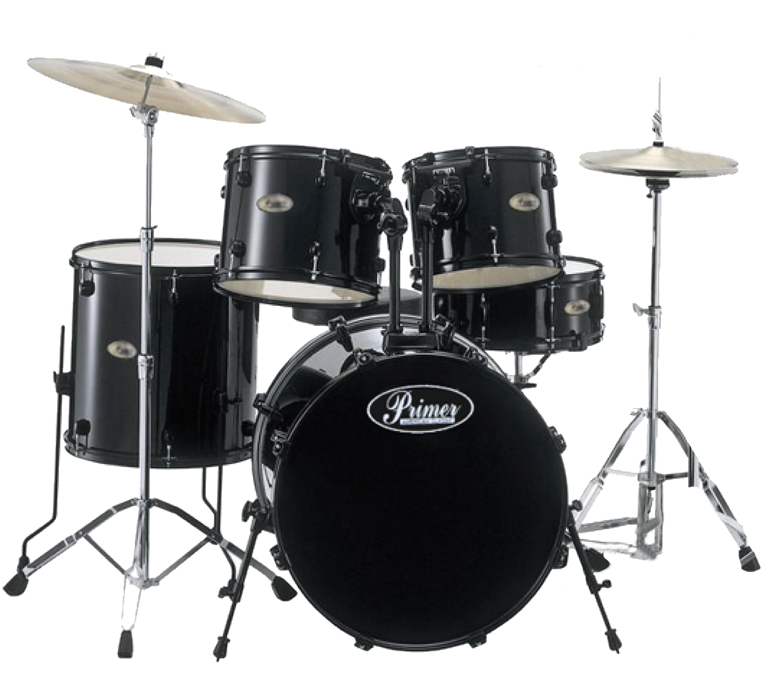

Autumn Term 2025
Y2 Topic Activities

Beat, Band, Boogie!

Our Theme | Here comes the marching band. Left, right, left, right. Step in time to the beat: 1, 2, 3, 4; let's make sounds, high and low. That sound is loud. That one’s quiet. What can you hear? There are sounds all around. What’s making each one? Pat your knees, clap your hands, tap your feet, let’s move to the beat. Now march up the hill with the Grand Old Duke of York, beating your drum or shaking your shaker. Then it’s time to perform.
Languages, Literacy  and  Communication | The children will begin to hear and use new vocabulary such as beat, rhythm, sound, high, low, loud, soft, quiet, fast, slow. They will develop an understanding of these words when they listen to, and follow instructions given to them.
Mathematics and Numeracy | The children will be learning to clap, tap, and stamp along to music. Counting the beats and time will support the children’s mathematical learning.
Science and Technology | We will work in pairs to make a glass bottle orchestra by filling lots of bottles with different levels of water. The children will get to experiment with the sounds the bottles make. They will also get to take on the role of a conductor by raising or lowering their hands while their partner will follow the instruction given.
Humanities | During our topic sessions the children will get to listen to music from all over the world, from traditional Welsh Hymns to American marching bands and classical Indian music to name just a few.
Expressive arts | To start the topic off we will be having 2 students from the Music Service to perform a drum demonstration, play body percussion and rhythm games then get all the drums out for the children to play, and to experiment with the different sounds that they make.  The children will get to create and decorate their very own percussion instrument using a variety of materials.
Health and Well-being | The children will be developing skills such as collaboration when they are learning to work together by listening to each other and turn taking. They will be giving their opinions about the music they hear and say how it makes them feel. They will also get to compose their very own rhythms. During P.E sessions the children will get to move around the hall in the style of the music they are listening to.
How parents can help | Please could you collect items at home to help us create our instruments. We will be using materials such as  - Plastic bottles with screw lids  - Dried peas, small beads, buttons or pebbles  - Ribbon or string  - Glitter pens  - Paper plates  Thank you.
