**Autumn Term 2025**

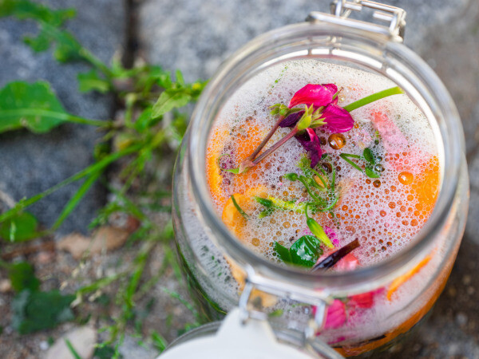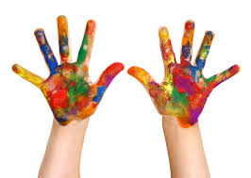

**Squirrels Topic Activities**

***Muck, Mess and Mixtures***

|  |  |
| --- | --- |
| **Our Theme** | Our theme this year has an Expressive Arts focus so the children will have opportunities to explore different materials and develop their creative skills. The children will then apply their skills and understanding to create pieces of art to create a class gallery.  The children will be having opportunities to explore and taste different foods and observe changes in the food through a range of experiments. |
| **Languages, Literacy**  **and**  **Communication** | Our theme will also influence our writing journeys this term. The genres we will be focusing on are instruction writing and narrative.  The children will be learning to write their own recipes and create their own narratives using clay and animation software. We will also be reading a wide range of texts including fiction and nonfiction.  Please can you support your child at home by listening to them read their school reading book every week. |
| **Mathematics and Numeracy** | This term we will be working on:   * Reading and writing numbers to 100. * Knowing our number bonds to 20. * Counting in 2s, 5s, and 10s. * Measurement and temperature. |
| **Science and Technology** | We will be carrying out an investigation to observe the melting process of different foods. The children will give predictions about what they think will happen and will observe and record the changes throughout the process.  They will also be learning how to use animation software to create their own stop motion animations. |
| **Humanities** | We will be exploring a range of foods and identifying their origins. The children will begin to identify what countries the food comes from and if it comes from a plant or animal.  We will also be learning about the Hindu festival Diwali and how it is celebrated. |
| **Expressive arts** | This theme has an Expressive Arts focus so there will be several opportunities for the children to explore a range of materials and methods of application, such as ice cube and bubble painting!  The children will be using their skills to create their own pieces of art to showcase in our class art gallery. |
| **Health and Well-being** | The children will take part in Forest School and P.E. sessions on Friday afternoons, alternating each week.  They will also be learning about the diversity of families, who makes up their family and who keeps them safe in and outside of school. We will be looking at different types of food and thinking about how we can have a healthy, balanced diet. |
| **How parents can help** | This is an insight into what we will be learning this term, but some things can change depending on the children’s interests. Hopefully you will be able to use this to share ideas with your children and talk about what they are learning in school.  REMINDER  Please return book bags on Wednesday so your child’s book can be changed and sent home on Friday.  If you have any queries or concerns, please ring the school or send me an email – [RowlandsM47@hwbcymru.net](mailto:RowlandsM47@hwbcymru.net).  Thanks for your continued support,  Miss Rowlands |

