**Autumn Term 2025**

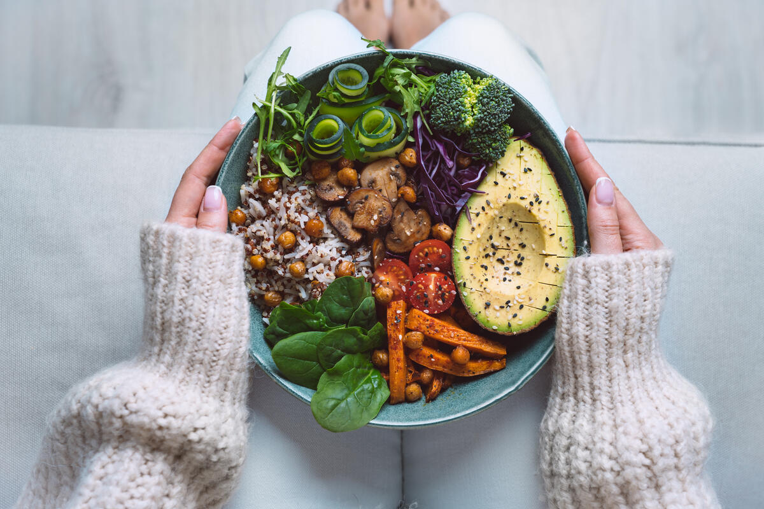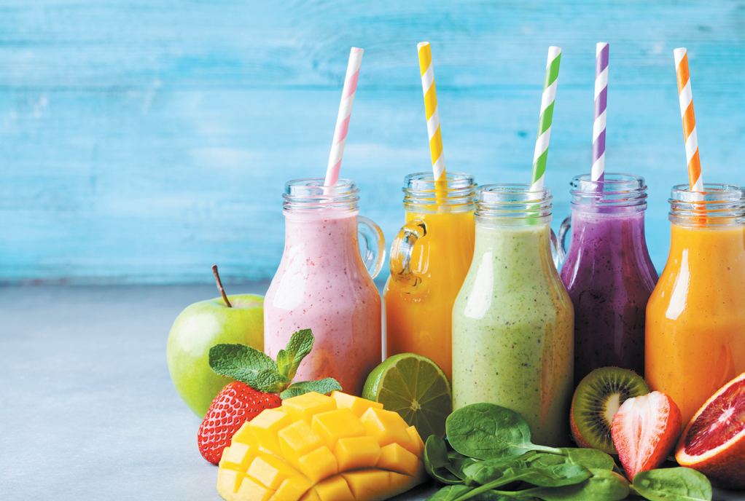

**Y3/4 Topic Activities**

**Scrumdiddlyumptious**

|  |  |
| --- | --- |
| **Our Theme** | This term only, Tuck in and enjoy a yummy journey of discovery, tasting fantastic fruits, venerable vegetables and tantalizing treats. Work up an appetite with delicious stories about food, have fun with a vegetable orchestra or become a fruity sculptor. Find exciting recipes to read – and write your own, too. Then get busy in the kitchen, making tasty dishes from across the world and discover how good food helps you grow fit and strong. Be a whizz and create your own scrumdiddlyumptious smoothie or fruit cocktail. And here’s food for thought – if you are what you eat, what does that make you? |
| **Languages, Literacy**  **and**  **Communication** | We will be focusing on two specific genres of writing while keeping our topic theme of ‘Scrumdiddlyumptious’ this term. The two genres are Instruction and Persuasion. These will be used to create recipes, research a variety of aspects of nutrition and provide information on the key benefits of healthy eating. |
| **Mathematics and Numeracy** | This term will be revising previous topics and activating our prior knowledge on place value. This will include;   * Thousands, Hundreds, Tens and Units * Number lines * Rounding to the nearest 10, 100 and 1000 |
| **Science and Technology** | This term we will explore a range of foods using touch, smell and taste. Sort and classify items according to their own criteria and explain their ideas. Afterwards, attempt to sort the food into given food groups as a class. |
| **Humanities** | This term we will research the journey taken by a banana or another non-native fruit or food item of their choice, from its country of origin to the fruit bowl in school. Use a range of sources to gather information and plot routes on a world map. Use the chosen fruit as a main ingredient in making our chosen creation |
| **Health and Well-being** | In groups, join in a MasterChef style challenge to cook a dish using the ingredients provided. Let your imagination spark on creating your own healthy smoothie or fruit cocktail kebab while seeing the physical and mental benefits of healthy eating. |

