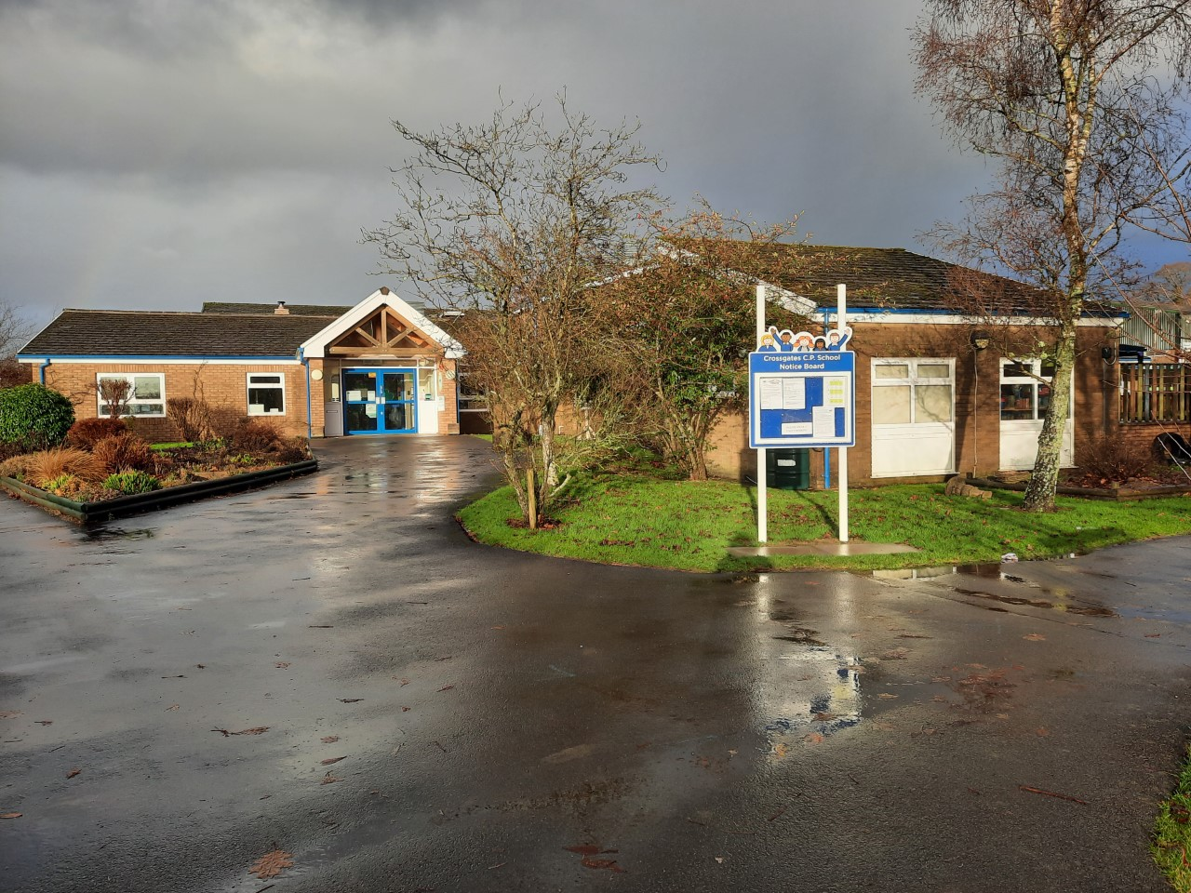

Prospectus

Prosbectws

2022-2023

www.crossgates.powys.sch.uk

Croeso/Welcome to Crossgates CP School

Thank you for taking the time to read our prospectus, we hope that it will give you a brief introduction to our school.

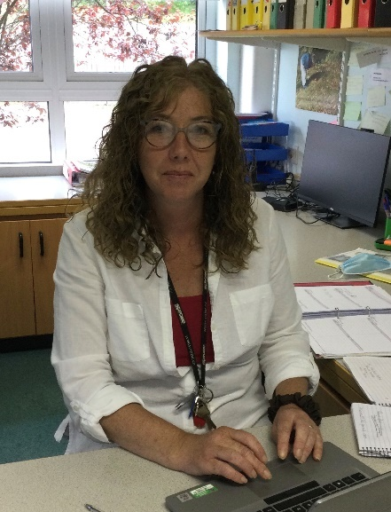

Mrs Lisa Williams Head teacher
Tel: 01597 851667
Email: head@crossgates.powys.sch.uk

Crossgates Community Primary School
This Photo by Unknown Author is licensed under CC BY-NC
Our Values (interpreted by the children)
- To provide a nurturing, inclusive environment where everyone, staff and children can flourish.
To make a caring and safe school that is interesting and fun for the children and all the grown-ups
- To value all pupils equally and educate each pupil to achieve their full potential. To this end we strive to support pupils with additional needs and extend the more able.
To treat all the children the same and teach every child to do their best. All children will be helped and challenged to grow into ambitious and confident children.
- To fulfil and deliver the requirements of the New Curriculum for Wales through the four purposes of the curriculum – the starting point and aspiration for every child and young person in Wales.
To teach the curriculum to all the pupils, allowing them to become ambitious, capable learners, enterprising, creative individuals, healthy, confident individuals and ethical, informed citizens
- To recognise the needs of all individuals at the school and provide professional development in order for staff to support pupils and to fulfil their roles.
Staff need to know that all children have different learning abilities. The school must realise the importance of training for the staff, so that they can be better at their jobs.
- To develop good communication through home school links and recognise the place of the school in the local and wider community.
To make good, happy connections between school and home and aim to mix in the wider community, being inviting and friendly to the local area and the bigger world.

“Growing together, Learning forever”

At Crossgates School, we all (staff and pupils) strive to give of our best and make the most of the opportunities available to us.

The School: Background and Organisation

N.O.R. Sept 2022 120 Age range 4-11 years

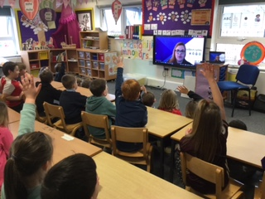
Crossgates School was originally opened in 1977 and rebuilt in 2009. It is situated in the middle of the rural village of Crossgates and has a catchment area including the villages of Abbeycwmhir, Llanddewi, Penybont, Llandegley and Nantmel. The school was rebuilt to modern standards in 2008.

The junior block consists of four junior classrooms, an IT suite, Library and quiet room. The old part of the school was revamped and completed in May 2008 and comprises of offices, staffroom and cloakrooms, extended hall, music room, two Foundation Phase classrooms and a classroom which has been adapted for our new satellite class supporting children from Penmaes School.

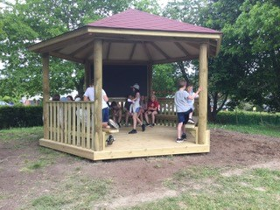
The school has beautiful grounds amounting to just under seven acres, which are used for sporting activities and as an educational resource. The children and community have been involved in developing the grounds for the benefit of all who enjoy them. We have been lucky to receive a large donation from E A Severn Charity this year. This money will be used to enhance our outdoor area to create a forest school area and pond habitat. We were also able to purchase a fantastic outdoor classroom through the COVID hardship fund which the children have really enjoyed using.

The school is a community primary school and is an English medium school. We cater for children between the ages of 4 and 11, currently organised into five classes. Organisation is based on both age and ability according to numbers in each year group. We currently operate as a Reception/Year 1 class, Year 1/Y2, Year 3/4, Year 4/5 and Year 5/6 class. In Wales class sizes in the Infant classes cannot be set above 30 at the beginning of the year.

The school is a member of the “Healthy Schools” Network.

School Staff and the organisation of classes

Members of staff and the organisation of classes are listed as below. Due to different numbers of pupils in year groups this structure is not the same every year.

Headteacher & ALNCO | Mrs L Williams
Dosbarth Camlo-Reception/Year 1 | Foundation Phase Lead & Class Teacher: Mrs E Jenkins  Teaching Assistants: Mrs D Margetts & Ms G Richards
Dosbarth Elan-  Years 1/2 | Class Teacher: Mrs V Pritchard  Teaching Assistants: Mrs S Bufton & Mrs T Knill
Dosbarth Afon Gwy-  Years 3/4 | Class Teacher: Miss R Bufton  Teaching Assistant: Mrs N James & Mrs K Pople
Dosbarth Pen Y Fan  Years 4/5 | Class Teachers: Mrs C Watkins/Mrs L Thomas  Teaching Assistant: Mrs Y Price
Dosbarth yr Wyddfa  Year 5/6 | Deputy Headteacher & Class Teacher: Mrs B Smith  Mrs E Kolano Rogers  Teaching Assistants: Mrs C Stokes
Penmaes Satellite Class | Mrs C Bevan,
PPA Cover | Mr L Thomas
Teaching assistants | Mrs A Griffiths
Secretary | Mrs S Powell
Mid day Supervisors | Mrs N James, Mrs K Pople Ms G Richards,  Mrs T Knill
School Cook | Mrs E Jardine
Kitchen Assistants | Mrs P Roberts, Mrs J Bradford,
Out of School Club | Ms A Griffiths, Ms J Morris, Ms G Richards
Breakfast Club | Ms A Griffiths, Mrs D Powell, Mrs S Bufton
Cleaning Staff | Mrs D Powell, Mrs J Drew

The Governors

Chairperson 22/23: Mrs Claire Lewis
The Rabber, Penybont
Llandrindod Wells,
LD1 6UT

Clerk to the governing body: Mrs Stacey Powell
c/o Crossgates CP School
Crossgates
Powys LD1 6RE

Day to day management and organisation of the school is the responsibility of the Headteacher. The Governing Body has responsibility for the strategic management of the school, acting within the framework set by national legislation and by policies of the Local Authority (LA).

Governing Body | Name | Term of Office Ends
Local Authority Governor | Geoff Morgan
Local Authority Governor | Melanie Ross | March 2025
Local Authority Governor | Claire Lewis (Chair) | October 2021
Parent Governor | Karen Bridgewater | December 2024
Parent Governor | Julia Lewis | December 2024
Parent Governor | Julie Morgan | May 2025
Parent Governor | Lyndon Jones | May 2025
Teacher Governor | Verity Pritchard | September 2023
Minor Authority Governor | Clare Haslam | June 2025
Community Governor | Stephanie Morgan | February 2026
Community Governor | Currently vacant | March 2022
Community Governor | Mark Stafford-Tolley | March 2024
Staff Governor | Caroline Stokes | February 2022
Head Teacher | Lisa Williams | (Appointed Sept 15)

The School Day and Information
The school day begins at 9.00am and ends at 3:30pm. Parents can drop children off between 8.50am and 9.00 am. Staff will meet the children at the classroom door. We expect all children to arrive in school punctually. It should be noted that the school cannot, and does not, accept legal responsibility for children left outside school before 9am or after 3:30pm. Parents wishing their child/children to walk home unaccompanied must sign a permission slip allowing them to do so. It is important that we know the person that you have asked to collect your son/daughter from school. If it is not you, please make sure that you have notified us of your arrangements. We will not let a child leave with a “stranger”. As a final resort we will always try to telephone you to confirm arrangements if you have forgotten to inform us. Please understand your child’s safety is our main concern.

There is a short mid-morning break for which the children are able to bring a snack and we ask that the children adhere to the school’s healthy eating policy and only bring in healthy foods such as fruit rather than crisps, chocolate and sweets. We undertake Dal y fynd in the afternoon.
The school has a very successful Breakfast Club before school and Out of School Child Care Club after school. Should you wish your child to attend these please contact the school office. Currently both of these clubs are based in the school hall.

We currently charge £1.25 per Breakfast Club session per child. The after-school club is a chargeable care session.
Monday- 3.30- 4.30pm £3.50
Tuesday- 3.30-5.30pm £7
Wednesday- 3.30-5.30pm £7
Thursday- 3.30-4.30pm £3.50

School Session Times
The governing body of Crossgates CP School is responsible for the setting of school session times, in accordance with Welsh Government guidance as set out in ‘The Education (School Day and School Year) (Wales) (Amendment) Regulations 2008’.
The school day must ‘allow sufficient lesson time to deliver a broad and balanced curriculum that includes the national curriculum and religious education. Schools are free to decide the length of each session but current weekly lesson time in hours is: children aged 5-7 years 21.6 hours and children aged 8-11 years 23.5 hours’ (regulations 2008).

The School Calendar 2022/23
All term dates can be found on the Powys County Council website:
www.powys.gov.uk

The school will meet for 380 sessions which equals 190 full days. In addition, the staff meet for an additional 5 days (INSET days), which are set aside for training and development.

Emergency School Closure
Occasionally, usually due to extremely poor weather conditions, it becomes necessary to close the school at short notice. In the event of this happening a message will appear on Powys County Council’s website. You are advised to register for an account with the Council via. their website so that you are automatically notified when the school is closed. http://www.powys.gov.uk/en/schools-students/find-out-if-a-school-is-open-or-closed/
We will also notify parents via SCHOOP, Facebook and Twitter.

Charging and Remissions Policy

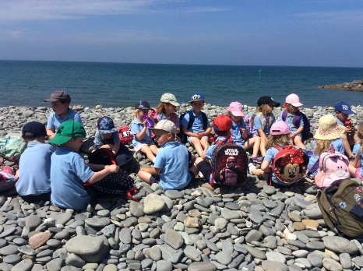
In accordance with the 1998 Education Act, the Governing Body has agreed on the following Charging and Remissions Policy. When activities requiring additional payment occur, it may be necessary to ask for voluntary contributions or donations. Examples of such activities are transport to swimming, field study visits and outdoor pursuit courses. However, we emphasise that these are voluntary contributions, and all pupils will receive equal opportunity to attend.
We organise many experiences to enrich the curriculum for children and undoubtedly without the support of voluntary contributions these experiences could not take place. However, charges are not voluntary for residential trips. In order to participate in residential trips payment MUST be made in full.

Curriculum Statement/Our Vision
At Crossgates, the wellbeing of our pupils is at the heart of our school.
Our aim is to provide a nurturing, inclusive environment where everyone, staff and children can flourish.
Our school provides a rich, varied and purposeful learning environment that supports children to achieve their full potential and have high expectations of themselves. Our School supports the concept of lifelong learning, recognising that both adults at school and children learn new things every day. We maintain that learning should be a rewarding and enjoyable experience for everyone. Through our teaching we seek to equip children with the skills, knowledge and understanding necessary to be able to make informed choices about the important things in their lives and be prepared for future challenges as confident and ambitious learners.

The 4 purposes will be at the heart of our new curriculum. They will be the starting point for all decisions on the content and experiences developed as part of the curriculum to support our children and young people to be:

- ambitious, capable learners ready to learn throughout their lives
- enterprising, creative contributors, ready to play a full part in life and work
- ethical, informed citizens of Wales and the world
- healthy, confident individuals, ready to lead fulfilling lives as valued members of society.
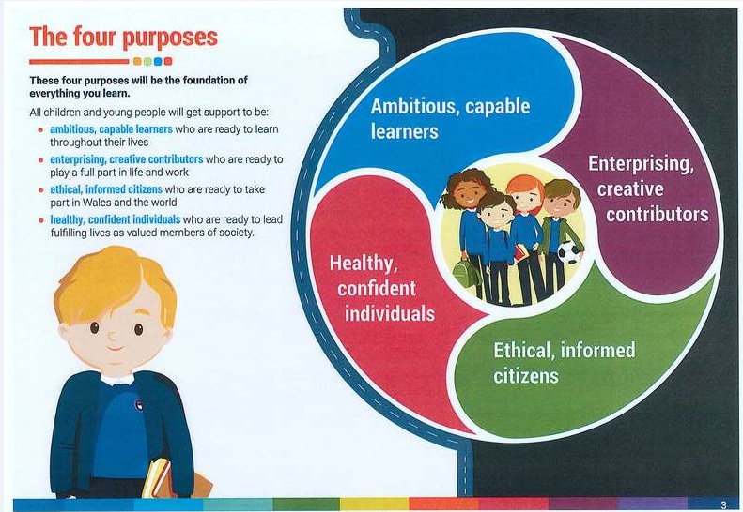

It’s designed by teachers.

Teachers will plan the lessons and learning that will help your children be ready for their future. They will work with other schools and have guidance which other teachers have written to help them.

It’s built for all children.

The new curriculum will support children through creative lessons that have real-life meaning. It will help them to reflect and think about what they’ve learnt and move forward.

It’s made for a fast-changing world.

The world is more connected, so the subjects children learn will be more connected too. Knowledge is still really important, so the new curriculum will give our children skills and opportunities to grow.

Key elements
The new curriculum will include:
- 6 Areas of Learning and Experience from 3 to 16
- 3 cross curriculum responsibilities: literacy, numeracy and digital competence
- progression reference points at ages 5, 8, 11, 14 and 16
- achievement outcomes which describe expected achievements at each progression reference point.
The curriculum will be organised into 6 Areas of Learning and Experience:
- Expressive arts
- Health and well-being
- Humanities (including RE which should remain compulsory to age 16)
- Languages, literacy and communication (including Welsh, which should remain compulsory to age 16, and modern foreign languages)
- Mathematics and numeracy
- Science and technology (including computer science).

Download a copy of 'A Curriculum for Wales - a Curriculum for Life'
Download a poster explaining 'The Four Purposes'.

Extra-Curricular Activities
Members of staff run after school activities. Clubs have been held in netball, cross country, football, rugby, cricket, cookery, art and craft, eco club including gardening and waste recycling and Games Zone.

Additional Learning Needs/Talented Pupils

Additional Learning Needs Children in Crossgates School are treated very much as individuals and as far as possible we cater for their individual needs. All teachers provide differentiated work to cater for the needs and abilities of all children. All children are given work at an appropriate level to enable them to fulfil their true potential and this is inclusive of those who are particularly gifted. We have a lift that allows wheelchair users to access all areas of the building. When children first enter school, they are given a baseline assessment. Children from Year 2 onwards take the Welsh National tests in Literacy, Numeracy and Reasoning, and school-based assessments also take place termly. These results, together with ongoing teacher assessment, help to identify children who are not making appropriate progress in Literacy and Numeracy. Those children are provided with extra help either within the class or in small intervention groups. In Wales a new ALN code has come into place September 2021, for more information please visit
https://gov.wales/additional-learning-needs-transformation-programme-frequentlyasked-questions-html

Our ALNCo has day-to-day responsibility for the operation of ALN policy and coordination of specific provision made to support individual pupils with ALN, including those who have an Individual Development Plan (IDP)/ Statement of Special Educational Need. Our ALNCo provides professional guidance to colleagues and will work closely with staff, parents, and other agencies. Our ALNCo is aware of the ALN Code and the duties that fall to us as a school. They also liaise with other external agencies and professionals who provide support to families to ensure that our pupils with ALN receive appropriate support and high-quality teaching.
Our ALNCo is Mrs Lisa Williams and their email address is head@crossgates.powys.sch.uk

We follow a graduated approach to meeting the learning needs of all children and young people. This approach follows the Powys County Council Inclusion Pathway. The pathway has the following stages:
- Emerging Needs
- Universal Learning Provision (ULP)
- School IDP
- LA IDP
A pupil has ALN where their learning difficulty or disability calls for additional learning provision (ALP), namely provision different from or additional to that normally available to pupils of the same age.
We will assess each pupil’s current skills and level of attainment on entry to the school and we will make regular assessments of progress for all pupils throughout the academic year. These will seek to identify pupils making less than expected progress given their age and individual circumstances.

Complaints
Most complaints are the result of misunderstanding or poor communication. We believe that the best interests of the pupils are paramount. To this end we encourage early discussion of problems. We believe that problems can be handled most effectively when a complaint is:
- Made politely
- Received sympathetically
- Dealt with speedily to the satisfaction of all concerned.

We have a preferred system of dealing with complaints.
- Minor problems should be taken directly to the class teacher. If you are not satisfied with the outcome, please speak to the Headteacher.
- More serious complaints should be explained to the Headteacher or Deputy Head in the Head’s absence.
- A parent who is not satisfied with this outcome should contact the Chair of Governors.
- A complaint may be made to the Director of Education at Powys County Hall if you are still not satisfied with the outcome.

You may request a full copy of our Complaints Policy from the school office.

Sex Education

Health and Sex Education is integrated into the curriculum and teachers do all that is possible to approach sensitive issues sympathetically. The area is covered through our Science and PSE curricula as and when it arises. Year 6 pupils follow a Sex Education programme with the School Nurse which has been developed/ supported by the Health Authority.

We aim to help the pupils adjust to the physical and emotional challenges of growing up. Opportunities are made for discussion and questions are answered honestly and with sensitivity.

Parents are reminded that they have a right, by prior arrangement with the Headteacher, to withdraw any child, from all or part of sex education teaching.

School Meals

We have meals which are provided by Powys Catering and are cooked on the premises. Seasonal menus are given to the children and special diets can be catered for by arrangement. Please see the Powys County Council website for an up-to-date menu. Children may bring in a packed lunch to eat in the dining hall if they prefer. Dinner money is paid online via Parent Pay, and we ask that parents ensure they have sufficient credit in their account at all times.
Some children may be eligible for free school meals, details of eligibility and relevant forms are available from the school office. As of September 2022 - all learners offered universal free school meals in Reception. • April 2023 - all learners offered free school meals in Reception, Year 1 and Year 2.
Please note: We are a nut free school, therefore no products containing peanuts, or any other nuts should be brought onto the school premises. Lunchtime lasts for one hour and the children are supervised throughout both in the school hall and outdoors.

Educational Visits

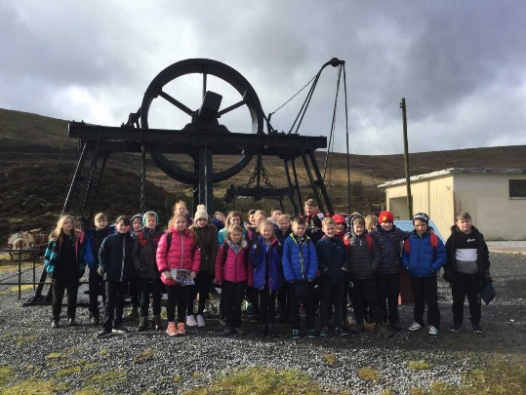
It is important to provide children with first hand contextual opportunities for learning, particularly in areas they may not otherwise experience. Each year, classes undertake visits to a variety of locations in order to enhance children’s learning experiences. Where possible, visits are related to the themes that children are studying in order to develop their understanding and contribute towards their classwork but residential experiences are also offered in KS2 to places such as Llangrannog and Cardiff Bay. If a child is eligible for Free School Meals some of the cost will be covered by grants received by school.

School Admissions

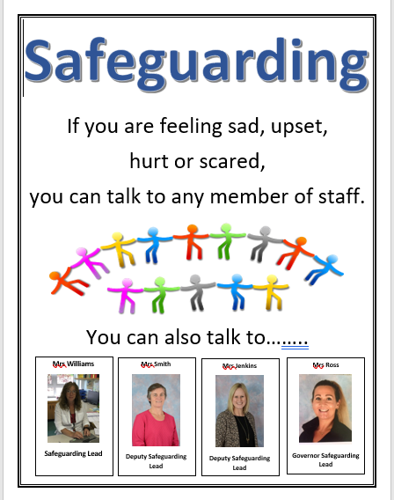
Parents who are considering sending their children to our school are welcome to contact the school office and arrange a visit to look around and meet the staff. Pupils start school in the September preceding their 5th birthday. There is regular liaison between Little Acorns and Reception staff and visits are arranged for all children before they start school. All admissions are administered by the Local Authority. The publication ‘Admissions Information and Arrangements’ is a comprehensive guide to admissions across Powys Local Authority Schools and can be found on the Council’s website at:
Applying for a School Place - Powys County Council
Alternatively, the Admissions Team may be contacted on
(01597) 826499 or via email: admissions@powys.gov.uk

Safeguarding
The school operates a thorough and comprehensive
safeguarding policy to ensure the wellbeing of all of our
children. This includes our Child Protection and
Safeguarding Policy (available on the website).
All parents and carers should be aware that if the school
has any concerns regarding the safety of a child, under
our duty of care we would make a referral to Children’s
Services.

Absences
If you know in advance that your child will be missing any part of a day’s schooling, or if a late arrival or an early departure is needed, please let us know in advance by calling the school office. Please note that without an acceptable reason for nonattendance, all absences will be recorded as unauthorised. Unauthorised absences appear on a written report which you will receive at the end of each academic year; we are also obliged to inform the local authority of any ongoing absences or lateness. Families wishing to go on holiday will need to complete a holiday form from the office. For safeguarding reasons, the school will telephone parents within an hour of the start of the day, for any absent child that we have not received a message for.

Medical Provision
The school staff are not legally obliged to administer any medication to children during the school day. However, in exceptional circumstances, where medication is essential and where it is difficult for parents to come into school to administer the medication to their child, the staff may agree to do so. Parents will be required to sign a form absolving the teacher of responsibility in such a case. Medical permission forms can be obtained from the office. Asthmatic children who need to carry inhalers to be used in school will also need their parents to sign a form to allow them to do so. Any medication brought into school should be in the original packaging and clearly marked with the child's name and handed to the teacher on arrival at school. Should your child become ill during the school day, we will need to get in touch with you and ask that you provide us with your mobile, home and work telephone numbers and an emergency number for someone local who may be contacted if you are not reachable. Minor accidents will be treated by a qualified First Aider. All accidents are recorded and in the event of more serious accidents, necessary action will be taken and parents will be contacted.

Discipline
Crossgates adopts a positive Behaviour policy which embeds emotional coaching. This means we place high value on the pupils acting as responsible members of our school and community, coupling self-discipline with a regard for others and a respect for property. We regard discipline not as a system of punishment but as rules for good behaviour which cultivate in pupils an understanding of their actions and decisions, and an acceptance of responsibility for the consequences. The purpose of these rules is to assist the school to fulfil its function of developing in full the potential of all pupils. We seek to produce a relaxed pleasant atmosphere where all children feel safe and secure, where we encourage and reward achievement and so far as possible avoid boredom or frustration which are all too often the root cause of many discipline problems.
Unacceptable behaviour is dealt with immediately and firmly with a reprimand, loss of privileges and in more serious cases, consultation with parents. The ultimate sanction is exclusion from school, which is a legal available option but hopefully an unnecessary option at Crossgates School.

Bullying
We will not tolerate bullying in our school. The headteacher and staff work hard to ensure your child feels safe and secure in school. From time to time, children fall out and we are aware that we cannot force them to be friends all the time – this is part of the learning process. However, bullying either verbal or physical is a more serious offence than everyday falling out. Should we have an incident of bullying we would consider it unacceptable and take immediate action to resolve the problem. We are a restorative conversation school and follow a 5 question structure, to resolve issues.

However, sometimes bullying can take place unknown to the school. We encourage the children to tell us but sometimes we remain unaware. If this should be the case, we urge you to inform us as soon as you become aware. Please remember the sooner we know the sooner we can resolve the problem. We WILL resolve the problem, IF we ALL work TOGETHER.

School Uniform
Crossgates School has a school uniform. We encourage all pupils to wear uniform but we cannot enforce this as compulsory. We encourage uniform because it contributes significantly to the ethos of our school.
Wearing uniform
- makes children feel equal
- looks smart and attractive
- makes the children safer - they are easily recognisable when out.

What is the uniform?
- Navy blue/grey/black trousers, shorts, skirts or pinafore dresses.
- pale blue/white shirts or polo shirts
- navy blue cardigan, jumper or sweatshirt
- blue and white gingham or striped dresses in the Summer

For PE your child will also need a change of clothes
- T shirt and shorts/joggers and trainers. These should be kept in a drawstring bag which will hang on their cloakroom peg.
- A ONE piece swimming costume and towel are also needed. (Bikinis may not be worn during swimming lessons). We are not permitted to allow children to wear goggles at the swimming pool unless they bring a letter from a parent taking full responsibility for this action.

Parents are able to order school uniform direct from School Trends using their on-line service via. the link below:
https://www.schooltrends.co.uk/uniform/CrossgatesPrimarySchoolLD16RE
Please make sure your child’s name is on all clothing and property. Second hand clothes are available- please come to the school office.

Jewellery
For health and safety reasons the wearing of jewellery is not permitted. Pupils may wear a watch and small studded earrings only. However, BOTH of these items should be removed for PE and swimming by the CHILD. We cannot accept responsibility for lost jewellery. Children wearing other items of jewellery will be asked to remove them and they will be sent home in an envelope at the end of the school day with a note for your attention.

Transport
You can apply for free school transport through the Council’s school transport team, depending on where you live. The bus/ car will pick them up and drop them off at an agreed point at a set time. To comply with insurance regulations, the driver will only carry pupils he/she is authorised to do so. If your child wishes to take a friend home to tea, you must make your own travel arrangements for the friend. Please do not put the driver in an awkward position by asking him/her to break the rules.

Our prime concern is your child’s safety. In the interest of safety your child will only be dropped off at a point different to the normal if YOU have let the driver or the school know of the different arrangements. Please do not send verbal messages with the child. If your child is to be met by a person who would not be known to the driver we also need to know of these arrangements.

Communication
We welcome regular contact between staff, governors, parents of pupils and the community as an essential element in the success of the school.
Parents’ Evenings: These are held in October and March each year. Curriculum and medical evenings are also arranged throughout the year. On these evenings the parents may meet a child’s teachers and look the child’s class work.

Reports: A written report on your child’s progress is sent out at the end of June each year. Pupils who are on the school’s ALN register receive ALN reports. CATs results for Year 4 are sent out before January. Reports are made at the end of the Foundation Phase and end of KS2 giving end of KS assessments for the pupil. National Test results are sent out at the end of the school year.

Newsletters: Newsletters are sent out every Friday via Schoop, our parent/school communication tool. A Governor newsletter is also sent out termly.

Any communications sent home are given to the oldest child in a family.

Parent Planners: At the start of each half term a letter is sent informing the parents of each child’s class projects and topics for that half term.

Website: The school has a website address www.crossgates.powys.sch.uk

SCHOOP: Lots of reminders, alerts and newsletters are sent via this app. Each class’ topics and news is regularly updated here. Our schoop ID is 5612.

Facebook- You can also like us on Facebook at ‘Crossgates Community Primary School’

Equal Opportunities
We are committed to the view that all children are of equal value and have equal rights to education whatever their race, gender, class, disability, learning need, age or religion. This is central to the school’s philosophy and ethos.

The school has adopted an Equal Opportunities and Strategic Equality policy which are both available upon request for inspection.

Pupils with Disabilities/Accessibility
In accordance with the Disability Discrimination Act, disabled pupils are admitted to the school providing the facilities that we have are adequate for their needs and are included as fully and as equally as possible in the mainstream of the school.

We have ramp access to the main school building and lift access to the junior block and school fields. These facilities allow for wheelchair access. All pupils share the same accessibility to the curriculum regardless of any physical disability.

Children Looked After- Coordinator: Mrs Lisa Williams
Several foster parents live in our community and the school is used to receiving children who are looked after by someone other than their parents. The school and its staff are sympathetic to these children and their needs. Mrs Williams is the CLA coordinator for the school who will attend CLA review meetings and ensure the children’s educational development is promoted, their needs met and the appropriate groups are kept up to date with the child’s educational development. The child’s social worker will meet with the class teacher within the first six weeks of the child starting school to draw up a PEP (Personal Education Plan) to ensure everyone knows and understands the child’s educational needs.

It is important to recognise the emotional support that these pupils may also require. THRIVE is often used with these pupils but we also support work with Windfall and other therapeutic agencies. This is reviewed on a termly basis. Our system reflects the County’s LAC policy which has been adopted by the school.

Overview of Assessment
As Curriculum for Wales rolls out in schools and settings across Wales, it marks a significant shift in the role of assessment within education, at both a national and a school/setting level. We are clear that the purpose of assessment is to support each individual learner to progress at an appropriate pace, ensuring they are supported and challenged accordingly.
To do so, the Curriculum for Wales sets out that we assess for three key reasons, to:
- support individual learners on an ongoing, day-to-day basis
- identify, capture and reflect on individual learner progress over time
- understand group progress in order to reflect on practice

To enable this approach to assessment, aspects of the current arrangements that do not support the ethos of Curriculum for Wales will be removed and new requirements will be introduced to ensure that supporting learners to make progress is at the heart of assessment going forward. We can build on and further develop assessment methods that are already in use to support learners to progress on an ongoing, day-to-day basis, and look to develop new strategies.

Results from all assessments and activities are kept in pupil profiles and recorded on Teacher Centre. Staff meet at the end of each academic year to discuss pupils academic and emotional needs. They share information and look at pupil’s books. This promotes the transfer of information on each learner from class to class. Each learner’s progress across all subjects is also recorded on Taith 360. This allows the teacher to track the learner’s knowledge and understanding and provide indicators for improvement.
The standardised Literacy and Numeracy tests undertaken in May from year 2 upwards are used to inform future teaching and learning. This information also helps to identify children who require additional support and MAT children.

