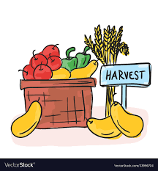
Our Harvest Poem
H ~ having lots of lovely food
A ~ and we thank God for the delicious food we eat
R ~ rights – we have the right to good food and water (Article 24)
V ~ vegetables fresh and healthy
E ~ eating food farmers have harvested for us
S ~ so many things to be grateful for
T ~ time to celebrate Harvest at Autumn time

