1st October 2026
Year 11 End of Year Celebration 2027
Dear Parents and Carers,
As we look ahead to the end of the academic year, we are delighted to invite Year 11 pupils to attend our End of Year Celebration on Wednesday 30th June 2027 at the Glyn Clydach Hotel, Longford. This special event is an opportunity to mark the end of their time at Ysgol Bae Baglan and recognise the effort, resilience and achievements they have demonstrated throughout their school journey.
The evening provides a chance for pupils and staff to come together to mark the end of Year 11, reflect on memories made, celebrate successes and wish one another well for the future. It also gives staff, many of whom have supported pupils throughout their school journey, the opportunity to spend time with them in a more informal setting before they move on to the next stage of their education, training or employment.
It is important to recognise that the evening is a celebratory event and is not a compulsory part of Year 11. Staff give a significant amount of their own time to organise and run the event because they value the opportunity to celebrate pupils' achievements and say goodbye in a positive and memorable way.
The invitation is open to all Year 11 pupils. However, attendance at the celebration will be dependent upon pupils continuing to meet the standards of behaviour, attendance and conduct expected throughout the remainder of Year 11. Pupils who consistently meet school expectations, attend regularly and contribute positively to the school community will be able to attend. Where there are serious or ongoing concerns regarding a pupil's behaviour, attendance or conduct, the school reserves the right to withdraw their invitation.
We want as many pupils as possible to attend and enjoy this special occasion. We therefore encourage all Year 11 pupils to continue to demonstrate commitment, maturity and a positive attitude throughout their final year at Ysgol Bae Baglan.
Further information regarding timings, cost and arrangements for the evening will be shared later in the academic year.
Thank you for your continued support.
Yours sincerely,
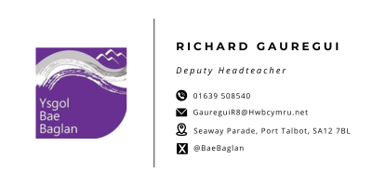
R. Gauregui

