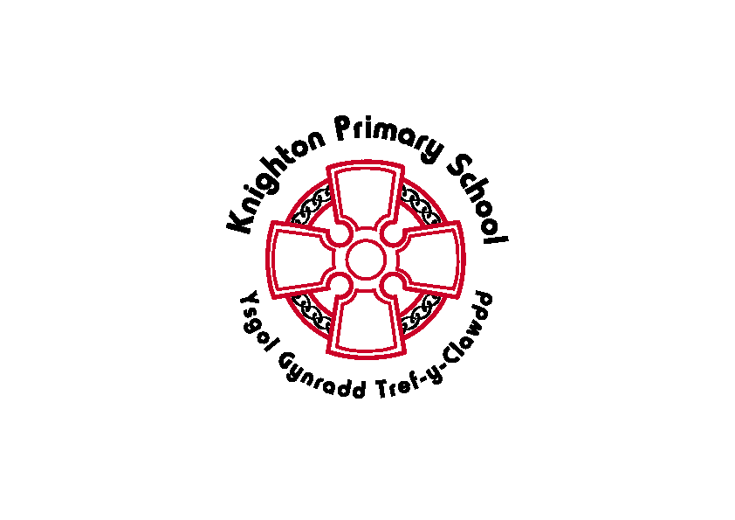Knighton Primary School
Eco-School Action Plan 2021/22
Aims/Targets | Activities & tasks | Organisation:  Who, where, how, when | Cost | Monitoring:  Evidence collection | Evaluation  Of effectiveness
Waste minimization  Reduce the amount of cling film used in the school kitchen for puddings  -prompted by Y5/6 class | Research cling film  Measure amount used  Speak to kitchen staff | Eco committee | NA | Measurements and gathering data | Kitchen agreed to reduce use of clingfilm  See work from Y4 to see how much could be saved.  Ongoing talks as they still use it sometimes.
School grounds  Develop the hedgerows of our school field  -prompted by EW in Y5  -increase biodiversity of creatures of school grounds | Measure the spaces that have missed the opportunities for hedgerows  Research different trees  Apply to Woodland Trust and From the Group Up for free trees  Data collection before and after they are planted. | Eco committee & Miss Jones | NA | Photos of school field | 4 trees planted and ‘won’ application for more trees, but they won’t arrive until November 2022.
Global citizenship  To learn about deforestation and endangered animals | School curriculum | Class and teachers | NA | Thema books | See minutes from meeting 04.07.22 for review of the year and learning.

