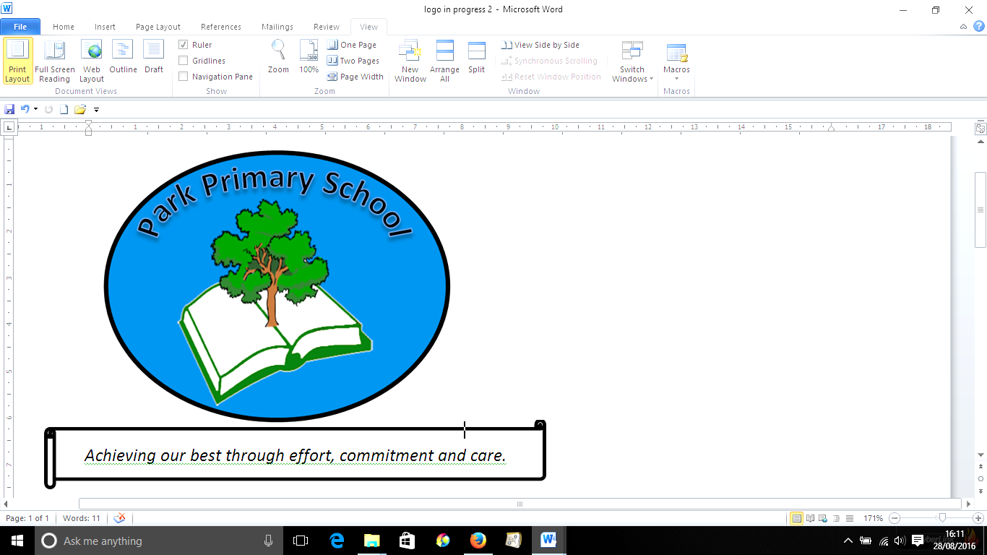
4th September 2024

Dear Parents/ Carers,
I hope you managed to have a lovely break over the summer and were able to make the most of the good weather. It’s been so lovely to have the children back in school. They look very smart in their uniforms and I’m very grateful for your support with this. We already have some confirmed diary dates and I’ll update you further when new dates are made.
Dates for your diary
Friday 19th September: Individual and sibling photographs with Tempest Photography
Tuesday 7th October: Chance to Shine Cricket sessions with Cricket Wales for Y2/3; Y4/5: Y5/6 (Also 14th and 21st Oct)
Thursday 9th October: Provisional date for Harvest Festival (Reception-Y6)- more details to follow
Friday 10th October: Hello Yellow Day, raising awareness of mental health (a small contribution for Young Minds would be much appreciated)
Friday 18th October: Wear Red for “Show Racism the Red Card”
Monday 27th October- Friday 31st October: Half term holiday
After school clubs
After school clubs will start week beginning 8th September. More information about these will go out to parents/carers separately.
Many thanks,
Mrs C Rees

