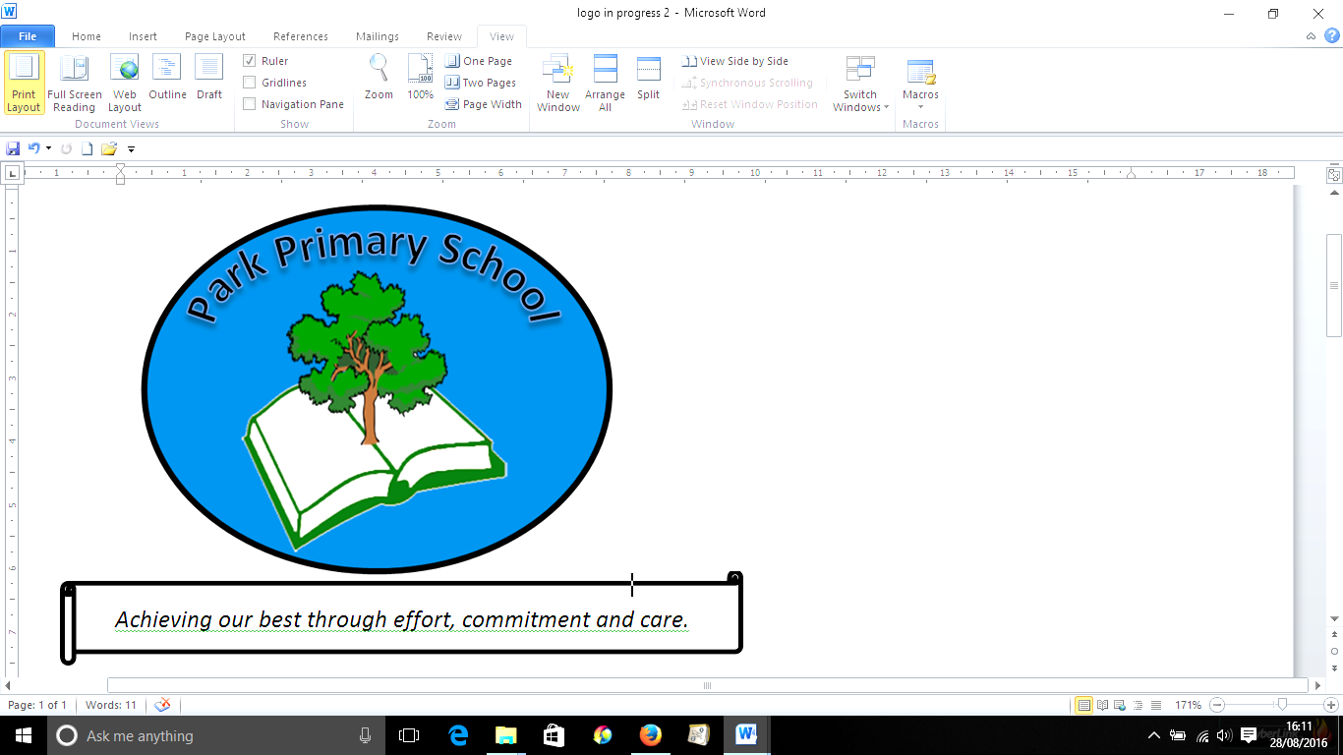
16th July 2025

Dear Parents/ Carers,
As we come to the end of another school year, Park staff and I would like to express our gratitude for your excellent support. We’ve had a very successful year, the children have enjoyed some wonderful experiences to support their learning, and I’m very pleased with the progress they’ve made. On trips and sporting events, our children have behaved impeccably, proving, once again, that they are a credit to their families and their school.
Seesaw
During Covid, Seesaw became an important tool to assist with home-school communication. However now, in some instances, Seesaw has taken over from the office for some communication and I feel this is no longer appropriate. From September, Seesaw won’t be available for messaging from home. The office is manned from 8.15am until 3.30pm daily, and outside these hours, messages can always be left, which will be dealt with promptly. You will still be able to receive photos of your children in school via Seesaw.
Staff Changes
Whilst our core staff remains the same, Mrs Usher is moving to Gilfach for a year and Miss Coles is coming to Park. Miss Coles is excited about her move and is looking forward to bringing her skills to the team. She’s recently been trained in Forest Schools, meaning that with Mrs Lloyd, we now have two fully trained members of staff. Needless to say, Forest School sessions will be starting again in the new term.
Fore
Many thanks for your continued support, and I wish you a wonderful summer.
Mrs C Rees

