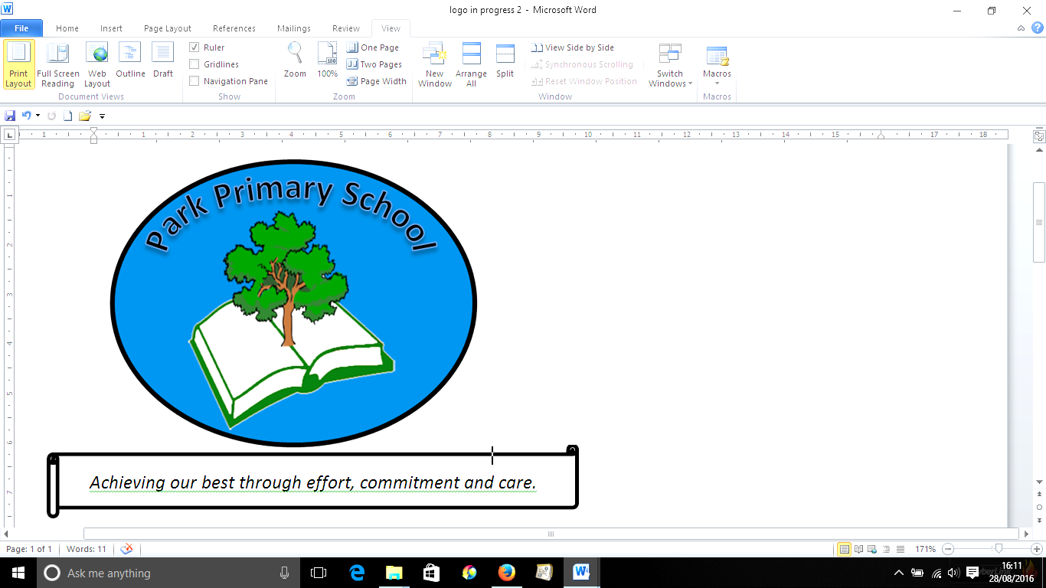
25th June 2025

Dear Parents/ Carers,
We’ve had a very busy few weeks, with lots of sporting events, visitors to school and workshops. It was lovely to see so many of you at our sports day on Monday.
Mr Vik Yadh visited school to speak to children from Y3-Y6 about opportunities at Bargoed Library to be part of a gaming club. The next event is on Saturday 5th July. See over the page for more information.
End of year reports for Reception-Year 6 have now gone out to parents/carers. Lots of work goes into the reports and, I’m sure you’ll agree, they are very informative. Also included, for children in Y2 onwards, are the results of recent personalised assessments in reading and numeracy (procedural and reasoning). If you have any queries regarding the reports, the final parents’ evening of the year is taking place on Tuesday 8th July. Appointments should be made via the office. If you don’t have any queries, we’ll look forward to seeing you at other events this term or for next term’s parents’ evening.
In readiness for September, we will be having class swap day on Monday 14th July. This will be when your child spends an afternoon with their new class. In the week prior to this, I will be sending information home to parents/ carers about new classes. As you know, we have mixed classes through much of the school, and our planning is carefully tailored to take this into account. Teachers are skilful at differentiating work according to children’s needs, and decisions about class allocation for children are reached carefully, with several factors taken into account, including maturity and friendships. No child is “kept back”, although children may remain with the same class teacher. These decisions are made by senior leadership at school.
Finally, when term starts on 1st September, we will be having two INSET days where staff will be retraining in important aspects such as annual safeguarding and additional learning needs.
Remaining dates for your diary for this academic year
- Thursday 26th June- Scooter skills for Year 2 onwards. Children will need to bring their scooter (and helmet if they have one) to school if they wish to access the training
- Thursday 26th June- Y5/6 visit to Bargoed Library to view winning recycling statues
- Monday 30th June- Y3/4 bowls team, finals event
- Wednesday 2nd July- N and R/Y1 trip to Mountain View Ranch, including the Gruffalo Trail
- Tuesday 8th July- Y6 Leavers’ Assembly, starting at 9.30am (Please note the change of date.)
- Tuesday 8th July- parents’ evening for anyone with queries about reports
- Wednesday 9th July- Y5/6 trip to Parc Stormy (letter pending)
- Monday July 14th - Class swap afternoon: children spend the afternoon in their new classes
- Tuesday 15th July- 9.30am, Nursery Graduation
- Monday 14th July-Wednesday 16th July- Transition at Heolddu for Y6 pupils who will attending Heolddu in September (children return to Gilfach for Thursday and Friday)
- Thursday 17th July- Year 6 leavers’ party after school, ending at 5pm
- Friday 18th July- end of term.
Many thanks for you continued support,
Mrs C Rees

Information regarding CTG Club at Bargoed Library- next session is 5th July

Teach your child there is more to games than consoles and mobile devices! Learn strategy, maths (STEM) and socialize with other fellow gamers for real. CTG is a free monthly gaming society that will meet in the Baroed Library once a month 10-4pm. Free to all pupils and their families in the Bargoed and Greater Bargoed Area. Funded by Bargoed Town Council.

CTG STEMHOUR 11-12noon, where only games with Maths and Strategy themes will be played.

Be it table top board games, role-play games (RPG) and war gaming board games and also Pokemon, Magic and Yi-Gi-Oh card games – this is the place to be. Why not pop in and bring your games with you? Teach fellow students your favourite games. Learn and join into different games. But don’t worry if you don’t have your own games - we have many.

Please note Library rule: Parents/carers are advised pupils under 8 years old cannot be left unsupervised!

