



**Gilfach Fargoed and Park Primary Schools Federation**

|  |  |  |  |
| --- | --- | --- | --- |
| Policy Title: | FIRST AID POLICY | | |
| Adoption Date: | January 2025 | Review date: | January 2027 |
| Signed, Chair of Governors: |  | Signed, Headteacher: |  |

I

**Mission Statement**

In our Federation, we are all learners for life. Our schools prioritise authentic, nurturing relationships through which we provide engaging and inspiring learning experiences. We set high-expectations, achievable through the development of resilient and confident learners who have a curiosity and enthusiasm about their community and the wider world. We take a pride in our learning, we thrive on collaboration and we are ambitious to solve problems and to achieve our best. We respect one another and our wider world while valuing our Welsh heritage. We aim to give our learners the tools to succeed in the 21st Century, with the guidance of a strong moral compass. We develop skills and knowledge, while fostering wellbeing and a growth mindset. Our whole community aims to develop:

* Healthy, confident individuals;
* Ethically informed citizens;
* Creative, confident contributors and
* Ambitious and capable learners.

Contents

SECTION 1 INTRODUCTION Page 3

SECTION 2 POLICY STATEMENT Page 3

SECTION 3 SCOPE Page 3

SECTION 4 DEFINITIONS Page 3

SECTION 5 LEGISLATION Page 4

SECTION 6 RESPONSIBILITIES Page 4

SECTION 7 MANAGEMENT ARRANGEMENTS Page 7

SECTION 8 SUPPORTING DOCUMENTS Page 11

APPENDIX 1 MINIMUM CONTENTS OF FIRST AID BOX AND

TRAVEL FIRST AID KITS Page 12

APPENDIX 2 FACILITIES AND EQUIPMENT TO BE PROVIDED

IN FIRST AID ROOMS Page 14

APPENDIX 3 PROVISION OF APPOINTED PERSONS AND

FIRST AIDERS Page 16

APPENDIX 4 FORM FOR RECORDING FIRST AID TREATMENT Page 18

APPENDIX 5: Some specifics for Gilfach Fargoed and Park Primaries

**1. INTRODUCTION**

**1.1** This document sets out the policy to be implemented within Caerphilly County Borough Council (the Authority) to ensure the health, safety and welfare of its employees in relation to first aid at work.

**1.2** The policy sets out the responsibilities of individuals and departments within the Authority to ensure the health, safety and welfare of its employees, occupiers of buildings, members of the public, contractors and others in relation to first aid provision and treatment for personal injury or sudden ill health.

**2. POLICY STATEMENT**

**2.1** The Authority recognises that its employees are its most valuable resource in delivering high quality services to the community and will take all practical steps to ensure their health and safety, and also that of contractors and visitors to and users of council premises by ensuring adequate first aid provision is available.

***2.2*** This will be facilitated by the provision of first aid equipment and personnel as set out in this policy and the provision of appropriate training, instruction and supervision.

**2.3** The Authority accepts that it has specific duties as set out in Section 5.

**3. SCOPE**

**3.1** This policy has been agreed with the Trade Unions and applies to all employees.

**3.2** The policy will be reviewed at least every 3 years to ensure that it is in line with current legislation.

**3.3** The effective date of version 4 of the policy is: February 2020.

**4. DEFINITIONS**

**4.1** For the purposes of this policy ‘First Aid’ is defined as

• Treatment for the purpose of preserving life and minimising the consequences of injury and illness.

• Treatment of minor injuries which would otherwise receive no treatment or which do not need treatment by a medical practitioner or nurse.

**5. LEGISLATION**

**5.1** This policy, along with supporting procedures, is designed to ensure that the Authority meets its legal obligations as stated in:

• The Health and Safety at Work etc Act 1974

• Management of Health and Safety at Work Regulations 1999

• The Health and Safety (First Aid) Regulations 1981

• The Reporting of Injuries, Diseases and Dangerous Occurrences Regulations 2013

**6. RESPONSIBILITIES**

Please note that all employees have a legal responsibility to comply with health and safety law and the provisions of this policy. Failure to do so could result in personal and/or corporate liability.

**6.1 The Chief Executive Officer will:**

6.1.1 Be ultimately responsible for ensuring compliance with this policy within Caerphilly County Borough Council.

**6.2 Directors and Heads of Service will:**

6.2.1 Be responsible for ensuring the effective implementation of corporate policy and site-specific arrangements within their Service Area.

6.2.2 Ensure that appropriate resources are made available for the effective operation of the policy, including training.

**6.3 Managers with responsibilities for employees will:**

6.3.1 Ensure arrangements are in place for the provision of first aid treatment in the event of an accident to/ill health of an employee, member of the public (on an Authority site) or pupil/client in their care.

6.3.2 Cooperate with other managers in their building or location with regards to the provision of first aid facilities and personnel.

6.3.3 Ensure that minimum requirements relating to first aid provision are met or exceeded e.g. number of trained first aiders, contents of first aid boxes (as detailed in appendices 1, 2 and 3) and that arrangements are in place to maintain them (restock first aid boxes etc).

6.3.4 Ensure first aiders are allowed time to undertake their responsibilities as detailed in this policy.

6.3.5 Ensure that training records are kept and refresher training provided.

6.3.6 Ensure risk assessments/needs analysis (as detailed in appendix 5) specifically relating to first aid provision are completed, recorded for inspection or audit reference and kept until such time as a new assessment is undertaken or the assessment is revised.

6.3.7 Put in place measures to control the risks highlighted by the risk assessment that will remove them altogether or reduce them to the lowest possible level.

6.3.8 Ensure that all employees are aware of the provision and location of first aid facilities and personnel within their building, workplace or location.

6.3.9 Ensure that an Accident and Incident Report Form is completed, where appropriate, in line with the Accident / Incident Reporting and Investigation Policy.

6.3.10 Ensure, where applicable, Automated External Defibrillators (AED’s) are provided in all corporate offices and relevant training provided.

6.3.11 Ensure, where AED’s are donated to CCBC where Council employees are located, training is provided.

6.3.12 Ensure, when AED’s are required, the Health and Safety Division is consulted on the appropriate number of AED’s required and their locations.

6.3.13 Ensure servicing of AED’s is carried out in accordance with manufacturer’s recommendations.

**6.4 Building Managers will:**

6.4.1 Ensure that all visitors and contractors are appropriately made aware of the first aid arrangements for the location they are visiting.

6.4.2 Ensure with local managers, that appropriate arrangements are in place with regards to the provision of first aid facilities and personnel.

6.4.3 Conduct weekly checks ensuring the AED is in working order, pads are in-date and battery has sufficient charge.

6.5 Each Employee of the Council will:

6.5.1 Ensure that they are aware of the provision and location of first aid facilities and personnel within their building, workplace or location.

6.5.2 Not misuse the first aid provisions provided.

6.5.3 Report to their line manager any failures in the provision of first aid facilities.

6.5.4 Act in accordance with their instruction and training with regards First Aid provision and assistance.

6.5.5 Act in accordance with this policy.

6.6 Procurement Departments will:

6.6.1 Ensure that requests for first aid provisions are met in a timely fashion.

6.7 The Occupational Health Department will:

6.7.1 Provide guidance, where requested, to first aiders.

6.7.2 Offer appropriate immunisations to those first aiders identified by risk assessment as requiring them.

6.8 First Aiders and Appointed Persons will:

6.8.1 Undertake approved training, including refresher training, as appropriate to their position.

6.8.2 Notify their line manager, in advance of their certificate expiring, that they require refresher training.

6.8.3 Act in accordance with their instruction and training.

6.8.4 Ensure that their first aid box/room is kept stocked with the appropriate supplies/equipment and that stock is within its expiry dates

6.8.5 Act according to the provisions of this policy.

6.9 The Health and Safety Division will:

6.9.1 Ensure that this policy is reviewed at least every 3 years to ensure it is in line with current legislation.

6.9.2 Provide advice and information on legislation or guidance relating to first aid.

6.9.3 Audit compliance with the policy.

**7. MANAGEMENT ARRANGEMENTS**

7.1 Risk Assessment;

7.1.1 Risk assessment of first aid requirements is the joint responsibility of managers with responsibility for employees and others in a particular building or location, in consultation with the building or site manager, and coordinated by a senior member of staff.

7.1.2 The risk assessment should consider the following as a minimum:

• The nature of the work

• The size of the workforce

• Other individuals who may use the premises

• Any history of accidents

• Hazards and risks particular to the environment/work tasks

• Risks specific to multi-occupied premises

• Risks specific to lone workers and remote workers

• The absence of first aiders/appointed persons to cover annual leave/sickness etc.

• The remoteness of the site from emergency services

• The requirement of Automated Electronic Defibrillators

7.1.3 A written record of the risk assessments/need analysis as detailed in appendix 5 should be kept until such time as a new assessment is undertaken or the assessment is revised.

7.2 Minimum Requirements;

7.2.1 There must be adequate and appropriate facilities and stock (e.g. first aid rooms and appropriate equipment in first aid boxes) for enabling first aid to be administered to employees and others if they are injured or become ill at work and it must be readily available to each employee at all times.

7.2.2 The facilities required will vary according to the number of employees present, the type of work being carried out and the hazards associated with the work, and will be defined by the risk assessment. When establishing the facilities required you should take into consideration others who may share the premises.

7.3 First Aid Boxes;

7.3.1 First aid boxes should be located as deemed necessary by the risk assessment. Their location must be clearly signposted and the box itself identified as a first aid container (marked with a white cross on a green background).

7.3.2 It is the responsibility of the appointed person(s) or first aider(s) to ensure that the first aid box is fully stocked and that the contents are discarded and replaced when they reach their expiry date. Managers must ensure that first aiders are allowed time to undertake these duties.

7.3.3 Where applicable the names and contact numbers of first aiders should be located near to the first aid box.

7.3.4 The contents of the first aid box should be determined by your risk assessment. For guidance a list of minimum contents can be found at Appendix 1. As part of the risk assessment consideration should be given to providing such items as scissors, disposable gloves and aprons, cold packs, cling film, adhesive tape, etc. to be stored in, or alongside, the first-aid container. The risk assessment should consider if any specialist requirements are necessary e.g. eye washes, emergency showers.

7.3.5 Medicines must not be stored in the first aid box.

7.3.6 Where mains water is not readily available for eye irrigation, at least a litre of sterile water in sealed disposable containers should be provided.

7.3.7 Lone and remote workers should, if deemed necessary by an appropriate risk assessment, be provided with a first aid kit suitable for their needs and at least to the minimum standard (Appendix 1).

7.4 First Aid Rooms;

7.4.1 If deemed necessary by the risk assessment, designated first aid rooms should be provided.

7.4.2 First aid rooms must be clearly marked as such and should also display, on the door, the names and locations of the nearest first aider.

7.4.3 First aid rooms should be used solely for rendering first aid or health screening. Access should only be granted to authorised personnel, and the room should be lockable from the inside for the purposes of privacy and dignity.

7.4.4 The room itself should be suitable for its purpose in terms of size (big enough to move around comfortably in), facilities (see Appendix 2) and location (near to a point of access for transport to hospital). The entrance should be wide enough to accommodate a stretcher or wheelchair.

7.4.5 The first aid room must be kept in a clean and hygienic state, with an appropriate cleaning regime in place.

7.4.6 All clinical waste must be disposed of in an appropriate fashion.

7.5 First Aiders and Appointed Persons;

7.5.1 It least one ‘suitable person’ must be appointed to administer first aid where required. These people may be ‘appointed persons’, ‘first aiders’ or a combination of both.

7.5.2 The number of appointed persons and first aiders required will be determined by the minimum requirements (Appendix 3) and the results of your risk assessment, however there must be enough appointed people and first aiders to cover all times when employees are at work, and cover foreseeable absences (such as annual leave).

7.5.3 In larger premises cover must be established with other managers. A list of local appointed persons and first aiders, and the means of communicating with them (i.e. telephone extension number), should be displayed in a prominent location.

7.5.4 Low risk environments (i.e. small offices) may simply require an ‘appointed person’ whose duties would be to contact emergency services, maintain the contents of the first aid box and undertake basic first aid (such as the control of bleeding) in exceptional circumstances. ‘Appointed persons’ must undertake basic first aid training, but are not expected to undertake the full duties of a qualified First Aider.

7.5.5 Where it is a minimum requirement (see Appendix 3), or the risk assessment shows it to be necessary, first aiders must be appointed.

7.5.6 First Aiders must hold a HSE approved first aid qualification, which must be refreshed within three years. In addition, if there are any specific risks that would require specialist first aid treatment (i.e. exposure to toxic chemicals) the first aider may be required to undertake additional training as appropriate.

7.5.7 The selection of a person to be a first aider will depend on a number of factors including the individual’s:

• Reliability, disposition and communication skills.

• Attitude and ability to absorb new knowledge and learn new skills.

• Ability to cope with stressful and demanding procedures.

• Ability to leave their normal duties to attend an emergency.

• Physical ability to undertake the required tasks.

7.5.8 First aiders must keep written records of all first aid treatment given on the appropriate form, (Appendix 4) which must be kept in a secure location (such as a locked cupboard, or a cupboard in a locked room) for at least 4 years.

7.5.9 First aiders should remind employees to fill in an Accident/Incident Report Form, or fill one in on their behalf if the injured person is unable to do so or is not an employee, for all incidents caused by a fault of the workplace site or building, the work activity or work equipment in accordance with the Authority’s Accident/Incident Reporting and Investigation Policy.

7.6 Automated Electronic Defibrillators (AED);

7.6.1 Corporate offices must provide AED’s. The health and Safety Division must be consulted on the number of AED’s to be provided and suitable locations.

7.6.2 The Head of Service / Head Teacher must provide authorisation for the provision of AED’s in all other CCBC buildings and Schools.

7.6.3 Where AED’s are provided First Aid staffing provision must be considered by the Building Manager to ensure that a trained employee is on site during opening hours.

7.6.4 Training in the use of AED’s is required on a 2 yearly basis and is provided by the Authority’s Health and Safety Division.

7.6.5 All AED units must be ordered via the Health and Safety Division to ensure consistency on the type of units being provided.

7.6.6 Where AED’s are donated to CCBC premises where Council employees are located, relevant staff must undergo training on a 2 yearly basis to ensure they are confident in using the AED.

7.6.7 The building manager must ensure the AED is serviced in accordance manufacturer’s recommendations and the necessary routine checks are carried out on a weekly basis, including checking battery life and the expiry dates of defibrillator pads.

7.7 Schools and School Pupils

7.7.1 Schools as employers must comply with this policy in relation to their employees.

7.7.2 Schools must also take into account, when assessing the need for first aid provision, visitors to their premises and pupils. Schools must comply with the provisions laid out in the Department for Education and Employment’s leaflet ‘Guidance on First Aid for Schools’.

**8. SUPPORTING DOCUMENTS**

8.1 L74 “First Aid At Work – Health and Safety (First Aid) Regulations 1981: Approved Code of Practice and Guidance”

8.2 Other sources of Information:

• Basic Advice On First Aid At Work – HSE leaflet INDG347

• First Aid At work: Your Questions Answered – HSE leaflet INDG214

• Guidance on First Aid for Schools: A good practice guide – Department for Education and Employment Booklet

• www.hse.gov.uk/firstaid

This policy should be read in conjunction with the following Caerphilly

County Borough Council Policies:

• Corporate Health and Safety Policy

• Risk Assessment Policy

• Accident and Incident Reporting Policy

APPENDIX 1 – Minimum contents of First Aid box and travel first aid kits

Taken from L74 the Health and Safety (First Aid at Work) Regulations 1981 Guidance on Regulations

**Minimum contents of First Aid box and travel first aid kits**

There is no mandatory list of items to be included in a first-aid container. The decision on what to provide will be influenced by the findings of the first-aid needs assessment. However, as a guide, where work activities involve low hazards, a minimum stock of first-aid items should be:

■ a leaflet giving general guidance on first aid advice on first aid at work

■ 20 individually wrapped sterile plasters (assorted sizes), appropriate to the type of work (hypoallergenic or food-detectable plasters can be provided if necessary);

■ two sterile eye pads;

■ two individually wrapped triangular bandages, preferably sterile;

■ six safety pins;

■ two large, sterile, individually wrapped unmedicated wound dressings;

■ six medium-sized sterile individually wrapped unmedicated wound dressings;

■ at least three pairs of disposable non-latex gloves.

Managers may wish to refer to British Standard BS 8599 which provides further information on the contents of workplace first-aid kits. Whether using a first aid kit complying with BS 8599 or an alternative kit, the contents should reflect the outcome of the first-aid needs assessment.

Travel First Aid Kits for lone workers should contain the following as a minimum (N.B. the exact contents should be determined by your risk assessment):

Similarly there is no mandatory list of items to be included in first-aid kits for travelling workers. However, as a guide they might typically contain:

■ a leaflet giving general guidance on first aid (

■ six individually wrapped sterile plasters (hypoallergenic or food-detectable plasters can be provided if necessary);

■ two individually wrapped triangular bandages, preferably sterile;

■ two safety pins;

■ one large, sterile, unmedicated dressing;

■ individually wrapped moist cleansing wipes;

■ at least three pairs of disposable non-latex gloves.

Either of the above should be considered as suggested contents lists only, and are based on guidance in the Health and Safety Executive publication L74 ‘*First Aid At Work: Guidance on the Health and Safety (First-Aid) Regulations 1981*

**NOTE:** First aid treatment items e.g. bandages and eyewashes do have expiry dates and must not be used if this date has passed.

**APPENDIX 2 – Facilities and equipment to be provided in first aid rooms**

Taken from L74 the Health and Safety (First Aid at Work) Regulations 1981 Guidance on Regulations

**Facilities and equipment to be provided in first aid rooms**

Where the risk assessment has deemed the provision of a first aid room to be necessary, they should

■ be large enough to hold an examination/medical couch, with enough space at each side for people to work, a chair and any necessary additional equipment;

■ have washable surfaces and adequate heating, ventilation and lighting;

■ be kept clean, tidy, accessible and available for use at all times when employees are at work;

■ be positioned as near as possible to a point of access for transport to hospital;

■ display a notice on the door advising of the names, locations and, if appropriate, telephone extensions of first-aiders and how to contact them.

Typical examples of the equipment and facilities a first-aid room may contain are:

■ a sink with hot and cold running water;

■ drinking water with disposable cups;

■ soap and paper towels;

■ a store for first-aid materials;

■ foot-operated refuse containers, lined with disposable, yellow clinical waste bags or a container suitable for the safe disposal of clinical waste;

■ an examination/medical couch with waterproof protection and clean pillows and blankets (a paper couch roll may be used that is changed between casualties);

■ a chair;

■ a telephone or other communication equipment;

■ a record book for recording incidents attended by a first-aider or appointed person.

Where special first aid equipment is needed, this may also be stored in the first aid room

[source HSE publication L74 ‘*First Aid At Work: Guidance on the Health and Safety (First-Aid) Regulations 1981’ ]*

**APPENDIX 3 – Provision of Appointed Persons and First Aiders**

Taken from L74 the Health and Safety (First Aid at Work) Regulations 1981 Guidance on Regulations

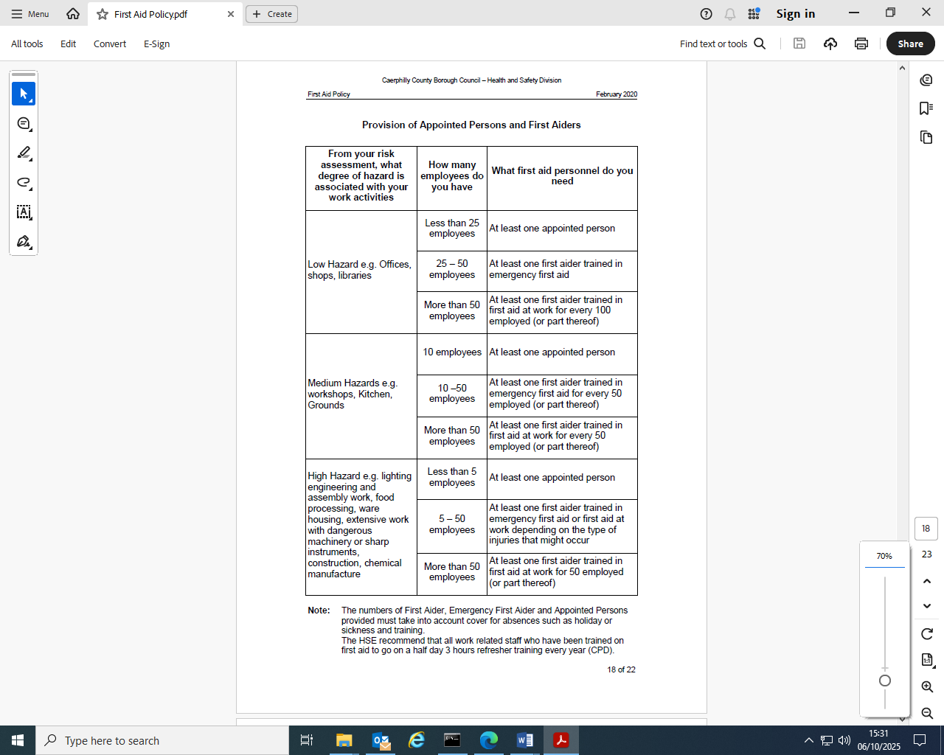

**APPENDIX 4 – Form For Recording First Aid Treatment**

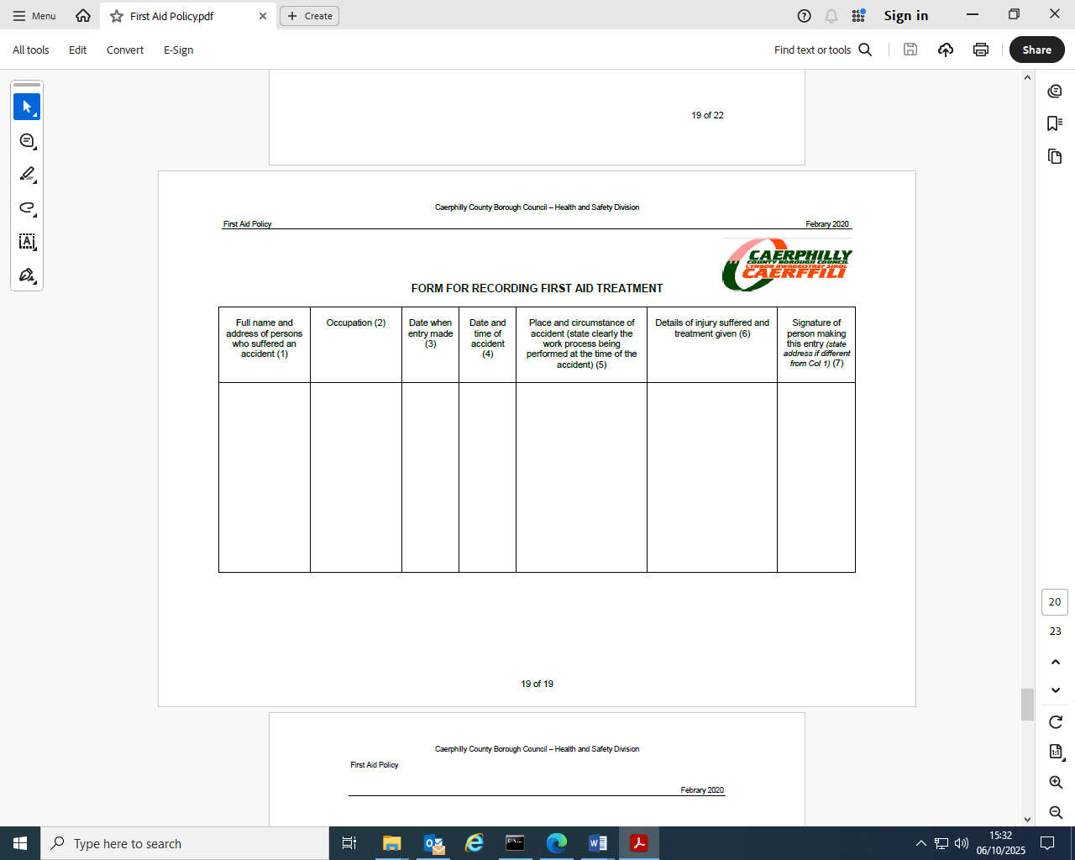

Appendix 5

Gilfach Fargoed and Park Primaries

Reporting and recording of first aid treatment

Where an injury no matter how small requires a first aider to provide treatment then a record must be completed. Records are held in the offices and should be returned there for safe keeping. If the injury is because of a work-related incident (attributable to the workplace, work organisation or work activity), then first aid details must also be recorded via the incident/accident form and send to the Health and Safety Division. This applies if a child is undertaking a curriculum based activity, rather than at play. However, in the event of an injury requiring hospital treatment, details must also be sent to the Health and Safety Division: [healthandsafety@caerphilly.gov.uk](mailto:healthandsafety@caerphilly.gov.uk) .

**First aid trained staff**

Up to date lists of first-aid trained staff can be found in the offices. There will always be a first aid trained staff member on playground duty.

Gilfach Fargoed and Park Federation’s first aid protocol includes identifying qualified first aiders, treating minor injuries with first aid kits, assessing serious incidents to call emergency services if necessary, and promptly informing parents of injuries or illness accordingly.

Staff should remain calm, reassure the injured child, and document all incidents for reporting and future reference.

**Key Steps for Staff:**

1. **Assess the Situation:** The closest staff member assesses the injury or illness and decides if a qualified first aider is needed.  Antiseptic wipes for very minor scrapes can be administered without the need for a first aider.
2. **Call for Assistance:** Seek out a qualified first aider when the injury requires it, or contact the emergency services (999) for serious incidents.
3. **Administer First Aid:** A trained first aider provides appropriate treatment for minor injuries. Superficial scrapes and grazes can be treated with an antiseptic wipe, monitored by general staff member.
4. **Ensure Safety:** Stay calm, keep other children away, and reassure the injured child.
5. **Contact Parents:** Inform parents/carers promptly if a head injury has occurred. In a non-head related incident, inform parents/carers at collection time that first aid has been administered, provide relevant details about the incident and the first aid given
6. **Record the Incident:** Log details of the accident, injury, or illness. This should be done by the person who initially dealt with the incident, with first aider (if needed) named in the report.
7. **Report to H&S:** report any work-related injury to Health & Safety Department

**When to Call for Emergency Services (999)** Call for an ambulance immediately if there is a life-threatening injury, a serious head injury resulting in unconsciousness or fits, or other symptoms such as vomiting, confusion, or persistent dizziness.

**Reporting and Documentation**

* **Minor Incidents:** May be documented on a first aid slip and stored in the office. Details of which should be given to parents at the end of the day.
* **Serious Incidents:** Require immediate contact with the emergency services and parents, and detailed logging of the incident with Health and Safety.
* **Work Related Injury:** All work-related injuries must be reported to Health & Safety Department without delay.
* **Trained Staff:**  Schools ensure there are a sufficient number of staff with valid first aid qualifications.

**First Aid Kits:** Portable first aid kits are located around the school and are regularly checked and replenished.