

Traffic Management Policy

Ysgol Carreg Hir

Sept 2021

Adopted by the Governing Body: 14th November 2019

Review Date: 4th March 2021
23rd November 2021
26th April 2022
18th January 2024
29th September 2025
14th July 2026

TRAFFIC MANAGEMENT ARRANGEMENTS AT
Ysgol Carreg Hir
September 2021

Contents

Section

1. Introduction

2. Layout / Access

3. School Opening / Closing times

4. Minibus and Bus management on and around the site
- Minibuses and Buses on site
- Minibuses and Buses on curtilage of site
- Staff supervision

5. Vehicles at school site
- Vehicles on site
- Parents vehicles
- Staff vehicles
- Senior Staff / Sixth Form
- Visitors
- Contractor’s vehicles
- Building works vehicles
- Servicing / Deliveries
- Buses, Mini Buses and Taxis
- Emergency Access

6. Pedestrians at school site

7. Parking

8. Cycles

9. Pupils

10. Footways

11. Access to and from school

12. Split sites

13. Shared sites

1. Introduction
This document has been prepared to inform and instruct employees, pupils, parents and others who come onto the site, including visitors (both pedestrians and people in vehicles), about the site rules concerning pedestrian and vehicle separation.
Ysgol Carreg Hir takes the health and safety of all site users very seriously. It is therefore imperative that individuals, when in the school grounds or within the vicinity of the school grounds, take care, exercise caution and follow instructions to avoid risk of injury. If there are any concerns about traffic safety, they should be reported to the school leadership team.
We urge all site users to read this document carefully and act in accordance with the instructions contained therein. The instructions constitute site rules. Pupils in breach of the site rules may be subject to disciplinary action.
Copies of the traffic management arrangements are also available from reception and on the school website: http://ysgolcarreghir.npt.school/en_GB/
The document will be reviewed annually and awareness raised regularly through parental events, pupil sub-groups, assemblies and school meetings.
For further information, please contact:
Mrs Lesley Hynes,
Headteacher,
Tel No: 01639 502892
Email: office@carreghir.npt.school

2. Layout / Access

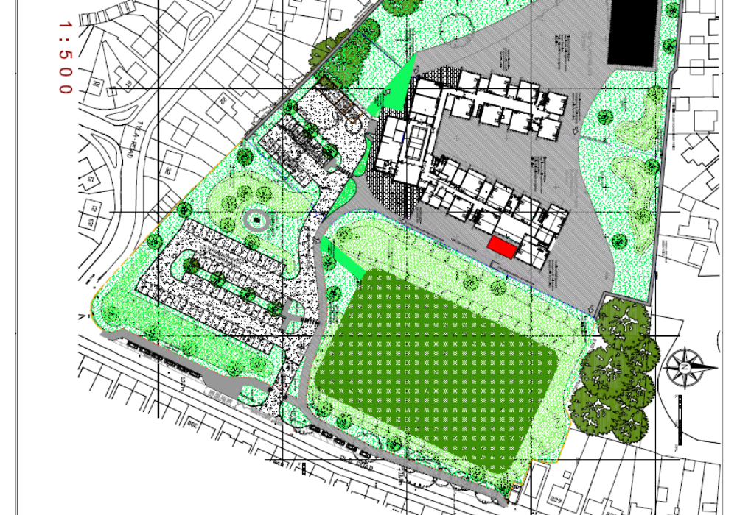

Vehicle access to the school is via Old Road. The school has a barrier at the entrance which is controlled from the school office. On entry into the grounds, the first car park on the left is for staff and visitors. The car park closer to the school is for the Senior Management Team, visitors and Blue Badge holders.

The main double gate on Old Road will be closed to traffic between 8.40am – 9am and between 2.45pm and 3.15pm.

3. School Opening / Closing times

School opens for Breakfast Club at 8.30–8.40am, Nursery sessions are 8.50–11.00am and 1pm – 3.10pm. Registration times for the rest of the school are 8.50am

4. Minibus and Bus management on and around the site

Buses and minibuses are not permitted on site and are encouraged to park in the layby situated outside the school gates. External parking and school layby are subject to external highways.

Staff supervision

Staff supervise pupils’ arrival and departures in the morning and in the afternoon into the school building. It is parental responsibility to supervise children before the start of the school day and after dismissal at 3.05pm.

Staff supervision location & timings at start / end of school day

Breakfast Club staff will be located in the dining hall in the morning from 8.30am to supervise the arrival of breakfast club pupils and Teaching staff at 8.50am, to supervise pupils arriving at the start of the school day.

5. Vehicles at school site

All vehicle drivers authorised to enter the site must be informed of the need to exercise extreme caution during access and egress. The main double gate on Old Road will be closed to traffic between 8.40am – 9am and between 2.45pm and 3.15pm.

Vehicles on site

Authorised visitors are welcome to park in the school grounds. The car park is often busy, however visitors should only park in available designated bays. Doing so will allow unrestricted movement of other vehicles during the school day or at peak times. The main double gate on Old Road will be closed to traffic between 8.40am – 9am and between 2.45pm and 3.15pm. During these times there should be no movement of vehicles by any users on school site until the Caretaker has opened the access/egress gates or removed the cones. Failure to adhere to these rules could mean permission to park on site is withdrawn.

Alternative on street parking is available in the surrounding area, but if you are unfamiliar with the area, please make sure that you do not block residential driveways or park where this could cause an obstruction.

Parents’ vehicles
Parents/ Guardians are not permitted to bring vehicles into the school compound at any time, however the Head Teacher may give permission in exceptional circumstances.

Blue badge holders are permitted to park on site. The Blue badge is to be presented at the School Office when requested and is to be in the name of the person responsible for escorting the child to the relevant entrance door. Blue badges are to be displayed so it can be seen clearly. Between 8.40am – 9am and 2.45pm and 3.15pm there should be no movement of vehicles by any users on school site until the Caretaker has opened the access/egress gates or removed the cones. Failure to adhere to these rules could mean permission to park on site is withdrawn.
When dropping children off, or picking them up, parents are requested not to park indiscriminately on the highway, and where possible are encouraged to walk their children to school. In the light of the Authority’s “Safe routes to schools” initiative, parents/ guardians are reminded of this request via newsletters and social media.
The school displays clear 5mph speed limit signs, which should be respected by all road users.

Staff vehicles

Staff are permitted to park in the top car park, in the clearly marked bays. Staff are required to adhere to the speed limit on the drive (5mph) during access and egress of the site. Staff are required to use the keypad which will open the barrier to enter the site. Staff will be unable to access or egress the site between 8.40am-9am and 2.45pm-3.15pm when the main gates will be closed. During these times there should be no movement of vehicles by any users on school site until the Caretaker has opened the access/egress gates or removed the cones. Failure to adhere to these rules could mean permission to park on site is withdrawn.

Staff must park in the allocated car park only and should take care not to obstruct any access routes. Drivers should proceed slowly within the car park at all times. Please bear in mind that some young people and some pupils with additional support needs may have little or no awareness of road safety and you should take account of this. Staff are expected to act responsibly on the site when parking and accessing the school building. It would be helpful if staff could supply the school with their registration number so that you can be contacted if there is a need to do so.

Visitors

Visitors should arrange to visit the site by appointment and they must be informed not to arrive or depart at the start/end of the day. They will not be granted vehicle access between 8.40am-9am and 2.45pm-3.15pm.

All visitors must report to reception and sign in before going anywhere in the school. Visitors are required to leave a note of their registration number with staff. On departure, visitors should sign out at reception and leave the building by the main entrance door.

There are also disabled parking bays for use by permit holders.

If visitors need any advice on access or parking before their visit, please call the school reception on 01639 502892.

Contractor’s vehicles

Contractors should arrange to visit the site by appointment, and they must be informed not to arrive or depart at the start/end of the day or break/lunchtime. They will not be granted vehicle access between 8.40am-9am and 2.45pm-3.15pm.
Building works vehicles
Where significant works are proposed the vehicle access and working arrangements must be discussed and agreed at the feasibility stage between Headteacher and Contractor.

Where possible, arrangements should be made to dedicate one particular vehicle entrance for construction traffic only. If this is not possible then the time the construction vehicles enter site needs to be agreed with the Head Teacher and closely supervised by a banksman. They will not be granted vehicle access between 8.40am-9am and 2.45pm-3.15pm.
The amended site access arrangements need to be recorded and communicated to all site users.

Servicing / Deliveries

Drivers of service vehicles (if they have not been on the site before or obtained instruction in advance) should report to the reception desk at the main entrance. Drivers may be issued with a copy of this plan for reference or simply be advised of the site rules in relation to the area they are parking at the time.

Where the contractor is on site to carry out works by prior arrangement, please call the school reception on 01639 502892 in advance, to agree the most suitable parking location.

Service vehicles do not have access to the car park or delivery area between 8.40am-9am and 2.45pm-3.15pm.

Appropriate signage is displayed advising delivery drivers where deliveries are to be made.

Buses, Mini Buses and Taxis

Buses and minibuses are not permitted on site and are encouraged to parking in the layby situated outside the school gates. External parking and school layby are subject to external highways.

Taxis are permitted to enter the site to collect or deliver pupils and must be informed of
the following: -

- The location of the Visitors parking area and the requirement to use them.
- The speed limit on site.
- The time they are expected to deliver and collect the passengers. They need to be on site by 8.30am (before the gates shut) in the morning and by 2.45pm (before the gates shut).
- Any changes to the above arrangements.
5.2 Pupils using taxis on site must be informed of the correct procedures and should be closely supervised by their escort.

Emergency Access

If a vehicle has to be driven through the playground it should be done when the playground is free from pupils. If this is not possible due to exceptional circumstances, then vehicles should be driven slowly through the playground whilst sounding the horn and activating their hazard warning lights to alert all in the area. A nominated person should clear the vehicles route in advance.

6. Pedestrians at school site

All pedestrians are advised to enter/exit the school from the designated entrances/exits.

Pedestrians should only access the school from the designated entry points. Pedestrians need to recognise that these may be adjacent to vehicular access points that will be in use during peak times and should exercise caution.

Learner Travel Wales

In line with the Welsh Government Learner Travel Act, the council identifies and assesses pupil journeys to and from school. All assessed routes are available to view on the Authority’s Road Safety website nptroadsafety.co.uk, with pupils also being given individual safe route information. For further information please contact the Learner Travel Officer, Gavin Hughes on 01639 686828.

7. Parking

A regular review of parking arrangements is undertaken to consider if:-
- The parking spaces are in appropriate places.
- The position of the spaces hinders access to/egress from the building.
- Vehicles have to cross pedestrian routes to access them.
- The route allows suitable access for emergency vehicles.
- The parking area is in a suitable condition.
- Arrangements are in place for visitor parking.
- Arrangements are in place for disabled parking.
- Vehicles must give way to pedestrians at designated crossing points.

8. Cycles/E-bikes/Skateboards

Cyclists/E-bike/skateboard users must dismount before entering the school premises and park in the cycle shelter.

9. Pupils

Pupils are made aware that parking areas are out of bounds. Pupils are not asked to collect or carry things from staff vehicles unless a member of staff accompanies them. Pupils are not allowed to open/close the school gates to allow vehicles access/egress.

10. Footways

Pedestrian footways are maintained in good condition. They are kept free from obstruction, overhanging vegetation and moss. Footways which are in poor condition may result in tripping accidents or pedestrians may be put at risk by walking on the road to avoid them.

11. Access to and from school

The school suffers from severe vehicle congestion problems close to and surrounding the premises. Parents who drop off and pick up their children by car, cause much of the congestion.
The school considers the following, in an attempt to reduce the congestion:
- We encourage walking and cycling by collaborative work with the Road Safety Team and to involve pupils in education and safety initiatives.
- We liaise with local Police/Parking Attendants regarding enforcement.
- We revise the travel plan annually.
- We remind parents from time to time of the dangers and problems associated with congestion at school entrances.
- We encouraged parents to car share, to reduce the number of vehicles outside the site.
- We liaise with operators who pick up/drop off pupils transported by bus/taxi.
- We liaise with the Local Authority regarding remedial measures (speed limits, road marking, traffic calming etc.).
- We ensure that a record of traffic incidents that occur off site in the vicinity of the school is maintained.

Accepted by Ysgol Carreg Hir Governing Body

Designation | Name | Signature | Date

Review Date: 26.4.2023

