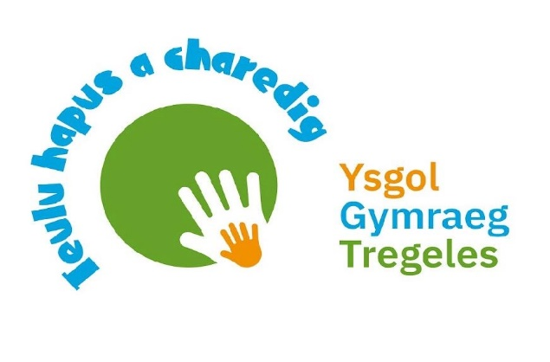

YGG Tregeles
Anti Bullying Policy

Introduction
We are committed to providing a supportive, caring and safe environment at Y.G.G. Tregeles for all our pupils, so that they can learn and play in a relaxed and secure environment. We acknowledge that incidents of bullying do happen from time to time as it would be unrealistic to claim otherwise. However, bullying of any kind is unacceptable and will not be tolerated at our school, and as a result we take all incidents of bullying seriously. If bullying does occur, everyone should be able to tell and know that incidents will be dealt with promptly and effectively in accordance with this anti-bullying policy.
What is bullying?
Bullying is defined as deliberately hurtful, upsetting, frightening or threatening behaviour by an individual or group towards another person or persons repeated over a period of time.
Bullying can be:
- Emotional - being unfriendly, excluding, tormenting (e.g. hiding possessions, threatening gestures), ridicule, humiliation.
- Verbal - name calling, sarcasm, spreading rumours, threats,teasing, making rude remarks, making fun of someone.
- Physical violence - pushing, kicking, hitting, pinching, spitting or any other use of violence
- Racial - racial taunts, graffiti, gestures
- Online / Cyber - sending offensive text messages, e-mails or internet chat room misuse.
- Sexual - any undesirable physical contact or any offensive sexual comments
- Disability/ALN - any unfavourable or negative comments, gestures or actions made to someone relating to their disability or special educational needs.
Bullying is not…..
It is important to understand that bullying is not the odd occasion of falling out with friends, name calling, arguments or when the occasional trick or joke is played on someone. It is bullying if it is done several times on purpose.
Children sometimes fall out or say things because they are upset. When occasional problems of this kind arise it should not be classed as bullying. It is an important part of children’s development to learn how to deal with friendship breakdowns, the odd name calling or childish prank. We all have to learn how to deal with these situations and develop social skills to repair relationships.
Where does bullying happen?
It can happen anywhere – in the classroom, in the corridors, in the dining hall, the toilets or the playground. Bullying may also happen on the way to and from school.
Why is it important to respond to bullying?
Bullying damages all those involved – not only the children being bullied but also the children who are doing the bullying. No one deserves to be a victim of bullying- everybody has the right to be treated with respect, and pupils who are bullying need to learn different ways of behaving.
Schools have a duty to respond promptly and effectively to issues of bullying.
The objectives of this policy are:
- All governors, teaching and non-teaching staff, pupils and parents/carers should have an understanding of what bullying is.
- All governors and teaching and non-teaching staff should know what the school policy is on bullying, and follow it when bullying is reported.
- All pupils and parents/carers should know what the school policy is on bullying, and what they should do if bullying occurs.
- Pupils and parents/carers should be assured that they will be supported if and when incidents of bullying are reported.
Signs and symptoms of bullying
Pupils who are being bullied may show changes in behaviour, such as becoming withdrawn and nervous, be unwilling to go to school or feign illness. There may be evidence of changes in a pupil’s work patterns e.g. lack of concentration, deterioration in standard of school work.
These signs and behaviours could indicate other problems, but bullying should be considered as a possibility and should be investigated.

They could discover, for example, if a child:
• is fearful of walking to or from school
• doesn't want to go on the school bus/public bus, appeals to be taken to school in the car
• changes their usual routine
• is reluctant to go to school (school phobia)
• starts truanting
• goes into their shell, is anxious or showing lack of confidence
• develops a stammer
• tries to or threatens to commit suicide or runs away
• cries themselves to sleep at night or has nightmares
• feels ill in the morning
• begins doing badly in their school work
• comes home with ripped clothes or damaged books
• "loses" their belongings
• asks for money or starts stealing money (to pay the bully)
• "loses" lunch money or other money all the time
• can't explain a cut or bruises
• comes home starving (money/lunch having been stolen)
• becomes aggressive, disruptive or unreasonable
• bullies other children or his brothers and sisters (imitating)
• refuses to eat
• is scared of saying what's wrong
• gives unlikely excuses for any of the above.
These signs and behavioural aspects could suggest other problems, but bullying should be considered as a possibility and investigated.

Procedures
- Report bullying incidents to staff.
- Bullying incidents will be recorded by staff .
- In serious cases, parents/carers should be informed and will be asked to come in to a meeting to discuss the problem.
- If necessary and appropriate, the school’s police liaison officer will be consulted.
- The bullying behaviour or threats of bullying must be investigated and the bullying stopped quickly.
- An attempt will be made to help the bully (bullies) change their behaviour.
Outcomes
- The bully (bullies) may be asked to genuinely apologise. Other consequences may take place.
- In serious cases, or when bullying persists despite warnings/action by school, suspension or even exclusion will be considered.
- If possible, the pupils will be reconciled.
- After the incident/incidents have been investigated and dealt with, each case will be monitored to ensure repeated bullying does not take place.
Prevention
The school will raise awareness of bullying through inclusion in PSHE, class circle time, school assemblies etc.,in an attempt to eradicate such behaviour.
Following consultation with pupils, ideas for preventing/reducing bullying were suggested by each class, and the following were chosen by the school council for implementation:
- All pupils to be prepared to tell if they know of any incidents of bullying in school
- All pupils to identify a member of staff they would tell if they were being bullied.
- Pupils to tell their parents/carers if they are being bullied.
- Pupils can ask a friend/friends to come with them to report incidents of bullying.
- Pupils should invite children who look lonely in the playground to come and play with them.
Monitoring, evaluation and review
The school will review this policy when necessary, and will assess its implementation and effectiveness. The policy will be promoted and implemented throughout the school.
Accepted March 2024
Reviewed
Next Review Date Spring 2025

Bullying Incident Record Form

Pupil's name __________________________________________ Year _____________.

Date _______________________ .

Details of the incident (who, what, when, where, how, why etc.)

Incident reporter ___________________________________________________________

Witnesses __________________________________________________________________

Action that was taken _______________________________________________________

Signed: Pupil _________________________________________

Member of Staff _______________________________________

